LLM Inference Performance Lab
  - Project Guide: GPU and LLM inference performance engineering with production-ready serving
Generated 2026-10-08 from docs/project-guide.md
Table of Contents

The living reference for this project. It explains what we’re building, why, how the pieces fit together, and what each module takes in and produces. Update it whenever a component, interface, decision or phase status changes (see §13 Maintaining this guide).
Last updated: 2026-10-08 · Current phase: 0, benchmark infrastructure · Hard deadline: Sun 13 Dec 2026
Status legend: ✅ done · 🚧 in progress · ⬜ planned · ❓ open decision

1. Goal
Central question: How far can LLM inference performance on a GPU be pushed under explicit latency, throughput and memory constraints, and can the bottleneck be explained at every layer?
Method, applied to every optimization:
Measure → Profile → Hypothesize → Optimize → Measure again → Explain
What success looks like: being able to explain a complete inference workload, from the transformer computation down to the GPU memory hierarchy and back up to production metrics, and to answer “why is this slow?” with evidence.
This is a performance engineering project. It is not a chatbot, a RAG app, a Kubernetes showcase or a cloud-architecture project. Serving and infrastructure exist only to show that the optimized engine can be operated for real.
Learning mode: the owner writes the code. Claude acts as mentor and reviewer (see CLAUDE.md).

The ten questions the final report must answer
# | Question | Answered mainly by
Q1 | Where is inference spending its time? | Phases 2, 4: Nsight Systems, PyTorch profiler
Q2 | Is the workload compute-bound or memory-bound? | Phases 2, 3: roofline, Nsight Compute
Q3 | How does precision affect performance? | Phase 4: precision/quantization sweep
Q4 | How does batch size affect throughput and latency? | Phases 1b, 4: batching experiments
Q5 | What happens to KV-cache memory as concurrency increases? | Phases 1, 4: KV simulator + vLLM
Q6 | Why do vLLM and TensorRT-LLM outperform the baseline? | Phase 4: runtime comparison
Q7 | Where is GPU utilization being lost? | Phases 2–4: Nsight timelines
Q8 | Can a custom CUDA/Triton kernel improve the bottleneck? | Phase 3: kernels
Q9 | What throughput can be sustained before P99 latency becomes unacceptable? | Phases 4, 5: load tests, open-loop arrival
Q10 | What is the final improvement, and what caused it? | Final report

2. Positioning
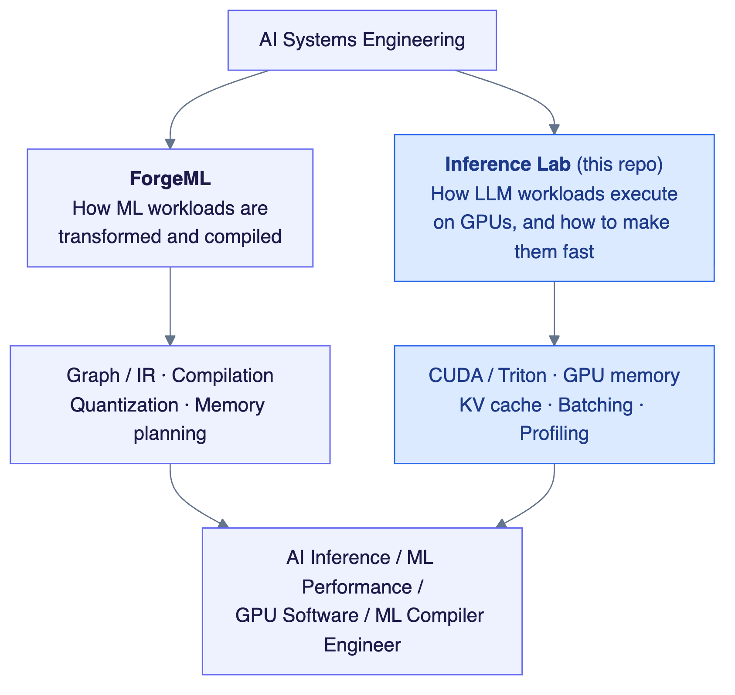
2. Positioning
Where the owner’s existing experience connects:
Prior experience | Where it shows up here
Static memory planning, tensor reuse, address allocation | KV-cache simulator (contiguous vs paged allocation, fragmentation)
Operator fusion, tiling | Fused CUDA/Triton kernel, tiled GEMM
PTQ / QAT / partial quantization | Precision and quantization sweep (INT8/INT4 weight-only)
GEMM analysis | Tiled GEMM kernel, roofline analysis, prefill (GEMM) vs decode (GEMV)

3. Architecture

3.1 Target system
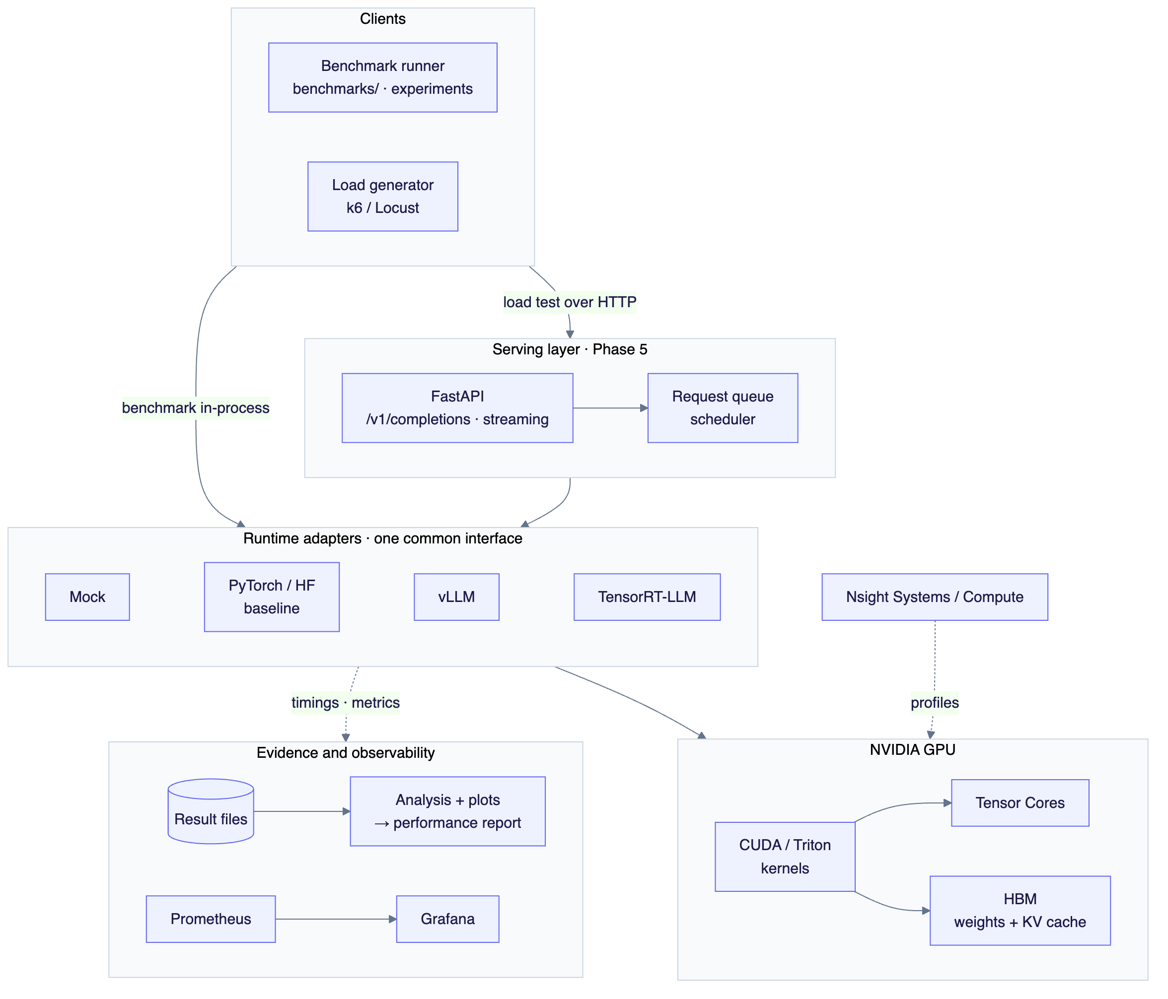
3.1 Target system
There are two ways in:
- Experiment path: the benchmark runner calls runtimes directly (in-process) or through the API. This is where performance is measured and explained. It’s most of the project.
- Serving path: clients go through FastAPI and the scheduler to a runtime. This shows the optimized engine can be operated with metrics, health checks and timeouts.

3.1b How the modules connect (data flow)
Green = built, grey = planned. Every producer of latency data writes the same RequestRecord format, so one analysis pipeline handles real runtimes and simulators alike.
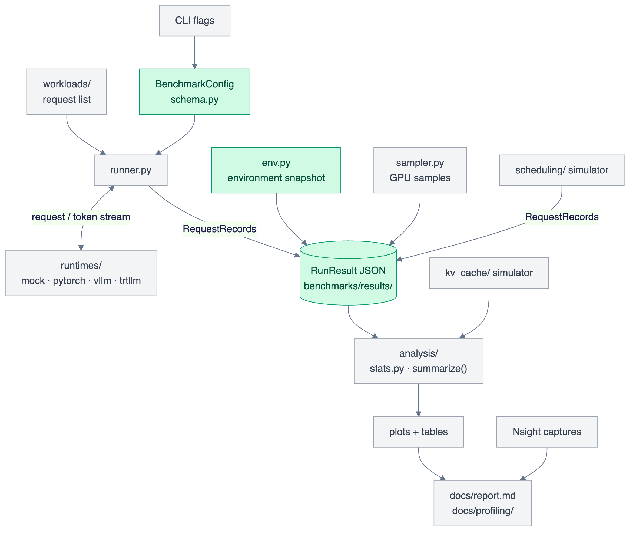
3.1b How the modules connect (data flow)

3.2 Layers and what each one tells us
Layer | Question it answers | Tools
Transformer computation | Which FLOPs and bytes does each op need? | Arithmetic, roofline
Runtime | How are requests batched and how is the KV cache managed? | vLLM, TRT-LLM, simulators
Kernel | Is this kernel limited by compute, memory or latency? | Nsight Compute, CUDA, Triton
GPU timeline | Where is the GPU idle? Launch overhead? Syncs? | Nsight Systems, PyTorch profiler
Serving | Queueing, tail latency, saturation point | Load tests, Prometheus

4. Hardware and environment strategy
Machine | Used for | Not used for
MacBook Air M5 (16 GB unified memory) | Harness, simulators, serving, monitoring, K8s manifests, writing kernels, testing bandwidth-bound predictions | Any number in the performance report
Cloud NVIDIA GPU (L4 or A10G, 24 GB, full VM) ❓ provider | Every report number: baselines, kernels, Nsight, vLLM, TRT-LLM, quantization | Development or debugging (that’s paid time)
Rules: - Mac numbers only validate the harness. They never appear in the report. - First GPU session: check that ncu (Nsight Compute) can read hardware counters before anything else. - GPU sessions are scripted: provision → install → run the experiment list → copy results back → shut down.
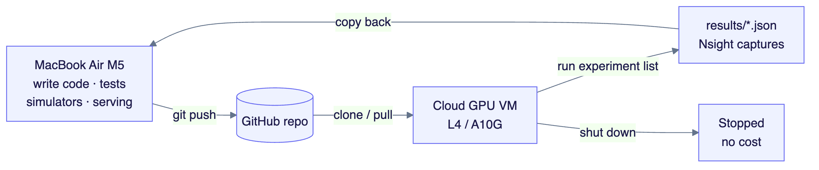
4. Hardware and environment strategy
Toolchain: Python 3.12, uv (dependencies pinned in uv.lock), pytest, ruff. The CUDA build of torch is installed separately on the GPU machine to match its driver.

5. Repository layout
Planned modules are only created when there is real code for them.
llm-inference-performance/
├── CLAUDE.md ✅ Context and mentor rules for Claude sessions
├── README.md ✅ Entry point
├── pyproject.toml, uv.lock ✅ Pinned environment
├── docs/
│ ├── project-guide.md ✅ This document
│ ├── benchmark-methodology.md ✅ Metric definitions and measurement rules
│ ├── export/ ✅ Builds the Word/PDF versions of this guide
│ ├── schedule.html ✅ Day-by-day schedule tracker with live re-planning
│ ├── profiling/ ⬜ One write-up per Nsight investigation
│ └── report.md ⬜ Final performance report
├── benchmarks/
│ ├── env.py ✅ Environment snapshot
│ ├── stats.py ✅ Percentiles and distributions
│ ├── schema.py ✅ Config, per-request records, run results
│ ├── runtimes/ ⬜ Runtime interface + adapters (mock, pytorch, vllm, trtllm)
│ ├── runner.py ⬜ Runs workloads against a runtime
│ ├── workloads/ ⬜ Prompt/output length definitions, arrival processes
│ ├── sampler.py ⬜ GPU utilization and memory sampling
│ ├── analysis/ ⬜ Load results → tables and plots
│ ├── results/ ✅ Raw result JSON (committed)
│ └── plots/ ⬜ Generated plots
├── kv_cache/ ⬜ KV-cache allocation simulator
├── scheduling/ ⬜ Batching/scheduling simulator
├── kernels/
│ ├── cuda/ ⬜ vector add, reduction, tiled GEMM, fused kernel
│ └── triton/ ⬜ Triton kernel(s)
├── serving/ ⬜ FastAPI app and scheduler
├── deployment/ ⬜ Docker, Kubernetes, GPU session scripts
├── monitoring/ ⬜ Prometheus config, Grafana dashboards
├── tests/ ✅ Unit tests
└── .github/workflows/ ⬜ CI: tests, lint, regression check

6. Phases
Each phase has a goal, deliverables and an exit criterion. A phase is done when its exit criterion is met and this guide is updated.
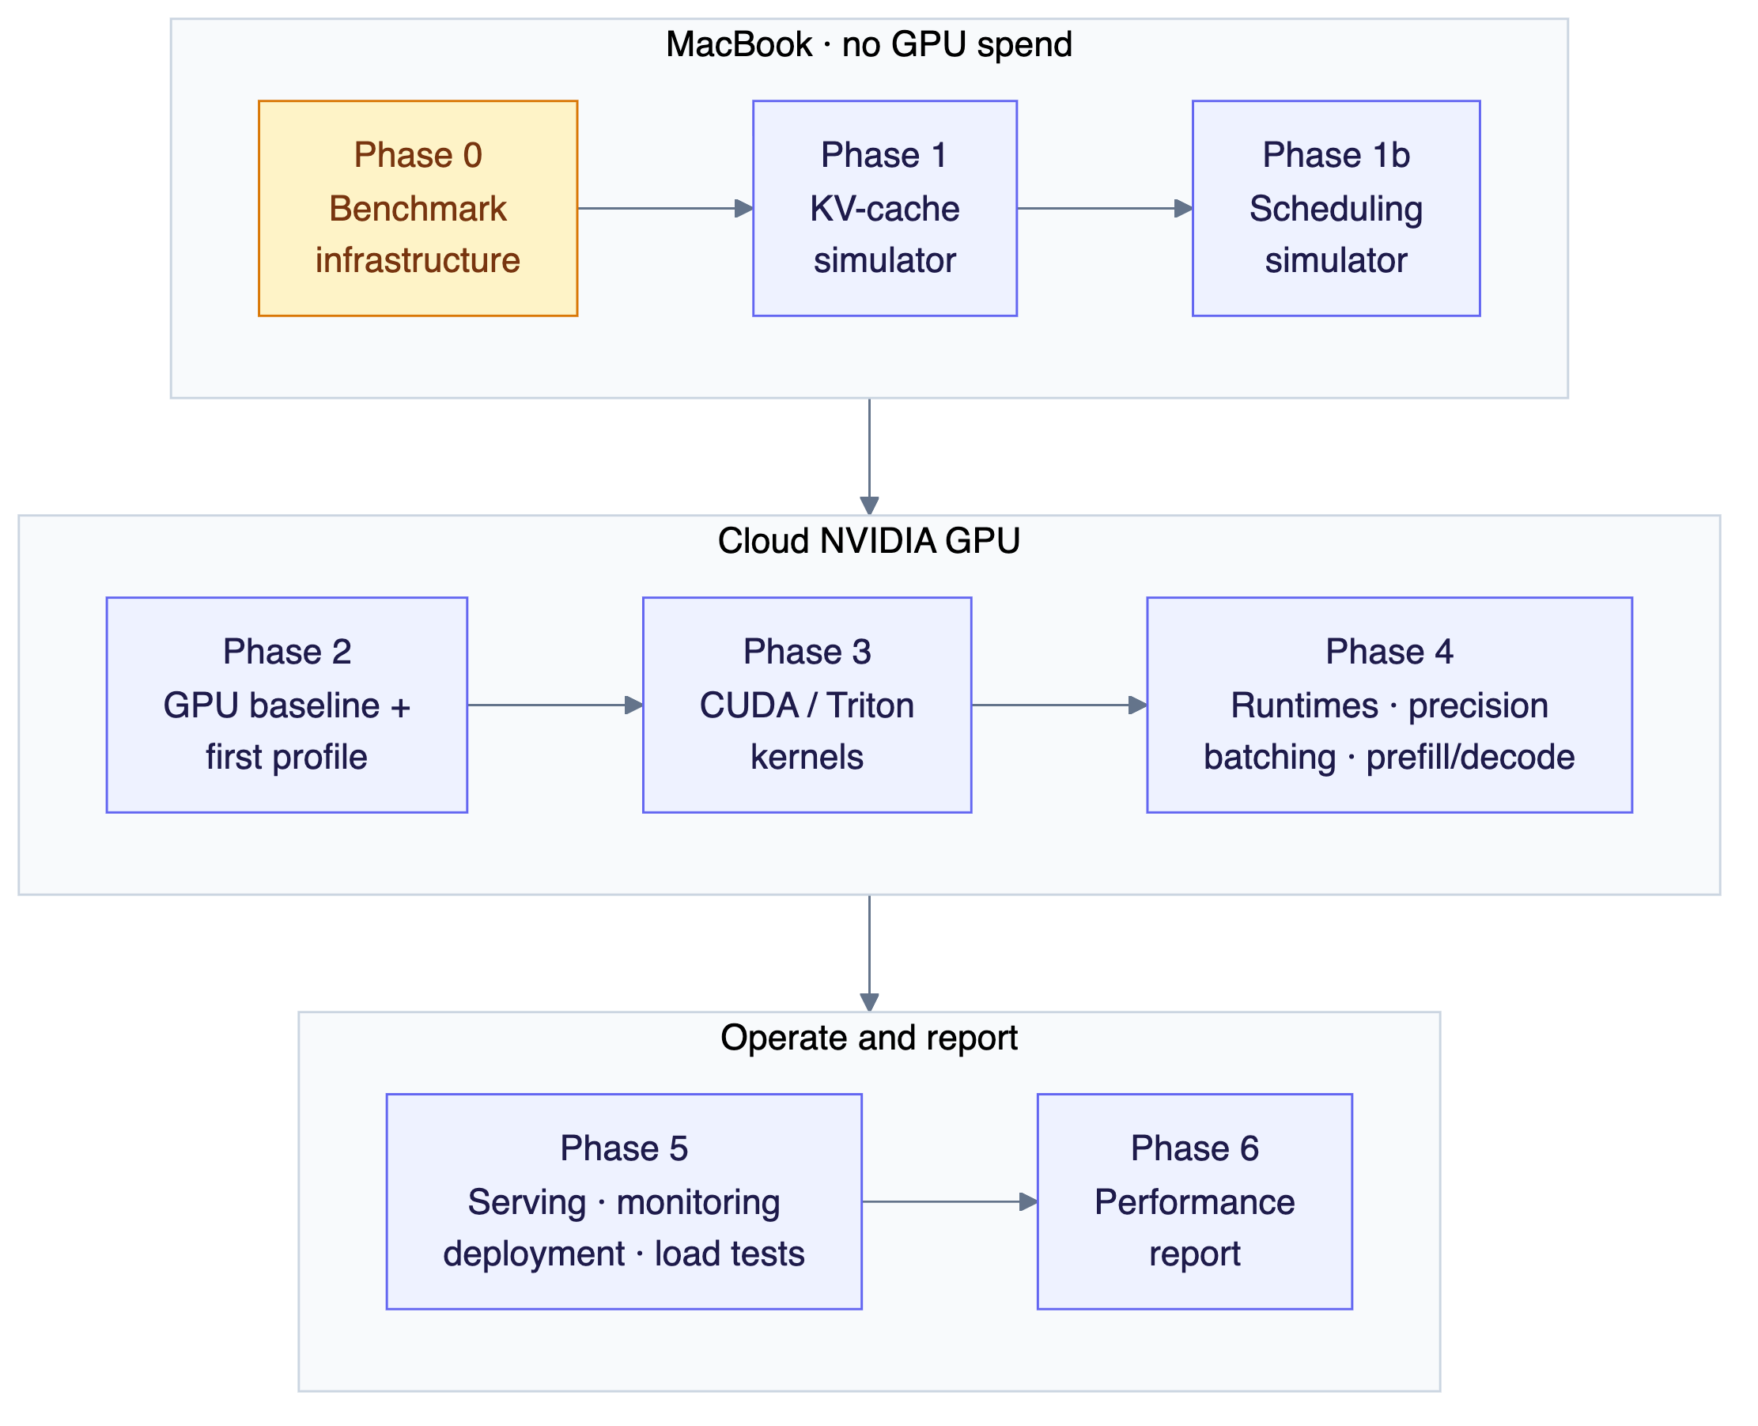
6. Phases
Phase | Where | Goal | Key deliverables | Exit criterion | Report Qs | Status
0 Infrastructure | Mac | A benchmark harness you trust | env capture, schema, stats, runtime interface, mock runtime, runner, CLI, plots | Mock runtime with known timings gives the expected TTFT/ITL within a justified tolerance | n/a | 🚧
1 KV-cache simulator | Mac | Understand why paged KV caches exist | Contiguous vs paged allocator, fragmentation and max-concurrency analysis | Plots of utilization and max concurrency vs block size and sequence-length spread | Q5 | ⬜
1b Scheduling simulator | Mac | Understand batching trade-offs before touching a GPU | No / static / continuous batching on top of the mock runtime | Latency vs throughput curves for each policy | Q4 | ⬜
2 GPU baseline | GPU | A reliable PyTorch baseline on NVIDIA | Nsight check, HF baseline runtime adapter, GPU sampler, first Nsight Systems timeline | Reproducible baseline (repeat runs within a stated noise band) + first profiling write-up | Q1, Q2, Q7 | ⬜
3 Kernels | GPU | Apply GPU optimization to real bottlenecks | 4 CUDA kernels + ≥1 Triton kernel, each with before/after profiles | Each kernel has a profile → hypothesis → change → measurement → explanation write-up | Q2, Q8 | ⬜
4 Runtimes and LLM optimizations | GPU | Explain why optimized runtimes are faster | vLLM and TRT-LLM adapters, precision sweep, batching sweep, prefill vs decode, KV-cache comparison with Phase 1 | Runtime comparison with mechanisms backed by evidence | Q3–Q7, Q9 | ⬜
5 Serving and operations | Mac → GPU | Operate the optimized engine for real | FastAPI, streaming, scheduler, metrics, Grafana, Docker, minimal K8s, load tests, CI regression | Saturation point found under open-loop load with a dashboard | Q9 | ⬜
6 Report | — | Turn evidence into a strong engineering document | docs/report.md with methodology, results, analysis, limitations | All ten questions answered with measured evidence | Q10 | ⬜
Effort split: benchmarking 15% · CUDA/Triton 20% · profiling 20% · runtimes 15% · KV/batching 15% · serving 10% · docs 5%.

Schedule and hard deadlines
Baseline plan: 300 hours at 5 h/day, every day, starting Fri 9 Oct 2026, with a holiday from 20 to 25 Oct. Each phase includes a buffer task. Day-by-day tracking, task check-off and live re-planning are in docs/schedule.html; open it in a browser.
Phase | Hours | Starts | Hard deadline
0 Infrastructure | 35 | Fri 9 Oct | Thu 15 Oct
1 KV-cache simulator | 22 | Fri 16 Oct | Mon 26 Oct
1b Scheduling simulator | 16 | Mon 26 Oct | Thu 29 Oct
2 GPU baseline | 35 | Thu 29 Oct | Thu 5 Nov
3 Kernels | 59 | Thu 5 Nov | Tue 17 Nov
4 Runtimes and LLM optimizations | 67 | Tue 17 Nov | Mon 30 Nov
5 Serving and operations | 43 | Mon 30 Nov | Wed 9 Dec
6 Report | 23 | Wed 9 Dec | Sun 13 Dec
These deadlines are fixed. When work slips, the tracker re-plans the projected dates and shows the pace needed to recover; the deadlines move only on a deliberate re-baseline (logged in §11).

7. Components
Each entry lists: purpose · status · inputs → outputs · example · depends on.
Examples marked illustrative show the shape of data only. They are not measurements.

7.1 Benchmark infrastructure (benchmarks/)

env.py: environment snapshot ✅
- Purpose: record everything about the machine and software that could affect a result, so any number can be traced back to where it came from.
- Inputs: none. It reads the system, installed packages, git, nvidia-smi and torch.
- Outputs: a JSON-serializable dict that is embedded in every result file.
- Run it: uv run python -m benchmarks.env
- Example output (actual snapshot from the M5, trimmed):
{
"python": "3.12.14",
"cpu": {"machine": "arm64", "logical_cores": 10, "model": "Apple M5", "memory_bytes": 17179869184},
"git": {"commit": null, "dirty": true},
"packages": {"torch": null, "vllm": null, "...": "..."},
"torch": null,
"nvidia_smi": null,
"env_vars": {"CUDA_LAUNCH_BLOCKING": null, "...": "..."}
}
- Why the environment variables are captured: for example, CUDA_LAUNCH_BLOCKING=1 serializes every kernel launch and silently invalidates timing.

stats.py: latency distributions ✅
- Purpose: percentiles and summary statistics for latency samples.
- Inputs: a list of floats (latencies in ms).
- Outputs: {n, mean, min, max, p50, p90, p95, p99}.
- Example:
distribution([1, 2, 3, 4])
# {"n": 4, "mean": 2.5, "min": 1, "max": 4, "p50": 2.5, "p90": 3.7, "p95": 3.85, "p99": 3.97}
- Rule: always report n. A P99 from fewer than ~100 samples is close to just the maximum.

schema.py: configs and results ✅
- Purpose: define what a benchmark run is and how it is stored. Metrics are derived from raw timestamps and never stored as typed-in numbers.
- Types:
Type | Role
BenchmarkConfig | What was run: runtime, model, precision, quantization, batch size, concurrency, token lengths, request counts, seed, device
RequestRecord | One request: submit time + arrival time of each output token (ns)
RunResult | Config + environment + all RequestRecords + wall time + device samples
summarize() | RequestRecords → TTFT / ITL / TPOT / E2E distributions + throughput
- Example: from raw timestamps to metrics (taken from the unit tests):
Request submitted at t = 0 ms; tokens arrive at 100, 110, 130, 140 ms
TTFT = 100 ms (first token − submit)
E2E = 140 ms (last token − submit)
ITL = [10, 20, 10] ms (gaps between tokens)
TPOT = (140 − 100) / 3 ≈ 13.3 ms (mean decode time per token for this request)
- Output file: benchmarks/results/<date>_<runtime>_<run_id>.json. See §9.
- Known review item: open findings from Assignment 0 are tracked in §11.

Runtime interface + adapters (benchmarks/runtimes/) ⬜ Assignment 1 ❓ design
- Purpose: one interface that the runner (and later the server) uses to talk to any engine: mock, PyTorch/HF, vLLM, TensorRT-LLM.
- Requirements (the design is the owner’s):
  - Must be able to stream tokens, so that TTFT and ITL can be measured.
  - Must support running many requests at once (concurrency).
  - Must report failures per request without stopping the run.
  - Must fit both an in-process engine (HF generate, vLLM engine) and a remote HTTP server.
- Inputs: a request (prompt or prompt tokens, maximum output tokens, sampling settings).
- Outputs: a stream of tokens, with timing captured by the caller → RequestRecord.

Mock runtime ⬜ Assignment 1
- Purpose: a fake LLM with known timings, used to check the harness itself before any GPU is involved.
- Inputs: prefill time per prompt token, decode time per output token, optional slowdown under load.
- Outputs: a token stream with those timings.
- Example: with 50 ms prefill and 10 ms/token decode, a correct harness should measure TTFT ≈ 50 ms and ITL ≈ 10 ms. Any difference is overhead or error in the harness.

Runner + CLI ⬜ Assignment 1
- Purpose: run a workload against a runtime under a given concurrency and produce a RunResult.
- Inputs: BenchmarkConfig (from CLI flags), a runtime adapter, a workload.
- Outputs: a saved result JSON plus a short printed summary.
- Example invocation (target interface from the brief):
uv run python -m benchmarks.run \
--runtime mock --precision fp16 --batch-size 8 \
--input-tokens 1024 --output-tokens 256 --concurrency 16
- Open decisions: ❓ concurrency mechanism (threads / asyncio / processes) · ❓ arrival process (closed loop / open loop) · ❓ warmup policy.

Workloads (benchmarks/workloads/) ⬜
- Purpose: define what traffic looks like, separately from how it is sent.
- Inputs: prompt-length and output-length distributions (fixed, uniform, or taken from a real dataset), number of requests, seed, arrival process.
- Outputs: a reproducible list of requests (same seed → same workload).
- Example (illustrative): fixed-1024in-256out, chat-mix (short prompts, varied outputs), long-context (long prompts, short outputs, which stresses prefill).

Device sampler (benchmarks/sampler.py) ⬜ Phase 2
- Purpose: record GPU state while a benchmark runs.
- Inputs: sampling interval, device index.
- Outputs: device_samples: a list of {t_ns, gpu_util_pct, mem_used_bytes, power_w, sm_clock_mhz, ...}.
- Note: “GPU utilization” from NVML means a kernel was running, not the SMs were busy. The difference is explained in the profiling write-ups.

Analysis and plots (benchmarks/analysis/) ⬜
- Purpose: turn result files into tables and plots with no manual copying.
- Inputs: a set of result JSON files (selected by filter, e.g. runtime=vllm, precision=fp16).
- Outputs: PNG/SVG plots in benchmarks/plots/ and Markdown tables for the docs.
- Example plots: throughput vs P99 latency (one line per runtime); TTFT vs prompt length; ITL vs concurrency; KV-cache usage vs concurrency.

7.2 KV-cache simulator (kv_cache/) ⬜ Phase 1
- Purpose: show why paged/block KV allocation beats contiguous allocation. This builds directly on the owner’s static memory-planning experience.
- Inputs:
  - Model shape: layers, KV heads, head dimension, bytes per element
  - Memory budget for the KV cache
  - Allocation policy: contiguous (reserve the maximum sequence length up front) vs paged (fixed-size blocks)
  - Block size (for paged)
  - A request trace: arrival time, prompt length, output length for each request
- Outputs: memory utilization over time, internal and external fragmentation, maximum number of concurrent requests, requests rejected or delayed.
- Key relationship:
KV bytes per token = 2 (K and V) × layers × kv_heads × head_dim × bytes_per_element
Illustrative arithmetic for a hypothetical model (16 layers, 8 KV heads, head dim 64, FP16): 2 × 16 × 8 × 64 × 2 B = 32 KiB per token, so a 2,048-token sequence holds 64 MiB of KV cache. - Later: compare the simulator’s predictions with vLLM’s actual behaviour in Phase 4.

7.3 Scheduling simulator (scheduling/) ⬜ Phase 1b
- Purpose: compare no batching, static batching and continuous batching on top of the mock runtime.
- Inputs: workload, batching policy, maximum batch size, a cost model for prefill and decode steps.
- Outputs: per-request records in the standard schema, so the same analysis code produces the plots.
- Question: how does batching move the latency/throughput trade-off, and what happens to ITL P99 when prefills are mixed in with decode steps?

7.4 Inference backends ⬜ Phases 2 and 4
All backends sit behind the runtime interface, so they produce comparable result files.
Backend | Purpose | Inspect / measure
PyTorch / HF | Baseline: plain eager inference | Kernel launches, idle GPU time, HF KV cache, prefill vs decode
vLLM | Paged KV cache + continuous batching | Block manager, scheduler, attention kernels, KV usage
TensorRT-LLM | Compiled engine, fused kernels, in-flight batching | Engine build options, kernel fusion, quantized kernels
- Model: ❓ a 1–3B model for baselines and kernels, plus possibly a 7–8B model for memory-pressure experiments.
- Precisions: FP32 → FP16/BF16 → INT8 → INT4 (weight-only), plus FP8 if the GPU supports it.

7.5 Kernels (kernels/) ⬜ Phase 3
Each kernel follows: baseline → profile → hypothesis → optimization → profile → benchmark → explanation.
Kernel | Teaches | Inputs → outputs | Key Nsight Compute metrics
Vector add | Memory access, coalescing | two vectors → sum | achieved DRAM bandwidth vs peak
Reduction | Shared memory, warp shuffles, syncs | vector → scalar | bandwidth, warp stall reasons
Tiled GEMM | Tiling, registers, arithmetic intensity | A (M×K), B (K×N) → C | FLOP/s vs peak, roofline position, occupancy
Fused inference kernel ❓ | Fusion in a real workload (e.g. RMSNorm, SiLU-mul, bias+activation) | layer activations → output | bytes moved vs unfused version
Triton kernel ❓ | Productivity vs control compared with CUDA | same as one of the above | latency, bandwidth, compared with PyTorch and CUDA
Output per kernel: source, a correctness test against PyTorch, a benchmark result file and a profiling write-up in docs/profiling/.

7.6 Profiling workflow ⬜ Phases 2–4
- Nsight Systems (timeline): CPU/GPU overlap, kernel launch gaps, syncs, memcpy, where the GPU is idle.
- Nsight Compute (per kernel): memory vs compute throughput, occupancy, registers, shared memory, stall reasons.
- Output: one write-up per investigation, in this format:
Observed problem → Evidence (screenshot/metric) → Hypothesis → Change → Result (measured) → Conclusion
Profile files (*.nsys-rep, *.ncu-rep) are large and stay out of git. Write-ups link to them.

7.7 Serving (serving/) ⬜ Phase 5
- Purpose: expose the optimized engine for real use.
- Endpoints: POST /v1/completions, POST /v1/chat/completions, GET /health (liveness), GET /ready (model loaded), GET /metrics (Prometheus).
- Example request/response (illustrative, OpenAI-compatible shape):
POST /v1/completions
{"model": "<model-id>", "prompt": "Explain paged attention", "max_tokens": 64, "stream": true}
→ text/event-stream
data: {"id": "req_…", "choices": [{"text": "Paged", "index": 0}]}
data: {"id": "req_…", "choices": [{"text": " attention", "index": 0}]}
data: [DONE]
- Behaviour: request IDs, timeouts, cancellation when the client disconnects, request-size limits, API key authentication, structured logs.

7.8 Monitoring (monitoring/) ⬜ Phase 5
- Inputs: /metrics from the server, GPU metrics (DCGM exporter or NVML).
- Outputs: a Grafana dashboard showing requests/s, P50/P95/P99 latency, TTFT, ITL, tokens/s, GPU utilization and memory, KV-cache utilization, queue time, error rate.

7.9 Deployment (deployment/) ⬜ Phase 5
- Docker: pinned, CUDA-compatible image with a health check.
- Kubernetes: minimal Deployment + Service with GPU resource requests, readiness and liveness probes, rolling update. Single-node k3s + NVIDIA GPU Operator on the cloud VM.
- GPU session scripts: provision → set up → run the experiment list → copy results back → shut down.

7.10 CI and regression checks (.github/workflows/) ⬜ Phase 5
- On every push: tests and lint (no GPU needed).
- Regression check: the mock-runtime benchmark checks that the harness itself hasn’t drifted. GPU regression checks run on demand during GPU sessions, with thresholds based on measured noise.

8. End-to-end flows

8.1 Running one experiment
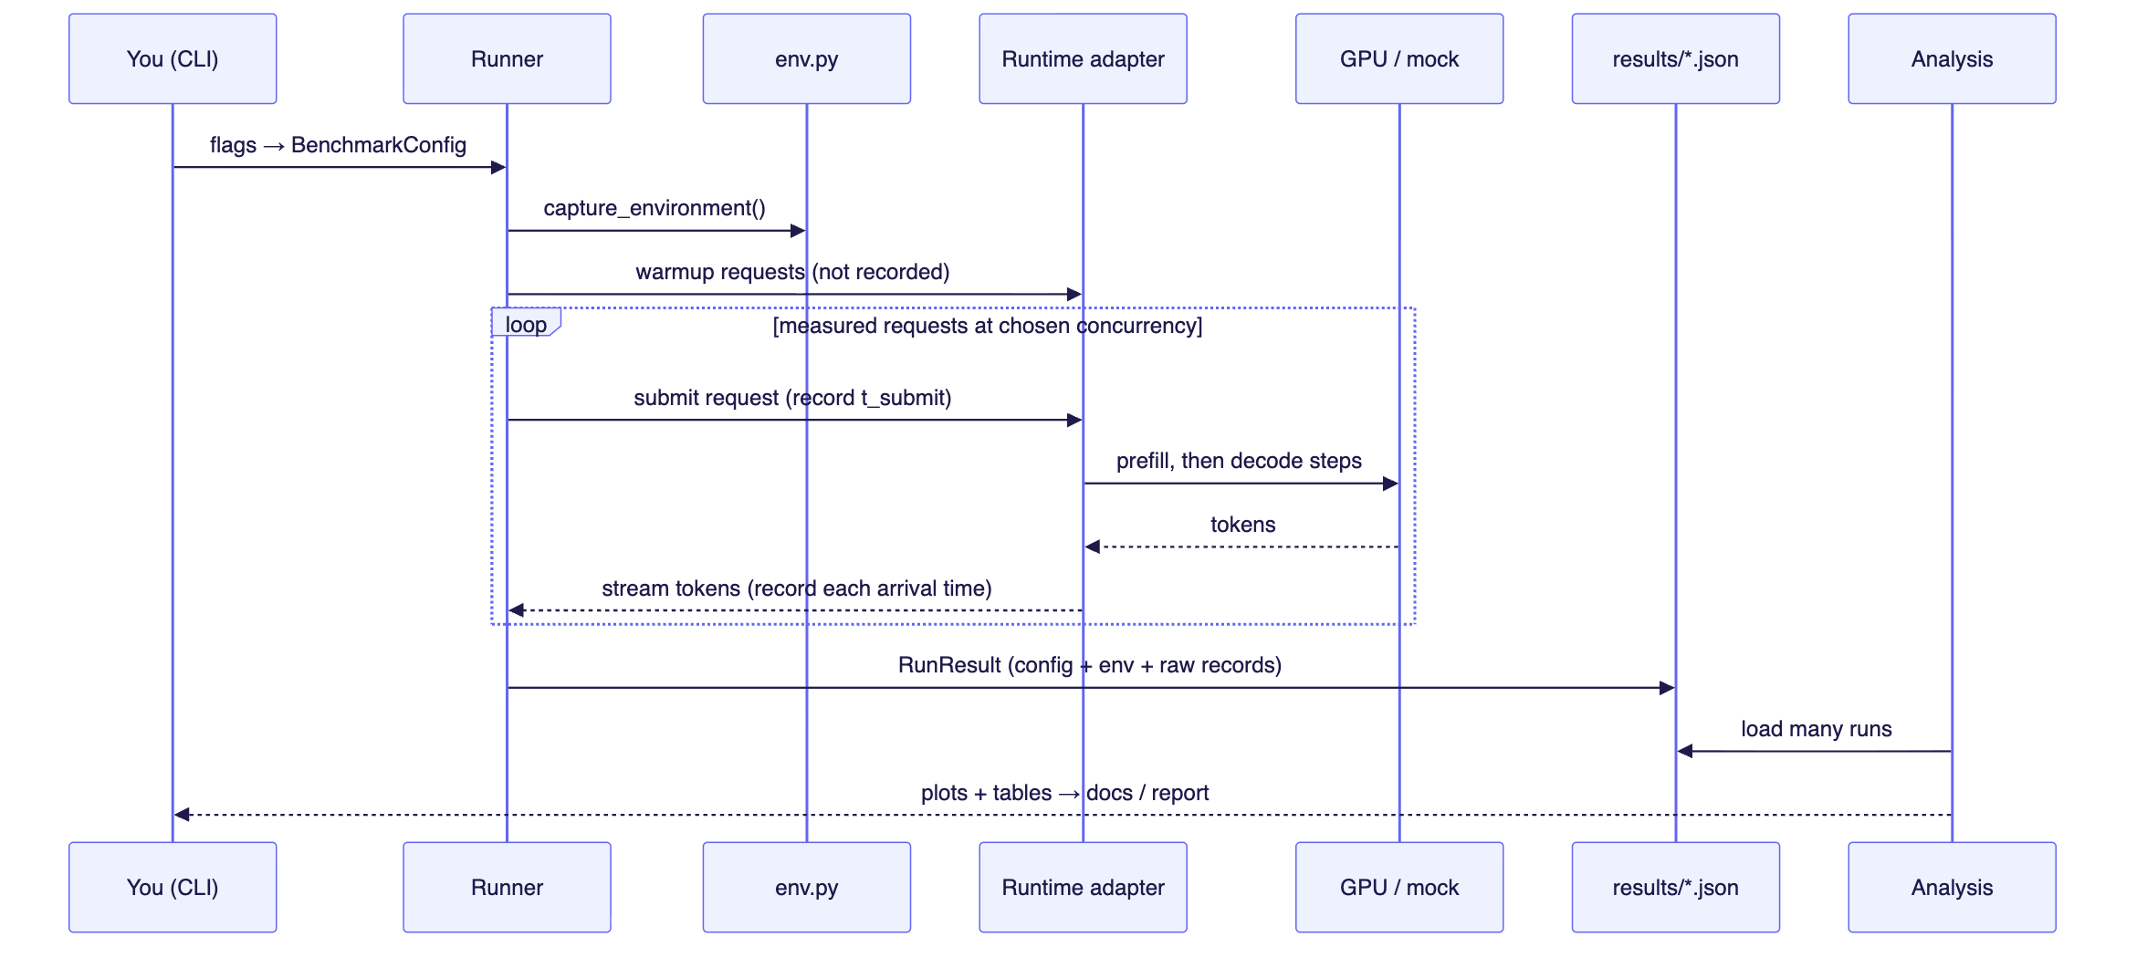
8.1 Running one experiment

8.2 One optimization cycle
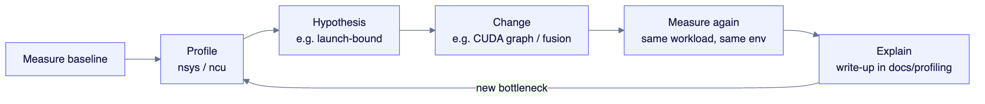
8.2 One optimization cycle

8.3 Serving one request (Phase 5)
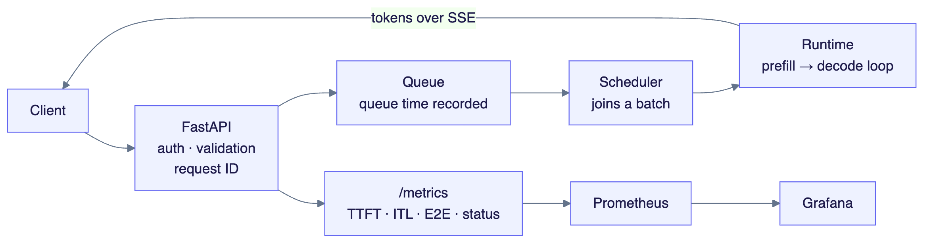
8.3 Serving one request (Phase 5)

9. Data contracts

Result file (schema_version: 1)
Path: benchmarks/results/<YYYY-MM-DD>_<runtime>_<run_id>.json
{
"schema_version": 1,
"run_id": "a1b2c3d4e5f6",
"created_at": "2026-10-01T10:00:00+00:00",
"config": { "runtime": "mock", "model": "...", "precision": "fp16", "concurrency": 8, "...": "..." },
"environment": { "...": "output of env.py" },
"summary": { "ttft_ms": {"n": 0, "p50": 0.0, "p99": 0.0}, "itl_ms": {}, "output_tokens_per_s": 0.0, "...": "..." },
"requests": [ { "request_id": "...", "prompt_tokens": 0, "t_submit_ns": 0, "token_times_ns": [0, 0], "error": null } ],
"device_samples": []
}
Illustrative shape; the values are placeholders.
Rules: - summary is always recomputed from requests. Never edit it by hand. - If the schema changes, increment schema_version. The loader rejects versions it doesn’t know. - Result files are committed. Profiler captures are not.
Metric definitions: benchmark-methodology.md.

10. Experiment catalog
Each experiment changes one thing and keeps everything else fixed. Before running it, write down a prediction, then compare it with the measurement.
ID | Question | Changed | Fixed | Key metrics | Phase | Status
E0 | Does the harness measure correctly? | mock timings, concurrency | — | TTFT/ITL vs configured values | 0 | ⬜
E1 | Bandwidth limit on batch-1 decode | precision | model, batch = 1 | decode tok/s vs bandwidth ÷ weight bytes | 0 (Mac, prediction only) / 2 | ⬜
E2 | Contiguous vs paged KV | policy, block size, length spread | memory budget, model shape | utilization, fragmentation, max concurrency | 1 | ⬜
E3 | Batching policy trade-off | policy, concurrency 1→32 | workload | throughput, TTFT, ITL P99 | 1b / 4 | ⬜
E4 | Baseline breakdown | — | model, workload | prefill vs decode time, idle GPU time | 2 | ⬜
E5 | Prefill vs decode bottlenecks | prompt length, output length | model, precision | TTFT, ITL, achieved bandwidth and FLOP/s | 2 / 4 | ⬜
E6 | Kernel optimizations | kernel version | shapes, GPU | latency, % of peak bandwidth / FLOP/s | 3 | ⬜
E7 | Precision and quantization | FP32 → FP16 → INT8 → INT4 | model, workload | memory, latency, throughput, quality check | 4 | ⬜
E8 | Runtime comparison | PyTorch / vLLM / TRT-LLM | model, precision, workload | full metric set + mechanisms | 4 | ⬜
E9 | Saturation point | arrival rate (open loop) | deployment | P99 vs throughput, queue time | 5 | ⬜

11. Decision log

Decided
Date | Decision | Why
2026-09-30 | Hybrid hardware: Mac for development, rented NVIDIA GPU for every reported number | No NVIDIA GPU locally; keeps GPU spend focused on experiments
2026-09-30 | Python 3.12 + uv, lockfile committed | PyTorch / GPU libraries lag the newest Python; reproducibility
2026-09-30 | Store raw per-token timestamps; derive all metrics | Audit trail, no hand-copied numbers, metrics can be redefined later
2026-09-30 | Host-side perf_counter_ns timing at token visibility | Measures what a client experiences; kernel timing is a separate explanatory tool
2026-09-30 | Mentor mode: the owner writes the code, Claude reviews | Learning project
2026-10-08 | Baseline schedule: 5 h/day, 7 days/week, hard deadline 13 Dec 2026 | Full scope with per-phase buffers; deadlines move only on a deliberate re-baseline

Open ❓
Question | Decided in | Notes
Runtime interface design | Assignment 1 | Must fit in-process engines and HTTP servers
Concurrency mechanism (threads / asyncio / processes) | Assignment 1 | Effect on timestamp accuracy, GIL
Closed-loop vs open-loop arrival | Assignment 1 | Q9 needs a way to find the saturation point
Warmup policy | Assignment 1 | What distorts the first requests on a GPU?
Assignment 0 review findings on existing code | Assignment 0 | Includes at least one real design flaw
Model choice | Before Phase 2 | 1–3B for 24 GB; maybe 7–8B for memory pressure
Cloud provider and GPU (L4 vs A10G) | Before Phase 2 | Must allow Nsight Compute counter access
Fused kernel target | Phase 3 | Pick from what the baseline profile shows to be costly

12. Changelog
Date | Change
2026-09-30 | Repository created. Phase 0 started: env capture, result schema, stats, methodology doc, tests
2026-10-01 | Project guide created. Mentor mode adopted
2026-10-01 | Added diagrams (module data flow, GPU session workflow, phase roadmap, serving flow) and Word/PDF export
2026-10-08 | Baseline schedule set: 300 h, 9 Oct → 13 Dec 2026, holiday 20–25 Oct; interactive tracker docs/schedule.html

13. Maintaining this guide
Update this guide in the same change as the work, whenever:
- a component is added, or its inputs/outputs/interface change → §5, §7 (and §9 for data formats)
- a phase starts or finishes, or an assignment is completed → §6, header, §12
- a decision is made or an open question is resolved → §11
- an experiment is designed, run or concluded → §10 (link the result files and write-up)
Never put measured numbers here without a link to the result file that produced them. Detailed analysis belongs in docs/profiling/ and docs/report.md. This guide links to it.

Word and PDF versions
This Markdown file is the source of truth. The Word and PDF versions are generated from it, with every Mermaid block rendered as a diagram:
uv run python docs/export/build.py
Outputs: docs/export/out/LLM-Inference-Performance-Lab-Guide.docx and .pdf. Rebuild after every change to this guide. Edits made directly in the Word file are not carried back here and are lost on the next rebuild.
Requires pandoc (brew install pandoc), Node.js (for npx @mermaid-js/mermaid-cli) and Google Chrome.

