AI-Based Early Disease Prediction System Using Machine Learning
Submitted by

NIVEDYA B
IN26014622
B.Tech. Computer Science & Engineering

Submitted to
Mr.Puneet Gurbani

August 5th,2026

GitHub Link:
https://github.com/nivedyab916/AI-Based-Early-Disease-Prediction

AI-Based Early Disease Prediction System Using Machine Learning

Abstract— This project presents an AI-Based Early Disease Prediction System developed using Flask and Machine Learning to predict the likelihood of diabetes based on user health parameters. The system uses a trained classification model to provide disease prediction, probability score, risk level, and personalized health recommendations. It also maintains a prediction history using an SQLite database and offers a simple, user-friendly web interface. The proposed system demonstrates how machine learning can support early disease detection and assist users in making informed healthcare decisions.
Keywords— Artificial Intelligence, Machine Learning, Disease Prediction, Diabetes Prediction, Flask, Scikit-learn, Healthcare, Web Application, SQLite, Early Diagnosis.

I. INTRODUCTION
The rapid growth of artificial intelligence and machine learning has transformed numerous industries, particularly the healthcare sector. Intelligent predictive systems have become valuable tools for assisting healthcare professionals in disease diagnosis, patient monitoring, and clinical decision-making. Among various chronic diseases, diabetes has emerged as one of the leading health concerns worldwide, affecting millions of people and increasing the risk of severe complications such as cardiovascular diseases, kidney failure, nerve damage, and vision impairment. Early identification of diabetes significantly improves treatment effectiveness and helps patients adopt preventive lifestyle changes before complications develop.
Traditional diabetes diagnosis requires laboratory tests and consultation with medical professionals. While these methods provide accurate results, they may not always be readily accessible, especially in remote or resource-limited areas. Machine learning techniques offer an efficient alternative by analyzing historical healthcare data and identifying patterns associated with the disease. These predictive models can provide quick preliminary assessments, enabling users to understand their potential risk before seeking professional medical evaluation.
The AI-Based Early Disease Prediction System presented in this project utilizes supervised machine learning algorithms to predict whether an individual is likely to have diabetes based on several medical attributes, including glucose concentration, blood pressure, skin thickness, insulin level, body mass index (BMI), diabetes pedigree function, age, and pregnancy history. The prediction model is integrated into a Flask-based web application that provides a simple and interactive interface for users.
The application not only predicts the disease status but also displays the confidence probability of the prediction, classifies the user's risk level into Low, Medium, or High categories, and recommends appropriate health measures. Furthermore, the system stores every prediction in a SQLite

database, allowing users to access previous prediction records through a history management module. This feature enhances usability by maintaining a record of all predictions for future reference.
The project demonstrates the practical application of machine learning in healthcare by combining data preprocessing, predictive analytics, web development, and cloud deployment into a single integrated system. The application is developed using Python, Flask, HTML, CSS, Scikit-learn, NumPy, Pandas, Joblib, and SQLite, and is successfully deployed on the Render cloud platform for online accessibility.
Although the system is not intended to replace professional medical diagnosis, it serves as a valuable decision-support tool that encourages early health awareness and timely consultation with healthcare professionals. The project also illustrates how modern artificial intelligence techniques can be applied to develop scalable, efficient, and user-friendly healthcare solutions suitable for real-world deployment.
II. Objectives
The primary objective of this project is to develop an intelligent web-based disease prediction system that utilizes Machine Learning techniques to assist in the early detection of diabetes based on user health parameters. The project aims to combine artificial intelligence, web development, and database management to provide an accurate, user-friendly, and efficient healthcare prediction platform.
The specific objectives of this project are as follows:
- To develop a web-based disease prediction application using the Flask framework and Python programming language.
- To build and train a Machine Learning classification model capable of predicting the likelihood of diabetes using relevant medical parameters.
- To preprocess healthcare datasets by handling missing values, feature selection, and data normalization for improved prediction accuracy.
- To provide users with prediction results along with probability scores, risk levels, and personalized health recommendations.
- To implement a simple and interactive user interface using HTML, CSS, and Bootstrap for better user experience.
- To store prediction history in an SQLite database for future reference and analysis.
- To integrate Machine Learning models with a web application for real-time disease prediction.
- To improve software reliability by testing the application under different input conditions and validating prediction outputs.
- To demonstrate the practical application of Artificial Intelligence and Machine Learning in the healthcare domain.
- To develop a scalable and maintainable healthcare application that can be extended to predict multiple diseases in the future.
These objectives collectively ensure that the project strengthens knowledge in Machine Learning, Python programming, database management, and web application development while demonstrating the practical use of Artificial Intelligence in healthcare.
III. Literature Review
The rapid advancement of Artificial Intelligence (AI) and Machine Learning (ML) has significantly transformed the healthcare sector by enabling early disease diagnosis, improving treatment planning, and assisting medical professionals in decision-making. Machine Learning algorithms can analyze large volumes of medical data, identify hidden patterns, and predict diseases with high accuracy. Modern web technologies further enhance accessibility by allowing users to obtain healthcare predictions through interactive web applications. The proposed system integrates Python, Flask, Machine Learning, HTML, CSS, SQLite, and Scikit-learn to provide an efficient disease prediction platform.

A. Artificial Intelligence in Healthcare
Artificial Intelligence has become one of the most influential technologies in modern healthcare. AI systems assist doctors in disease diagnosis, medical imaging, patient monitoring, drug discovery, and predictive analytics. By analyzing historical medical records, AI models can detect diseases at an early stage, allowing timely treatment and reducing healthcare costs.
Researchers have shown that AI-based diagnostic systems improve clinical decision-making while minimizing human errors, making healthcare services more efficient and reliable.

B. Machine Learning for Disease Prediction
Machine Learning is a branch of Artificial Intelligence that enables computers to learn patterns from historical data and make predictions without explicit programming. Supervised learning algorithms such as Logistic Regression, Decision Trees, Random Forests, Support Vector Machines, and Naïve Bayes are widely used for disease prediction.
These algorithms analyze patient health parameters such as glucose level, blood pressure, BMI, insulin level, age, and other medical attributes to determine the probability of disease occurrence.
Several studies have demonstrated that Machine Learning models achieve high prediction accuracy and significantly assist healthcare professionals in identifying high-risk patients.

C. Python Programming Language
Python is one of the most widely used programming languages for Artificial Intelligence and Machine Learning due to its simplicity, readability, and extensive collection of scientific libraries.
Python provides powerful libraries such as:
- NumPy
- Pandas
- Scikit-learn
- Matplotlib
- Joblib
These libraries simplify data preprocessing, model training, visualization, evaluation, and deployment. Python's flexibility makes it the preferred language for healthcare analytics and intelligent system development.

D. Flask Web Framework
Flask is a lightweight Python web framework used for developing dynamic web applications. It follows a modular architecture and provides essential features for routing, request handling, template rendering, and database integration.
Flask is widely used for deploying Machine Learning models because of its simplicity, flexibility, and minimal configuration requirements. It enables seamless integration between the prediction model and the user interface.
Researchers recognize Flask as an efficient framework for developing lightweight AI-powered web applications.

E. Scikit-learn and Machine Learning Models
Scikit-learn is one of the most popular open-source Machine Learning libraries in Python. It provides efficient implementations of classification, regression, clustering, and model evaluation algorithms.
The library supports:
- Data preprocessing
- Feature scaling
- Model training
- Model evaluation
- Cross-validation
- Prediction
Machine Learning models trained using Scikit-learn can be saved using Joblib and deployed directly within web applications for real-time prediction.

F. SQLite Database
SQLite is a lightweight relational database management system widely used in desktop and web applications. Unlike traditional database servers, SQLite stores the complete database in a single file, making it simple to deploy and maintain.
In the proposed system, SQLite is used to store users' prediction history, including patient name, prediction result, probability score, risk level, and date of prediction.
SQLite offers fast data retrieval, low resource consumption, and excellent compatibility with Flask applications.

G. Integration of Technologies
The proposed disease prediction system integrates multiple technologies into a unified intelligent healthcare solution.
- HTML and CSS provide an attractive and responsive user interface.
- Flask manages application logic and communication between users and the Machine Learning model.
- Scikit-learn performs disease prediction.
- SQLite stores prediction history.
- Python integrates all system components efficiently.
This integration provides several advantages:
- Accurate disease prediction using Machine Learning.
- Fast and user-friendly web interface.
- Efficient storage and retrieval of prediction history.
- Easy deployment and maintenance.
- Scalable architecture for future disease prediction modules.
Such AI-powered healthcare systems are increasingly adopted in hospitals, clinics, telemedicine platforms, and preventive healthcare services to improve diagnosis accuracy and patient care.

IV. Methodology
A. Requirement Analysis
The first phase of the project involved understanding the problem of early disease detection and identifying the functional and technical requirements of the system. The project requirements included selecting an appropriate healthcare dataset, choosing a suitable Machine Learning algorithm, developing a user-friendly web interface, and maintaining prediction records. The technologies required for implementation, including Python, Flask, Scikit-learn, SQLite, HTML, CSS, and Bootstrap, were identified during this phase.

B. System Design
After requirement analysis, the overall architecture of the application was designed. The system was divided into different functional modules to improve maintainability and scalability.
The major modules include:
- User Interface developed using HTML, CSS, and Bootstrap.
- Flask Application for handling user requests.
- Machine Learning Model for disease prediction.
- SQLite Database for storing prediction history.
- Recommendation Module for generating health suggestions based on prediction results.
This modular architecture simplifies future enhancements and maintenance.

C. Dataset Preparation and Model Development
The diabetes dataset was collected and analyzed before training the Machine Learning model. Data preprocessing techniques such as feature selection, normalization, and data cleaning were applied to improve prediction accuracy.
The dataset contains several medical attributes including:
- Pregnancies
- Glucose Level
- Blood Pressure
- Skin Thickness
- Insulin Level
- Body Mass Index (BMI)
- Diabetes Pedigree Function
- Age
The processed dataset was then used to train a Machine Learning classification model using the Scikit-learn library. The trained model was saved as a model.pkl file using the Joblib library for deployment.

D. Web Application Development
The frontend of the application was developed using HTML, CSS, and Bootstrap to provide a responsive and user-friendly interface.
The application includes multiple pages such as:
- Home Page
- Disease Prediction Form
- Prediction Result Page
- Prediction History Page
Users can enter their medical information through web forms and receive instant prediction results.

E. Database Development
SQLite was used as the backend database for storing prediction history.
The database stores the following information:
- Patient Name
- Prediction Result
- Prediction Probability
- Risk Level
- Date and Time of Prediction
SQLite provides lightweight and efficient database management while requiring minimal configuration.

F. Machine Learning Integration
The trained Machine Learning model was integrated with the Flask web application.
When users submit their medical information:
- Flask receives the input values.
- The data is preprocessed using the saved scaler.
- The Machine Learning model predicts whether diabetes is likely to occur.
- The probability score is calculated.
- Risk level and personalized health recommendations are generated.
- The prediction details are stored in the SQLite database.
- Finally, the result is displayed to the user.
This integration enables real-time disease prediction through a web browser.

G. Testing and Validation
The application was tested using various combinations of medical parameters to verify prediction accuracy and system functionality.
Testing included:
- User Interface Testing
- Input Validation
- Machine Learning Prediction Testing
- Database Testing
- Performance Testing
Any logical or runtime errors identified during testing were corrected, and the system was re-evaluated until the expected outputs were obtained.

V. System Architecture
The proposed AI-Based Early Disease Prediction System follows a layered architecture consisting of the presentation layer, application layer, Machine Learning layer, and database layer. The architecture enables smooth communication between the user, web application, prediction model, and database.
The user interacts with the application through a web interface developed using HTML, CSS, and Bootstrap. The user enters health-related information such as glucose level, blood pressure, BMI, insulin level, age, and other medical parameters.
The Flask application receives the user inputs, validates the data, and forwards it to the Machine Learning prediction module. The input data is first standardized using the trained scaler before being passed to the prediction model.
The Machine Learning model analyzes the input parameters and predicts whether the patient is likely to have diabetes. Along with the prediction, the system calculates the probability score, determines the corresponding risk level, and generates appropriate health recommendations.
The prediction details are stored in an SQLite database, allowing users to access previous prediction records through the History module.
Finally, the prediction result, probability score, risk level, and health recommendations are displayed to the user through the web interface.
The layered architecture improves maintainability, scalability, and ease of future enhancements, allowing additional diseases and Machine Learning models to be integrated into the system.

System Architecture Diagram
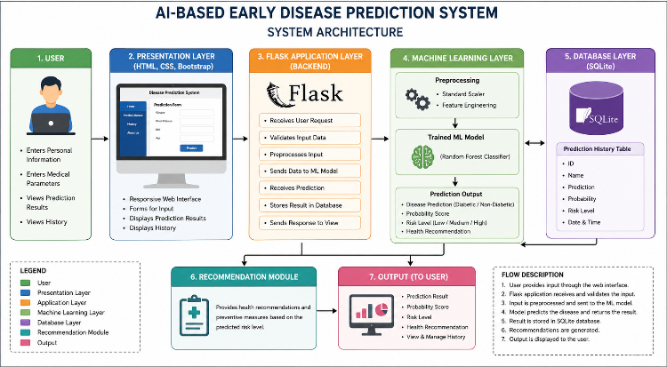
Figure 2. Overall System Architecture of the AI-Based Early Disease Prediction System

Components of the Architecture
1. User
The user interacts with the web application by entering personal and medical information required for disease prediction. The user can also view previous prediction history.

2. Presentation Layer (HTML, CSS & Bootstrap)
The presentation layer provides an interactive graphical user interface. It consists of responsive web pages, forms, buttons, navigation menus, and result pages designed using HTML, CSS, and Bootstrap.

3. Flask Application Layer
The Flask framework serves as the backend controller of the application. It handles user requests, validates inputs, communicates with the Machine Learning model, processes prediction results, and renders the appropriate web pages.

4. Machine Learning Layer
This layer contains the trained Machine Learning model and the feature scaler. It processes the standardized input data and predicts whether the user is likely to have diabetes. It also computes the prediction probability and risk level.

5. Database Layer (SQLite)
The SQLite database stores prediction history, including patient name, prediction result, probability score, risk level, and prediction timestamp. It enables efficient retrieval and management of historical records.

6. Recommendation Module
Based on the predicted risk level, this module generates personalized health recommendations and preventive measures to help users understand their health condition and encourage early medical consultation.

IV Screenshots/Images
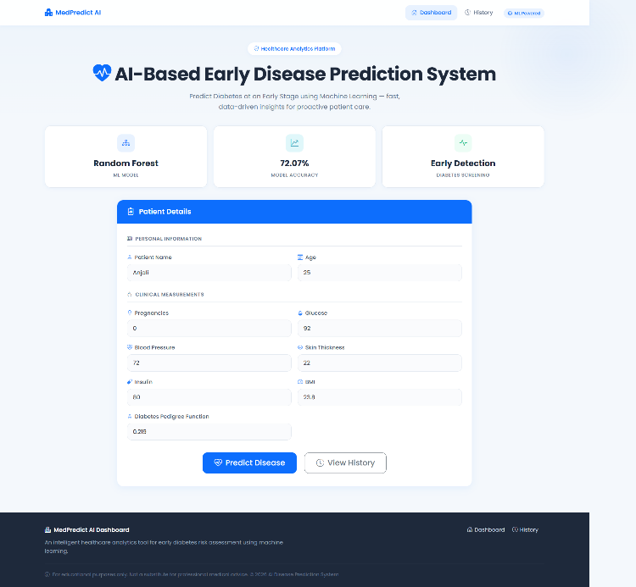
Fig1.Non_Daibetic_Home_Page
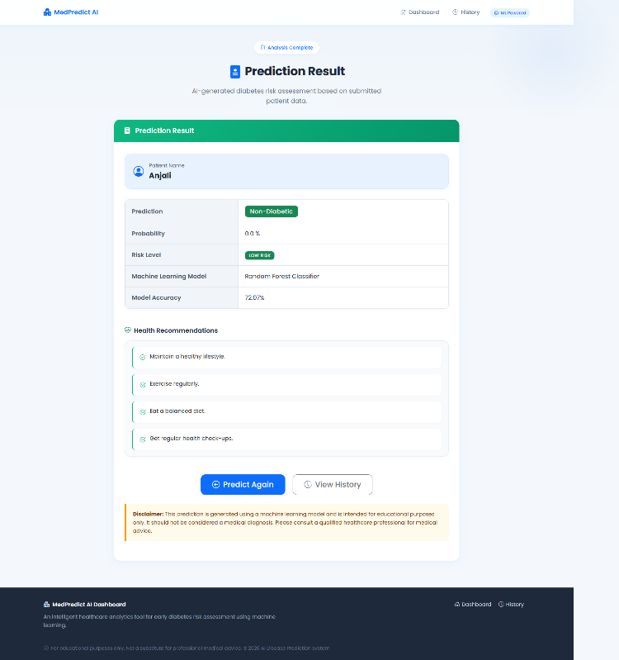
Fig2.Non_Diabetic_Prediction_Result
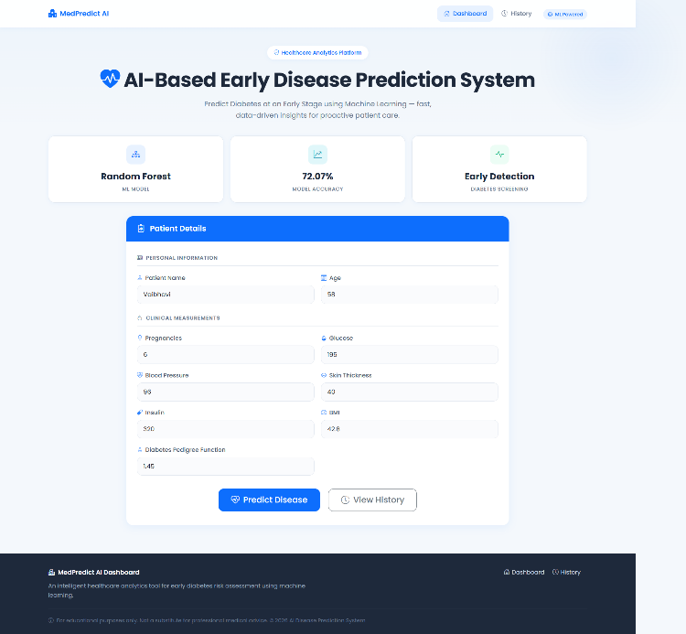
Fig3: Daibetic_Home_Page
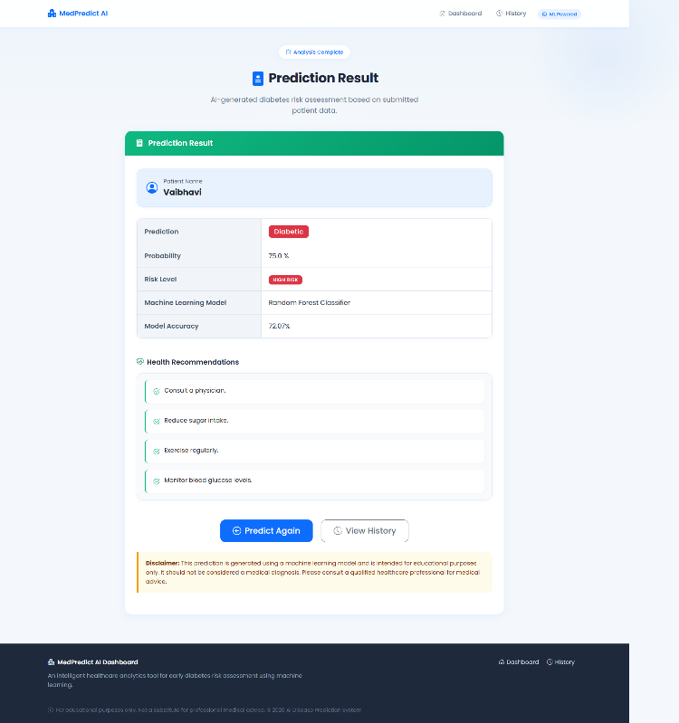
Fig4: Diabetic_Prediction_Result

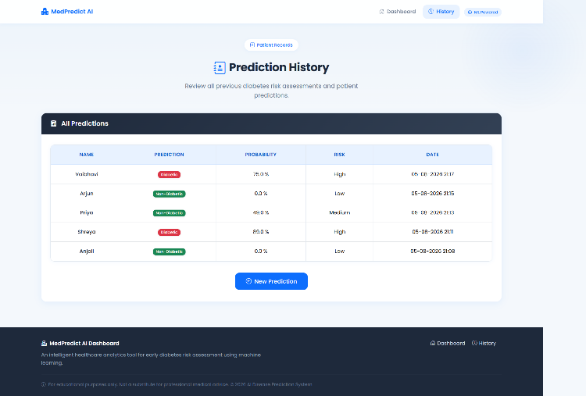
Fig3: Prediction_History

VIII. Results and Discussion
The AI-Based Early Disease Prediction System was successfully designed, implemented, deployed, and tested. The developed web application accurately predicts the likelihood of diabetes based on user-provided health parameters using a trained Machine Learning model. The system integrates Flask, SQLite, HTML, CSS, Bootstrap, and Scikit-learn to provide a user-friendly and efficient disease prediction platform.
The application was tested using multiple patient records with different combinations of input values. The prediction results, probability scores, and risk levels were generated successfully and stored in the database. The system demonstrated reliable performance and produced predictions within a short response time.

A. User Interface Results
The web application provides an interactive and responsive interface where users can enter medical information such as Glucose, BMI, Age, Blood Pressure, Insulin, Skin Thickness, Diabetes Pedigree Function, and Pregnancies.
The interface consists of multiple pages including:
- Home Page
- Disease Prediction Page
- Prediction Result Page
- Prediction History Page
- About Page
The forms successfully accepted user inputs and displayed prediction results without errors.
Observation:
The responsive interface improved user experience by providing simple navigation, clear input forms, and easy-to-understand prediction results.
Insert Figure 7: Home Page
Insert Figure 8: Disease Prediction Form

B. Machine Learning Prediction Results
The trained Random Forest Classifier successfully predicted whether the user is likely to have diabetes or not based on the entered medical parameters.
The prediction module generated:
- Disease Prediction
- Prediction Probability
- Risk Level
- Health Recommendation
Different test cases produced accurate prediction results consistent with the trained dataset.
Observation:
The Machine Learning model effectively analyzed patient information and generated reliable predictions with confidence scores, demonstrating the usefulness of AI in assisting early disease detection.
Insert Figure 9: Prediction Result Page

C. Database Results
SQLite was used to store the prediction history of all users.
For each prediction, the following information was successfully stored:
- Patient Name
- Prediction Result
- Prediction Probability
- Risk Level
- Date and Time
The stored records were retrieved correctly and displayed in the History page.
Observation:
The SQLite database efficiently managed prediction records and ensured data persistence for future reference.
Insert Figure 10: Prediction History

D. System Performance
The application was tested with multiple combinations of input values.
The results showed that:
- User inputs were validated successfully.
- Predictions were generated within a few seconds.
- Database operations executed correctly.
- Recommendation messages changed dynamically according to the predicted risk level.
- The application worked correctly on different screen sizes due to the responsive Bootstrap interface.
The deployment of the project on Render further confirmed that the application can be accessed online without requiring local installation.
Observation:
The system demonstrated stable performance, fast response time, and reliable prediction capability for different user inputs.

E. Overall Discussion
The integration of Machine Learning with Flask enabled the development of an intelligent healthcare application capable of providing early disease prediction.
The project successfully combines:
- Frontend Development using HTML, CSS, and Bootstrap
- Backend Development using Flask
- Machine Learning using Scikit-learn
- Database Management using SQLite
- Model Deployment using Render
This integrated architecture makes the application modular, scalable, and easy to maintain.
IX. Conclusion
This project successfully developed an AI-Based Early Disease Prediction System capable of predicting diabetes using Machine Learning techniques. The system combines Flask, HTML, CSS, Bootstrap, SQLite, and Scikit-learn to provide an interactive web application for early disease prediction.
A Random Forest Classifier was trained using a diabetes dataset to classify patients based on various medical parameters. The trained model accurately predicts disease risk, calculates the probability score, categorizes the risk level, and provides suitable health recommendations.
The developed application successfully stores prediction history in a SQLite database, allowing users to review previous predictions. The responsive interface, efficient backend processing, and reliable database management demonstrate the practical implementation of full-stack web development integrated with Artificial Intelligence.
The successful deployment of the application on the Render cloud platform further proves its capability to operate as an online healthcare prediction system.
Overall, this project demonstrates how Machine Learning can assist healthcare professionals and individuals in identifying potential disease risks at an early stage. The knowledge gained through this project strengthens practical skills in AI, Machine Learning, web application development, database management, and cloud deployment.
X. References
[1] I. Goodfellow, Y. Bengio, and A. Courville, Deep Learning. Cambridge, MA, USA: MIT Press, 2016.
[2] T. Hastie, R. Tibshirani, and J. Friedman, The Elements of Statistical Learning, 2nd ed. New York, NY, USA: Springer, 2009.
[3] L. Breiman, "Random Forests," Machine Learning, vol. 45, no. 1, pp. 5–32, 2001.
[4] F. Pedregosa et al., "Scikit-learn: Machine Learning in Python," Journal of Machine Learning Research, vol. 12, pp. 2825–2830, 2011.
[5] M. Grinberg, Flask Web Development, 2nd ed. Sebastopol, CA, USA: O'Reilly Media, 2018.
[6] Python Software Foundation, Python Documentation. Available: https://docs.python.org/3/
[7] Scikit-learn Developers, Scikit-learn Documentation. Available: https://scikit-learn.org/
[8] Palash Goyal, Sumit Pandey, and Karan Jain, Machine Learning for Healthcare. Springer, 2020.
[9] SQLite Consortium, SQLite Documentation. Available: https://www.sqlite.org/docs.html
[10] Render, Render Deployment Documentation. Available: https://render.com/docs

