K. L. N COLLEGE OF ENGINEERING

## (An Autonomous institution , Affiliated to Anna University Chennai) POTTAPALAYAM-630 612



**DEPARTMENT OF INFORMATION TECHNOLOGY**

**20IT6L1-INTERNET of THINGS LABORATORY**

**AUTOMATIC TOLL USING ARDUIMO UNO**

**P. PONKALPANA – 910620105051**

**K. G. NIVEETHA – 910620105049**

**T. B. SANDHIYA DEVI - 910620105059**

**Abstract**

# Title of the Project:Automatic Toll using Arduino

# 

The Toll Tax System using Arduino, Ultrasonic Sensor, and Servo Motor is an automated solution for toll collection. It utilizes an ultrasonic sensor to detect vehicles and a servo motor to control a toll barrier. When a vehicle is detected within a specified range, the servo motor raises the barrier to collect toll tax or permit passage. The system offers efficiency, accuracy, and reliability, reducing the need for manual intervention and improving traffic flow. It provides a cost-effective and flexible solution for toll management, enhancing overall toll collection processes.

In this project, we are making an exact replica found in toll plaza centers that is called as stopping system, The idea for this project was inspired from actual system, in actual toll they stop the vehicles using a stopper that is completely automated and it is activated when any vehicle passes in front the sensor, or some time it’s activated through a button.

In our case, we are using an HC-SR04 or called as ultrasonic distance sensor to detect an obstacle(vehicle) and later to lift the barrier we are using micro servo, that is the mechanism involved in this project, Now let us dive into the building stage

# Aim :

The aim of the Toll Tax System using Arduino, Ultrasonic Sensor, and Servo Motor is to create an automated system that can detect the presence of a vehicle using an ultrasonic sensor and control a servo motor to raise and lower a barrier to collect toll tax or allow passage. The system should be able to accurately detect vehicles within a certain range and operate the servo motor to control the barrier accordingly.

# Components Used:

# Arduino Uno

# Servo Motor

# Ultrasonic Sensor

# Jumper Wires

**Procedure:**

The procedure for implementing the "Toll Tax System using Arduino: Ultrasonic Sensor with Servo Motor" project involves the following steps:

1. Connect the Ultrasonic Sensor to the Arduino:

* Connect the VCC pin of the sensor to the 5V pin on the Arduino.
* Connect the GND pin of the sensor to the GND pin on the Arduino.
* Connect the Trig pin of the sensor to any digital pin (e.g., Pin 2) on the Arduino.
* Connect the Echo pin of the sensor to any digital pin (e.g., Pin 3) on the Arduino.

1. Connect the Servo Motor to the Arduino:
   * Connect the VCC pin of the motor to the 5V pin on the Arduino.
   * Connect the GND pin of the motor to the GND pin on the Arduino.
   * Connect the signal pin of the motor (usually labeled as "S" or "Data") to any digital pin (e.g., Pin 9) on the Arduino.
2. Write the Arduino code:

* Open the Arduino IDE on your computer.
* Write the code to control the Ultrasonic Sensor and Servo Motor. Here's an example code to get you started.

# Pin Diagram:



**Program:**

#include <Servo.h>

int trigPin = 11; // Trigger int echoPin = 12; // Echo long duration, cm, inches;

Servo myservo;

int pos = 0;

void setup() {

myservo.write(0); Serial.begin (9600);

pinMode(trigPin, OUTPUT); pinMode(echoPin, INPUT);

myservo.attach(9); // attaches the servo on pin 9 to the servo object

}

void loop() {

digitalWrite(trigPin, LOW);

delayMicroseconds(5); digitalWrite(trigPin, HIGH); delayMicroseconds(10); digitalWrite(trigPin, LOW);

// Read the signal from the sensor: a HIGH pulse whose

// duration is the time (in microseconds) from the sending

// of the ping to the reception of its echo off of an object. pinMode(echoPin, INPUT);

duration = pulseIn(echoPin, HIGH);

// Convert the time into a distance

cm = (duration/2) / 29.1; // Divide by 29.1 or multiply by 0.0343 inches = (duration/2) / 74; // Divide by 74 or multiply by 0.0135

Serial.print(inches); Serial.print("in, "); Serial.print(cm); Serial.print("cm"); Serial.println();

delay(100);

if(cm<=30){

myservo.write(180); // waits 15ms for the servo to reach the position

}

else{ myservo.write(0);

}

}

**OUTPUT :**

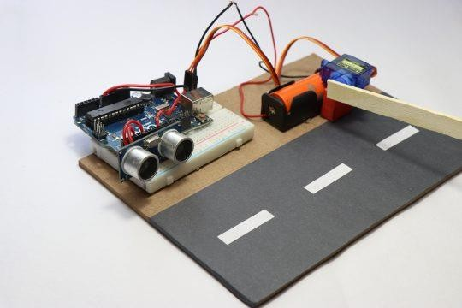

**Conclusion**:

## In conclusion, the Toll Tax System using Arduino, Ultrasonic Sensor, and Servo Motor provides an automated and efficient solution for toll collection. By accurately detecting vehicles with the ultrasonic sensor and controlling the servo motor to raise and lower the barrier, the system enables seamless toll tax collection or passage, reducing manual intervention and improving overall efficiency.

# Output Screenshot: