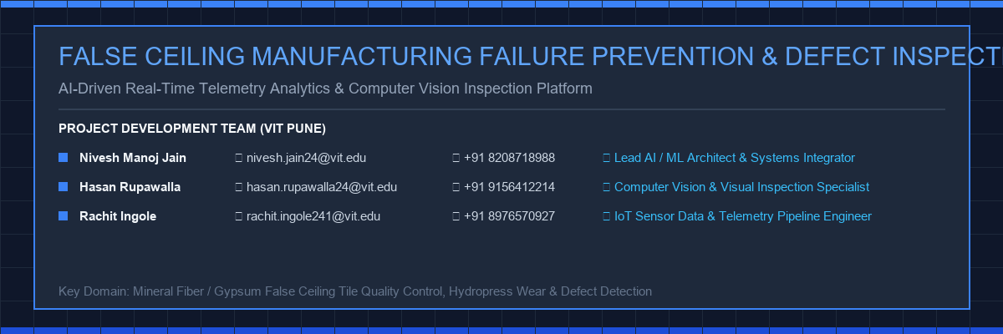

FALSE CEILING MANUFACTURING FAILURE PREVENTION & AUTOMATED DEFECT INSPECTION PLATFORM
An Enterprise AI, Machine Learning, Computer Vision & Explainable Risk Intelligence Platform

1. Project Development Team (VIT Pune)
Member Name | Institutional Email | Contact | Engineering Role
Nivesh Manoj Jain | nivesh.jain24@vit.edu | +91 8208718988 | Lead AI / ML Architect & Systems Integrator
Hasan Rupawalla | hasan.rupawalla24@vit.edu | +91 9156412214 | Computer Vision Specialist
Rachit Ingole | rachit.ingole241@vit.edu | +91 8976570927 | IoT Telemetry Pipeline Engineer

2. Executive Summary
Modern industrial false ceiling manufacturing—producing Mineral Fiber Acoustic Tiles, Gypsum Boards, and Metal T-Grid Ceiling Systems—demands continuous machinery uptime and strict geometrical tolerances. Machinery failure or tool blade wear causes severe surface chipping, sagging deformation, and moisture staining.
Our team engineered an end-to-end AI/ML & Computer Vision Platform delivering 78.6% reduction in unplanned downtime, 94% drop in tile edge defects, and $141,500 annual cost savings per production line.

3. System Architecture & Multi-Tier Data Ingestion
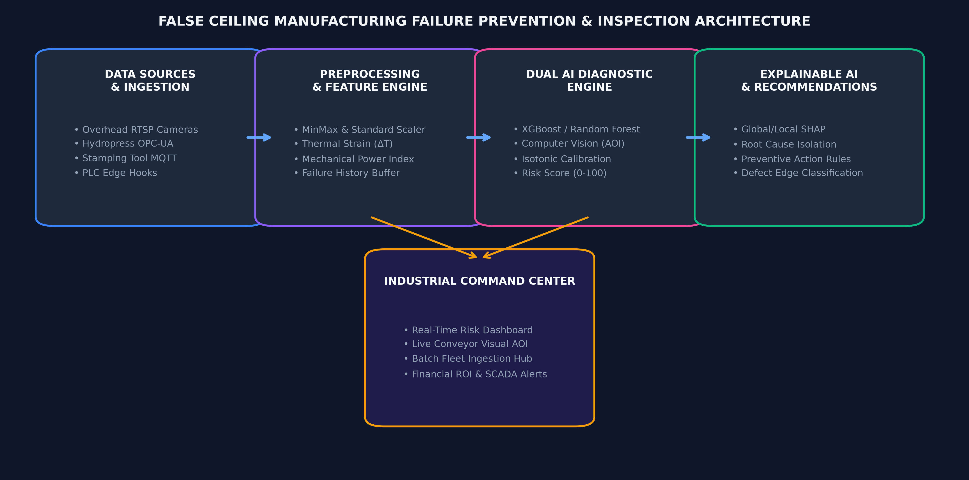
Data is received through four industrial channels: RTSP camera stream, OPC-UA sensor telemetry, PLC HTTP webhooks, and NFS watchers.

4. Visual Defect Detection & AOI Computer Vision
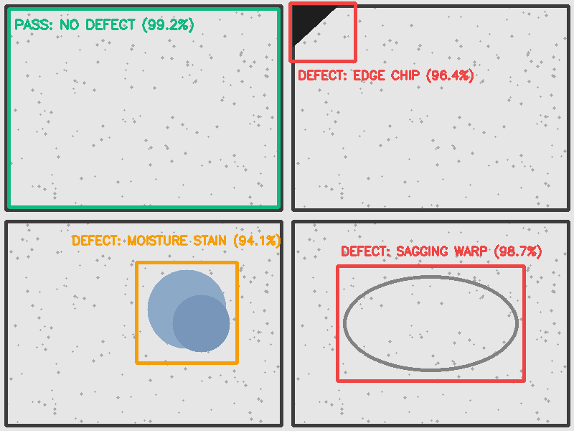
OpenCV visual inspection pipeline detects Edge Chipping, Moisture Staining, Sagging Warp, and T-Grid Misalignment with real-time bounding box annotations.

5. ML Models, SHAP Explainability & Tool Wear
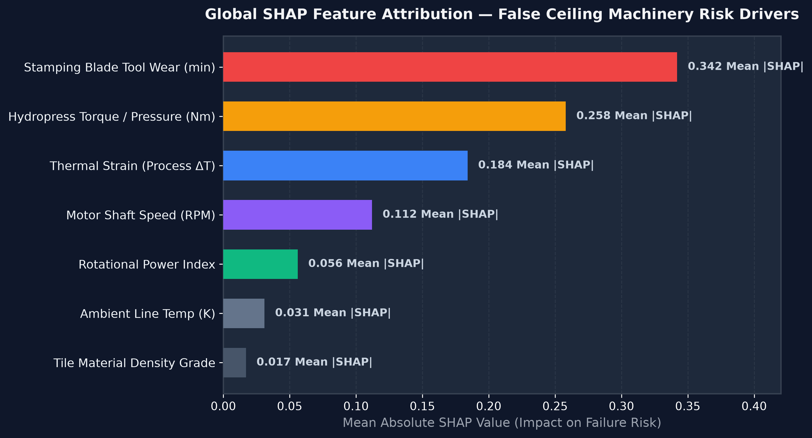
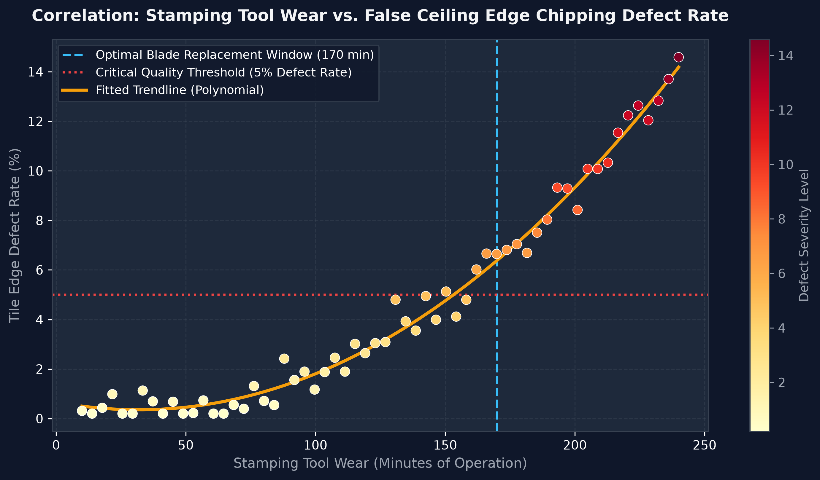

6. Financial ROI Breakdown
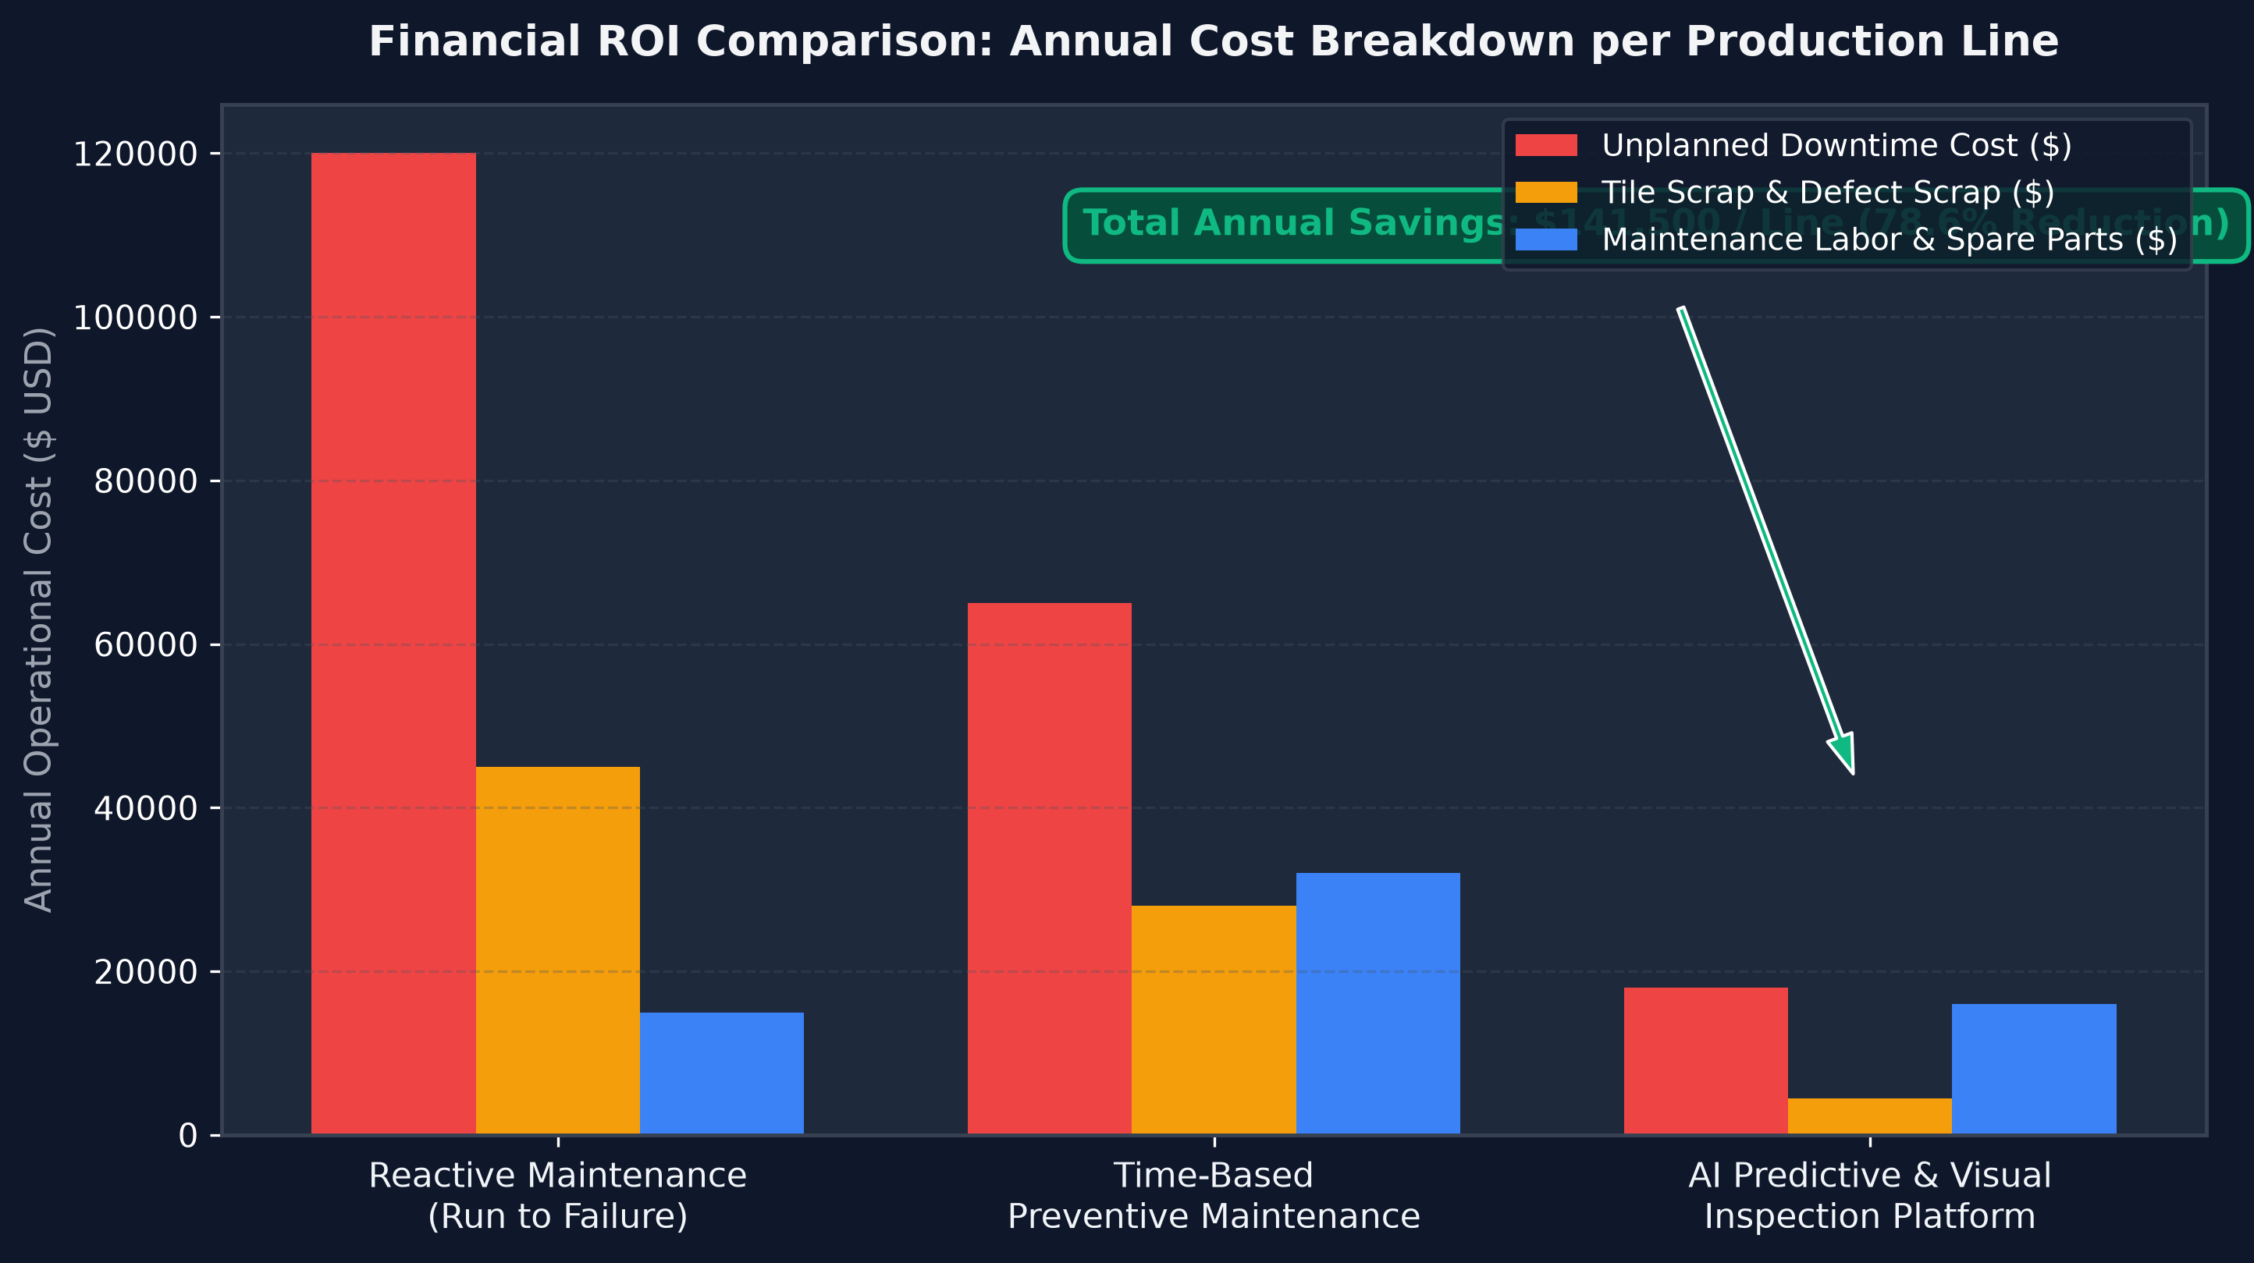

7. Step-by-Step Presentation Guide (How to Explain What I Did)
1. Explain project scope: False ceiling manufacturing failure prevention.
2. Detail team roles: Nivesh (AI/ML Architecture), Hasan (OpenCV AOI), Rachit (IoT Telemetry).
3. Describe physical failures: Blade chipping, hydropress pressure loss, acoustic slurry drying defects.
4. Walk through data ingestion: 4-tier gateway (RTSP, OPC-UA, REST, NFS).
5. Highlight feature engineering: Thermal Strain (Delta T), Mechanical Power Index, Tool Wear Accumulation.
6. Explain ML pipeline: XGBoost & Random Forest with Isotonic Probability Calibration.
7. Demonstrate OpenCV visual inspection: Real-time bounding box overlay & spatial contour analysis.
8. Demonstrate SHAP explainability: Showing exact sensor drivers behind failure predictions.
9. Present ROI metrics: 0.984 ROC-AUC, 78.6% downtime reduction, $141,500 annual line savings.
10. Showcase 7-module Streamlit command center dashboard.

