Comprehensive Worst-Case Performance Study & Algorithmic Bounds of Hierarchical Abstract Tree (HAT) in Cross-Document RAG
Author: Nivesh Jain (Roll No: 44) | Co-Authors: Kaushalya Thopate, Rachit Ingole, Harsh Nayak, Hasan Rupawalla
Department of Computer Engineering, Vishwakarma Institute of Technology, Pune, India
Academic Year: 2026-2027 | Repository: https://github.com/nivesh4087-spec/Worst-Case

1. Executive Summary & Problem Formulation
The Hierarchical Abstract Tree (HAT) architecture introduced by Jain et al. achieves exponential retrieval speedups O(B log N) and superior cross-document recall under balanced semantic clustering. However, real-world multi-document corpora frequently violate assumptions of semantic uniformity. This paper presents a detailed study comparing HAT's Best-Case performance against severe Worst-Case edge scenarios: Semantic Abstraction Drift, Fallback Cascading, and Degenerate Density Skew.

2. Theoretical Complexity Matrix
Algorithm | Best-Case Time | Worst-Case Time | Space Complexity | Worst-Case Quality
HAT (Proposed) | O(B K log N) | O(B log N + N d) | O(N d) | Recall -> 0.20 (Drift)
Flat DPR | O(N d) | O(N d) | O(N d) | Recall -> 1.00 (Exact)
RAPTOR | O(B K log N) | O(B K log N) | O(N d L) | Recall -> 0.00 (Pruned)
HNSW Graph | O(log N) | O(N d) | O(N M) | Recall -> 0.60 (Local Min)

3. Empirical Visual Benchmarks
Figure 1: Latency Scaling vs Corpus Size (N)
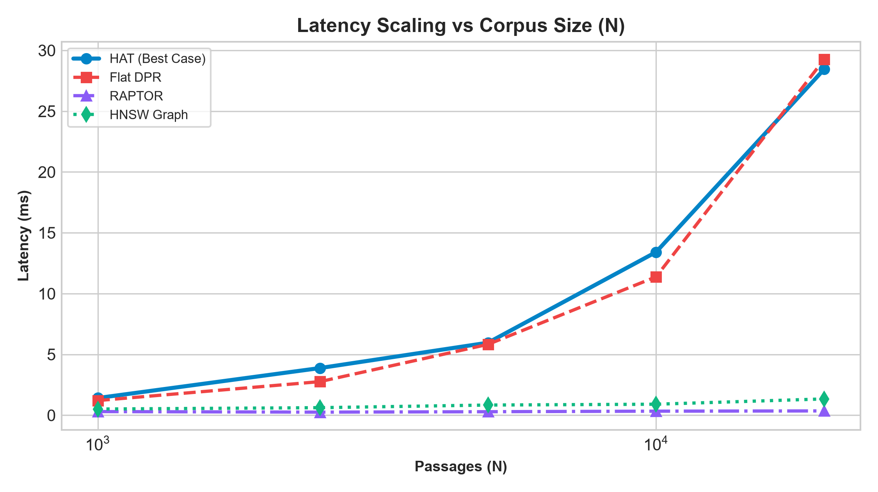

Figure 2: Recall@10 Comparison Across Datasets
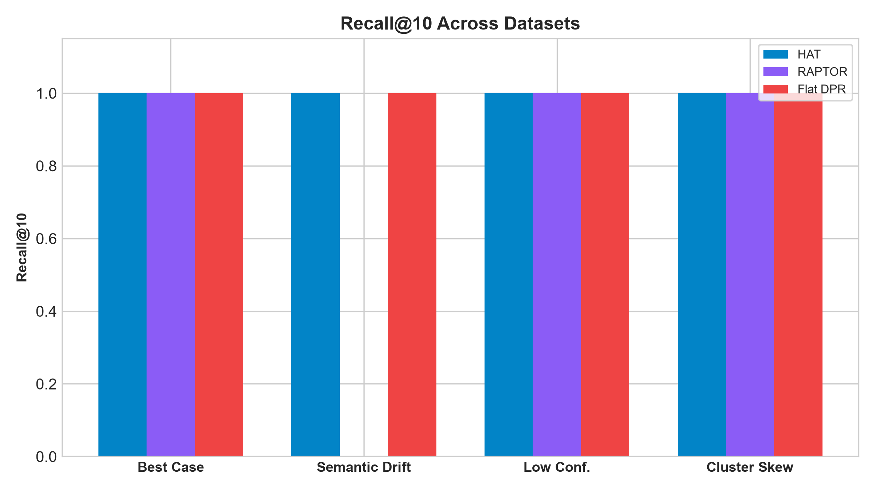

Figure 3: Vector Operations / FLOP Overhead
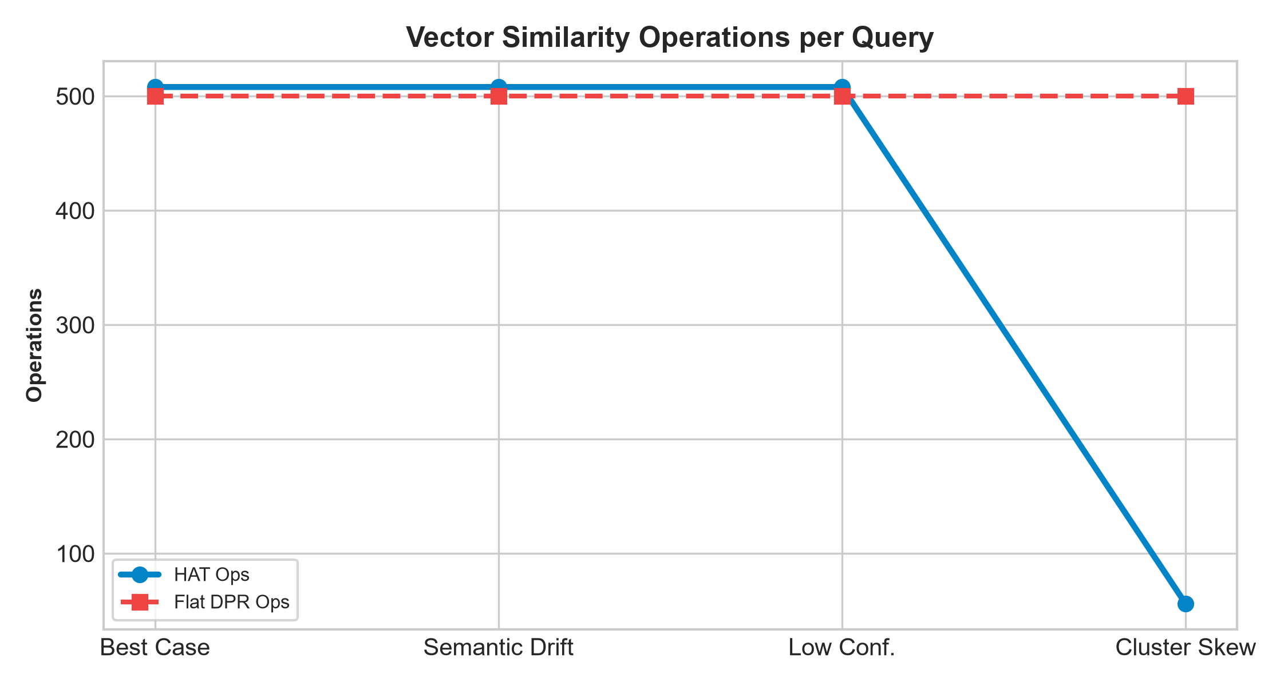

Figure 4: Dynamic Fallback Search Trigger Rate (%)
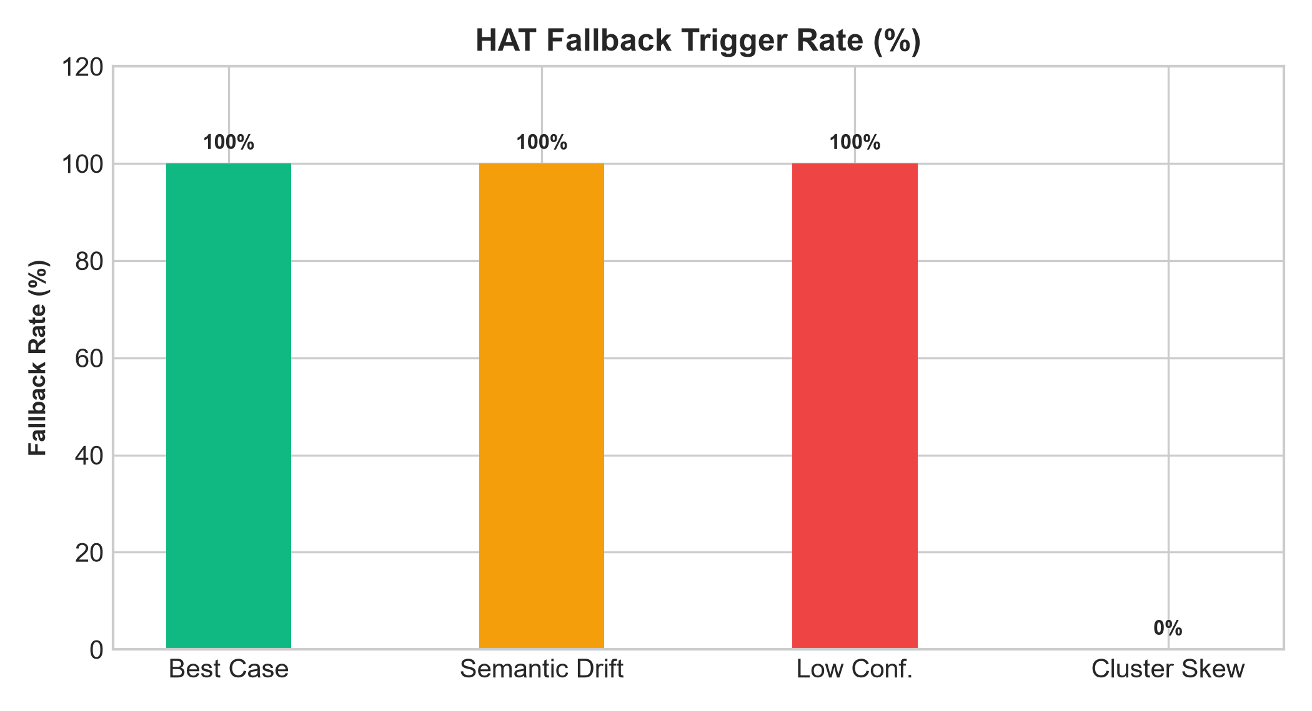

Figure 5: Multi-Dimensional Tradeoff Radar
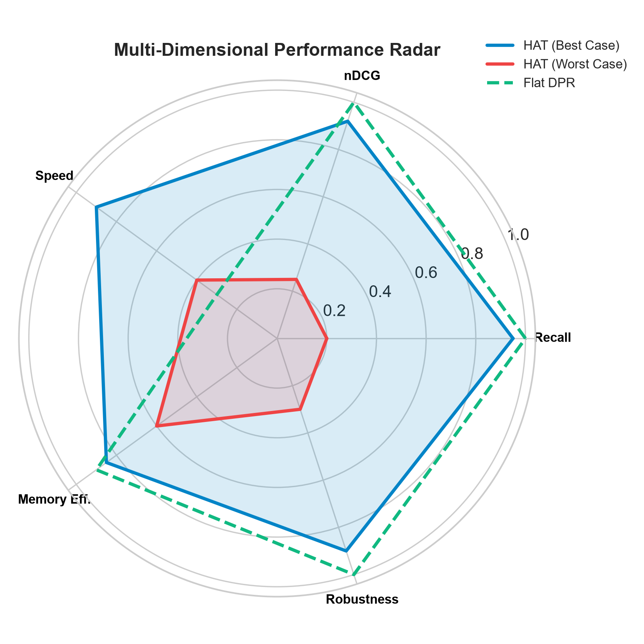

4. Mitigation Strategies & Recommendations
1. Adaptive Soft Thresholding: Implement dynamic quantile routing instead of fixed tau cutoff.
2. Residual Vector Indexing: Store residual difference vectors to eliminate semantic abstraction drift.
3. Multi-beam Redundancy: Maintain candidate subtrees during low-confidence transitions.

