The Real Cost of AI Development in 2026

Introduction
The AI revolution isn't coming—it's here. And businesses are embracing it at an astonishing pace, using AI not just for basic queries but to automate workflows, extract insights from data, generate code, and even shape high-level strategy. The scale of this transformation is staggering Gartner reports that AI spending leaped from $975.6 billion in 2025 to $1.43 trillion in 2026—a 47% jump in just one year. Yet the promise of AI comes with a catch: without careful planning, costs can spiral out of control. In this blog, we'll break down the real cost of AI development in 2026 and share proven strategies to use it efficiently.

What Is a Token and Why Does It Matter? (side note)
Before we discuss costs, you need to understand one key concept: tokens.
A token is the smallest unit of text that an AI model processes. Roughly speaking, a token equals about 4 characters of text.
Why does this matter for your budget? For every AI interaction, token consumption is the primary factor that determines the cost.

Historical Trend of AI Costs
The cost trend of OpenAI's flagship models over the years:
Date | Model | Input Price (per 1M tokens) | Relative Cost (vs. GPT-3 Davinci)
June 2020 | GPT-3 Davinci | $60.00 | 1.0x (baseline)
November 2022 | GPT-3 Davinci-002 | $20.00 | 0.33x
March 2023 | GPT-3.5 Turbo | $2.00 | 0.033x
November 2023 | GPT-3.5 Turbo (updated) | $0.50 | 0.008x
May 2024 | GPT-4o | $5.00 | 0.083x
July 2024 | GPT-4o Mini | $0.15 | 0.0025x
April 2025 | GPT-4.1 Nano | $0.10 | 0.0017x
August 2025 | GPT-5 | $1.25 | 0.021x
March 2026 | GPT-5.4 Nano | $0.20 | 0.003x

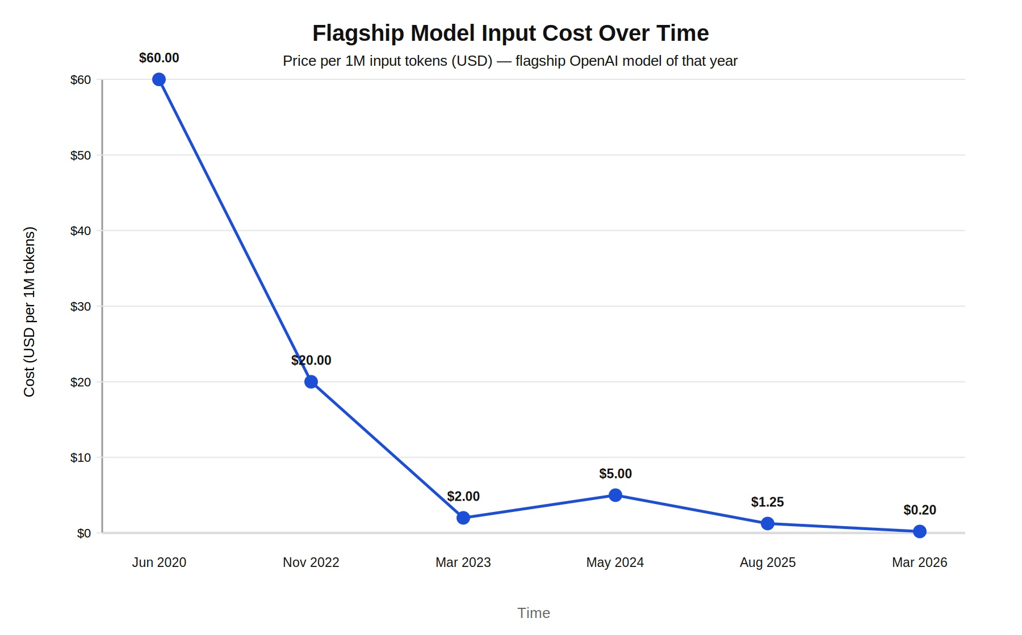
At first glance, it seems like AI should be much cheaper today. After all, token prices have dropped by more than an order of magnitude over the past few years. So why is AI still so expensive for organizations?
The answer lies not in the price of a token, but in how we use AI today. Early Generative AI applications were primarily simple prompt-response systems. Today, AI powers code generation, code reviews, document processing, data analysis, customer support, and increasingly, autonomous agentic workflows. These applications require multiple model calls, larger contexts, longer outputs, and continuous interactions.
In short, while the cost per token has fallen dramatically, the number of tokens consumed per business task has increased even faster. As AI has evolved from a chatbot into a business execution layer, overall, AI spending has continued to rise despite lower model prices.
Here are approximate token requirements for tasks at different levels, based on a variety of sources:
- Basic chatbot Q&A: 50 to 500 tokens
- Short document summary: 200 to 6,000 tokens
- Basic code assistance: 500 to 2,000 tokens
- Writing complex code: 20,000 to 100,000+ tokens
- Legal document analysis: 75,000 to 250,000+ tokens
- Multi-step agent workflow: 100,000 to one million+ tokens

Case Study: The Real Cost of AI Development in 2026
According to a study conducted by Netguru, a software development agency that has delivered 60+ projects in 2026, AI-based projects fall into three categories:
Project Tier | Typical Scope | Build Cost Range | Year 1 TCO (incl. inference)
Proof of Concept | Single model, synthetic data, no production infrastructure | $15K–$60K | $20K–$80K
Mid-market AI System | RAG pipeline, fine-tuned model, API integrations, monitoring | $80K–$350K | $150K–$600K
Enterprise AI Platform | Custom model training, MLOps infrastructure, human-in-the-loop review pipeline, multi-region | $400K–$1M+ | $800K–$2.5M+

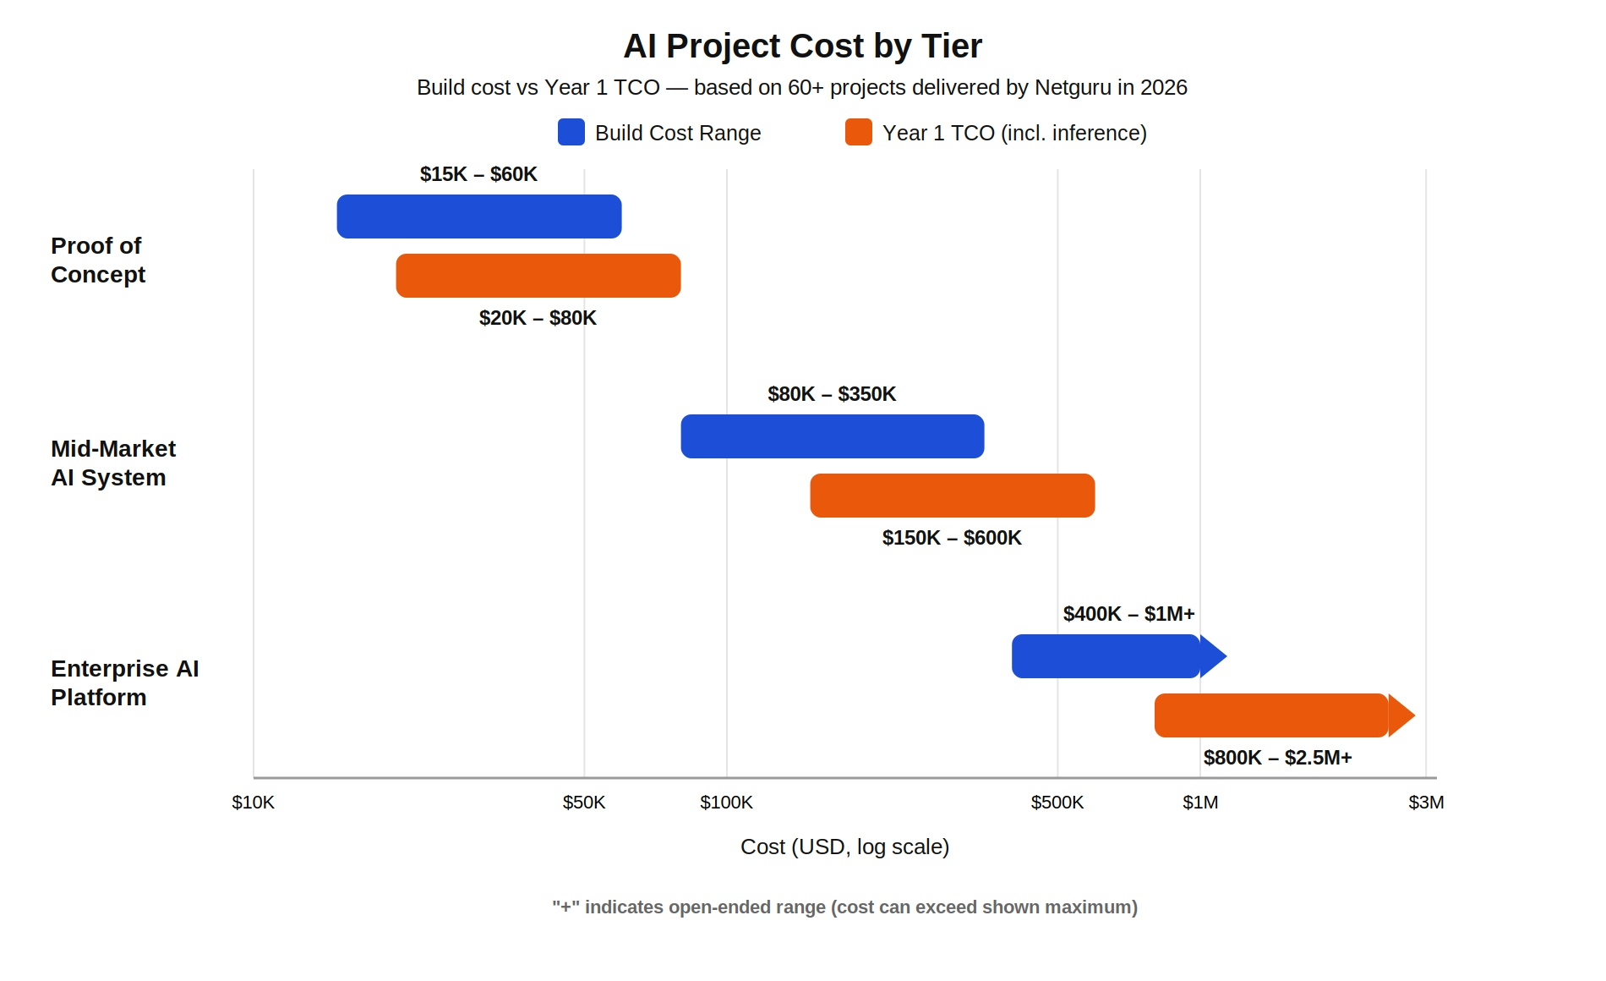
Note: TCO stands for Total Cost of Ownership—the full cost of running the system for a year, not just building it. This includes hosting, maintenance, and support costs on top of the build cost.
"Incl. inference" means the TCO figure also includes the cost of running the AI model itself—i.e., the per-token API costs each time the model generates a response—not just infrastructure and maintenance.
The major cost drivers across all tiers were:
- Testing
- Data labeling for training a model
- Response time
- Deployment infrastructure
- Human-in-the-loop processes
- Vector storage for RAG if data is large
- Model retraining from time to time on the latest data

The Effect of Agentic AI
Agentic AI implementations typically cost more than non-agentic generative AI, as they require multiple reasoning and execution steps instead of a single prompt-response interaction. Agentic AI systems can:
- Break complex tasks into steps
- Call themselves repeatedly
- Consult multiple data sources
- Evaluate their own output
- Keep working until they achieve a goal
How does this affect cost?
Agentic workflows can consume 30–240 times more tokens than simple question-answering. A single agent task might consume as few as 500 tokens or as many as 120,000 tokens depending on complexity.
(Source: https://zenodo.org/records/19371258
Note: Zenodo is a free, open-access repository created by CERN and OpenAIRE. It allows researchers and scientists to share and preserve datasets and papers.
Despite being more expensive, AI agents are increasingly becoming the preferred choice because they enable end-to-end intelligent automation, deliver promising results, operate 24/7, and can perform tasks that would otherwise require an entire team—often making the additional cost worthwhile.

Strategies to Manage AI Costs
1. Model Selection
Not every task requires a top-tier model. You can route smaller tasks to lower-cost models while reserving advanced models for heavier tasks.
2. Budget Guardrails and Governance on Spending
Companies should monitor:
- Which workflows consume the most tokens
- When costly models are being used unnecessarily
- Weekly and monthly usage through dashboards to manage budgets accordingly
3. Training Employees for Token Discipline
Users should learn to use models efficiently by:
- Asking for the smallest, useful answer
- Avoiding unnecessary document pasting
- Selecting the right model for each use case
- Constraining output length

Conclusion: Practical Recommendations for 2026
If you're planning an AI project, here's what is recommended:
- Start with a Proof of Concept: Don't jump into a $500,000 enterprise system without testing the waters. A PoC cost $15K–$60K and helps you understand if AI actually solves your problem.
- Budget for Total Cost of Ownership: The build cost is just the beginning. Plan for ongoing inference costs, retraining, and monitoring.
- Use the Right Model for Each Task: Not every task needs GPT-5. Route simple tasks to cheaper models and save premium models for complex reasoning.
- Build Governance Early: Track cost per outcome, not just token usage. Create dashboards so spending is visible to everyone.
- Train Your Team: Teach users how to use AI efficiently. Ask for concise outputs. Avoid unnecessary context. Think about token costs the way you think about electricity bills.
AI development in 2026 isn't about finding the cheapest model—it's about finding the right model for the right job. Understand your tokens. Track your costs. Build with intention. The companies that treat AI as a strategic asset—not a cost center—will be the ones leading in the next decade.

Sources
The following sources were referenced or consulted for this blog:
- https://techcrunch.com/2026/06/05/the-token-bill-comes-due-inside-the-industry-scramble-to-manage-ais-runaway-costs/
- https://www.flexera.com/blog/it-asset-management/state-of-itam-2026-ai-cost-optimization/
- https://thecuberesearch.com/ai-spend-governance-and-how-finops-must-evolve-for-the-ai-era/#content
- https://www.aitoday.io/autonomous-ai-economics-are-overwhelming-enterprise-budgets-a-31737
- https://www.businesstimes.com.sg/startups-tech/technology/cheaper-ai-better-soaring-bills-are-reshaping-how-businesses-choose-models
- https://ici.radio-canada.ca/rci/en/news/2263423/their-goal-was-use-as-much-ai-as-possible-now-some-companies-are-pulling-back
- https://www.netguru.com/blog/ai-development-cost-guide
- https://www.yipitdata.com/resources/cloud-llm-pricing-trends
- https://www.livemint.com/ai/ai-is-supposed-to-boost-brands-what-if-it-does-the-opposite-11783646234916.html
- https://aiwiki.ai/wiki/ai_pricing
- https://itbrief.in/story/gartner-sees-ai-spending-hit-usd-2-59-trillion-in-2026
- https://www.finout.io/blog/ai-model-cost-breakdowns-the-complete-2026-comparison-guide
- https://www.kellton.com/kellton-tech-blog/custom-ai-development-cost
- https://www.azilen.com/blog/ai-development-cost/

