ASSIGNMENT 1_2
1)
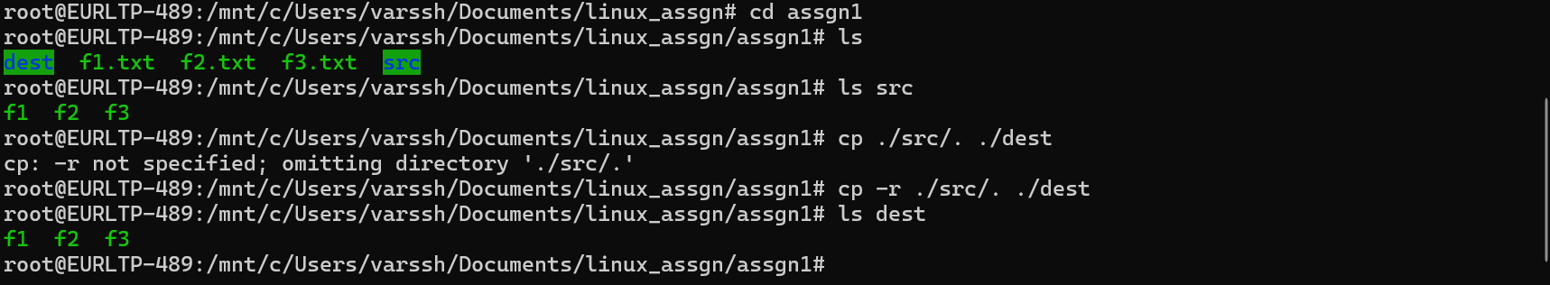
2) ftp
root@EURLTP-489:/mnt/c/Users/varssh/Documents/linux_assgn/assgn1# cd /home/demo1
root@EURLTP-489:/home/demo1# ls
file1.txt ftp_upload
root@EURLTP-489:/home/demo1# ls -l
total 8
-rw-r--r-- 1 root root 6 Mar 19 10:23 file1.txt
drwxrwxrwx 2 root root 4096 Mar 19 10:23 ftp_upload
root@EURLTP-489:/home/demo1# cat file1.txt
hello
root@EURLTP-489:/home/demo1# ftp localhost
Connected to localhost.
220 (vsFTPd 3.0.5)
Name (localhost:root): demo1
331 Please specify the password.
Password:
230 Login successful.
Remote system type is UNIX.
Using binary mode to transfer files.
ftp> cd ftp_upload
t file1.txt
ls
get file1.txt
bye250 Directory successfully changed.
ftp> lcd /home/demo1
Local directory now: /home/demo1
ftp> put file1.txt
local: file1.txt remote: file1.txt
229 Entering Extended Passive Mode (|||62273|)
150 Ok to send data.
100% |****************************************************************************************| 6 40.97 KiB/s 00:00 ETA
226 Transfer complete.
6 bytes sent in 00:00 (8.12 KiB/s)
ftp> ls
229 Entering Extended Passive Mode (|||46120|)
150 Here comes the directory listing.
-rw------- 1 1003 1003 6 Mar 19 10:36 file1.txt
226 Directory send OK.
ftp> get file1.txt
local: file1.txt remote: file1.txt
229 Entering Extended Passive Mode (|||45992|)
150 Opening BINARY mode data connection for file1.txt (6 bytes).
100% |****************************************************************************************| 6 110.55 KiB/s 00:00 ETA
226 Transfer complete.
6 bytes received in 00:00 (20.34 KiB/s)
ftp> bye
221 Goodbye.
root@EURLTP-489:/home/demo1#
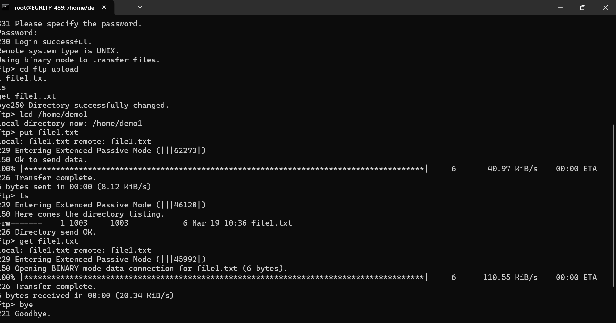

Sftp

root@EURLTP-489:/home/demo1# sudo service ssh start
root@EURLTP-489:/home/demo1# sftp demo1@localhost
The authenticity of host 'localhost (127.0.0.1)' can't be established.
ED25519 key fingerprint is SHA256:eJE7VDFT6qvs0ij7BGd3iCwRtUOOd+ikl3T8S+otzPk.
This key is not known by any other names.
Are you sure you want to continue connecting (yes/no/[fingerprint])? yes
Warning: Permanently added 'localhost' (ED25519) to the list of known hosts.
demo1@localhost's password:
Connected to localhost.
sftp> cd ftp_upload
sftp> ls
file1.txt
sftp> lcd /home/demo1
sftp> put file1.txt
Uploading file1.txt to /home/demo1/ftp_upload/file1.txt
file1.txt 100% 6 1.4KB/s 00:00
sftp> get file1.txt
Fetching /home/demo1/ftp_upload/file1.txt to file1.txt
file1.txt 100% 6 2.5KB/s 00:00
sftp> exit
root@EURLTP-489:/home/demo1#
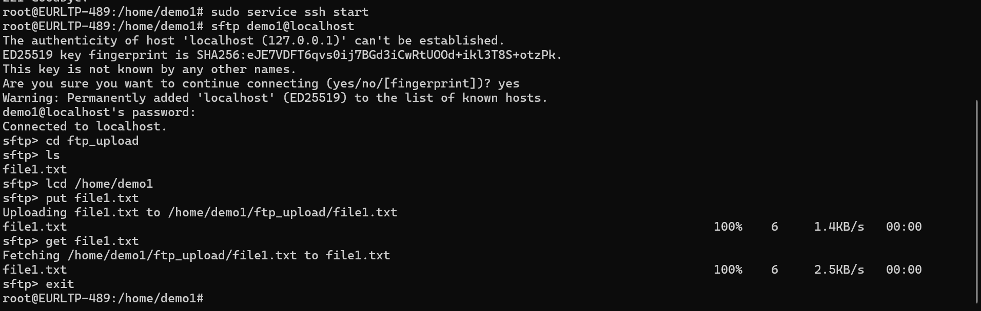

3)
Ping google.com
root@EURLTP-489:/mnt/c/Users/varssh/Documents/linux_assgn/assgn1# ping google.com
PING google.com (142.251.223.238) 56(84) bytes of data.
64 bytes from lcmaaa-al-in-f14.1e100.net (142.251.223.238): icmp_seq=1 ttl=116 time=40.4 ms
64 bytes from lcmaaa-al-in-f14.1e100.net (142.251.223.238): icmp_seq=2 ttl=116 time=27.5 ms
64 bytes from lcmaaa-al-in-f14.1e100.net (142.251.223.238): icmp_seq=3 ttl=116 time=20.2 ms
64 bytes from lcmaaa-al-in-f14.1e100.net (142.251.223.238): icmp_seq=4 ttl=116 time=33.2 ms
64 bytes from lcmaaa-al-in-f14.1e100.net (142.251.223.238): icmp_seq=5 ttl=116 time=38.8 ms
64 bytes from lcmaaa-al-in-f14.1e100.net (142.251.223.238): icmp_seq=6 ttl=116 time=26.6 ms

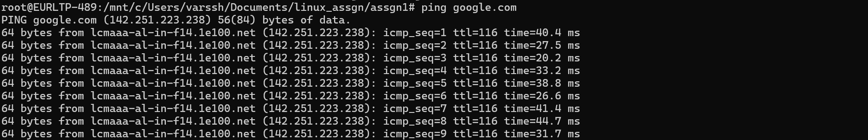
arp -a
root@EURLTP-489:/mnt/c/Users/varssh/Documents/linux_assgn/assgn1# arp -a
EURLTP-489.mshome.net (172.17.80.1) at 00:15:5d:05:67:2d [ether] on eth0

ifconfig
root@EURLTP-489:/mnt/c/Users/varssh/Documents/linux_assgn/assgn1# ifconfig
eth0: flags=4163<UP,BROADCAST,RUNNING,MULTICAST> mtu 1492
inet 172.17.83.38 netmask 255.255.240.0 broadcast 172.17.95.255
inet6 fe80::215:5dff:feb6:15d7 prefixlen 64 scopeid 0x20<link>
ether 00:15:5d:b6:15:d7 txqueuelen 1000 (Ethernet)
RX packets 7752 bytes 8328782 (8.3 MB)
RX errors 0 dropped 0 overruns 0 frame 0
TX packets 3921 bytes 291989 (291.9 KB)
TX errors 0 dropped 0 overruns 0 carrier 0 collisions 0

lo: flags=73<UP,LOOPBACK,RUNNING> mtu 65536
inet 127.0.0.1 netmask 255.0.0.0
inet6 ::1 prefixlen 128 scopeid 0x10<host>
loop txqueuelen 1000 (Local Loopback)
RX packets 295 bytes 35579 (35.5 KB)
RX errors 0 dropped 0 overruns 0 frame 0
TX packets 295 bytes 35579 (35.5 KB)
TX errors 0 dropped 0 overruns 0 carrier 0 collisions 0

ip addr

root@EURLTP-489:/mnt/c/Users/varssh/Documents/linux_assgn/assgn1# ip addr
1: lo: <LOOPBACK,UP,LOWER_UP> mtu 65536 qdisc noqueue state UNKNOWN group default qlen 1000
link/loopback 00:00:00:00:00:00 brd 00:00:00:00:00:00
inet 127.0.0.1/8 scope host lo
valid_lft forever preferred_lft forever
inet 10.255.255.254/32 brd 10.255.255.254 scope global lo
valid_lft forever preferred_lft forever
inet6 ::1/128 scope host
valid_lft forever preferred_lft forever
2: eth0: <BROADCAST,MULTICAST,UP,LOWER_UP> mtu 1492 qdisc mq state UP group default qlen 1000
link/ether 00:15:5d:b6:15:d7 brd ff:ff:ff:ff:ff:ff
inet 172.17.83.38/20 brd 172.17.95.255 scope global eth0
valid_lft forever preferred_lft forever
inet6 fe80::215:5dff:feb6:15d7/64 scope link
valid_lft forever preferred_lft forever

ip route

root@EURLTP-489:/mnt/c/Users/varssh/Documents/linux_assgn/assgn1# ip route
default via 172.17.80.1 dev eth0 proto kernel
172.17.80.0/20 dev eth0 proto kernel scope link src 172.17.83.38

netstat -tuln

root@EURLTP-489:/mnt/c/Users/varssh/Documents/linux_assgn/assgn1# netstat -tuln
Active Internet connections (only servers)
Proto Recv-Q Send-Q Local Address Foreign Address State
tcp 0 0 127.0.0.54:53 0.0.0.0:* LISTEN
tcp 0 0 127.0.0.53:53 0.0.0.0:* LISTEN
tcp 0 0 0.0.0.0:22 0.0.0.0:* LISTEN
tcp 0 0 10.255.255.254:53 0.0.0.0:* LISTEN
tcp6 0 0 :::22 :::* LISTEN
tcp6 0 0 :::21 :::* LISTEN
udp 0 0 127.0.0.54:53 0.0.0.0:*
udp 0 0 127.0.0.53:53 0.0.0.0:*
udp 0 0 10.255.255.254:53 0.0.0.0:*
udp 0 0 127.0.0.1:323 0.0.0.0:*
udp6 0 0 ::1:323 :::*

5)
- IP address conflict
- ARP confusion
- ARP table instability
- Intermittent connectivity
- Packet loss / wrong packet delivery
- Services randomly failing
- System warnings (duplicate IP detected)
- Unreliable network communication

8)ifconfig
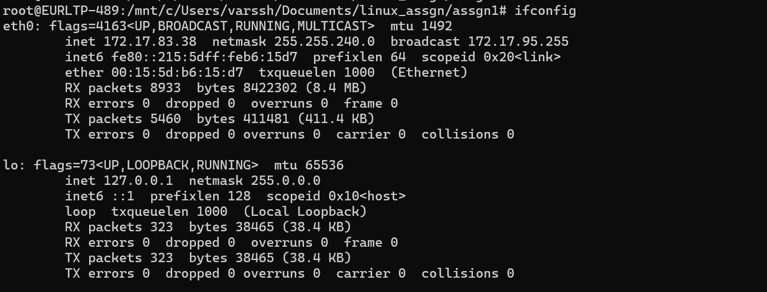
root@EURLTP-489:/mnt/c/Users/varssh/Documents/linux_assgn/assgn1# ifconfig
eth0: flags=4163<UP,BROADCAST,RUNNING,MULTICAST> mtu 1492
inet 172.17.83.38 netmask 255.255.240.0 broadcast 172.17.95.255
inet6 fe80::215:5dff:feb6:15d7 prefixlen 64 scopeid 0x20<link>
ether 00:15:5d:b6:15:d7 txqueuelen 1000 (Ethernet)
RX packets 8933 bytes 8422302 (8.4 MB)
RX errors 0 dropped 0 overruns 0 frame 0
TX packets 5460 bytes 411481 (411.4 KB)
TX errors 0 dropped 0 overruns 0 carrier 0 collisions 0

lo: flags=73<UP,LOOPBACK,RUNNING> mtu 65536
inet 127.0.0.1 netmask 255.0.0.0
inet6 ::1 prefixlen 128 scopeid 0x10<host>
loop txqueuelen 1000 (Local Loopback)
RX packets 323 bytes 38465 (38.4 KB)
RX errors 0 dropped 0 overruns 0 frame 0
TX packets 323 bytes 38465 (38.4 KB)
TX errors 0 dropped 0 overruns 0 carrier 0 collisions 0

Iwconfig

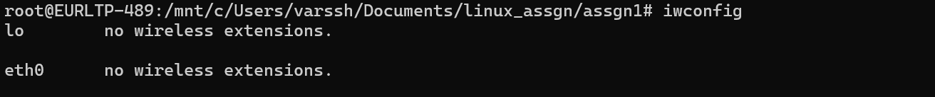root@EURLTP-489:/mnt/c/Users/varssh/Documents/linux_assgn/assgn1# iwconfig
lo no wireless extensions.

eth0 no wireless extensions.

10)
Client sends DHCP Discover
Server sends DHCP Offer
Client sends DHCP Request
Server sends DHCP ACK
A DHCP server automatically assigns network configuration to devices when they join a network it is done by DORA process.

