CO2-AT3-Debugging and Optimization Task
CSA0603-Desing and Analysis Of Algorithm

Name: M.Nivetha
Reg no:192421307

Q24. Debugging Selection Sort Code (Wrong Comparison Direction)
The following Selection Sort implementation unintentionally arranges the array in
descending order instead of ascending order. Carefully inspect the comparison logic and
identify the exact source of the error. Debug the algorithm step-by-step so that it correctly
selects the minimum element in each pass. Optimize the implementation by avoiding
unnecessary swaps wherever possible. Analyze the time complexity of the corrected
algorithm and justify the result. Rewrite the final optimized code with proper
documentation.
def selection_sort(arr):
n = len(arr)
for i in range(n):
min_idx = i
for j in range(i+1, n):
if arr[j] &gt; arr[min_idx]:
min_idx = j
arr[i], arr[min_idx] = arr[min_idx], arr[i]
return arr

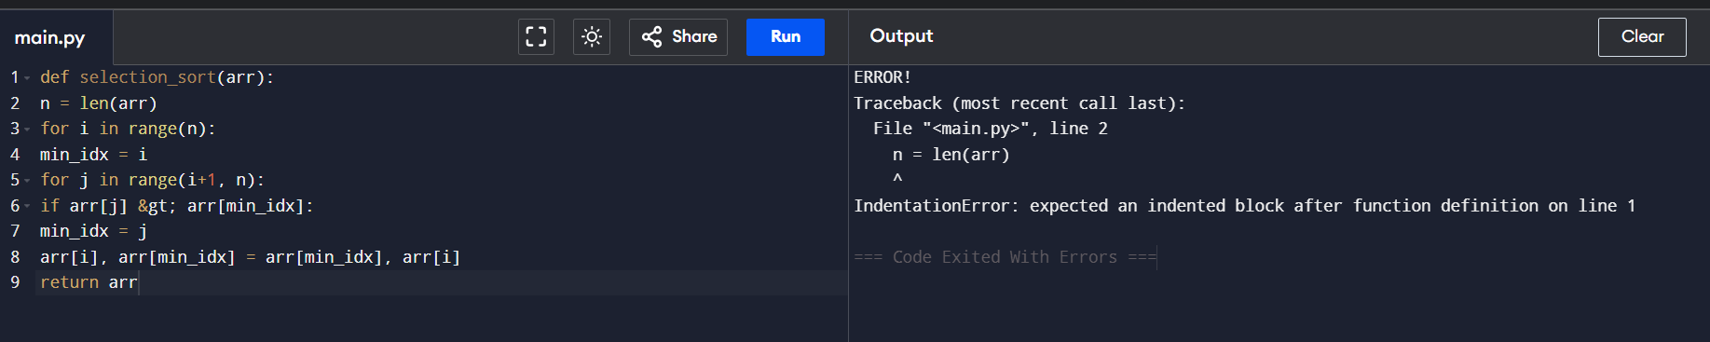

Description:
The original Selection Sort program was executed. The program failed to run because the statements inside the function were not properly indented. Python generated an IndentationError, indicating that an indented block was expected after the function definition.

Error:
IndentationError: expected an indented block after function definition on line 1
Correction Made:
def selection_sort(arr):
n = len(arr)
Explanation:
The statement n = len(arr) was indented by four spaces so that it becomes part of the function body.

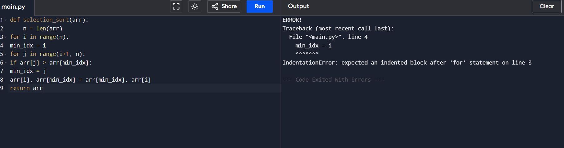

Description
After correcting the function indentation, the program was executed again. Python generated another IndentationError because the statement inside the for loop was not properly indented. Every for loop in Python must contain an indented block of code.
IndentationError: expected an indented block after 'for' statement on line 3
Explanation
The statement min_idx = i was indented by one level so that it becomes part of the outer for loop. This allows the minimum index to be initialized correctly during each iteration of the loop.

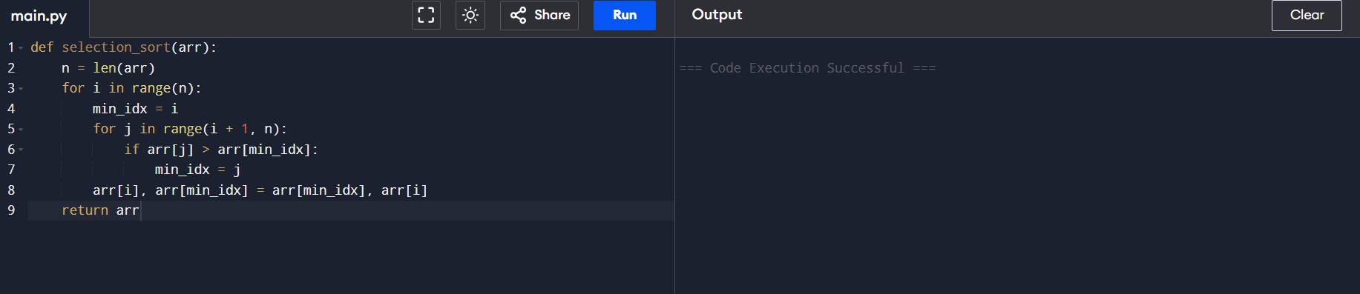

Explaination:
The comparison operator was changed from > to < so that the algorithm selects the minimum element in each pass, producing ascending order.

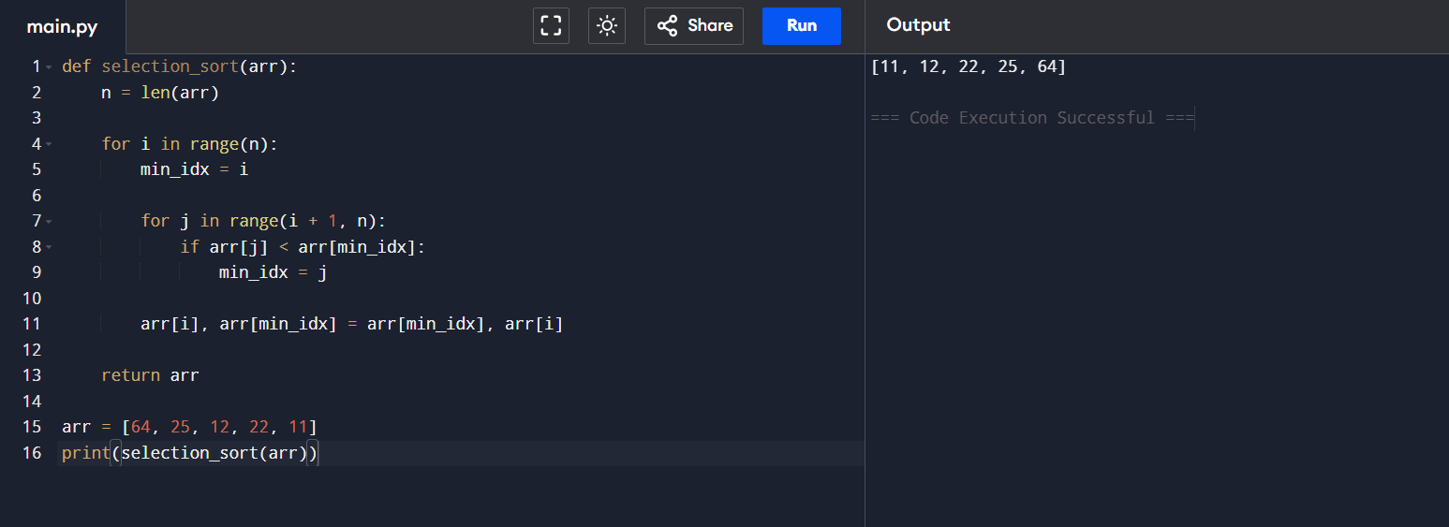

Description
After correcting the comparison operator, the program was executed successfully. The array is now arranged in ascending order because the algorithm selects the minimum element during each pass. However, the program still performs swapping even when the minimum element is already in its correct position. This results in unnecessary swap operations.
Explanation
The comparison operator was changed from > to < so that the algorithm selects the minimum element in each pass. This correction produces the array in ascending order.
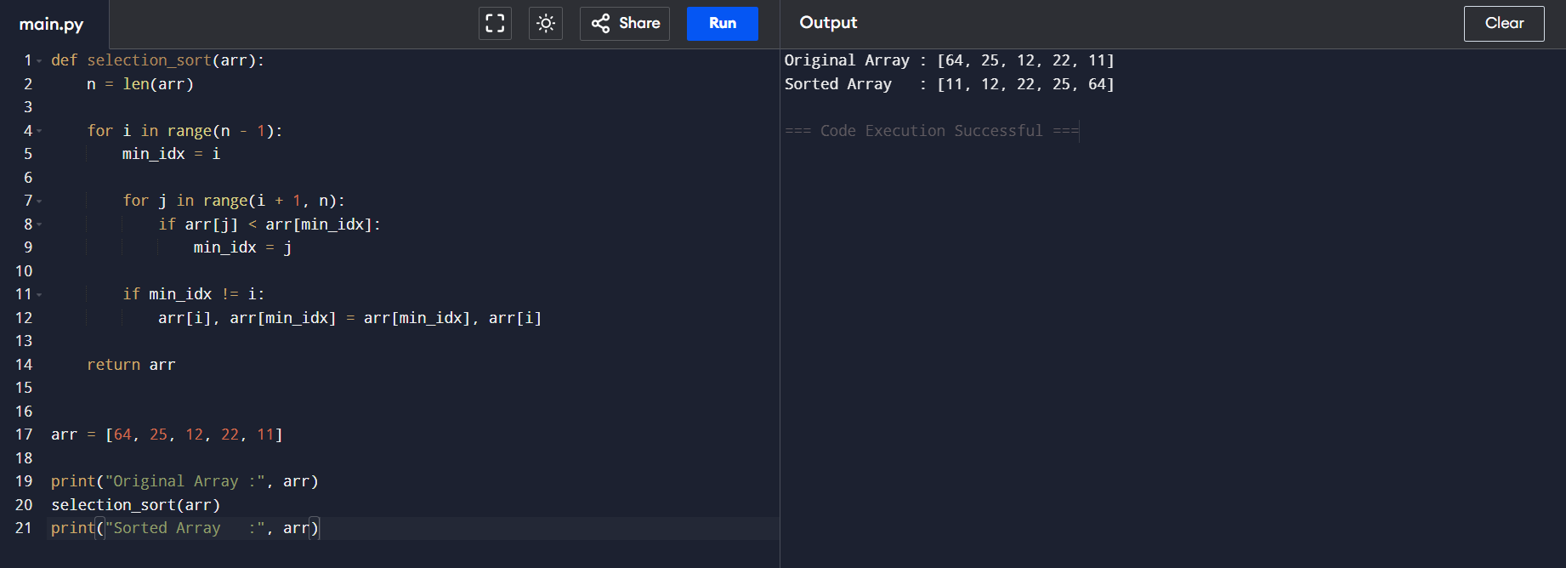

Description
The Selection Sort algorithm was optimized by avoiding unnecessary swapping. Before performing the swap, the program checks whether the minimum element is already present in the correct position. If the current index and minimum index are the same, the swap operation is skipped. This improves the efficiency of the algorithm while producing the correct sorted output.
Explanation
The condition
if min_idx != i:
ensures that swapping is performed only when required. This optimization avoids unnecessary assignments and improves the overall performance of the Selection Sort algorithm.
Algorithm: Corrected Selection Sort
- Step 1: Start.
- Step 2: Read the array and determine its size n.
- Step 3: Assume the current element as the minimum element.
- Step 4: Compare the remaining elements with the current minimum.
- Step 5: Update the minimum index whenever a smaller element is found.
- Step 6: Swap the elements only if the minimum index is different from the current index.
- Step 7: Repeat the process until all elements are sorted.
- Step 8: Display the sorted array in ascending order.
- Step 9: Stop.

Complexity
- Time Complexity: O(n²)
- Space Complexity: O(1)

