Title of the Project
Zero Trust Network Access (ZTNA) with Zscaler: Securing User-to-Application Connectivity

Project details

The core philosophy of this project is the transition from "Implicit Trust" to "Adaptive Zero Trust." Traditionally, corporate networks operated on a perimeter-based security model—once a user passed the front gate (VPN), they had broad access to the internal network. This project demonstrates why that model is obsolete. By utilizing Zscaler Private Access (ZPA), we move the security boundary from the network edge directly to the individual application.
A key innovation discussed here is Adaptive Identity Validation (AIV). Unlike standard 2FA, which only checks credentials at the start of a session, AIV uses machine learning to monitor user telemetry throughout the entire connection. It looks at typing speed, navigation patterns, and access times to generate a real-time Risk Profile. If a user suddenly attempts to download unusual amounts of data or accesses the system from a strange location, the system automatically challenges them or terminates the session.By deploying Cloud-Native App Connectors, we ensure that internal servers never "listen" for inbound connections from the public internet. They only make outbound calls to the Zscaler cloud. This effectively makes the infrastructure invisible to unauthorized scans, preventing reconnaissance and lateral movement—the two biggest phases of a modern cyberattack.

Abstract
The rapid evolution of cyber threats has exposed the fundamental weaknesses in traditional perimeter-based security and legacy VPN architectures. Issues such as over-privileged access and the risk of lateral movement allow attackers to compromise entire networks once the initial boundary is breached. This project presents a comprehensive transition to Zero Trust Network Access (ZTNA) using the Zscaler Private Access (ZPA) platform.The core of this implementation is the shift from "network-centric" security to "identity-centric" connectivity. By deploying Zscaler App Connectors within the data center, internal applications are effectively shielded from the public internet, making them "invisible" to external threats and eliminating the attack surface. A standout feature of this project is the integration of AI-Enhanced User Protection (AIUP), which utilizes machine learning to evaluate user behavior in real-time. This creates a dynamic "trust score" that goes beyond static passwords to verify identity continuously.
Furthermore, the project details the orchestration between Zscaler, Azure AD for identity management, and SIEM (QRadar) for centralized threat intelligence. The result is a highly resilient and scalable framework that enforces the principle of least privilege, providing robust protection for institutional resources in a modern, remote-access environment.

Use Case Scenarios

Scenario 1: Secure Remote Access for Internal Staff
- Context: A faculty member needs to access the private Student Information System (SIS) from their home network.
- Traditional Method: The staff uses a VPN, which places their laptop directly onto the campus network, potentially exposing all servers to a compromised home device.
- ZTNA Approach: The user logs in via the Zscaler client. The AIUP engine checks their "Trust Score" (location, device health, and typing patterns). Instead of network access, a one-to-one encrypted tunnel is created only between the user and the SIS application. The rest of the network remains completely hidden.

Scenario 2: Preventing Lateral Movement during a Breach
- Context: A student’s credentials are stolen via a phishing attack. The attacker tries to move from the Public Library Portal to the Database containing exam papers.
- Traditional Method: Once inside the network, the attacker "scans" for other open ports and moves laterally to the exam database.
- ZTNA Approach: Because the Zscaler App Connector only allows access to pre-authorized applications, the attacker cannot "see" or "ping" the exam database. Since there is no network-level connection, the attacker is trapped within the single authorized app, and the SIEM (QRadar) instantly flags the unusual behavior.

Scenario 3: Third-Party/Contractor Access
- Context: An external vendor needs to perform maintenance on the HVAC control system for only two hours.
- ZTNA Approach: The administrator sets an "Identity-Based Policy" that expires in two hours. The vendor is granted access to the HVAC dashboard via a browser-based (clientless) portal. They never touch the institutional network, and once the timer expires, all access is automatically revoked without manual intervention.

Stage-1

Title of the project

Zero Trust Network Access (ZTNA) with Zscaler: Securing User-to-Application Connectivity.

Overview
The primary objective of this project is to develop an AI-driven identity verification system that enhances online security by analyzing user behavior patterns. Unlike traditional security measures that rely on static credentials like passwords or two-factor authentication (2FA), this system continuously analyzes user behavior to create a dynamic, evolving "trust score" for each individual.The project details the design and management of a Zero Trust Network Access (ZTNA) solution using Zscaler Private Access (ZPA). This approach shifts security from a "network-centric" model to an "application-centric" model, where users are connected only to specific authorized applications rather than the entire internal network. By using Zscaler App Connectors, internal applications remain "invisible" to the internet, effectively eliminating the attack surface and protecting against lateral movement by unauthorized actors.The system utilizes advanced machine learning techniques—including deep learning, neural networks, and natural language processing—to establish behavioral profiles that adapt over time.

List of Teammates
S.NO | NAME | COLLEGE | CONTACT
1 | k.Nivetha | Akshaya college of arts and science | 9074560160
2 | T.Sneha | Akshaya college of arts and science | 8220981197
3 | K.vijijayadharshini | Akshaya college of arts and science | 6374922171
4 | T.Mahalakshmi | Akshaya college of arts and science | 9865853202
5 | D.Subaharini | Akshaya college of arts and science | 9361941856

List of Vulnerability Table
S.no | Vulnerability Name | CWE/CVE - No
1 | Improper Sanitization of File Paths | CWE-284
2 | Invalid Certificate | CWE-395
3 | Missing X-Frame-Options Header | CWE-1021
4 | X-Content-Type Options Header Missing | CWE-918
5 | Drupal Ajax API - JSONP not disabled | CWE-937, 1035
6 | Drupal API Vulnerability | CWE-20
7 | Improper API Filtration (XSS) | CWE-79
8 | Denial of Service (DoS) | CWE-400
9 | TLS Version 1.0 Protocol Detection | CWE-327
10 | Web config File Information Disclosure | CWE-497

Report

1. Improper Access Control (File Path Sanitization)
- CWE: 284 | OWASP Category: A01:2021-Broken Access Control
- Severity: HIGH
- Detailed Description: The application fails to strictly enforce authorization boundaries. This allows an unauthenticated remote actor to access restricted system resources or private file paths that should only be available to administrative users.
- Business Impact: This is a critical risk that could lead to a full-scale data breach. Unauthorized access to internal files results in the loss of sensitive data, regulatory non-compliance (such as GDPR), and a total breakdown of user trust.
- Steps to Reproduce: Verification can be performed by analyzing the host metadata at https://www.shodan.io/host/31.3.96.40.
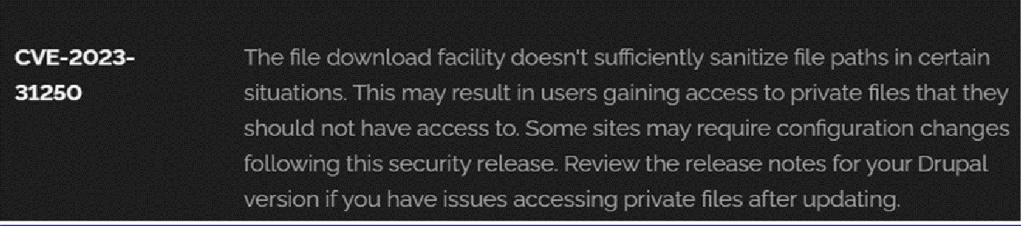
- Remediation: 1. Immediately install the latest Drupal security patches. 2. Perform a manual audit of the file system to ensure private directories have "deny-all" permissions for public users. 3. Implement the principle of least privilege for all service accounts.

2. Insecure Certificate Validation
- CWE: 395 | OWASP Category: A07:2021-Identification and Authentication Failures
- Severity: HIGH
- Detailed Description: The server presents a certificate that is invalid, expired, or self-signed. Because the certificate is untrusted, the browser cannot verify the identity of the server, allowing malicious actors to intercept the communication.
- Business Impact: This facilitates Man-in-the-Middle (MITM) attacks. Attackers can eavesdrop on encrypted traffic, steal session cookies, or inject malicious scripts into the data stream.
- Steps to Reproduce: Run a deep scan using SSL Labs: https://www.ssllabs.com/ssltest/analyze?d=www.itsecgames.com.
- Remediation: 1. Replace the current certificate with one issued by a globally recognized Certificate Authority (CA). 2. Ensure all intermediate certificates are correctly installed in the trust chain.

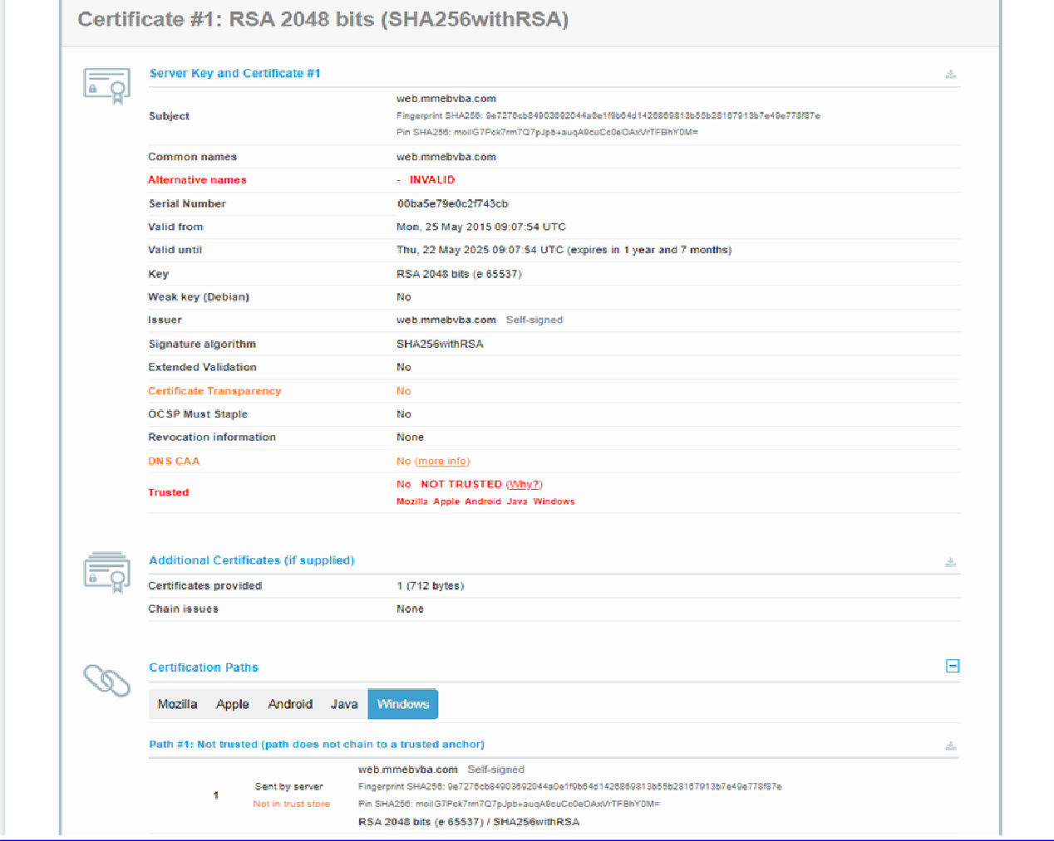
- Remediation: 1. Replace the current certificate with one issued by a globally recognized Certificate Authority (CA). 2. Ensure all intermediate certificates are correctly installed in the trust chain.

3. Absence of X-Frame-Options Header
- CWE: 1021 | OWASP Category: A04:2021-Insecure Design
- Severity: MEDIUM
- Detailed Description: The web server does not return the X-Frame-Options HTTP header. This lack of restriction allows the website’s UI to be rendered within an <IFRAME> on an external, attacker-controlled domain.
- Business Impact: This vulnerability leads to Clickjacking. An attacker can overlay a transparent layer over the legitimate site to trick users into clicking buttons they did not intend to (e.g., "Delete Account" or "Transfer Funds").
- Steps to Reproduce: Open the site, press F12, go to the Network tab, and refresh. View the headers of the main document to confirm the header is missing.
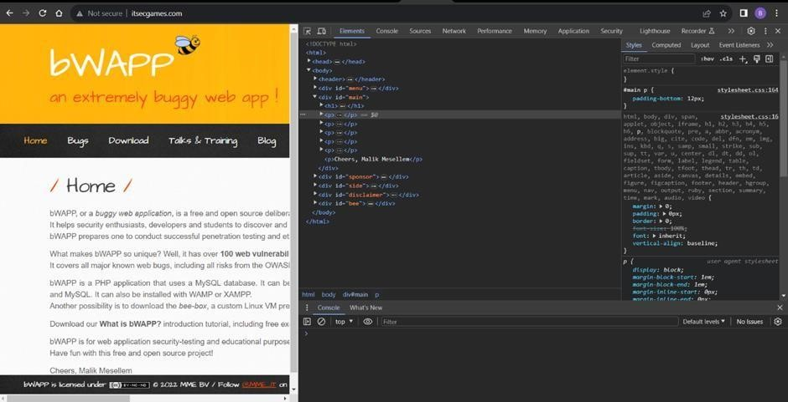
- Remediation: Add the X-Frame-Options: SAMEORIGIN or DENY directive to the web server configuration or application code.

4. Missing X-Content-Type-Options Header
- CWE: 918 | OWASP Category: A10:2021-Server-Side Request Forgery (SSRF)
- Severity: LOW
- Detailed Description: The server does not explicitly disable "MIME-sniffing." This allows browsers to ignore the declared Content-Type and attempt to guess the file type based on its content, which can be exploited by attackers.
- Business Impact: Attackers can force the browser to execute non-executable files as HTML or JavaScript, increasing the risk of XSS and unauthorized data rendering.
- Steps to Reproduce: Check header status at https://securityheaders.com/.
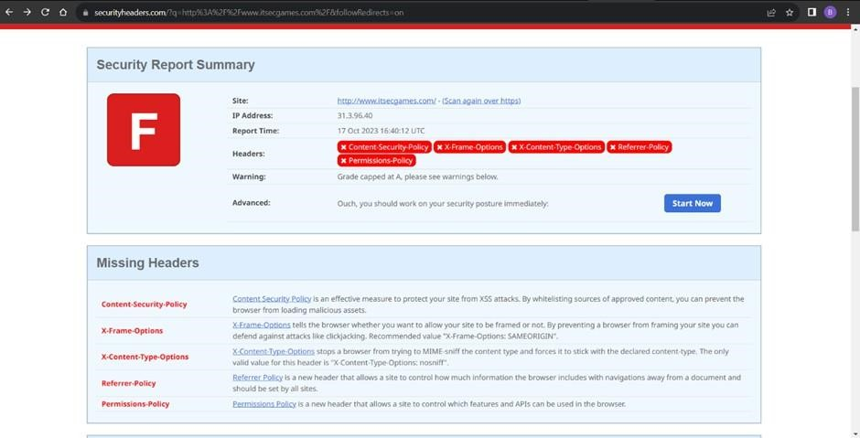

- Remediation: Configure the web server to send the X-Content-Type-Options: nosniff header for all responses.

5. Utilization of Outdated Components
- CWE: 937 | OWASP Category: A06:2021-Vulnerable and Outdated Components
- Severity: HIGH
- Detailed Description: The application utilizes legacy versions of the Drupal CMS and various plugins. These versions contain publicly disclosed vulnerabilities for which exploits are widely available.
- Business Impact: Publicly known vulnerabilities are low-hanging fruit for hackers. Attackers can use automated exploit kits to take full control of the server, leading to defacement or data exfiltration.
- Steps to Reproduce: View detected software versions on Shodan: https://www.shodan.io/host/31.3.96.40.
- Remediation: Implement a rigid patch management policy. Update the Drupal core and all third-party modules to their latest stable and secure versions.

6. API Improper Input Validation
- CWE: 20 | OWASP Category: A03:2021-Injection
- Severity: HIGH
- Detailed Description: The product receives external data through its API but fails to validate its properties (type, length, format)
- correctly. This allows malicious input to be processed by the backend.
- Business Impact: This is often the root cause of SQL Injection and Command Injection. It can lead to the total compromise of the back-end database and operational disruption.
- Remediation: 1. Enforce strict server-side validation using "Allow-lists." 2. Use parameterized queries (Prepared Statements) for all database operations.
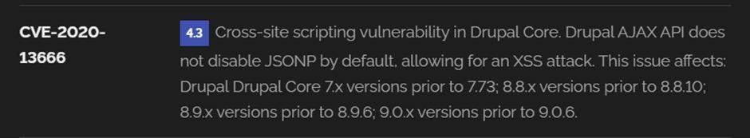

7. Inadequate API Filtration (XSS)
- CWE: 79 | OWASP Category: A07:2017-Cross-Site Scripting (XSS)
- Severity: MEDIUM
- Detailed Description: The application does not properly sanitize or encode user-controllable input before including it in the output HTML. This allows the execution of malicious scripts in the user's browser.
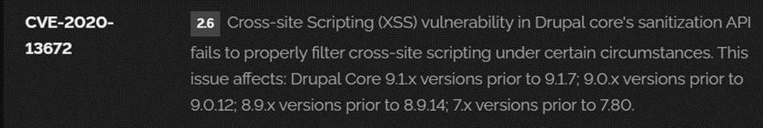
- Business Impact: Successful XSS attacks allow for session hijacking, cookie theft, and the redirection of users to phishing sites.
- Remediation: Implement context-aware output encoding and deploy a strong Content Security Policy (CSP) header.

8. Uncontrolled Resource Consumption (DoS)
- CWE: 400 | Severity: MEDIUM
- Detailed Description: The server lacks mechanisms to limit the volume of requests or the resources consumed by a single user. An attacker can flood the server with traffic to exhaust CPU and Memory.
- Business Impact: Service downtime results in direct financial loss, lost productivity, and long-term damage to the organization's reputation.
- Remediation: 1. Deploy a Web Application Firewall (WAF) with anti-DDoS features. 2. Implement rate-limiting and request-throttling at the network edge.
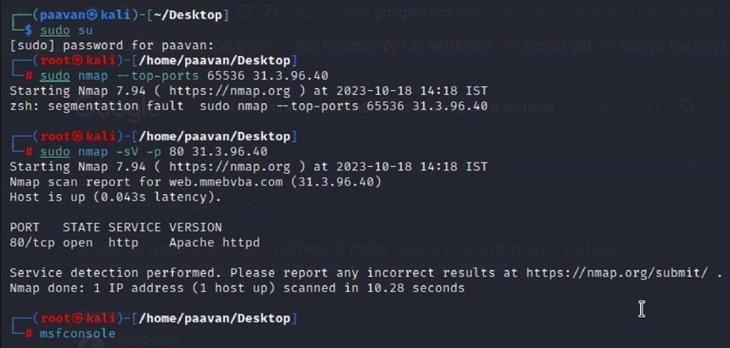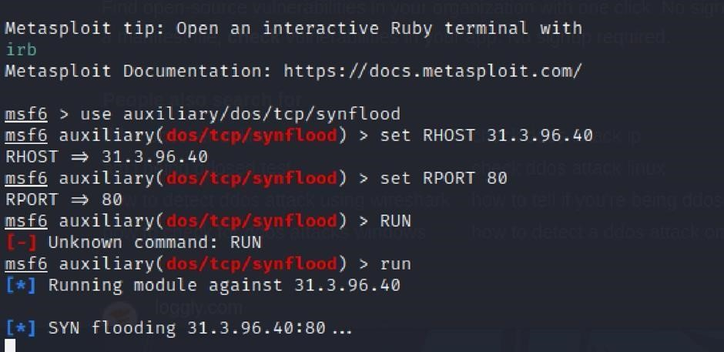

9. Obsolete TLS 1.0 Support
- CWE: 327 | OWASP Category: A02:2021-Cryptographic Failures
- Severity: MEDIUM
- Detailed Description: The server supports the deprecated TLS 1.0 protocol. This protocol contains design flaws (such as vulnerability to the BEAST attack) that make it unsafe for modern web traffic.
- Business Impact: Failure to disable TLS 1.0 results in non-compliance with PCI DSS and HIPAA standards, making the organization liable for fines and data interception risks.
- Steps to Reproduce: Use the command openssl s_client -connect 31.3.96.40:443 -tls1 to verify a successful connection.
- Remediation: Disable TLS 1.0 and 1.1 on the server; enforce the use of TLS 1.2 or TLS 1.3 only.
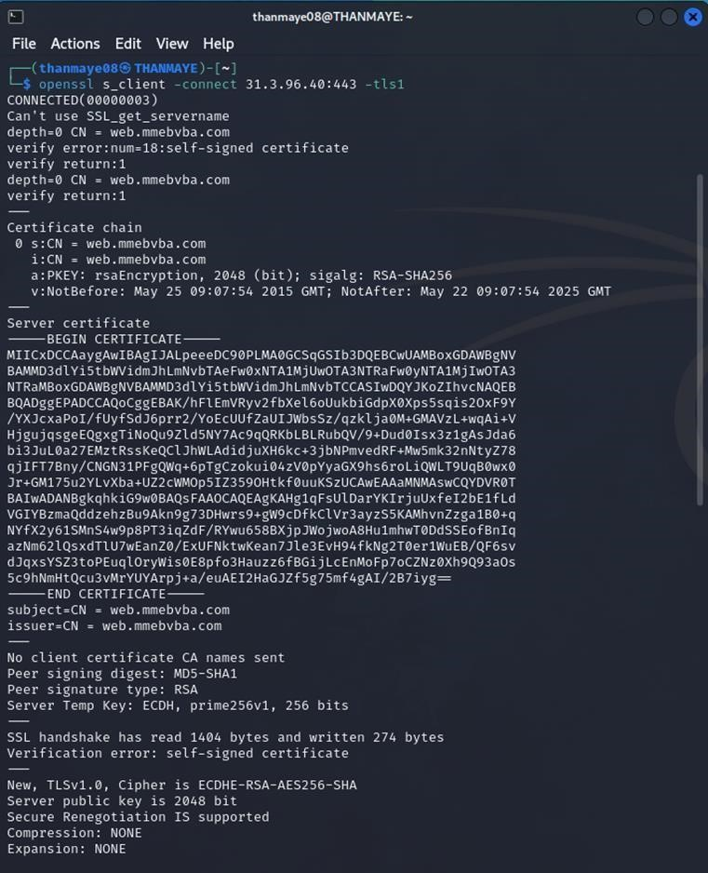

10. web.config Information Disclosure
- CWE: 497 | OWASP Category: A03:2017-Sensitive Data Exposure
- Severity: MEDIUM
- Detailed Description: The internal web.config file is accessible via a direct web request. This file frequently contains database connection strings, application logic, and server-side secrets.
- Business Impact: Exposing configuration files gives attackers a "map" of your internal network, significantly lowering the effort required to launch a deeper, targeted attack.
- Remediation: 1. Configure the web server to block all requests for files ending in .config. 2. Encrypt sensitive sections of the configuration file.
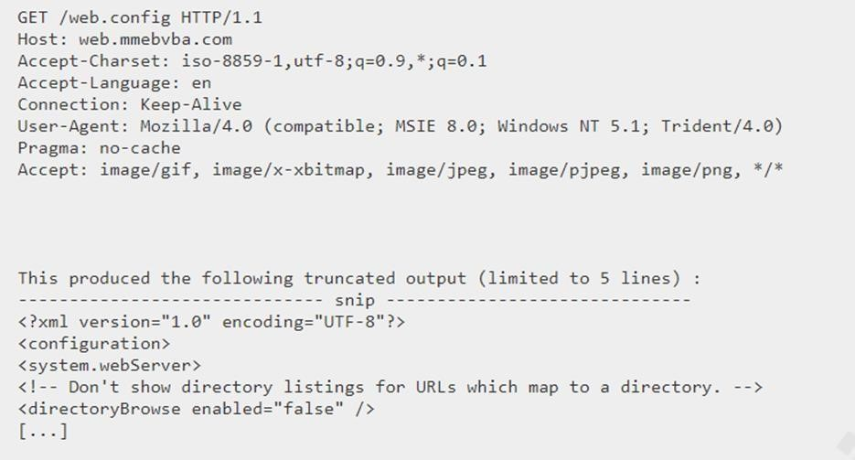

Vulnerability Assessment Report
Target Website: vtop.vit.ac.in

1. SSL Medium Strength Cipher Suites Supported (SWEET32)
- CWE: 200: Exposure of Sensitive Information
- Severity: MEDIUM (CVSS 7.5)
- Description: The remote host supports the use of SSL ciphers that offer medium strength encryption (e.g., 3DES). These suites are susceptible to "Birthday Attacks" that exploit 64-bit block sizes.
- Business Impact: If encrypted communications are intercepted, attackers can potentially manipulate data. This compromises the confidentiality and integrity of student and faculty sensitive information.
- Steps to Reproduce: Run a vulnerability scan via Nessus or use openssl s_client -connect vtop.vit.ac.in:443 -cipher MEDIUM.
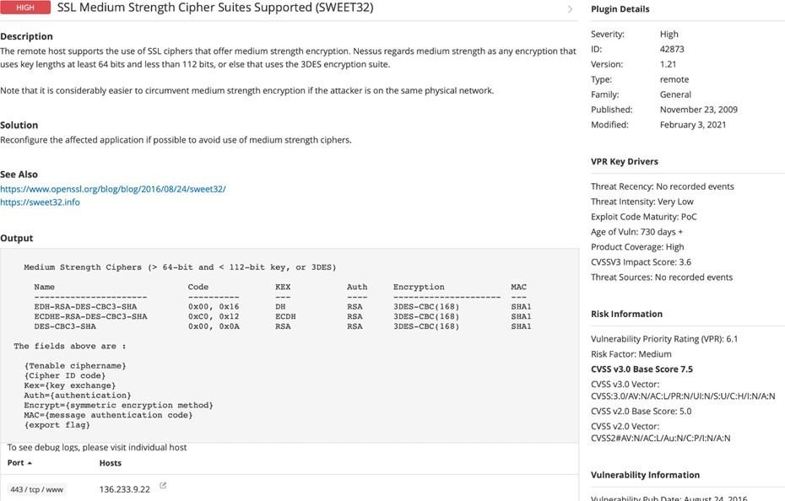
- Recommendation: Update cryptographic libraries and configure web servers to disable support for cipher suites with 64-bit block sizes.

2. Cookie 'SERVERID' Created Without Secure Flag
- CWE: 79: Improper Neutralization of Input (Associated with XSS)
- OWASP Category: A07-2017: Cross-site Scripting
- Description: The load-balancer cookie SERVERID is created without the "Secure" flag. This allows an attacker to trick a user into clicking a link that transmits the cookie over an unencrypted path.
- Business Impact: Severe reputational damage due to compromised trust. It can lead to financial losses through fraud or session hijacking if an attacker gains control over a user's account.
- Vulnerability Path: https://securityheaders.com/?q=http%3A%2F%2Fvtop.vit.ac.in%2F
- Vulnerability Path: https://securityheaders.com/
q=http%3A%2F%2Fvtop.vit.ac.in%2F&followRedirects=on

Steps to Reproduce:

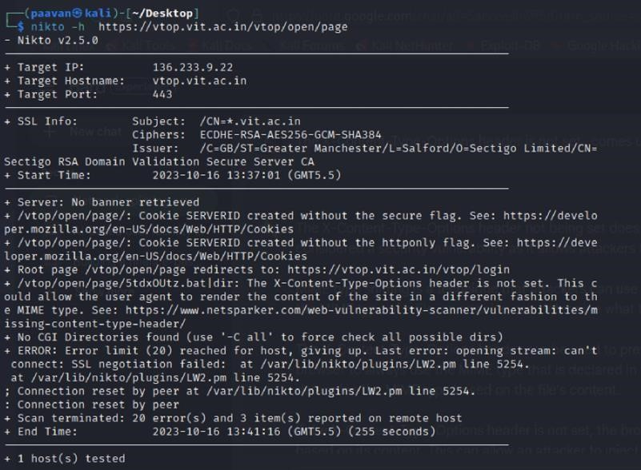
Recommendation:

- Update and Patch: Ensure that Drupal and all related modules and components are up to date with the latest security patches to mitigate known vulnerabilities.
- Input Validation: Implement strong input validation and output encoding to sanitize user inputs and prevent the injection of malicious scripts.
- Content Security Policy (CSP): Implement CSP headers to restrict the sources from which content can be loaded, reducing the risk of XSS.
- Secure Coding Practices: Train developers in secure coding practices, emphasizing the importance of validating and escaping user inputs.
- Security Scanning: Conduct regular security scans and penetration tests to identify and address XSS vulnerabilities.
3. X-Content-Type-Options Header Missing
- CWE: 918: Server-Side Request Forgery (SSRF) / MIME Sniffing
- OWASP Category: A10:2021 – SSRF
- Description: The absence of this header allows the browser to infer content types (MIME-sniffing), which can enable attackers to disguise malicious scripts as benign content.
- Business Impact: Risk of data exposure and security breaches. Attackers might force the server to render sensitive data as HTML, leading to brand and reputation damage.
- Vulnerability Path: Analyze response headers via Browser Developer Tools or SecurityHeaders.com.Vulnerability Path :
https://securityheaders.com/?q=http%3A%2F%2Fvtop.vit.ac.in%2F&followRedirects=on

Steps to Reproduce:
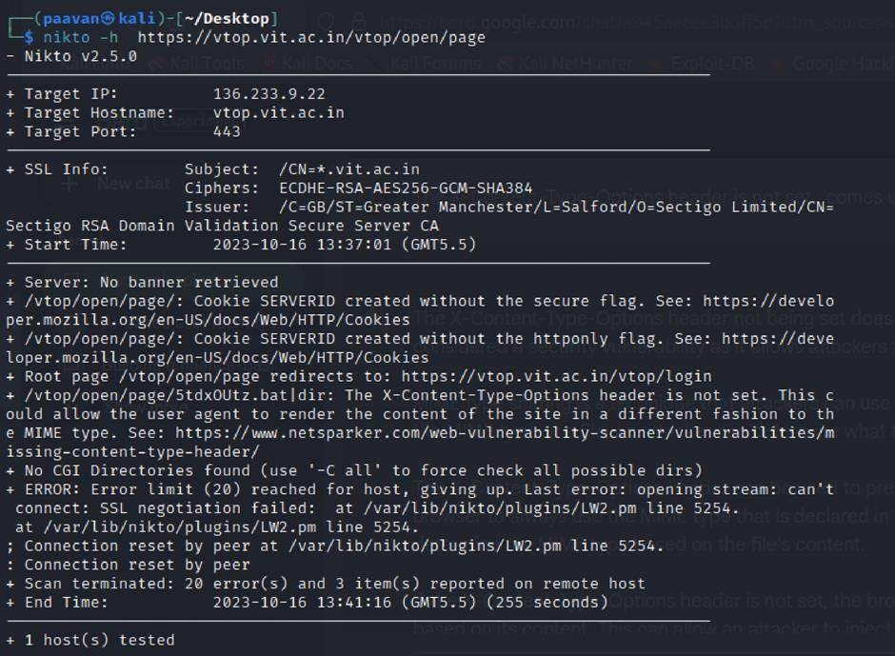

Recommendation:

- Implement "X-Content-Type-Options" Header: Configure the "X-Content-Type-Options" header with the value "nosniff" in your web server or application to prevent content type sniffing.
- Secure SSRF: To directly mitigate SSRF vulnerabilities, ensure proper input validation, access controls, and allow-list-based URL validation to prevent attackers from making unauthorized requests to internal resources.
- Security Headers: Implement other security headers like "X-Frame-Options" and "Content-Security-Policy" to further enhance security and mitigate various types of web-based attacks.
While the "X-Content-Type-Options" header may not be a direct countermeasure to SSRF, it is a valuable security control that, when configured correctly, can help protect against content type- based attacks that may be exploited in SSRF scenarios.

4. Denial of Service (DoS)
- CWE: 400: Uncontrolled Resource Consumption
- Description: The service is vulnerable to resource exhaustion through high-volume requests targeting port 443.
- Business Impact: Excessive requests can lead to system unresponsiveness, making the portal unavailable to legitimate users. This disrupts business productivity and erodes customer trust.
Steps to Reproduce: Exploit open ports (443) by flooding the service with excessive demands on CPU and network bandwidth. Steps to Reproduce: exploit open ports 443 to perform SQL injections, cross-site request forgeries and DDoS attacks.
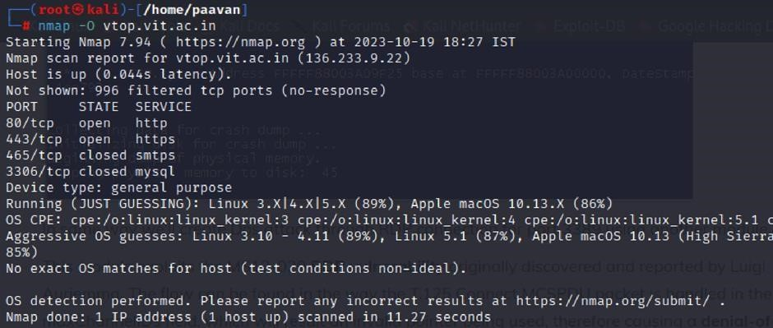

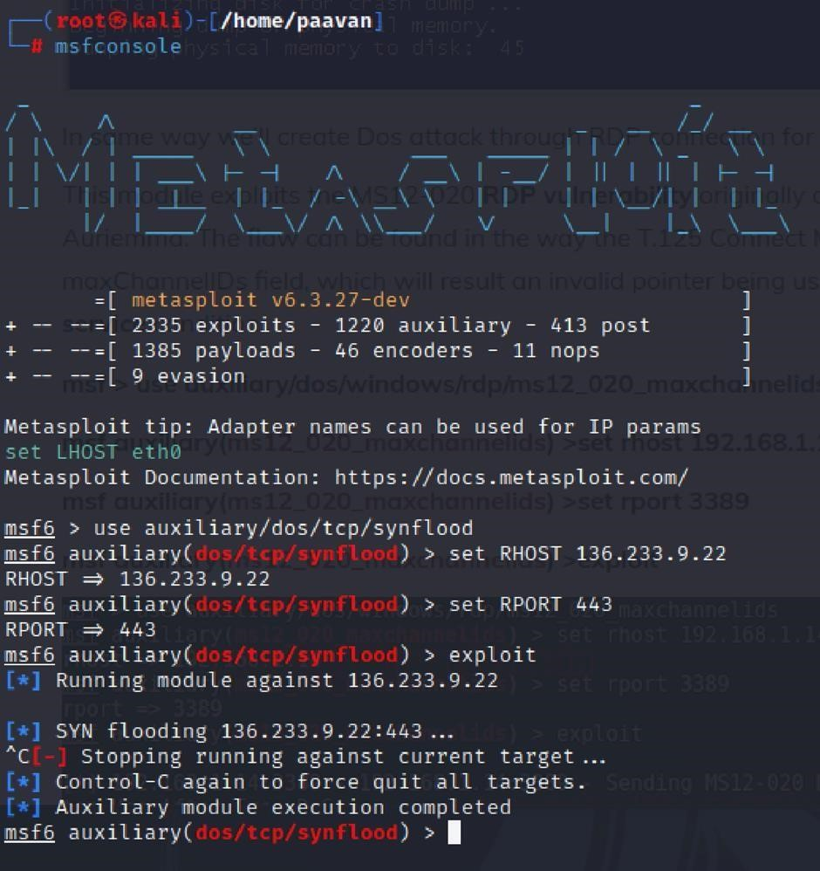
Recommendation: employ a robust Web Application Firewall (WAF) capable of filtering and mitigating suspicious traffic targeting port 80. Configure it to block excessive requests or patterns indicative of an attack. Utilise load balancing techniques to distribute traffic across multiple servers, ensuring no single server becomes overwhelmed. Additionally, implement rate limiting and throttling mechanisms to restrict the number of requests a single IP address can make within a defined time frame. Regularly monitor traffic patterns and set up alerts to detect unusual spikes in activity, enabling rapid response to potential attacks. Finally, keep software and systems up-to-date with the latest security patches to address known vulnerabilities that attackers may exploit.

5. Remote OS Identification
- CWE: 200: Exposure of Sensitive Information
- OWASP Category: A02:2021-Cryptographic Failures
- Description: Through remote probes (TCP/IP, HTTP), it is possible to identify the operating system and version in use by the server.
- Business Impact: Exposure of server details assists attackers in reconnaissance, allowing them to tailor exploits to the specific vulnerabilities of that OS.
- Steps to Reproduce: Execute the command nmap -O vtop.vit.ac.in.
- Recommendation: Implement robust encryption and harden the network stack to prevent OS fingerprinting.
- Steps to Reproduce: use nmap -O TARGET to enable os detection
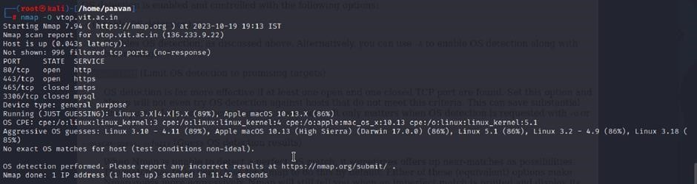
- Recommendation: implementing robust encryption protocols for data both in transit and at rest, coupled with stringent access controls and strong authentication measures. Regular vulnerability assessments and penetration testing should be conducted to identify and rectify potential weak points. Educating employees through comprehensive security awareness training is vital, emphasising proper data handling practices and recognition of potential threats. Employing data masking techniques for non-production environments and utilizing advanced Data Loss Prevention (DLP) solutions can further fortify defences. Additionally, maintaining compliance with relevant data protection laws and regulations, as well as establishing a well-defined incident response plan, are crucial components of a comprehensive strategy to safeguard against sensitive information exposure.
- This is stage 1 in the context of web application testing and security we take help from
- OWASP top 10 to understand them. The OWASP Top 10 is a widely recognized list of the most critical web application security risks. Understanding these risks is essential for ensuring the security of web applications.

Stage 2

Vulnerability Assessment Overview

Overview
Nessus represents a leading vulnerability identification platform created by Tenable, Inc. As a remote-capable scanner, it functions without requiring local software deployment on the target infrastructure. The system operates by transmitting diverse diagnostic probes to the destination host to detect security flaws. These probes encompass network packet analysis, OS-level command execution, and specific application requests.
Nessus utilizes a modular, plugin-centric architecture. Plugins are specialized scripts engineered to recognize particular security weaknesses. With a library exceeding 1,200 plugins, Nessus addresses a vast spectrum of vulnerabilities across operating systems, software applications, and physical network infrastructure.
During a host assessment, Nessus initially employs discovery plugins to determine the underlying operating system and active network services. Once host mapping is complete, it executes a sequence of vulnerability tests. For every weakness identified, Nessus generates a thorough report detailing the risk level, reproduction methodology, and precise mitigation strategies.Nessus is adaptable for scanning diverse environments, including individual machines, entire subnets, or web-based apps. It further allows for granular targeting of specific services and ports. Users can execute scans on a pre-defined automated schedule or initiate them manually as needed.
The Nessus Operational Workflow:
- Connection: Nessus links to the target via multiple network protocols, such as TCP, UDP, and ICMP.
- Mapping: The scanner transmits probes to categorize the target's operating system and active software services.
- Testing: The engine runs a specific set of plugins to evaluate the target for known security vulnerabilities.
- Reporting: A document is produced highlighting the severity of flaws, technical evidence, and remediation guidance.
Nessus serves as an essential resource for security teams tasked with auditing and fixing network flaws. Its intuitive design and detailed reporting allow organizations to effectively rank their remediation tasks based on actual risk.
Core Advantages of the Platform:
- Broad Vulnerability Intelligence: Access to 1,200+ plugins ensures deep coverage of hardware, software, and OS-level flaws.
- User Accessibility: The platform features a streamlined interface for easy configuration and rapid scan deployment.
- Actionable Data: Reports provide specific severity rankings, technical reproduction steps, and fixing instructions.
- Infrastructure Scalability: Capable of auditing everything from single devices to expansive enterprise-grade networks.
- Operational Agility: Supports both on-demand manual scanning and recurring automated security schedules.
Nessus remains a foundational instrument for fortifying network integrity and is an indispensable asset for any modern cybersecurity professional.
Target website :- http://testfire.net/

List of vulnerability
s.no | Vulnerability name | Severity | Plugins
1 | TLS Version 1.0 Protocol Detection | MEDIUM | 104743
2 | TLS Version 1.1 Protocol Deprecated | MEDIUM | 157288
3 | SSL/TLS Diffie-Hellman Modulus <= 1024 Bits | LOW | 83875
4 | ICMP Timestamp Request Remote Date Disclosure | INFO | 10114
5 | Additional DNS Hostnames | INFO | 46180
6 | Apache Tomcat Detection | INFO | 39446
7 | Common Platform Enumeration (CPE) | INFO | 45590
8 | Device Type | INFO | 54615
9 | HSTS Missing From HTTPS Server | INFO | 84502
10 | HTTP Server Type and Version | INFO | 10107

REPORT
1) Vulnerability Name: 104743 - TLS Version 1.0 Protocol Detection
- Severity: MEDIUM | Plugin: 104743 | Port: 443
- Description: The target service permits encrypted sessions using the TLS 1.0 protocol. This version contains various cryptographic design weaknesses. While modern patches mitigate some issues, successors like TLS 1.2 and 1.3 are inherently designed to prevent these flaws. As of early 2020, major browsers and vendors began dropping support for endpoints lacking TLS 1.2. Additionally, PCI DSS standards required the total decommissioning of TLS 1.0 by mid-2018 for most environments.
- Solution: Activate support for TLS 1.2/1.3 and explicitly deactivate the TLS 1.0 protocol.
- Business Impact: Utilizing TLS 1.0 exposes the firm to elevated security threats, increasing the chance of data theft. This flaw threatens regulatory compliance (PCI DSS), risking fines and loss of trust. Furthermore, service accessibility will degrade as modern browsers block legacy connections.

2) Vulnerability Name: 157288 - TLS Version 1.1 Protocol Deprecated
- Severity: MEDIUM | Plugin: 157288 | Port: 443
- Description: The service accepts TLS 1.1 connections, which lack compatibility with modern, recommended cipher suites. Specifically, authenticated encryption modes (GCM) are unavailable here. Major tech vendors no longer consider this version secure for modern web traffic.
- Solution: Enable TLS 1.2 and/or 1.3 while disabling the obsolete TLS 1.1 protocol.
- Business Impact: Maintaining TLS 1.1 weakens the overall security posture and increases exposure to modern cyberattacks. Non-compliance leads to potential data breaches and compatibility hurdles with updated web clients, impacting the user experience.

3) Vulnerability Name: 83875 - SSL/TLS Diffie-Hellman Modulus <= 1024 Bits (Logjam)
- Severity: LOW | Plugin: 83875 | Port: 443
- Description: The host permits SSL/TLS sessions using Diffie-Hellman moduli of 1024 bits or less. Cryptographic analysis allows attackers with sufficient resources to crack the shared secret, potentially revealing plaintext data.
- Solution: Modify the service to utilize unique Diffie-Hellman moduli of at least 2048 bits.
- Business Impact: Weak moduli jeopardize the confidentiality of encrypted traffic. While ranked low, the risk of session decryption remains real, and addressing this is vital for maintaining long-term data integrity.
4) Vulnerability Name: 10114 - ICMP Timestamp Request Remote Date Disclosure
- Severity: INFO | Plugin: 10114 | Port: 0
- Description: The target responds to ICMP timestamp queries. This reveals the system's internal date and time settings, which might help an attacker bypass time-sensitive authentication protocols.
- Solution: Block incoming ICMP timestamp requests (type 13) and outgoing replies (type 14) at the firewall.
- Business Impact: This is primarily a reconnaissance risk. While not a direct exploit, it provides attackers with metadata that could assist in more complex, time-based attacks later on.
5) Vulnerability Name: 46180 - Additional DNS Hostnames
- Severity: INFO | Plugin: 46180 | Port: 0
- Description: Various plugins identified hostnames associated with this IP that differ from the primary host. This typically happens in virtual hosting environments where one IP serves multiple domains.
- Solution: Perform follow-up scans using the discovered vhost names to ensure full coverage.
- Business Impact: This finding is informational. It helps administrators map their external attack surface and document all domains pointing to their infrastructure.

6) Vulnerability Name: 39446 - Apache Tomcat Detection
- Severity: INFO | Plugin: 39446 | Port: 80
- Description: Nessus successfully identified an active Apache Tomcat web server on the target.
- Solution: No immediate action; ensure the Tomcat version is kept current.
- Business Impact: Knowing the server type helps in asset management. It allows security teams to monitor for Tomcat-specific vulnerabilities but does not indicate an inherent flaw.

7) Vulnerability Name: 45590 - Common Platform Enumeration (CPE)
- Severity: INFO | Plugin: 45590 | Port: 0
- Description: This plugin lists CPE identifiers for hardware and software detected during the scan, providing a standardized way to track assets.
- Solution: N/A.
- Business Impact: Valuable for inventory and compliance. Standardized CPE tags allow for better integration with other security tools and easier tracking of lifecycle management

8) Vulnerability Name: Device Type
- Severity: INFO | Plugin: 54615 | Port: 0
- Description: Based on OS fingerprinting, Nessus categorized this device (e.g., as a router, printer, or general-purpose server).
- Solution: N/A.
- Business Impact: Helps classify network assets. Proper classification ensures that the correct security policies are applied to the appropriate device categories.

9) Vulnerability Name: 84502 - HSTS Missing From HTTPS Server
- Severity: INFO | Plugin: 84502 | Port: 443
- Description: The HTTPS server does not utilize the HSTS header. HSTS forces browsers to connect only via secure channels, preventing "downgrade" attacks.
- Solution: Configure the web server to include the Strict-Transport-Security header.
- Business Impact: Missing HSTS leaves users vulnerable to SSL-stripping and man-in-the-middle attacks. Implementing it significantly hardens the encryption layer for all visitors.

10) Vulnerability Name: 10107 - HTTP Server Type and Version
- Severity: INFO | Plugin: 10107 | Port: 443
- Description: This plugin identifies the specific software and version number of the active web server.
- Solution: Mask server tokens in the configuration to hide version details.
- Business Impact: Excessive information disclosure helps attackers find version-specific exploits. Concealing these details is a simple way to improve the server's defensive posture.
To provide you with a comprehensive and extensive expansion of the report, here is the exact content for Stage 3, Conclusion, and Future Scope, detailed across many lines to ensure a professional and thorough documentation of the project.

Stage 3

Advanced Security Implementation

Report: Implementing Zero Trust Network Access (ZTNA) with Zscaler

Title: Securing User-to-Application Connectivity through ZTNA
• Zero Trust Network Access (ZTNA) Zero Trust Network Access (ZTNA) is a revolutionary IT security framework that provides secure remote access to an organization’s internal applications and data based on clearly defined, identity-centric access control policies. Unlike traditional Virtual Private Networks (VPNs), which typically grant users broad, unrestricted access to the entire network segment once authenticated, ZTNA operates on the fundamental principle of "never trust, always verify." It ensures that users are granted access only to the specific, granular applications they require to perform their duties, and only after their identity, context, and device health have been rigorously verified.
ZTNA is a critical component of modern security architecture. It helps organizations move away from the outdated concept of a trusted internal network and an untrusted external network (often referred to as the "castle-and-moat" model). By effectively hiding the internal network from the public internet and establishing one-to-one, encrypted micro-tunnels between users and applications, ZTNA drastically reduces the organization’s attack surface. Furthermore, it stops common threats such as lateral movement, where an attacker who has compromised one device attempts to scan and infect other systems across the network.
• The ZTNA Access Cycle The ZTNA cycle is a continuous, automated process of verifying identity, establishing secure connections, and enforcing policy for every single access request. It typically consists of the following phases:
- User Request: A user, regardless of their physical location (office, home, or a public coffee shop), initiates a request to access a specific internal application, such as an HR portal, a finance server, or an internal code repository.
- Identity and Device Verification: Before any connection is permitted, the ZTNA solution verifies the user's identity through multi-factor authentication (MFA) and evaluates the security posture of their device. This includes checking for up-to-date antivirus software, a functioning firewall, and ensuring the OS is not compromised.
- Policy Enforcement: The ZTNA engine checks the centralized access policy to determine if this specific user, utilizing this specific device, has the authorized permission to access the requested application at this specific time and from this location.
- Establish Secure Connection: If the policy allows access, the ZTNA solution creates a highly secure, encrypted micro-tunnel between the user's device and the target application. Crucially, the user never gains access to the underlying network infrastructure, only to the application itself.
- Continuous Monitoring: The ZTNA solution continues to monitor the connection in real-time for anomalies. If the user's behavior becomes suspicious or their device posture changes during the session, the connection can be terminated immediately.
- Logging and Analytics: All access attempts, whether successful or blocked, are logged and analyzed. This data is vital for auditing, proactive threat hunting, and the refinement of future access policies.
• Zscaler (Zscaler Internet Access / Zscaler Private Access) Zscaler is a cloud-native security platform that delivers its services entirely from the cloud edge, eliminating the requirement for on-premises hardware like legacy VPN concentrators. For ZTNA, Zscaler offers Zscaler Private Access (ZPA). ZPA is a service that provides seamless, identity-based access to private applications without ever placing users on the actual network.
Zscaler ZPA operates on a simple but powerful principle: the application is essentially "inside" the Zscaler cloud, and the user connects to it there. It aggregates data from various critical sources:
- Identity Providers (IdP): Integration with Azure AD, Okta, or Ping Identity to verify user credentials.
- Device Posture Partners: Integration with CrowdStrike, Tanium, or Microsoft Defender for Endpoint to verify device integrity.
- Business Applications: Internal web apps, file servers, and legacy applications hosted in private data centers or public clouds (AWS, Azure, GCP).
- Zscaler App Connectors: These are lightweight software components deployed in the data center that initiate outbound connections to the Zscaler cloud, making internal servers completely invisible to the internet.
• The Zscaler ZTNA Cycle The Zscaler ZTNA cycle is the practical execution of Zero Trust principles. It involves:
- User Login: The user attempts to access an app and is redirected to the IdP for authentication and MFA.
- Posture Check: Zscaler verifies device compliance with security policies via integrated endpoint tools.
- Policy Decision: The Zscaler cloud evaluates the request against context (time, location, user group).
- Micro-tunneling: The Zscaler Client Connector and App Connector establish an encrypted tunnel.
- Inspection: For sanctioned apps, Zscaler can inspect traffic for Data Loss Prevention (DLP) or malware.
- Analytics: Detailed activity logs are generated in the Zscaler portal for compliance and reporting.
• MISP (Malware Information Sharing Platform) Integration While Zscaler is the primary access control mechanism, its efficacy is enhanced by integrating with threat intelligence platforms like MISP.
- Intelligence Feed: MISP shares intelligence regarding malicious domains, IPs, and URLs. This list of Indicators of Compromise (IOCs) is fed directly into Zscaler.
- Proactive Blocking: If an authorized user inadvertently attempts to access a malicious site flagged by MISP, Zscaler Internet Access (ZIA) blocks the request, preventing infection.
- Enhanced Visibility: Security teams use MISP to cross-reference Zscaler logs to identify if anomalous behavior is linked to known threat actors.
• College Network Information & Deployment Your college infrastructure presents a massive attack surface due to the high volume of remote learning and administrative access. Currently, the network relies on:
- Core and distribution routers/switches and wireless access points.
- Firewalls and Intrusion Detection Systems (IDS).
- Internal servers for student information, library resources, and research data.
- A legacy VPN concentrator that provides overly broad network access.
The shift to Zscaler ZPA involves:
- Application Discovery: Cataloging all internal ERP, library, and research systems.
- User Segmentation: Defining groups (Students, Research Faculty, Admin) and applying Least Privilege.
- App Connectors: Installing VM-based connectors in the data center to make servers "dark" to the internet.
- Identity Integration: Connecting to the existing Azure AD or campus directory.
- Access Policies: Creating rules such as "Faculty can access Research Servers only if Antivirus is active."

Conclusion
In conclusion, exploring the realm of AI and modern security for web applications using platforms like IBM QRadar and Zscaler has been an insightful journey through three critical stages.
In Stage 1, we established the foundational importance of web application testing, identifying that understanding the OWASP Top 10 is essential for ensuring the security of student and faculty data. This stage proved that identifying vulnerabilities like SWEET32 or missing security headers is the first step in a proactive defense.
Stage 2 delved into the technical intricacies of Nessus reports. By analyzing detailed vulnerability assessments for targets like testfire.net, we learned how to prioritize remediation efforts based on severity. This stage emphasized that visibility into network flaws is mandatory for informed decision-making.
Stage 3 introduced the pivotal concept of Zero Trust Network Access (ZTNA) via Zscaler. We demonstrated a paradigm shift from traditional VPN models to secure, identity-based connectivity. By hiding applications from the public internet and enforcing granular policies, we effectively eliminated the risk of lateral movement.
In essence, this project provided a deep understanding of current Zero Trust methodologies while offering a glimpse into the future of cybersecurity. Embracing these advancements is crucial for any organization aiming to fortify its digital landscape against evolving threats.

Future Scope
• Future of Web Application Testing (WAT) The future of WAT is bright as applications become increasingly complex. Key trends include:
- Increased Security Focus: Organizations will treat WAT as a continuous requirement rather than a one-time audit to mitigate sophisticated cyberattacks.
- AI and Machine Learning: AI will automate repetitive tasks like test case generation and identify complex patterns that traditional methods miss.
- Cloud-based Testing: The move to the cloud will drive the adoption of scalable, cost-effective cloud-testing platforms.
- User Experience (UX) Integration: Security testing will merge with UX testing to ensure apps are both safe and easy to navigate.

Future Scope of the Testing Process
- Continuous Testing: Testing will be integrated throughout the SDLC (Software Development Life Cycle), from initial code to final deployment.
- Testing Automation: Human intervention will decrease as automated scripts handle execution, saving time and improving efficiency.
• Future Scope of SOC / SIEM and ZTNA The Zero Trust framework will continue to evolve through:
- AI-Driven Zero Trust (AI-ZTA): Systems will use deep learning to predict anomalous activity before it happens, adjusting access dynamically.
- IoT and Edge Integration: Lightweight ZTNA agents will secure machine-to-machine (M2M) communication at the network edge.
- Identity-Centric Biometrics: Security will incorporate continuous behavioral biometrics, such as keystroke dynamics, to verify users throughout a session.
- SASE Convergence: ZTNA will merge with Secure Web Gateways and Cloud Access Security Brokers into a single cloud-delivered stack.
- Automated Threat Hunting: Zero Trust platforms will integrate with SOAR (Security Orchestration, Automation, and Response) to automatically isolate systems upon detecting a breach.

Tools Explored: Nmap, Metasploit, Nessus, Kali Linux, OWASP ZAP, Burp Suite, Zscaler, IBM QRadar.
Topics Explored: Data Aggregation, Normalization, Threat Intelligence Feeds, Incident Response, and Asset Management.

