**Assignment 1**:

Make a Smart Home in Tinkercad, using 2+ sensors, Led, Buzzer in single code and circuit.

**Circuit Diagram:**

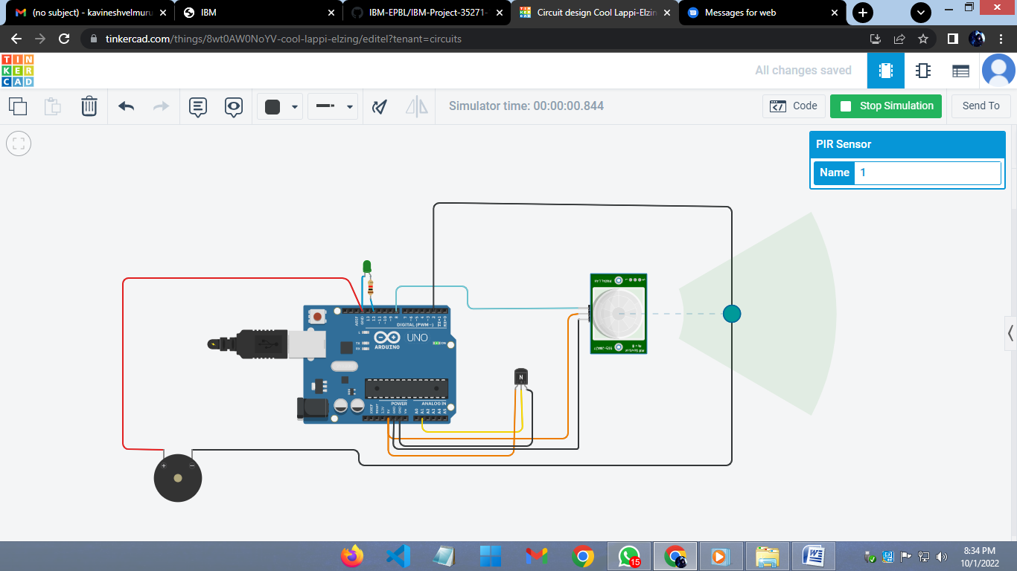

**CODE:**

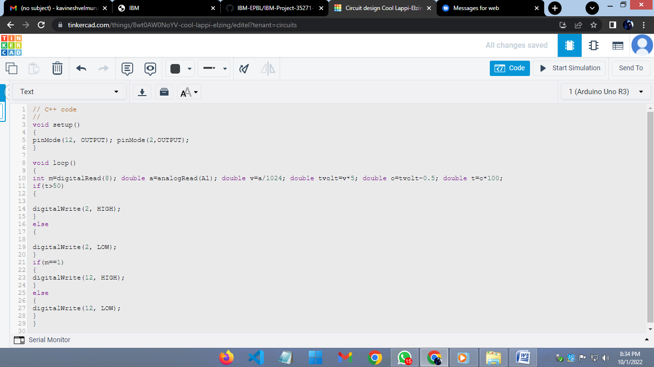

// C++ code

//

void setup()

{

pinMode(12, OUTPUT); pinMode(2,OUTPUT);

}

void loop()

{

int m=digitalRead(8); double a=analogRead(A1); double v=a/1024; double tvolt=v*5; double o=tvolt-0.5; double t=o*100;

if(t>50)

{

digitalWrite(2, HIGH);

}

else

{

digitalWrite(2, LOW);

}

if(m==1)

{

digitalWrite(12, HIGH);

}

else

{

digitalWrite(12, LOW);

}

}