DATA SCIENCE AND
VISUALIZATION
WEEK 7 PROJECT REPORT
Dimensionality Reduction
Implementing Feature Selection and PCA
Visualizing Explained Variance
Submitted by: TEAM 12
NIVETHA S (25BAD074)
POOJA T (25BAD077)
PUVIPRIYA M (25BAD084)
VAISHNAVI D (25BAD126)
DAISY RANI S (25BAD505)
Course: Data Science and Visualization
Academic Year: 2026–2027

Abstract
This project explores dimensionality reduction using a feature-engineered autoimmune disorder dataset. The notebook applies feature selection with SelectKBest and mutual information, then uses Principal Component Analysis (PCA) to transform the standardized numerical features into a smaller set of components. Explained variance and cumulative explained variance are visualized to understand how much information is retained. The dataset contains 12,500 records. After preparing the numeric inputs, 75 features are used for dimensionality reduction. Feature selection retains the top 10 features, while PCA requires 54 principal components to retain 95.02% of the variance. The reduced PCA dataset and feature-selection scores are exported as CSV files.

1. Introduction
Dimensionality reduction reduces the number of input variables while trying to preserve useful information. Datasets with many features can require more storage and computation and may contain redundant information. Feature selection keeps a subset of the original variables, whereas PCA creates new variables called principal components. This project demonstrates both approaches and visualizes the variance retained by PCA.

2. Objectives
- Load and inspect the Week 6 feature-engineered dataset.
- Prepare numerical input features and standardize them.
- Select the 10 most informative features using mutual information.
- Apply PCA to reduce the number of dimensions.
- Visualize explained variance and cumulative explained variance.
- Compare the original feature set, feature selection, and PCA.
- Export the reduced dataset and feature-selection scores.

3. Tools and Technologies Used
Tool / Library | Purpose
Python | Programming language used to implement the workflow.
Pandas | Load, inspect, and manipulate tabular data.
NumPy | Numerical operations and cumulative variance calculation.
Scikit-learn | StandardScaler, SelectKBest, mutual_info_classif, and PCA.
Matplotlib | Plot feature scores and PCA variance.
Seaborn | Set a consistent visualization theme.
Google Colab / Jupyter Notebook | Run the notebook cells.
CSV | Store the reduced dataset and feature scores.

4. Dataset Description
The notebook loads Week6_Feature_Engineered_Dataset.csv, created in the previous week's project. The loaded dataset has 12,500 rows and 79 columns. The target variable is Diagnosis_Encoded. Patient_ID and Diagnosis_Encoded are excluded from the numerical input feature list; constant-valued numerical columns are also removed.
Dataset item | Observed value
Records | 12,500
Loaded columns | 79
Target variable | Diagnosis_Encoded
Input features after filtering | 75
Prepared matrix shape | (12500, 75)
Missing values after preparation | 0

Missing values in the input features are filled using each feature's median. StandardScaler is then used to standardize the numerical data before feature selection and PCA.

5. Methodology

5.1 Data preparation and standardization
The target column Diagnosis_Encoded is stored separately as y. Numeric columns are selected for X, excluding Patient_ID and Diagnosis_Encoded. Columns with only one unique value are removed. Any missing values are filled with the column median. StandardScaler transforms the input features to a standardized scale, which is important for PCA because it is sensitive to feature scales.
Main methods used: select numeric columns → remove excluded/constant columns → fill missing values → standardize.

5.2 Feature selection using mutual information
SelectKBest is used with mutual_info_classif as its scoring function. Mutual information estimates how much information a feature provides about the target label. The selector ranks the 75 input features and retains the top 10. This method keeps original feature names, making the selected variables easier to interpret.
Rank | Feature | Mutual information score
1 | ACPA | 0.506712
2 | CRP | 0.499776
3 | Sickness_Duration_Months | 0.481592
4 | Hemoglobin | 0.330738
5 | RBC_Count | 0.322760
6 | ESR | 0.318682
7 | Hematocrit | 0.289430
8 | MBL_Level | 0.249728
9 | Esbach | 0.224240
10 | ANA | 0.217743

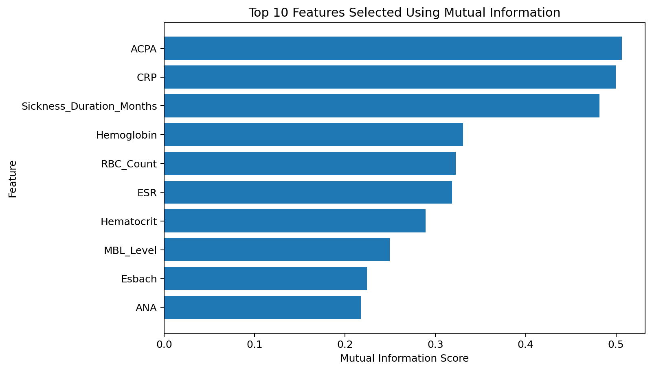
Figure 1. Top 10 features selected using mutual information.

5.3 Principal Component Analysis (PCA)
PCA is a dimensionality-reduction technique that transforms the original standardized features into new, uncorrelated variables called principal components. The first component captures the greatest possible variance, and each following component captures as much of the remaining variance as possible. The notebook first fits PCA to all 75 standardized features and calculates the explained variance ratio for each component.
The cumulative explained variance is calculated by adding the explained variance ratios in order. The number of components is chosen as the smallest number that reaches at least 95% cumulative explained variance.

5.4 Visualizing explained variance
- Explained variance bar chart: shows the percentage of variance represented by each principal component.
- Cumulative explained variance line chart: shows how retained variance increases as more components are included.
- The dashed 95% reference line indicates the target variance-retention level.
The notebook's PCA result reaches the 95% threshold at 54 components. These components retain 95.02% of the variance in the standardized input data.

6. Results and Discussion
Method | Number of features / components | Variance retained
Original numerical feature set | 75 | 100.00%
Feature selection (SelectKBest) | 10 | Not calculated in the notebook
PCA | 54 principal components | 95.02%

Feature selection reduces the input from 75 features to 10 original variables. The highest mutual-information scores in the notebook are ACPA (0.506712), CRP (0.499776), and Sickness_Duration_Months (0.481592). These scores indicate the relative information each feature provides about the encoded diagnosis within this dataset; they do not establish clinical importance.
PCA reduces the standardized feature matrix from 75 dimensions to 54 dimensions while retaining 95.02% of its variance. PCA components are combinations of the original variables, so they are not directly interpretable as single original features. The feature-selection and PCA outputs serve different purposes and their retained information values should not be treated as directly equivalent.

7. Output Files
Output file | Contents
Week7_PCA_Reduced_Dataset.csv | 54 principal component columns (PC1–PC54) and Diagnosis_Encoded.
Week7_Feature_Selection_Scores.csv | Feature names, mutual-information scores, and selected/not-selected status.

The notebook reports that both CSV files were saved successfully. The PCA output preserves the target column so the reduced features remain associated with their corresponding encoded diagnosis labels.

8. Limitations and Future Enhancements

8.1 Limitations
- The notebook performs dimensionality reduction but does not train or evaluate a predictive model.
- The number of PCA components is selected using a 95% variance threshold; another threshold may produce a different size.
- Mutual-information scores show statistical association with the target, not causation or clinical significance.
- The feature-selection table does not calculate a separate variance-retention percentage.

8.2 Future enhancements
- Compare classification performance using the original features, selected features, and PCA components.
- Use a train/test split and fit preprocessing steps on training data to avoid data leakage in predictive evaluation.
- Experiment with different numbers of selected features and PCA variance thresholds.
- Plot a scree plot and clearly label the component count required for different variance thresholds.

9. Conclusion
This project demonstrates two approaches to dimensionality reduction: feature selection and Principal Component Analysis. Mutual-information-based feature selection identifies 10 informative original features from the 75 prepared numerical inputs. PCA reduces the data to 54 principal components while retaining 95.02% of the variance. The variance visualizations help explain how much information each component contributes and how the cumulative variance reaches the chosen threshold. The exported CSV files can be used for further analysis and model experiments.

10. References
- Scikit-learn documentation — Feature selection: https://scikit-learn.org/stable/modules/feature_selection.html
- Scikit-learn documentation — Principal Component Analysis (PCA): https://scikit-learn.org/stable/modules/decomposition.html#pca
- Scikit-learn documentation — StandardScaler: https://scikit-learn.org/stable/modules/generated/sklearn.preprocessing.StandardScaler.html
- Pandas documentation: https://pandas.pydata.org/docs/
- Matplotlib documentation: https://matplotlib.org/stable/

