# Installation of nginx

**Step :1**

Update the package

Command : sudo apt update

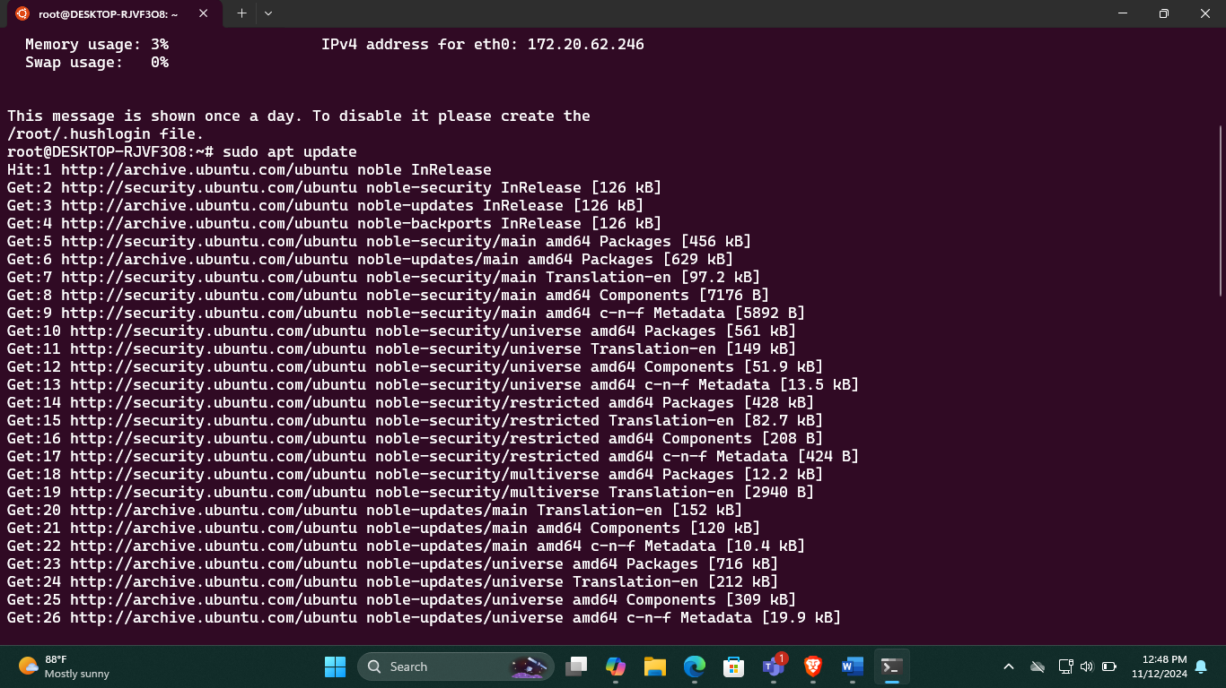

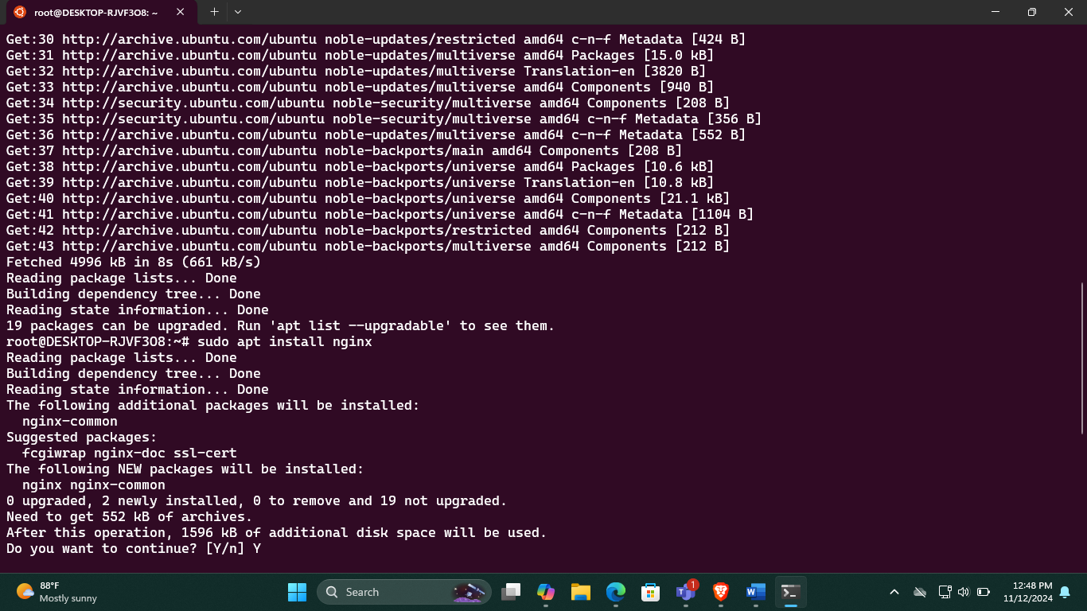

Step :2

Install nginx

Command : sudo apt install nginx

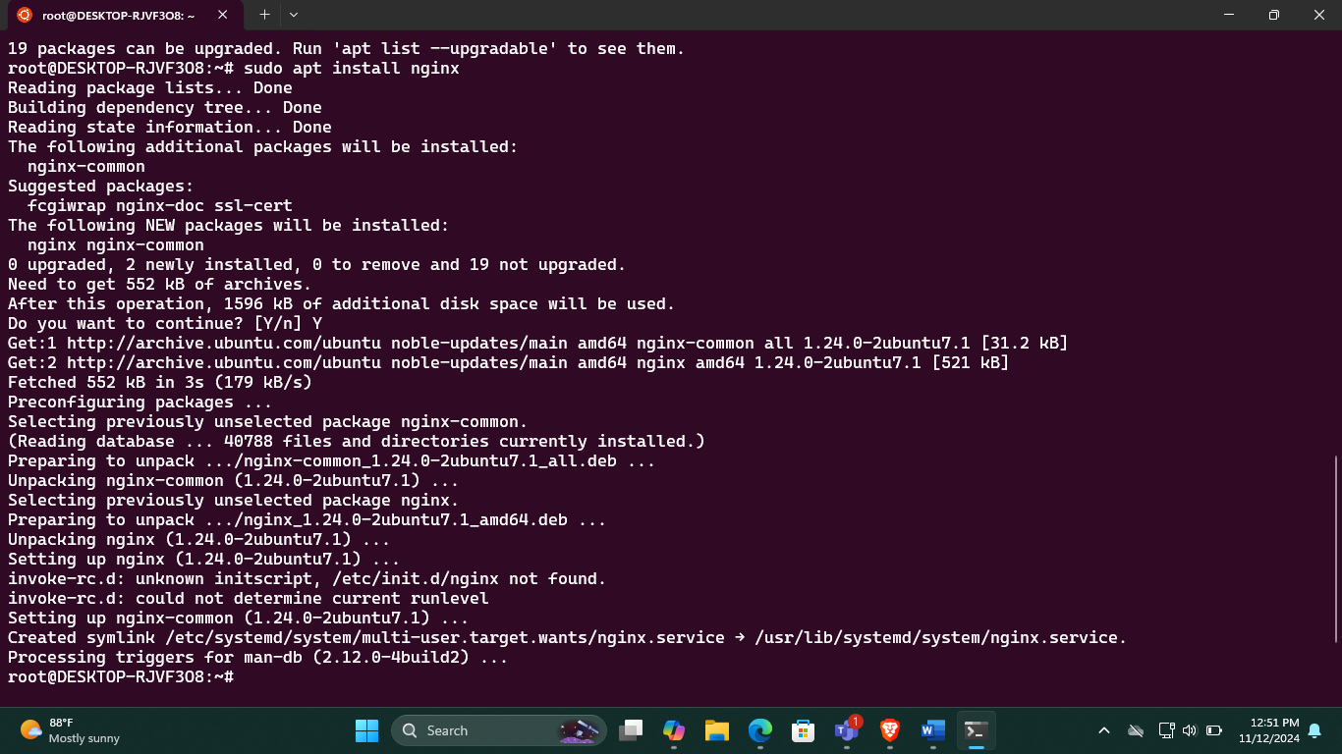

**Step :3**

Enable the nginx service

Command : sudo systemctl enable nginx

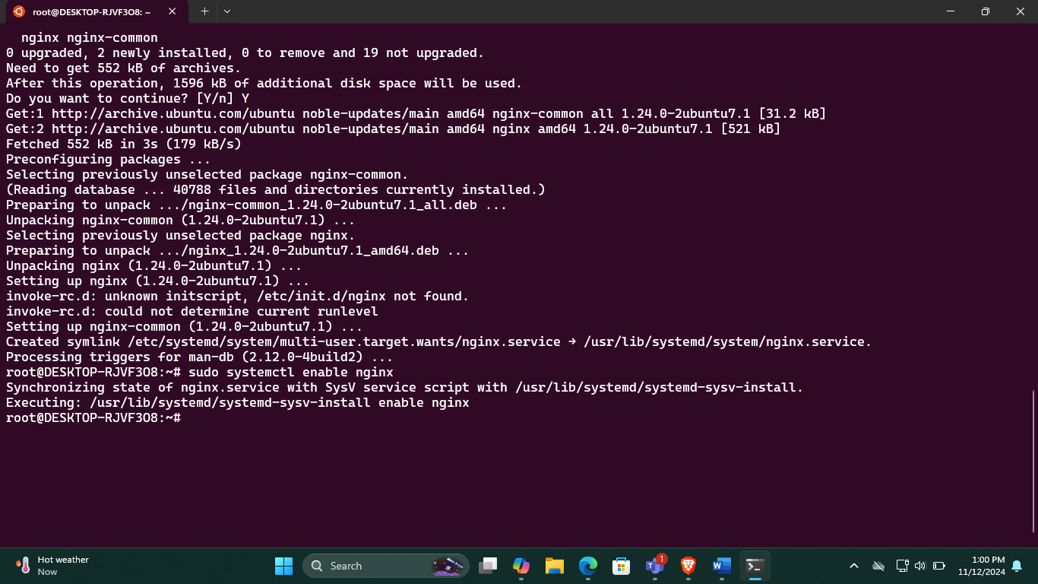

**Step :4**

Start the nginx service

Command : sudo nginx

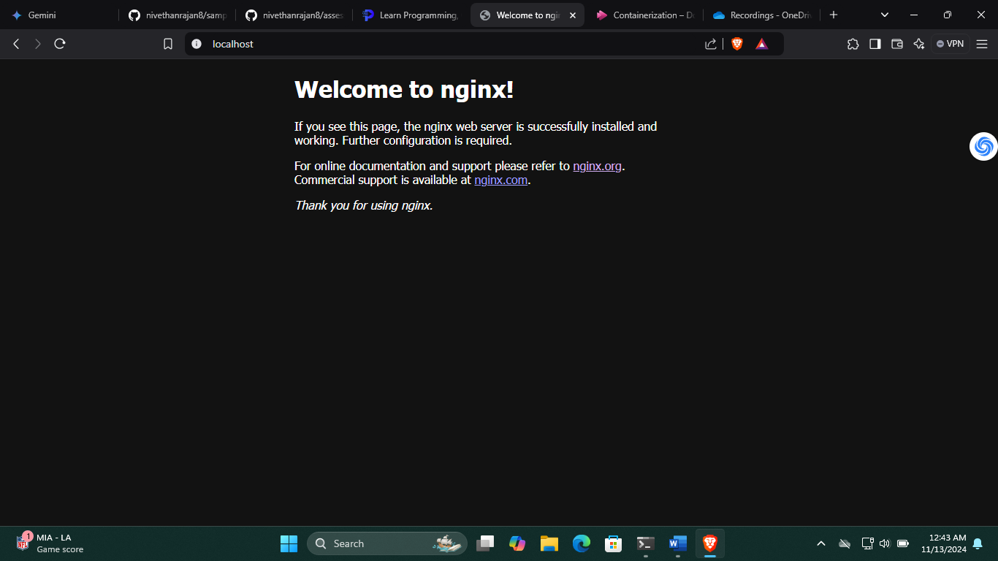

**Step :5**

Observe the nginx process

Command: ps aux | grep nginx

It checks the running process

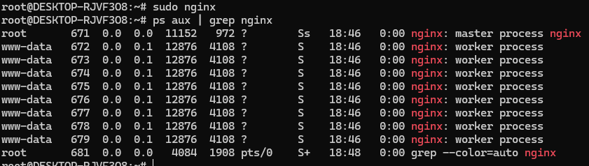

**Step :6**

Check the port used by nginx

Find out which port nginx is listenting on

Command: sudo lsof -i -P -n | grep LISTEN | grep nginx

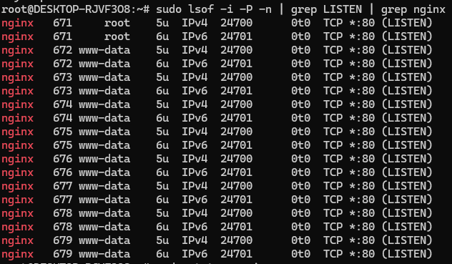

**Step :7**

Stop the nginx service

Command : sudo nginx -s stop

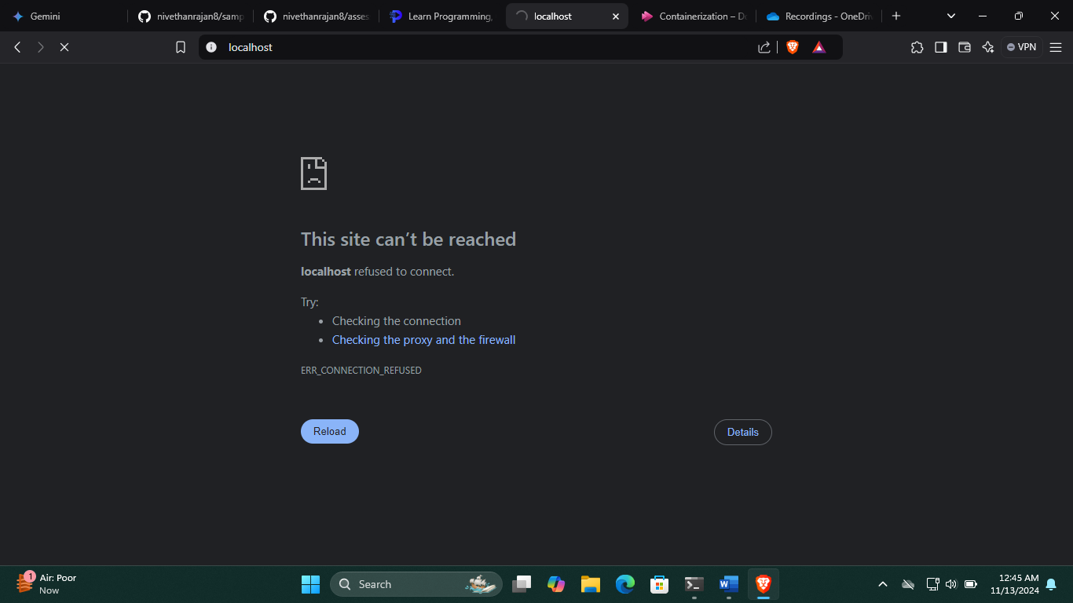

**Step :8**

Start the nginx service again

Command: sudo nginx

**Step :9**

Kill the nginx process

To manually kill ngnix process first find out the process ID (PID)

ps aux | grep nginx

pidof nginx

sudo kill -TERM <PID>

