**PROGRAM:**

#include<stdio.h>

#include<conio.h>

char *encrypt(char *plain,int key)

{

char cipher[100];

int i=0,cip,num;

while(plain[i]!='\0')

{

if((plain[i]>='A')&&(plain[i]<='Z'))

{

num=plain[i]-'A';

cip=(num+key)%26;

cip=cip+'A';

}

else if((plain[i]>='a')&&(plain[i]<='z'))

{

num=plain[i]-'a';

cip=(num+key)%26;

cip=cip+'a';

}

cipher[i]=cip;

i++;

}

cipher[i]='\0';

return cipher;}

char *decrypt(char *cipher,int key)

{

char *plain;

int i=0,cip,num;

while(cipher[i]!='\0')

{

if((cipher[i]>='A')&&(cipher[i]<='Z'))

{

num=cipher[i]-'A';

cip=(num-key)%26;

if(cip<0)

cip=cip+26;

cip=cip+'A';

}

else if((cipher[i]>='a')&&(cipher[i]<='z'))

{

num=cipher[i]-'a';

cip=(num-key)%26;

if(cip<0)

cip=cip+26;

cip=cip+'a';

}

plain[i]=cip;

i++;

}

plain[i]='\0';

return plain;

}

int main()

{

char message[100];

int key;

clrscr();

printf("Enter the plain text (only letters) : ");

scanf("%s",message);

printf("Enter the key to create cipher text (0-25) :");

scanf("%d",&key);

printf("\nThe encrypted message = %s",encrypt(message,key));

printf("\nThe decrypted message = %s",decrypt(encrypt(message,key),key));

getch();

return 0;

}

**OUTPUT:**

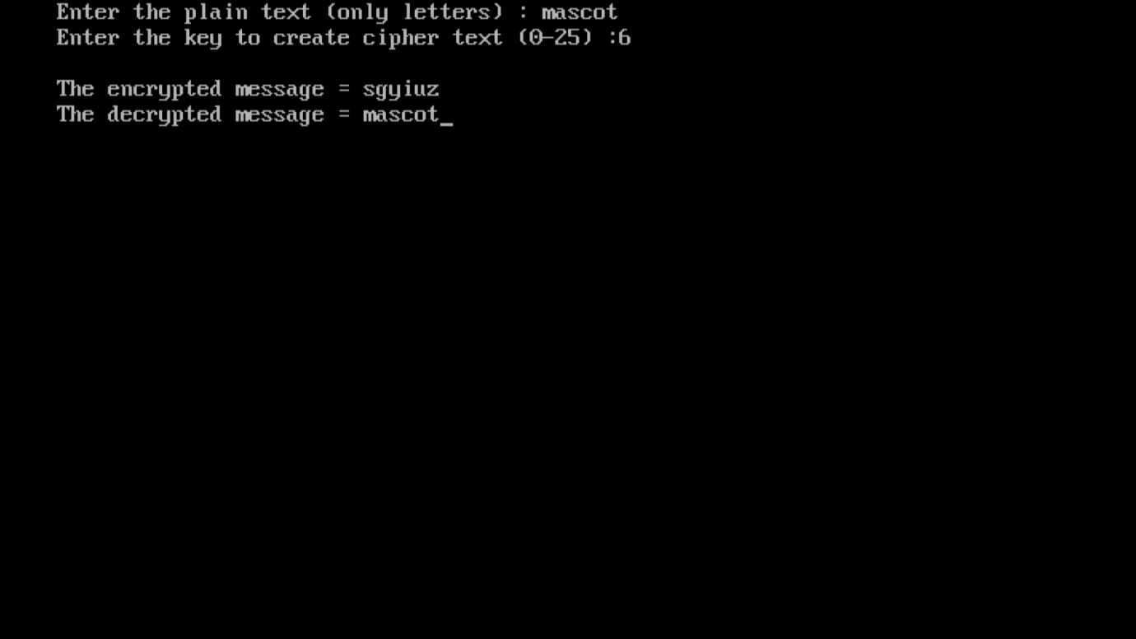

**PROGRAM:**

#include<stdio.h>

#include<conio.h>

#include<stdlib.h>

#include<string.h>

char mat[5][6],message[100],key[10],two[20][3],cipher[100];

int size;

void keygen()

{

int i=0,j=-1,l,dup=0,k;

char alp='a';

for(k=0;key[k]!='\0';k++)

{

dup=0;

for(l=k-1;l>=0;l--)

{

if(key[k]==key[l])

{

dup=1;

break;

}

}

if(dup==0)

{

if(j>=4)

{

i++;

j=0;

}

else

j++;

mat[i][j]=key[k];

}

}

while(alp!=123)

{

dup=0;

for(l=0;key[l]!='\0';l++)

{

if((alp==key[l])||(alp=='j'))

{

dup=1;

alp++;

break;

}

}

if(dup==0)

{

if(j>=4)

{

i++;

j=0;

}

else

j++;

mat[i][j]=alp++;

}

}

for(i=0;i<5;i++)

{

for(j=0;j<5;j++)

printf("%c\t",mat[i][j]);

printf("\n");

}

}

void split()

{

int i,len,k=0;

len=strlen(message);

for(i=0;i<len;i=i+2)

{

if(message[i]!=message[i+1])

{

two[k][0]=message[i];

if(message[i+1]=='\0')

two[k][1]='x';

else

two[k][1]=message[i+1];

}

else

{

two[k][0]=message[i];

two[k][1]='x';

i--;

}

two[k][2]='\0';

k++;

}

size=k;

for(i=0;i<size;i++)

printf("\nsplit=%s",two[i]);

}

void encrypt()

{

int i,j,k,m,n,temp1,temp2,x=0,o,p;

for(k=0;k<size;k++)

{

for(i=0;i<5;i++)

for(j=0;j<5;j++)

{

if(two[k][0]==mat[i][j])

{

for(m=0;m<5;m++)

{

if(two[k][1]==mat[i][m])

{

n=(j+1)%5;

cipher[x++]=mat[i][n];

n=(m+1)%5;

cipher[x++]=mat[i][n];

break;

}

else if(two[k][1]==mat[m][j])

{

n=(i+1)%5;

cipher[x++]=mat[n][j];

n=(m+1)%5;

cipher[x++]=mat[n][j];

break;

}

else

{

for(temp2=0;temp2<5;temp2++)

if(two[k][1]==mat[m][temp2])

{

cipher[x++]=mat[i][temp2];

cipher[x++]=mat[m][j];

break;

}

}

}

}

}

}

cipher[x]='\0';

printf("\nCipher= %s",cipher);

}

int main()

{

clrscr();

printf("\nEnter the message in small case letter ");

scanf("%s",message);

printf("\nEnter the key in small case letter");

scanf("%s",key);

keygen(key);

split();

encrypt();

getch();

return 0;

}

**OUTPUT:**

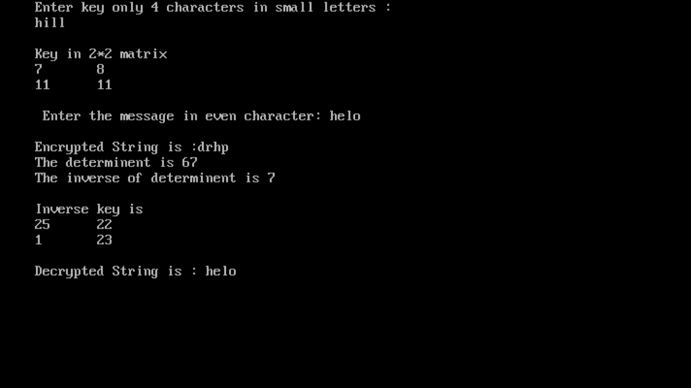

**PROGRAM:**

#include<stdio.h>

#include<math.h>

#include<string.h>

char message[20],key[10],encrypt[20],decrypt[20];

int ke[2][2],sp[10][2],e[10][2],length;

int in[2][2],adj[2][2],d[10][2],esp[10][2];

void encryption();

void decryption();

void getKeyMessage();

void inverse();

void splitmessage();

void splitcipher();

void main()

{

clrscr();

getKeyMessage();

encryption();

inverse();

getch();

}

void encryption()

{

int i=0,j,k;

splitmessage();

for(i=0;i<length;i++)

for(j=0;j<2;j++)

e[i][j]=0;

for(i=0;i<length;i++)

for(j=0;j<2;j++)

{

for(k=0;k<2;k++)

e[i][j]=e[i][j]+ke[j][k]*sp[i][k];

e[i][j]=e[i][j]%26;

}

printf("\nEncrypted String is :");

k=0;

for(i=0;i<length;i++)

for(j=0;j<2;j++)

encrypt[k++]=e[i][j]+97;

encrypt[k]='\0';

printf("%s",encrypt);

}

void decryption()

{

int i=0,j,k;

splitcipher();

for(i=0;i<length;i++)

for(j=0;j<2;j++)

d[i][j]=0;

for(i=0;i<length;i++)

for(j=0;j<2;j++)

{

for(k=0;k<2;k++)

d[i][j]=d[i][j]+in[j][k]*esp[i][k];

d[i][j]=d[i][j]%26;

}

printf("\nDecrypted String is : ");

k=0;

for(i=0;i<length;i++)

for(j=0;j<2;j++)

decrypt[k++]=d[i][j]+97;

encrypt[k]='\0';

printf("%s",decrypt);

}

void getKeyMessage()

{

int i,j=0,k=0;

printf("Enter key only 4 characters in small letters : \n");

scanf("%s",key);

for(i=0;i<2;i++)

for(j=0;j<2;j++)

ke[i][j]=key[k++]-97;

printf("\nKey in 2*2 matrix \n");

for(i=0;i<2;i++)

{

for(j=0;j<2;j++)

printf("%d\t",ke[i][j]);

printf("\n");

}

printf("\n Enter the message in even character: ");

scanf("%s",message);

}

void splitmessage()

{

int i=0,k=0,j=0;

while(message[i]!='\0')

{

sp[j][k]=message[i++]-97;

k=(k+1)%2;

if(k==0)

j++;

}

length=j;

}

void splitcipher()

{

int i=0,j=0,k=0;

while(encrypt[i]!='\0')

{

esp[j][k]=encrypt[i++]-97;

k=(k+1)%2;

if(k==0)

j++;

}

}

void inverse()

{

int i,j,k,det,idet=0;

det=((ke[0][0]*ke[1][1])-(ke[0][1]*ke[1][0])%26);

if(det==0)

{

printf("Determinent cannot be ZERO");

}

else

{

if(det<0)

det=det+26;

printf("\nThe determinent is %d\t",det);

adj[0][0]=ke[1][1];

adj[1][1]=ke[0][0];

adj[0][1]=-ke[0][1]+26;

adj[1][0]=-ke[1][0]+26;

for(i=1;i<26;i++)

if(((det*i)%26)==1)

{

idet=i;

printf("\nThe inverse of determinent is %d\n",idet);

break;

}

if(idet==0)

printf("SORRY, Inverse is not possible");

else

{

printf("\nInverse key is \n");

for(i=0;i<2;i++)

{

for(j=0;j<2;j++)

{

in[i][j]=(adj[i][j]*idet)%26;

printf("%d\t",in[i][j]);

}

printf("\n");

}

decryption();

}

}

}

**OUTPUT:**

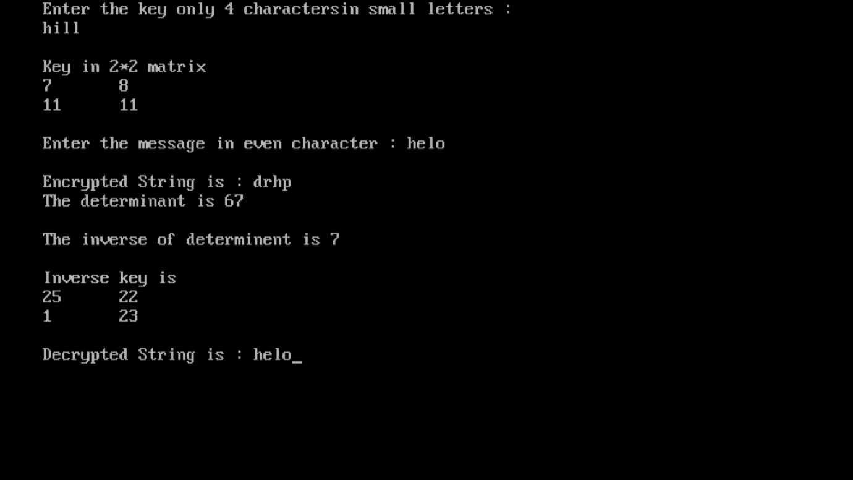

**PROGRAM:**

#include<stdio.h>

#include<conio.h>

#include<string.h>

char message[100],k[20],key[100],plain[100],cipher[20];

void genkey()

{

int i,j=0;

for(i=0;message[i]!='\0';i++)

{

if(k[j]!='\0')

key[i]=k[j++];

else

{

j=0;i--;

}

}

key[i]='\0';

printf("\nThe generated key to the length of message is %s\n",key);

}

void encryption()

{

int i=0,cip,num,k;

while(message[i]!='\0')

{

num=message[i]-'a';

k=key[i]-'a';

cip=(num+k)%26;

cip=cip+'a';

cipher[i]=cip;

i++;

}

cipher[i]='\0';

printf("\nThe encrypted message is %s",cipher);

}

void decryption()

{

int i=0,cip,num,k;

while(cipher[i]!='\0')

{

num=cipher[i]-'a';

k=key[i]-'a';

cip=(num-k)%26;

if(cip<0)

cip=cip+26;

cip=cip+'a';

plain[i]=cip;

i++;

}

plain[i]='\0';

printf("\nThe decrypted message is %s\n",plain);

}

int main()

{

clrscr();

printf("Enter the plain text (only lower case letters) ");

scanf("%s",message);

printf("Enter the key in lower case letter ");

scanf("%s",k);

genkey();

encryption(message,key);

decryption(cipher,key);

getch();

return 0;

}

**OUTPUT:**

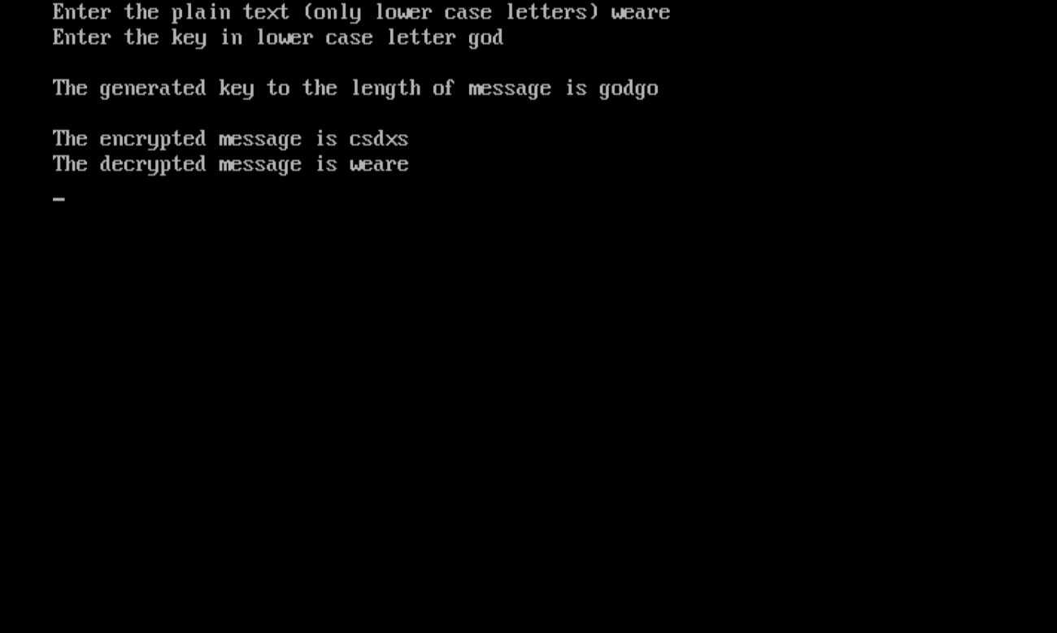

**PROGRAM:**

#include<stdio.h>

#include<conio.h>

#include<string.h>

char message[100],mes[10][100],plain[100],cipher[100];

int key;

void transpose()

{

int i=0,j=-1,k=0;

while(message[i]!='\0')

{

j++;

while(j<key)

{

if(message[i]!='\0')

mes[j++][k++]=message[i++];

else

break;

}

j--;

while(j>0)

{

if(message[i]!='\0')

mes[--j][k++]=message[i++];

else

break;

}

}

printf("\nThe transpose matrix is \n");

for(i=0;i<key;i++)

{

for(j=0;message[j]!='\0';j++)

printf("%c",mes[i][j]);

printf("\n");

}

}

void encryption()

{

int i,j,k=0;

transpose();

for(i=0;i<key;i++)

{

for(j=0;message[j]!='\0';j++)

if(mes[i][j]>='a'&&mes[i][j]<='z')

cipher[k++]=mes[i][j];

}

cipher[k]='\0';

printf("\nThe encrypted message is %s\n",cipher);

}

int main()

{

int i,j;

clrscr();

printf("Enter the plain text (onlt lower case letter): ");

scanf("%s",message);

printf("Enter the key in number ");

scanf("%d",&key);

encryption();

getch();

return 0;

}

**OUTPUT:**

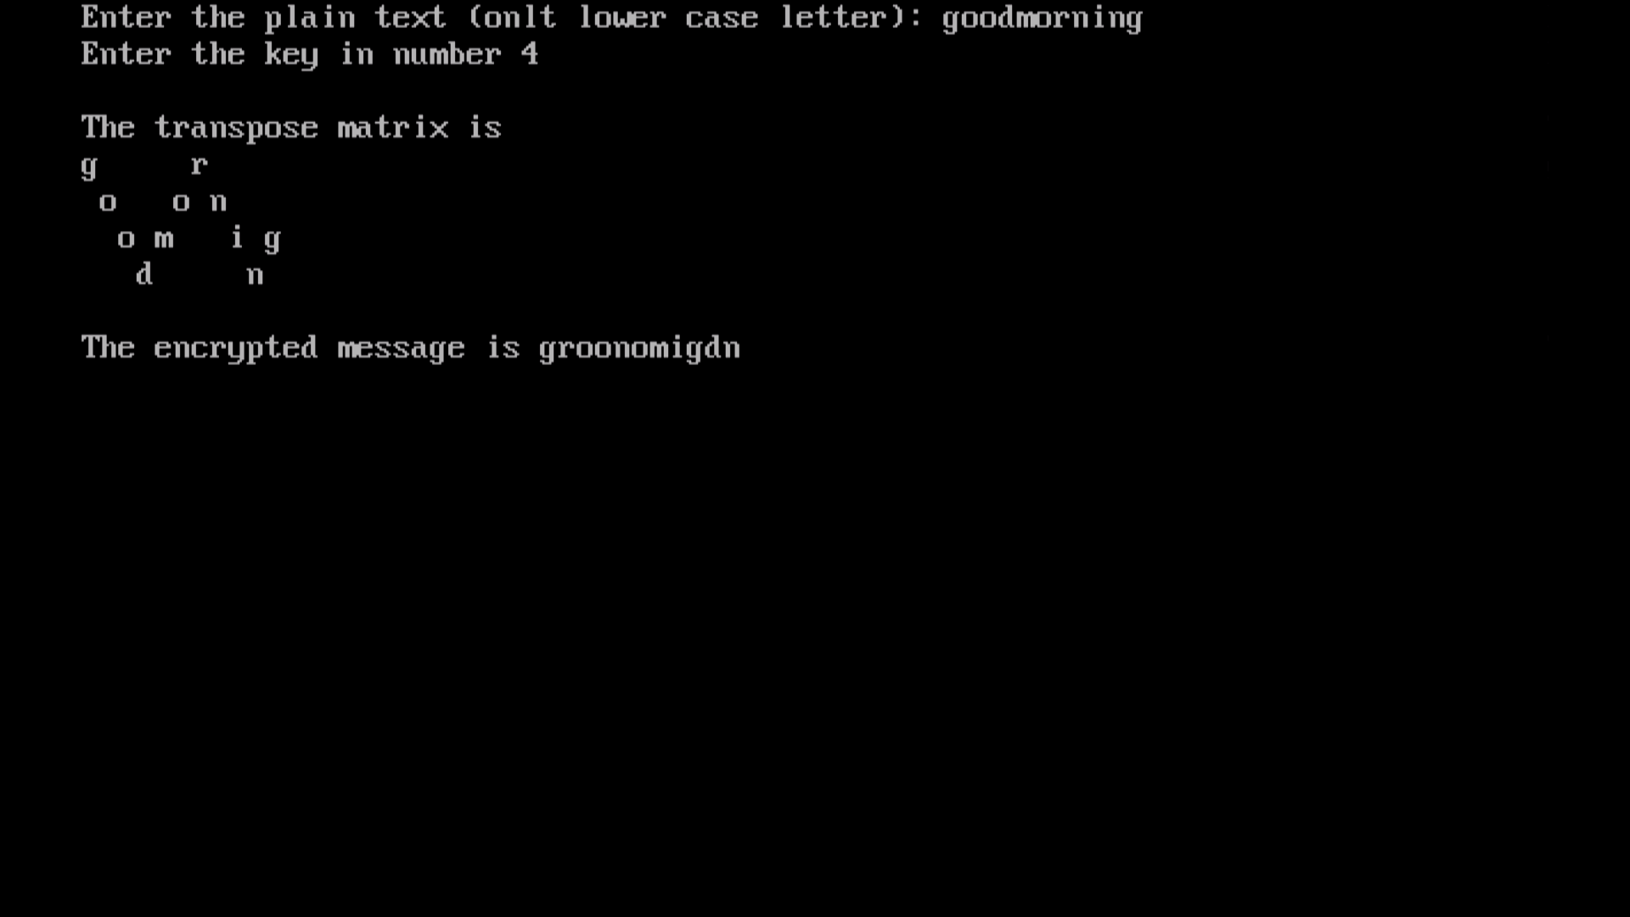

**PROGRAM:**

#include<stdio.h>

#include<conio.h>

#include<string.h>

char message[100],ke[20],mes[10][10],plain[100],cipher[20];

int key[20],length,len;

void transpose()

{

int i=0,j=0,k=0,len1;

len1=strlen(ke);

while(message[i]!='\0')

{

for(k=0;ke[k]!='\0';k++)

if(message[i]!='\0')

mes[j][k]=message[i++];

else

break;

j++;

}

j--;

while(ke[k]!='\0')

mes[j][k++]='x';

len=j+1;

printf("\nThe message in matrix format");

printf("%s",ke);

for(i=0;i<len;i++)

{

printf("\n");

for(j=0;j<len1;j++)

printf("%c\t",mes[i][j]);

}

}

void encryption()

{

int i,j,k,l;

transpose();

i=1,k=0;

for(i=1;i<=length;i++)

{

for(j=0;j<length;j++)

if(i==key[j])

break;

for(l=0;l<len;l++)

cipher[k++]=mes[l][j];

}

cipher[k]='\0';

printf("\nThe encrypted message is %s \n",cipher);

}

int main()

{

int i,j;

clrscr();

printf("Enter the plain text (only lower case letter) : ");

scanf("%s",message);

printf("Enter the key in lower case letter");

scanf("%s",ke);

for(i=0;ke[i]!='\0';i++)

{

key[i]=ke[i]-'0';

printf("\nKey[%d]=%d",i,key[i]);

}

length=i;

encryption(message,key);

getch();

return 0;

}

**OUTPUT:**

