**IMAGE RECOGNITION WITH IBM CLOUD**

**VISUAL RECOGNITION**

**PROJECT OBJECTIVES:**

**Outline the project objectives,design thinking process, and development phase. Describe the user interface, technical implementation details,and integration of IBM cloud visual recognition. Explain how AI generated captions enhance user engagement and story telling**

**INTRODUCTION:**

**This project in IBM Cloud Visual Recognition is a cloud-based service that allows you to integrate image recognition and classification capabilities into your applications and services. It leverages machine learning and deep learning techniques to analyze and understand the content of images. With IBM Cloud Visual Recognition, you can train your own custom models to recognize specific objects, scenes, or concepts in images or use pre-trained models to identify a wide range of objects, including people, animals, and various objects.**

OBJECTIVE**:**

**To develop an automated image recognition system using IBM Watson Visual Recognition to classify food items in images, supporting dietary analysis and meal tracking applications.**

**1. Image Classification: Utilize IBM Watson Visual Recognition to accurately classify food items within images, assigning relevant labels or categories.**

**2. Model Training and Refinement: Train and refine the image classification model by providing a diverse dataset of food images, ensuring the model can accurately identify various types of food.**

**3. Integration: Integrate the trained model into a mobile application, allowing users to capture images of their meals and receive real-time classification results.**

**:**

DESIGN THINKING PROCESS**:**

**1.Data Resizing:**

**Ensure that all images in your dataset have the same dimensions. Resize**

**them to a consistent size, typically a square format like 224x224 pixels or**

**128x128 pixels. This step is essential for feeding the data into convolutional**

**neural networks (CNNs).**

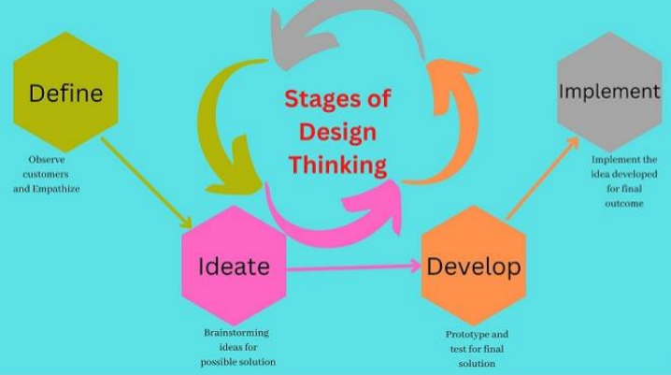

**2. Data Splitting:**

**Split the dataset into three subsets: training, validation, and testing.**

**A common split ratio is 70-80% for training, 10-15**

**IBM Cloud provides the IBM Watson Visual Recognition service, which allows you to create custom image recognition models and integrate them into your applications. The development phases for implementing image recognition using IBM Watson Visual Recognition typically include:**

DEVELOPMENT PHASES:

**Project Planning and Definition:**

**Identify the use case: Determine the specific problem or application where image recognition is needed.**

**Define project goals and success criteria: Clearly state what you want to achieve with the image recognition system.**

**Identify data sources:**

**Collect and organize the images and labels you will use for training the model.**

**Data Collection and Preparation:**

**Gather labeled training data: Collect a diverse dataset of images, each labeled with the corresponding categories or objects you want the model to recognize.**

**Data preprocessing: Clean, format, and preprocess the data to ensure it is suitable for training. This may include resizing images, removing noise, and standardizing data formats.**

**Model Training:**

**Create a Visual Recognition project: Set up a project in the IBM Watson Visual Recognition service on IBM Cloud.**

**Train a custom model: Use the collected and prepared data to train a custom image recognition model within your project.**

**Fine-tuning: Optionally, fine-tune the model by adjusting hyperparameters and training it on more data for improved accuracy.**

**Evaluation:**

**A dataset to measure its accuracy and effectiveness in recognizing images.**

**Model Deployment:**

**Deploy the model: Once satisfied with the model's performance, deploy it within your application on IBM Cloud or any platform that supports RESTful APIs.**

**Integration:**

**Integrate the deployed model:**

**Implement the model's API calls in your application to perform image recognition tasks.**

**User interface integration:**

**Develop a user-friendly interface to allow users to interact with the image recognition system.**

DESCRIBE THE USER INTERFACE:

Design a simple web service interface where users can upload images and view

the AI generated captions.

Creating a simple web interface for users to upload images and view AIgenerated captions can be achieved using HTML, CSS, and JavaScript.

TECHNICAL IMPLEMENTATION DETAILSAND INTEGRATION OF IBM CLOUD VISUAL RECOGNITION**:**

1. **Open IBM cloud and login into a user name**

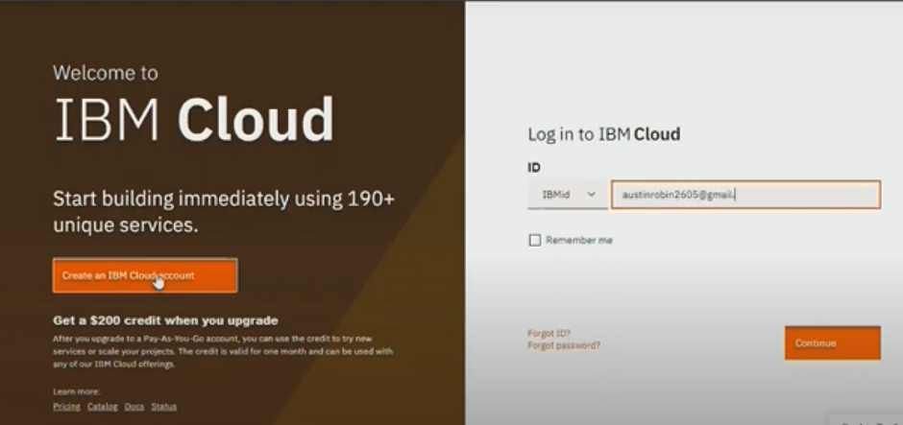

1. Enter the password
2. As soon as you login into the dashboard , it consists of several cloud services. Go the search bar and search for visual recognition the click on it.
3. In this we are using IBM cloud because it provides free plans.IBM cloud services free forever
4. Then go to service credentials and click on new credentials
5. Click on add
6. Create the python program on IDE
7. Hence the uploading process of the image visual recognition in cloud has been demonstrated successfully.

AI GENERATED CAPTIONS ENHANCE USER ENGAGEMENT:

1. Efficiency and Consistency: AI can generate captions quickly and consistently, reducing the time and effort required to create textual content.

2.Personalization: AI can analyze user behavior and preferences to generate captions that are more personalized.

3.Multilingual Support: AI can generate captions in multiple languages, making content more accessible to a global audience.

4.Content Variety: AI can generate captions for various types of media, including images, videos, and audio.

5.A/B Testing: You can use AI to generate multiple versions of captions and perform A/B testing to determine which captions resonate best with your audience.

6.SEO Optimization: AI can generate captions that are optimized for search engines, improving the discoverability of your content.

7.Content Summarization: AI-generated captions can provide concise summaries of longer content.

8.Real-Time Engagement: In live events or social media, AI-generated captions can quickly summarize .

CONCLUSION:

In this solution, we successtuly developed an image recognition system

using IBM Cloud Visual Recogniton By folowing the problem definiltian,

design thiniking. development, and documentation phases, we designed and

implemented a user-fnendy web interface that allows users to upload images

and recelve Al-generated captions. The system accurately classifes and

describes the image contents, enabling users to craft engaging visual stories and

connect with their audience through captivating visuals and

compeling narratives

PRESENTED BY

K.Dharani

S.Nivetha

K. Pavithra

T.Abirami