FRAUD DETECTION ANALYSIS
USING POWER BI DASHBOARD
A Banking Transaction Analytics Project Report
Submitted by
NIVETHA
Department: B.com (FinTech with AI)

Table of Contents
No. | Section | Page
1 | Cover Page | 1
2 | Table of Contents and Abstract | 2
3 | Introduction and Objectives | 3
4 | Dataset Description and Data Model | 4
5 | Power BI Report Link and Overview | 5
6 | KPI Page | 6
7 | Fraud and Transaction Chart Analysis | 7
8 | Interactive Dashboard Page (Slicers) | 8
9 | Tool Tip Page and Key Insights | 9
10 | Conclusion and Future Scope | 10

Abstract
This report presents an interactive fraud detection and transaction analytics dashboard developed in Microsoft Power BI as part of the FinTech with AI department curriculum. The dashboard turns banking data — accounts, transactions and fraud alerts — into clear visual insights that help analysts monitor transaction activity and spot suspicious behaviour quickly.
The report has three pages: a KPI page, an Interactive Dashboard page and a Tool Tip page. Together they show key indicators such as total accounts, total initial balance, total transactions, total transaction amount, average transaction amount and fraudulent transactions, along with fraud versus genuine comparison, transaction trend over time and alert-type analysis.
Screenshots of each report page are included in this document, together with the shareable Power BI link, so that the reader can open and interact with the live dashboard.

1. Introduction and Objectives

1.1 Introduction
Fraud is one of the biggest risks in digital banking and financial technology. Banks process millions of transactions every day, and unusual or fraudulent ones must be identified quickly to protect customers and the institution. Raw transaction data alone is hard to interpret, so it must be modelled and visualised for analysts and managers.
Microsoft Power BI is a leading business intelligence tool that connects to data sources, builds relational data models, defines calculations using DAX measures, and publishes interactive reports. This project uses Power BI to analyse banking transactions and fraud alerts, showing how analytics supports risk monitoring in FinTech.

1.2 Objectives of the Project
- Import and model data from the accounts, transactions and alerts tables.
- Create DAX measures for total accounts, transactions, amounts and fraudulent transactions.
- Compare fraudulent and genuine transactions using bar, column and donut charts.
- Show the transaction trend over time using a line chart.
- Analyse the number of alerts raised by each alert type.
- Add slicers for fraud status and alert type, and a tool tip page for quick context.
- Publish the report and share it through a Power BI link.

1.3 Scope
The scope covers data modelling, measure creation, visual design and report publishing, with a focus on fraud monitoring, transaction value and alert analysis.

1.4 Tools Used
Tool | Purpose
Microsoft Power BI Desktop | Data modelling, DAX measures and report design
Power BI Service | Publishing and sharing the report through a link
Microsoft Word | Preparing this project report

2. Dataset Description and Data Model
The dashboard is built on a relational banking dataset with three connected tables. Relationships between them allow every measure to be analysed by fraud status, time and alert type.

2.1 Tables Used
Table | Description
accounts | Bank account details including initial balance and fraud flag; used for account counts and balances.
transactions | Individual transactions with timestamp and fraud indicator (IS_FRAUD); used for trend and fraud analysis.
alerts | Fraud alerts with alert ID and alert type; used for alert-type analysis.

2.2 DAX Measures Created
Measure | Meaning
Total Accounts | Number of bank accounts
Total initial Balance | Sum of opening balances of all accounts
Total Transaction | Total number of transactions
Total Transaction Amount | Total value of all transactions
Average Transaction Amount | Average value per transaction
Fraudulent Transaction | Number of transactions flagged as fraud

3. Power BI Report Link and Overview
The complete interactive report has been published to the Power BI Service. The reader can open the link below to explore all pages, apply slicers and hover over visuals for tool tips.
Power BI Report Link
[PASTE YOUR POWER BI REPORT LINK HERE]

3.1 Report Pages
No. | Page Name | Content
1 | KPI | Six KPI cards, alerts by type, fraud comparison charts and transaction trend
2 | INTERACTIVE DASHBOARD | Full dashboard with KPI cards, charts and two slicers
3 | TOOL TIP | Hover page showing total transactions, amount and fraudulent transactions

4. KPI Page
The first report page gives a one-glance summary of banking activity. Six KPI cards across the top show headline numbers, while the charts below break down alerts, fraud and transactions.

4.1 KPI Cards
- Cards: Average Transaction Amount, Total Transaction, Total Transaction Amount, Fraudulent Transaction, Total Accounts and Total initial Balance.
- Charts: Number of alerts by alert type; transaction amount by fraud status; transaction trend over time; share of fraud versus genuine transactions.
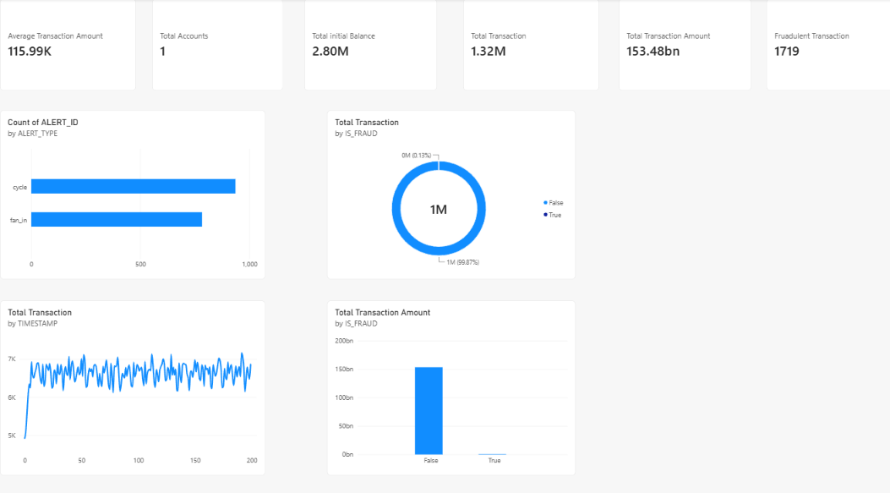

4.2 Observations
Write 2–3 lines here on the total transactions, the fraudulent transaction count and the average transaction amount, based on your dashboard values.

5. Fraud and Transaction Chart Analysis
This section looks at each chart in detail. Together they show how much of the transaction activity is fraudulent, how transactions change over time, and which types of alerts are raised most often.

5.1 Charts Used
- Clustered Bar Chart (Alerts by Type): Count of alerts for each alert type, showing the most common alert.
- Clustered Column Chart: Total transaction amount split by fraud and genuine transactions.
- Line Chart (Transaction Trend): Total transactions over time, showing peaks and unusual spikes.
- Donut Chart: Percentage share of fraudulent versus genuine transactions
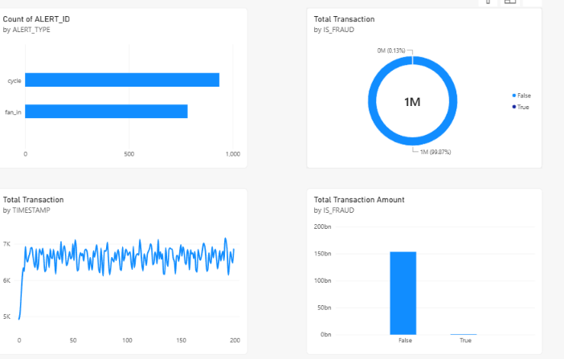

5.2 Observations
Write 2–3 lines here on the percentage of fraud, the most common alert type and any spike in the transaction trend.

6. Interactive Dashboard Page
The Interactive Dashboard combines all KPIs and charts on one canvas and adds slicers. Selecting a value in a slicer instantly updates every visual on the page, letting analysts focus on fraud cases or on a specific alert type.

6.1 Slicers and Interactivity
Slicer | Function
IS_FRAUD | Filters the dashboard to fraudulent or genuine transactions
ALERT_TYPE | Filters the dashboard to a selected alert type

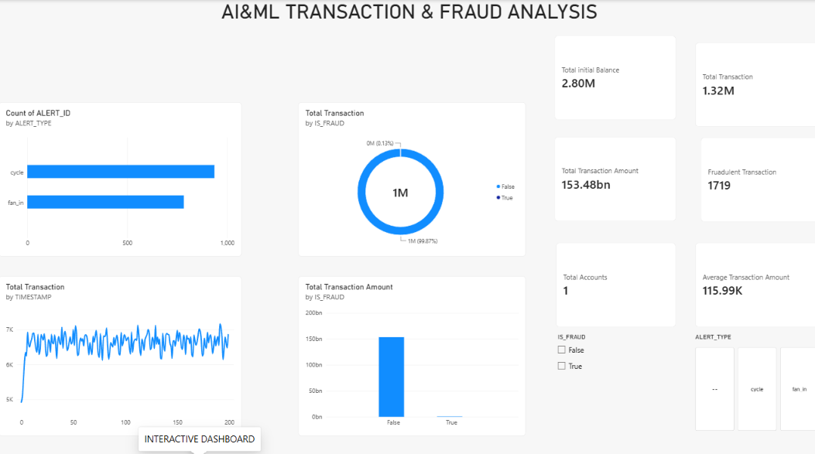

6.2 Observations
Write 2–3 lines here describing how the numbers change when you select fraud = true or a particular alert type.

7. Tool Tip Page and Key Insights
A tool tip page is a small hidden report page that appears when the user hovers over a visual. This report's tool tip page shows three cards — Total Transaction, Total Transaction Amount and Fraudulent Transaction — giving extra context without cluttering the main dashboard.

7.1 Screenshot
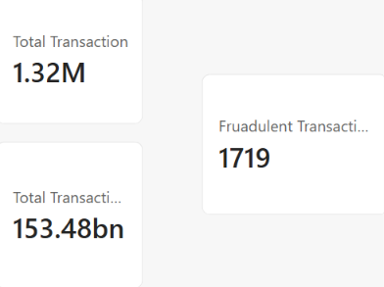

7.2 Screenshot of Tool Tip in Action
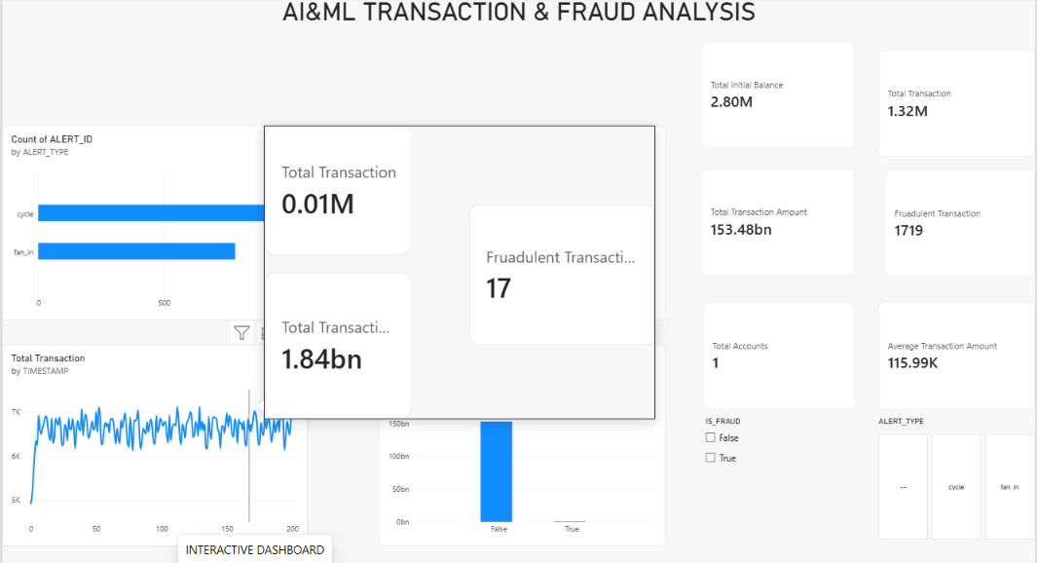

7.3 Key Insights
- The fraud share of transactions shows the overall risk level at a glance.
- Alert-type analysis shows which fraud patterns are detected most often.
- The transaction trend helps spot unusual spikes that may need investigation.
- Comparing fraud and genuine amounts shows the financial impact of fraud.

8. Conclusion and Future Scope

8.1 Conclusion
The project shows how Power BI can convert banking transaction data into an interactive, easy-to-understand fraud monitoring dashboard. By combining DAX measures, suitable chart types, slicers and a tool tip page, users can move from a high-level summary to detailed fraud and alert analysis in a few clicks.
The published link allows stakeholders to explore the data on their own, making the dashboard a practical tool for fraud monitoring and risk decision-making.

8.2 Relevance to FinTech with AI
Fraud detection is one of the most important applications of AI in FinTech. Well-modelled dashboards provide the foundation on which machine-learning features such as anomaly detection, fraud scoring and automated alerts can be added, while giving analysts a clear view of what the models find.

8.3 Future Scope
- Add machine-learning fraud scores and anomaly detection to the dataset.
- Use Power BI AI visuals such as Key Influencers and Decomposition Tree.
- Connect to live transaction data with scheduled refresh.
- Add row-level security so each user sees only relevant data.
- Integrate Copilot / Q&A for natural-language questions on the data.

8.4 References
- Microsoft Power BI documentation – learn.microsoft.com/power-bi
- DAX Guide – dax.guide
— Report prepared by NIVETHA, Department of FinTech with AI —

