Power BI Task 2
Global Sales and Financial Performance
Business Insight Report for Interactive Sales Dashboard
Name | Nivetha
Course | BCom Fintech with AI
Task | Task 2 - Global Sales & Financial Performance Dashboard
GitHub Repository | https://github.com/nivethasenthilvel/power-bi- (NIVETHA_DATASET_2.pbix)

Executive Summary
The dashboard reports a Total Sales figure of 14.39M, built from an Order Count of 17K and a Total Quantity of 51K, at an Average of 847.90. Total Profit is shown as 4.91M against a Total Cost of 9.47M, giving an implied profit share of about 34.1% (4.91M / 14.39M). Cost and Profit reconcile cleanly against Total Sales on these headline cards (9.47M + 4.91M ≈ 14.39M).
The Category, Region and Employee visuals, however, display noticeably larger totals (a combined 70.64M on the Region donut) than the 14.39M shown on the Total Sales card. This points to those visuals being captured under a different filter or slicer state than the KPI cards, and should be reconciled in Power BI before the category/region/employee figures are treated as final. Clothing leads the category mix, regional sales are closely balanced across all five regions, and the top employee-profit cluster sits well above the mid-tier group. [Ref: Dashboard screenshots supplied by Nivetha]

1. Dashboard Overview & Headline KPIs
The dashboard combines KPI cards, a monthly sales trend, employee profit comparison, category sales and regional sales into a single view of scale, mix and operating performance.
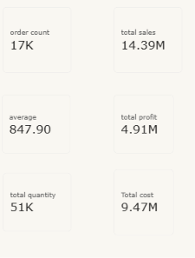
Figure 1: Headline KPI Cards (Order Count 17K, Total Sales 14.39M, Average 847.90, Total Profit 4.91M, Total Quantity 51K, Total Cost 9.47M).

KPI and Financial Performance Analysis
KPI | Visible Value | Interpretation
Average | 847.90 | Average sale value; interpret against the dashboard's measure definition
Order Count | 17K | Transaction volume for the current filter context
Total Sales | 14.39M | Principal revenue figure on the headline card
Total Cost | 9.47M | Cost base; consistent with Sales minus Profit on rounded figures
Total Profit | 4.91M | Approx. 34.1% of Total Sales (4.91 / 14.39)
Total Quantity | 51K | Volume base behind the sales total
Financial Reading: 9.47M (Cost) + 4.91M (Profit) ≈ 14.39M (Sales). This makes the sales-cost-profit relationship internally consistent on the headline cards. The implied profit share of ~34.1% is a useful baseline, not a substitute for margin analysis by product, region or customer.

2. Sales Mix and Trend Interpretation
Chart views reveal differences in concentration and balance not visible from the KPI cards alone.

Category Performance
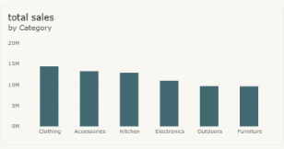
Figure 2: Total Sales by Category, on a 0-20M scale. Clothing is the tallest bar (just under 15M), followed by Accessories and Kitchen (roughly 12-13M each), then Electronics (~11M), with Outdoors and Furniture the smallest (~9-10M each).
Business Implication: Clothing is the primary category anchor, with Accessories and Kitchen close behind — the top three categories matter more to portfolio resilience than any single line. Action: protect availability and promotion for the leading categories while testing targeted growth plans for Electronics, Outdoors and Furniture.

Regional Performance
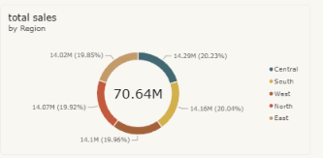
Figure 3: Total Sales by Region - 70.64M donut. Central 14.29M (20.23%), South 14.16M (20.04%), West 14.10M (19.96%), North 14.07M (19.92%), East 14.02M (19.85%). Gap of only 0.27M (0.38pp) between the highest and lowest region.
Business Implication: regional risk is low — no single market dominates. Growth will require coordinated gains across regions rather than one-region expansion. Action: set coordinated regional targets and use filters to identify each region's most profitable category mix.
Data Consistency Note: the Category and Region visuals total 70.64M, well above the 14.39M shown on the Total Sales KPI card. Since Cost + Profit reconciles cleanly to 14.39M on the cards, the mismatch most likely comes from the Category/Region/Employee visuals being captured under a different slicer or filter state than the cards. Recommend re-checking the active filters on each dashboard page in Power BI before quoting these chart-level totals in rupee/dollar terms — the percentage splits shown (e.g., each region ~20%) remain valid as relative proportions either way.

Monthly Sales Trend
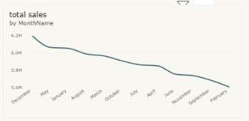
Figure 4: Total Sales by MonthName. Line declines from ~6.2M at the first label (December) to ~5.6M at the final label (February). The x-axis labels are not in calendar order (December, May, January, August, March, October, July, June, April, November, September, February appear consecutively).
Recommendation: this chart should not be used to assert seasonality or a time trend until the MonthName sort order is corrected/validated using a month-number column in Power BI.

3. Employee Performance
The employee profit chart supplies actionable detail behind the headline totals.
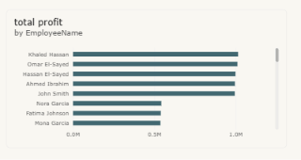
Figure 5: Total Profit by EmployeeName. Leading cluster near 1.0M each for Khaled Hassan, Omar El-Sayed, Hassan El-Sayed, Ahmed Ibrahim and John Smith. A second, lower cluster near 0.4-0.5M covers Nora Garcia, Fatima Johnson and Mona Garcia. The chart is scrollable, so this is the visible portion rather than a complete ranking.
Observation: the top cluster alone (roughly five employees near 1.0M each) would exceed the 4.91M Total Profit KPI if read literally, reinforcing the Data Consistency Note above — this view likely reflects a broader or differently filtered period than the headline cards. Taken as relative standing rather than absolute values, there is a clear gap between the leading and mid-tier employees that is worth reviewing for territory, account allocation and sales-support practices.
Note: a product-level table (individual ProductName / Total Sales / Total Quantity / Total Profit rows) was not included in the screenshots supplied for this dataset. It can be added to this report once that view is shared.

4. Business Insights and Recommendations
Observation | Business Implication | Recommended Action
Sales 14.39M and profit 4.91M, implying ~34.1% profit share | Healthy contribution, but 9.47M cost base remains material | Track sales, cost and profit together in every filtered view; add a profit-share KPI by category/region
Clothing leads category sales, with Accessories and Kitchen also large | Revenue partly concentrated in top categories | Protect availability/promotion for leading categories; test targeted growth for Electronics, Outdoors, Furniture
Each region contributes roughly one-fifth of sales | Regional risk is low; no single market can drive growth alone | Set coordinated regional targets; use filters to find each region's most profitable mix
Category/Region/Employee visuals total well above the Total Sales KPI card | Chart-level and card-level figures are not currently reconciled | Confirm slicer/filter state on every dashboard page before reporting chart totals as final
MonthName axis is not in calendar order | Line chart not yet reliable for a seasonal/trend read | Correct the month sort column before forecasting or setting monthly targets
Visible employee profit bars form a high and a mid-tier cluster | Performance practices may not be evenly shared | Compare leading vs mid-tier employees after applying common filters; use for coaching and account balancing

Conclusion
The dashboard shows a business generating 14.39M in sales and 4.91M in profit on the headline cards, with broadly balanced regional shares and a clear leading category in Clothing. Before drawing further conclusions, the next priority is reconciling the Category, Region and Employee visuals against the KPI cards (they currently show materially larger totals) and correcting the month-order issue on the trend chart. Once the filter context is aligned across dashboard pages, the same interactive filters can be used to pinpoint high-profit mixes, replicate high-performer practices and plan with a corrected monthly view.

Appendix: Data Notes, Tools and Links
- Power BI Desktop (.pbix) - NIVETHA_DATASET_2.pbix in https://github.com/nivethasenthilvel/power-bi-
- All figures transcribed from five supplied dashboard screenshots: headline KPI cards, category chart, region donut, monthly trend and employee profit chart.
- Product-level table not included in the screenshots supplied for this dataset.
- No unshown customer, date, order or category-level data assumed. Employee chart is scrollable and not treated as a full ranking.
- Calculation: Implied profit share = Total Profit / Total Sales = 4.91M / 14.39M ≈ 34.1%.
- Observed: Category, Region and Employee visuals show a combined total (70.64M) inconsistent with the Total Sales KPI card (14.39M); recommend confirming filter context in Power BI before final submission.
Prepared by: Nivetha | BCom Fintech with AI | Power BI Task 2 - Global Sales and Financial Performance | Date: September 2026

