POWER BI PROJECT REPORT
Sales Analytics Dashboard
Sales, Customer and Product Performance Analysis using Microsoft Power BI
Detail | Information
Prepared by | NIVETHA
Department | FinTech with AI
Dataset / File | NIVETHA_DATASET_3.pbix
Tool Used | Microsoft Power BI
Report Month | October 2026

Table of Contents
No. | Section | Page
1 | Cover Page | 1
2 | Table of Contents and Abstract | 2
3 | Introduction and Objectives | 3
4 | Dataset and Data Model | 4
5 | Report Structure and Key Measures | 5
6 | Sales Overview: KPI Cards | 6
7 | Sales Overview: Trends and Rankings | 7
8 | Product and Customer Analysis | 8
9 | Sales Dashboard and Tooltip Page | 9
10 | Power BI Link, Conclusion and Future Scope | 10

Abstract
This report documents an interactive sales analytics dashboard built in Microsoft Power BI by Nivetha of the FinTech with AI department. The dashboard brings together customer, order, product, category and employee data into a single data model and presents it through four report pages: Sales Overviews, Product and Customer Analysis, Sales Dashboard and a Tool Tip page.
Key measures such as Total Sales, Total Orders, Total Quantity Sold, Total Freight, Average Freight and Number of Customers are shown as KPI cards, while line, column and bar charts reveal monthly trends, category performance, employee performance and customer distribution by country. Slicers for year, country and category let the reader filter every visual instantly. Screenshots of each page and the published report link are included in this document.

1. Introduction and Objectives

1.1 Background
Modern finance and technology teams depend on data to understand how a business is performing. Raw tables of orders and customers are difficult to read, so business intelligence tools such as Power BI are used to turn them into visual, interactive dashboards. This project applies those techniques to a sales dataset to answer practical questions about revenue, order volume, shipping cost, products and customers.

1.2 Objectives
- Model: Build a clean data model linking customers, orders, products, categories and employees.
- Measure: Create DAX measures for sales, orders, quantity, freight and customer count.
- Trend: Track order trends over time using a monthly line chart.
- Compare: Compare sales across product categories and orders across employees.
- Discover: Identify the products and countries that contribute most to the business.
- Interact: Provide slicers so users can filter the dashboard by year, country and category.

1.3 Scope and Tools
The scope covers data loading, modelling, measure creation, visual design and publishing. Microsoft Power BI Desktop was used for development, DAX for calculations, and the Power BI Service for publishing and sharing the report through a link. The Frontier theme was applied to give the report a consistent look.

1.4 Why This Matters for FinTech with AI
Sales and shipping data of this kind is the foundation for financial forecasting, risk analysis and AI-driven decision support. A well-structured dashboard is the first step before applying machine learning models for demand prediction or customer segmentation.

2. Dataset and Data Model
The report file NIVETHA_DATASET_3 uses five related tables. The table below lists each table and the fields used in the visuals.
Table | Fields used in report | Purpose
customers | country; all calculated measures | Customer location and the home table for measures
orders | orderDate (Year, Month hierarchy) | Time analysis of orders
products | productName | Product-level sales detail
categories | categoryName | Grouping products by category
employees | employeeName | Orders handled per employee

Data Model View
The screenshot below shows the relationships between the tables in the Model view of Power BI Desktop.
[ INSERT SCREEN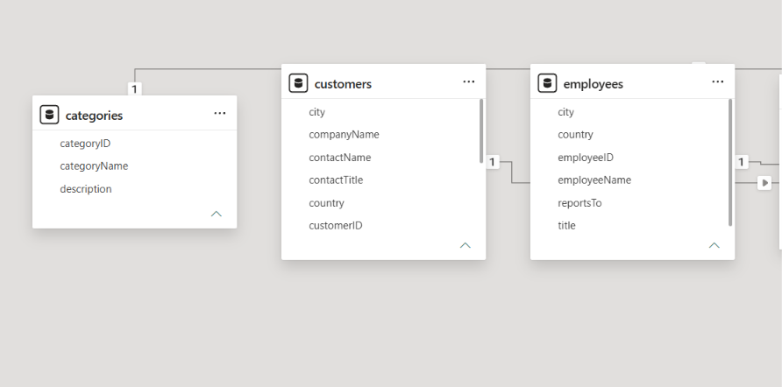SHOT HERE ]
Topic: Data Model / Relationships View
(Click here, delete this text, then Insert > Pictures)
Figure 1: Data model showing table relationships

3. Report Structure and Key Measures

3.1 Report Pages
No. | Page name | Visuals | Content
1 | SALES OVERVIEWS | 9 | 6 KPI cards, monthly order trend, sales by category, orders by employee
2 | PRODUCT AND CUSTOMER ANALYSIS | 2 | Product table with sales and quantity, customers by country
3 | SALES DASHBOARD | 14 | KPI cards, three charts, two text boxes and three slicers
4 | TOOL TIP | 3 | Hover card showing total orders, total sales and quantity sold

3.2 Key Measures
Measure | What it tells us
Total Sales | Overall revenue generated from all orders
Total Order | Number of orders placed
Total Quantity Sold | Total units of products sold
Total Freight | Total shipping cost across all orders
Average Freight | Average shipping cost per order
Number of Customers | Count of distinct customers

3.3 Visual Types Used
The report uses card visuals for headline numbers, a line chart for the time trend, clustered column and clustered bar charts for comparisons, a table for product detail, and slicers for filtering. This mix keeps the dashboard easy to read at a glance while still allowing detailed exploration.

4. Sales Overview: KPI Cards
The first page, SALES OVERVIEWS, opens with a row of six KPI cards. These give the reader the most important business numbers immediately: Average Freight, Total Order, Total Freight, Number of Customers, Total Sales and Total Quantity Sold.
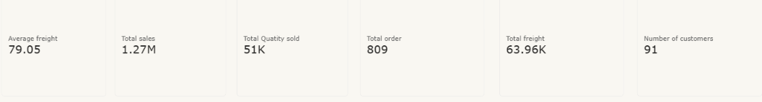
Figure 2: KPI cards on the Sales Overviews page

Interpretation
- Revenue: Total Sales and Total Quantity Sold show the revenue and volume achieved.
- Cost: Total Freight and Average Freight indicate how much is spent on shipping and whether shipping cost per order is under control.
- Activity: Total Order and Number of Customers show the size of the customer base and how actively it orders.

5. Sales Overview: Trends and Rankings
Below the KPI cards, three charts explain where the numbers come from.
- Monthly order trend: A line chart plots Total Order against the month from the date hierarchy, showing how order activity rises and falls over time.
- Sales by category: A clustered column chart compares Total Sales for each product category to show the strongest and weakest categories.
- Orders by employee: A clustered bar chart ranks employees by Total Order, showing workload and performance.

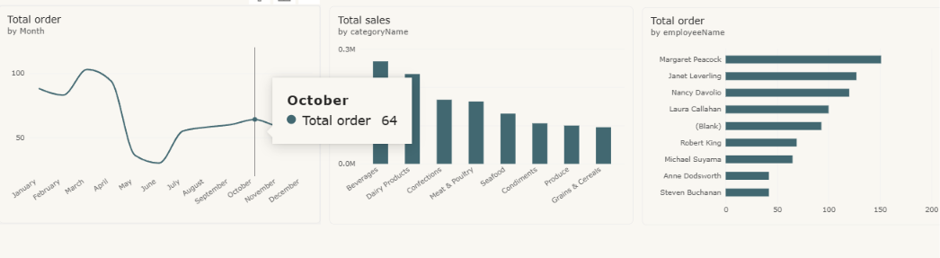
Figure 3: Order trend, sales by category and orders by employee

Interpretation
Peaks in the monthly line chart point to busy periods that need stock and staffing support, while low months may call for promotions. The category chart helps decide which product groups to prioritise, and the employee ranking supports fair target-setting.

6. Product and Customer Analysis
The second page, PRODUCT AND CUSTOMER ANALYSIS, has two visuals. A table lists each product name with its category, Total Sales and Total Quantity Sold, which makes it easy to spot best-selling products and compare value against volume. A clustered bar chart shows the Number of Customers for each country, revealing the geographic spread of the customer base.
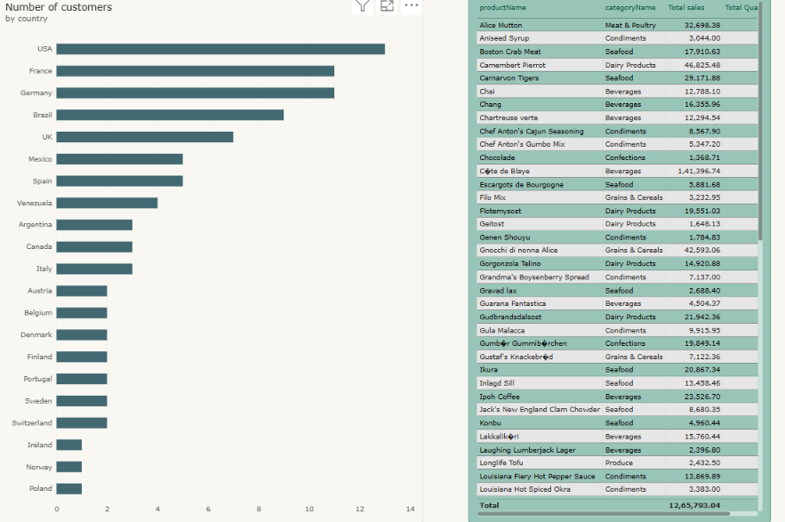
Figure 4: Product table and customers by country

Interpretation
- Products: Products with high sales but low quantity are high-value items; the reverse indicates low-priced, high-volume items.
- Countries: Countries with the most customers are the main markets; those with few customers are growth opportunities.

7. Sales Dashboard and Tool Tip Page

7.1 Sales Dashboard
The SALES DASHBOARD page combines the KPI cards and the three charts on one screen and adds three slicers: Year, Country and Category. Selecting any slicer value instantly updates every visual, allowing the reader to explore the data without any technical knowledge.
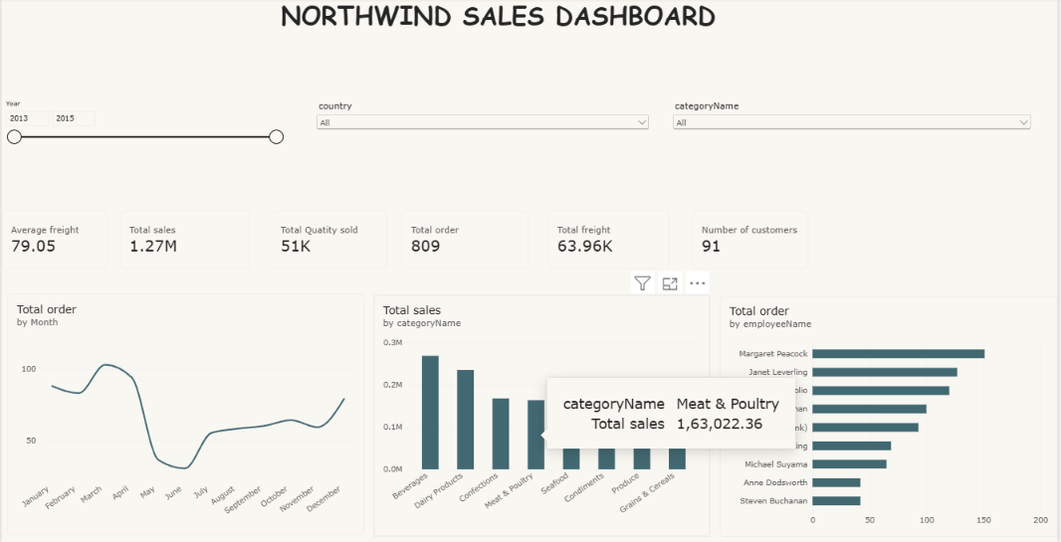
Figure 5: Complete Sales Dashboard

7.2 Tool Tip Page
The TOOL TIP page is a small custom page that appears when the reader hovers over a chart. It shows Total Order, Total Sales and Total Quantity Sold for the hovered item, giving extra detail without crowding the main page. 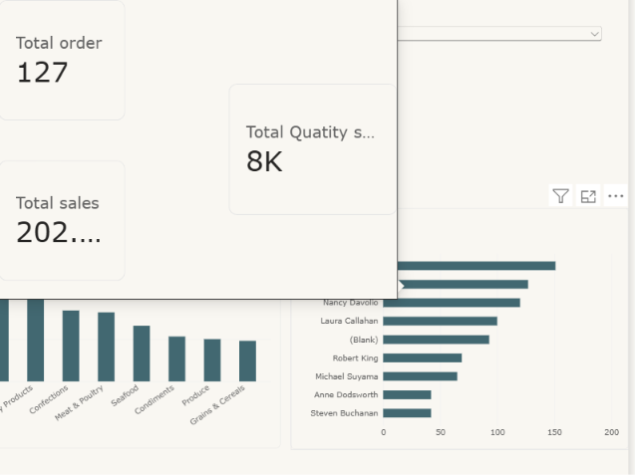

8. Power BI Link, Conclusion and Future Scope

8.1 Conclusion
The dashboard successfully turns customer, order and product data into a clear, interactive view of business performance. KPI cards give instant headline numbers, charts explain trends and rankings, and slicers let users drill into any year, country or category. The project demonstrates data modelling, DAX measures and visual design skills in Power BI.

8.2 Future Scope
- Forecasting: Add forecasting to predict future sales and orders using AI visuals.
- Segmentation: Group customers by value and behaviour using machine learning.
- Live data: Connect to a live database so the report refreshes automatically.
Prepared by Nivetha | Department: FinTech with AI

