Spendwise
Project overview:
SpendWise is a comprehensive, AI-powered financial management platform designed to help users, particularly students and individuals, track expenses, manage budgets, and optimize spending habits. It feastures real-time expense logging, AI-driven insights, receipt scanning, and budget tracking via web or mobile, fostering financial awareness and control.
Key objectives:
- Automated Expense Tracking & Categorization
- Financial Empowerment & Literacy
- Goal-Driven Budgeting
- Privacy-First & Secure Financial Management
- Tailored User Support
Target users:
- Individuals & Households
- Budget-Conscious Professionals
- Students
- Privacy-Focused Users
- Small Business Users
Project instruction:
- SpendWise is a backend-only project built using Node.js and Express.
Quick Start:
- npm install
- npm init
- npm run dev
steps to create the project:
- Choose or create a directory for the backend project.
- Open terminal and navigate to that directory.
- Initialize Node.js project using npm init.
- Install required packages: express, mongoose, jsonwebtoken, bcrypt, cors, dotenv.
- Create folders: models, routes, controllers, middleware, config.
- Start the server using npm run dev.
- Test APIs using Postman or Thunder Client at http://localhost:5000.
Pre-requisites:
Software Requirements
Software | Purpose
Node.js | JavaScript runtime for backend
MongoDB | NoSQL database for data storage
npm | Package manager
Git | Version control system
Code Editor | VS Code or similar
Knowledge Requirements:
- JavaScript ES6+
- Node.js and Express.js
- MongoDB and Mongoose
- JWT authentication
- Basic REST API concepts
Thumbnail for Project:
- A simple backend project thumbnail representing:
Node.js + Express + MongoDB + JWT + CRUD APIs
Project Architecture Image:

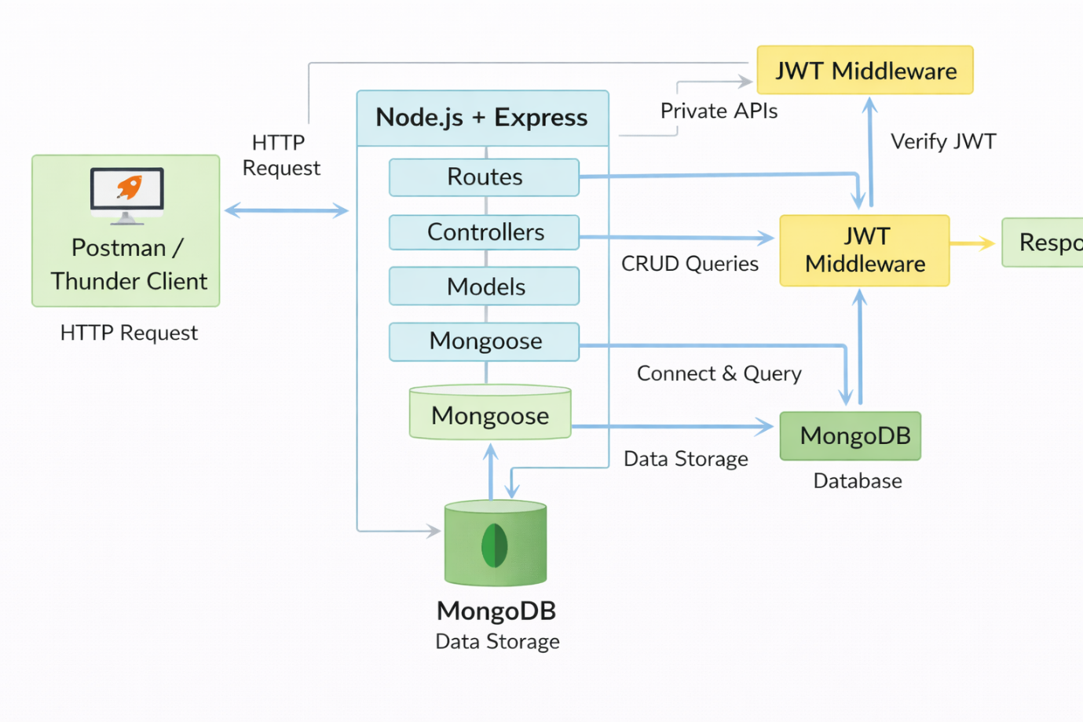

Technical Architecture:
Backend Architecture (Node.js + Express)
- Controllers: Handle business logic for authentication and CRUD
- Models: Mongoose schemas for User and Transaction
- Routes: API endpoints for auth and CRUD operations
- Middleware: JWT verification and request protection
- Configuration: Database connection and environment variables
Database Architecture (MongoDB):
- Users Collection:
_id, name, email, password (hashed), createdAt
- Transactions Collection:
_id, userId (FK), title/description, amount/value, createdAt
- Relationship:
Many Transactions belong to One User

ER Diagram

Features
Features
Features
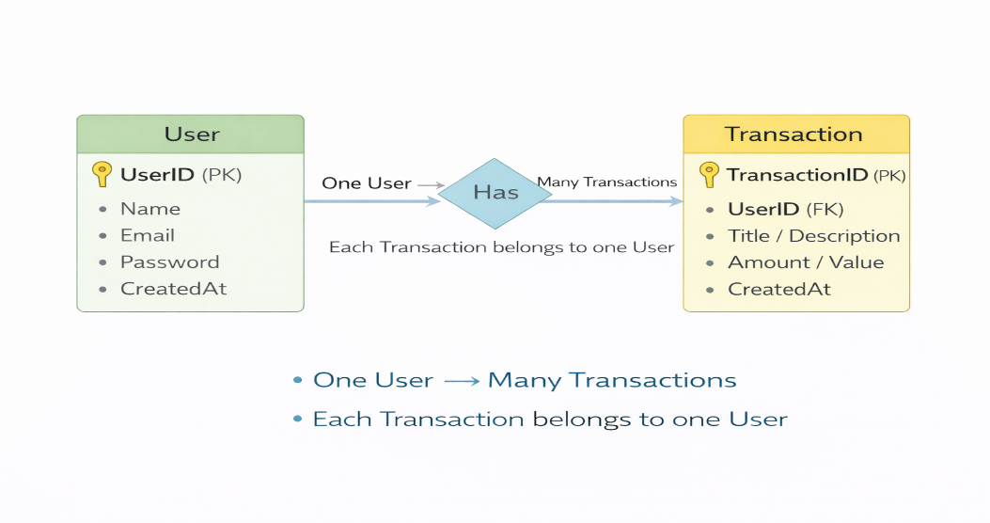
Features:
# | Feature | Description
1 | User Authentication | JWT-based registration and login
2 | CRUD Operations | Create, Read, Update, Delete transactions
3 | Protected Routes | Secure APIs using JWT middleware
4 | MongoDB Integration | Store and fetch data using Mongoose
Roles and Responsibilities:
Student / Developer:
- Write backend code
- Create APIs
- Test APIs using Postman/Thunder Client
- Push code to GitHub
System (Backend):
- Authenticate users using JWT
- Handle CRUD operations
- Store and fetch data from MongoDB
- Protect private routes

Users Flow:

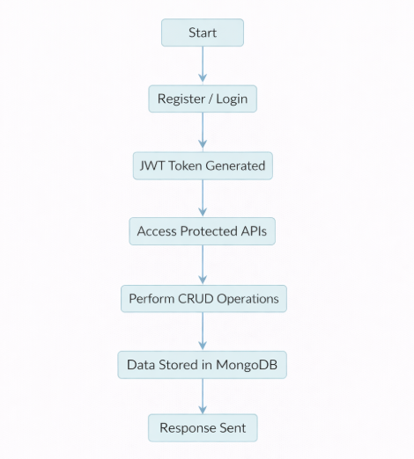
PROJECT SETUP AND CONFIGURATION:
Folder Structure

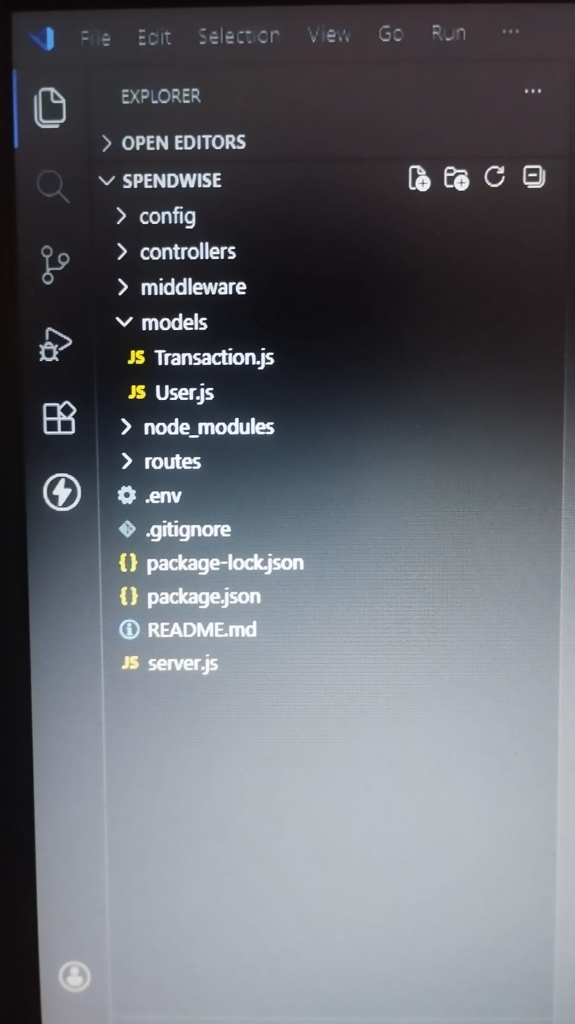

Project Setup:
1. Install required tools:
- Node.js
- MongoDB
2. Create project folders:
- server folders (models, routes, controllers, middleware, config)

3. Install Backend Packages:
- Express
- Mongoose
- Cors
- Jsonwebtoken
- Bcrypt
- Dotenv
BACKEND DEVELOPMENT:
- Setup Express server
- Create server.js file
- Create .env file and define PORT and DB UR
- Configure middleware (cors, express.json)
- User Authentication:
- Create Register and Login routes
- Generate JWT token
- Protect routes using middleware
- Define API Routes:
  - Auth routes

- Implement Data Models:
- User schema
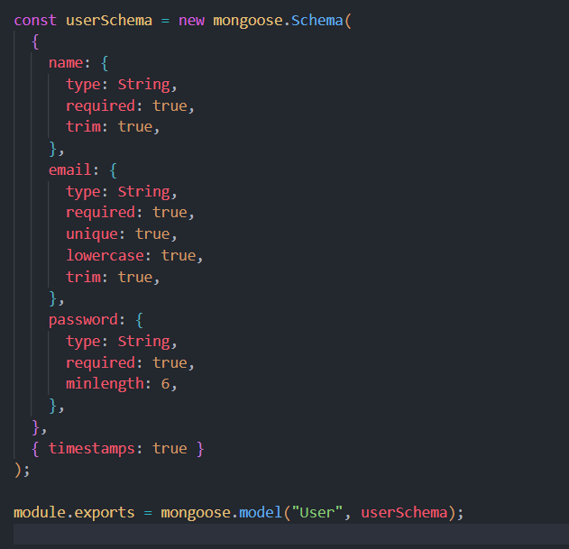
- Transaction schema
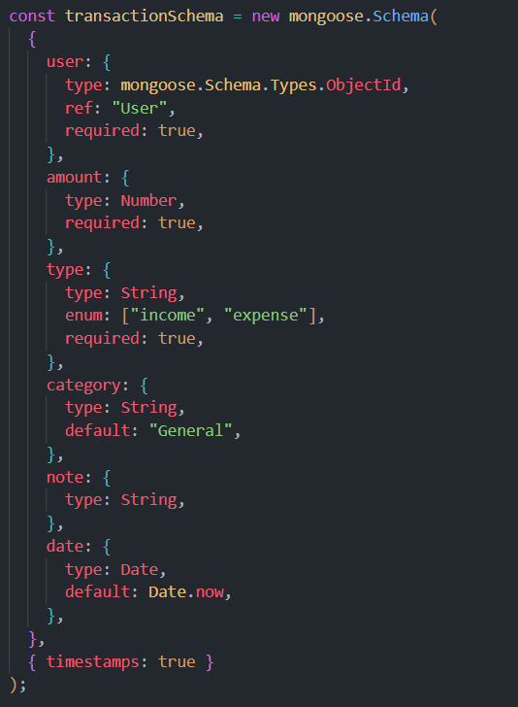
- Implement CRUD operations
- Add basic error handling
DATABASE DEVELOPMENT

Configure MongoDB
- Use MongoDB Atlas or local MongoDB
- Store connection URL in .env file
- Connect using Mongoose
- Create Database Connection
- Create a config file for DB connection
- Use mongoose.connect()
- Handle success and error cases

Create Schema and Models:

User Model:
- Name
- email
- password

Data / Transaction Model:
- userId
- title / description
- amount / value
- timestamps
PROJECT EXECUTION:
Project Execution Steps:
- Start MongoDB
- Run backend server
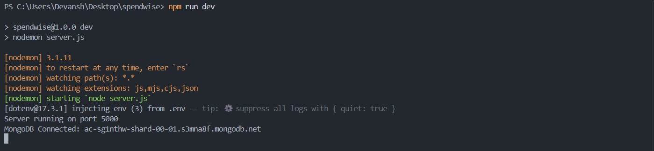

- Test Register API
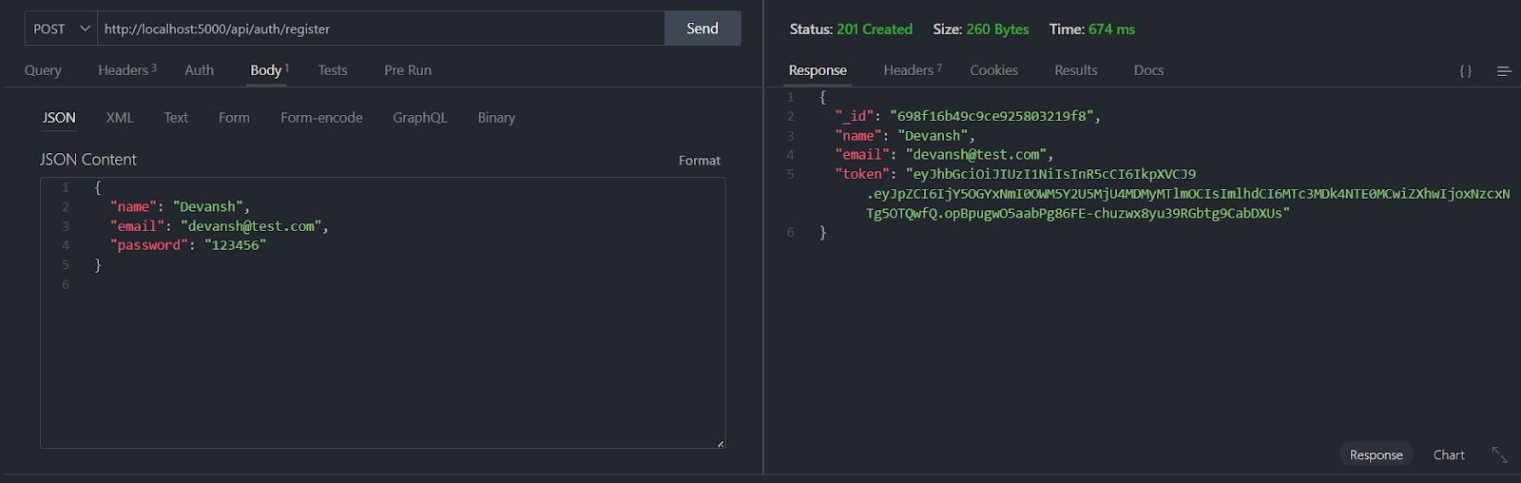

- Test Login API
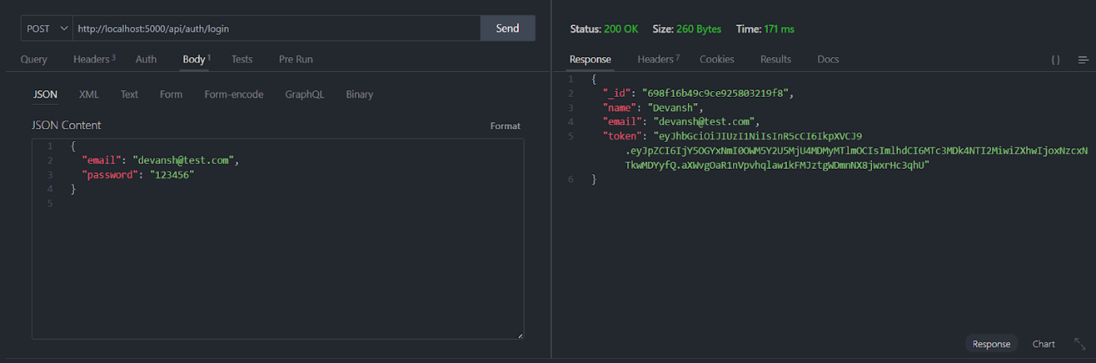

- Copy JWT token
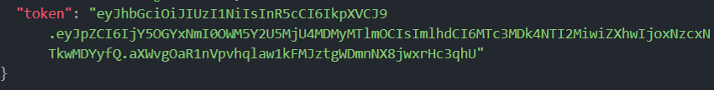
- Use token to access protected CRUD APIs
- Perform Create, Read, Update, Delete operations

OUTPUT SCREENSHOT

- Register API
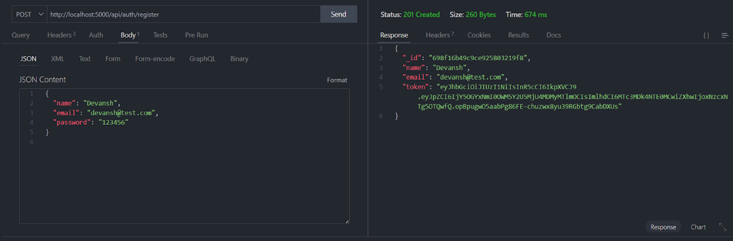

- Login API
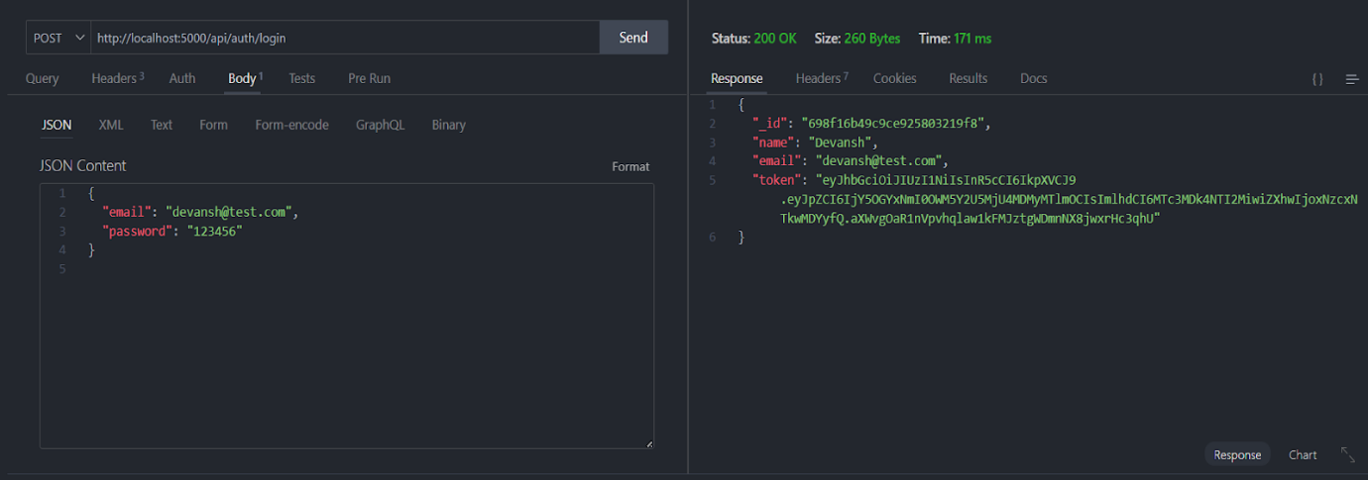

- Create Transaction
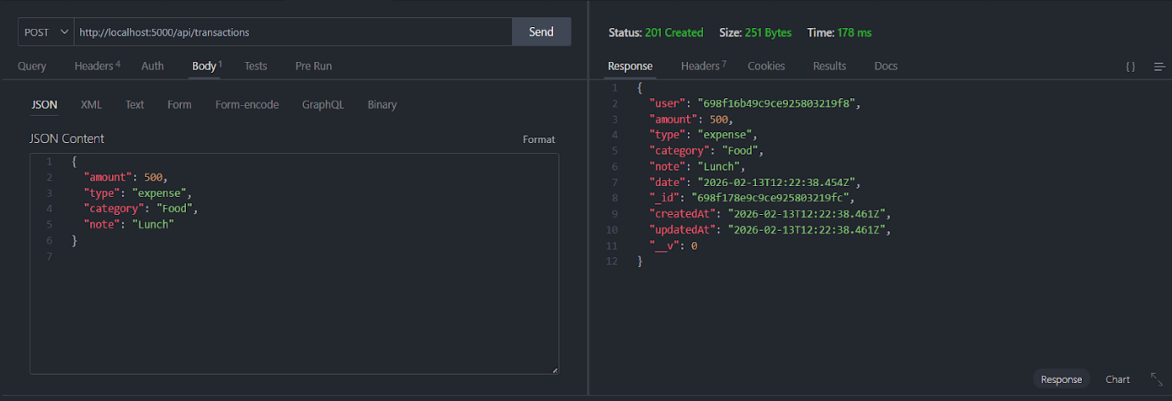

- Get information
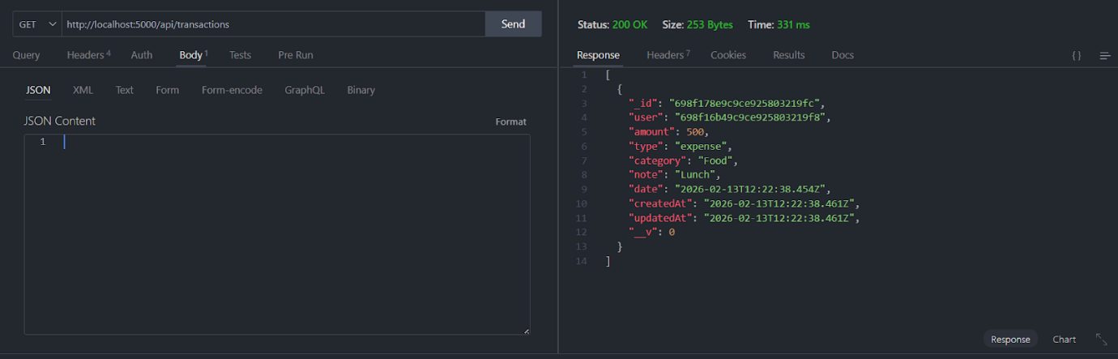

- Update API
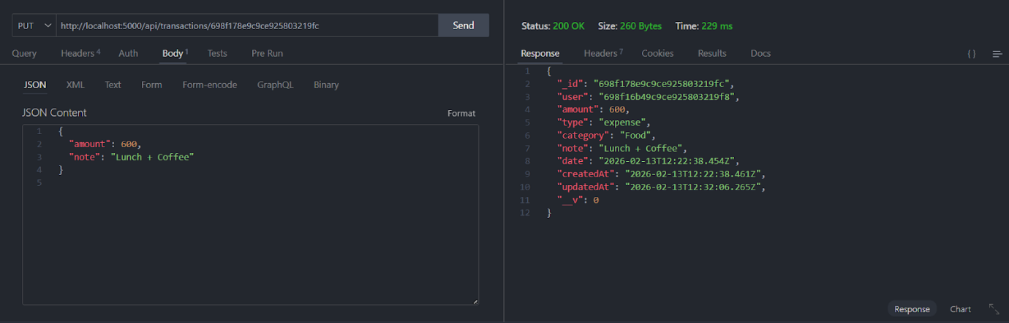

- Delete API
