ABSTRACT
Efficient garbage segregation is a major challenge in urban waste management systems. Improper waste classification leads to environmental pollution and inefficient recycling processes. Manual segregation is time-consuming, error-prone, and requires significant human effort. To address this problem, this project presents an automated system for garbage classification using deep learning techniques.
A convolutional neural network (CNN) model based on transfer learning is developed using MobileNetV2 architecture. The system is trained on an image dataset consisting of six waste categories: cardboard, glass, metal, paper, plastic, and trash. The model is trained and fine-tuned to improve performance using data augmentation and class weighting strategies.
A user-friendly web interface is built using the Streamlit framework that enables users to upload an image and receive real-time predictions. The trained model successfully classifies waste images with an overall accuracy of approximately 80%. The results demonstrate the potential of deep learning in enabling intelligent waste management solutions and automation.

1. INTRODUCTION
With the rapid growth of population and industrialization, waste generation has increased dramatically. Waste management has become a serious concern globally due to environmental and public health risks. Proper waste segregation plays a vital role in recycling, reducing landfill usage, and ensuring environmental sustainability.
Traditional waste segregation techniques rely on manual effort, which is slow, costly, and highly inaccurate. Human errors during segregation often lead to contamination of recyclable materials, resulting in greater environmental damage. Automated garbage classification using artificial intelligence can improve efficiency and accuracy significantly.
Deep learning, especially convolutional neural networks (CNNs), has proven to be effective in image classification tasks. In this project, deep learning models are used to develop a smart garbage classification system capable of identifying different waste materials from images.

2. PROBLEM STATEMENT
Manual garbage classification is inefficient and unreliable. Improper waste segregation causes problems such as:
- Environmental pollution
- Ineffective recycling
- Higher waste-processing costs
- Increased landfill usage
There is a need for an automated garbage classification system that can accurately identify different types of waste and assist in intelligent recycling processes.

3. OBJECTIVES OF THE PROJECT
The main objectives of this project are:
- To build a deep learning-based garbage classification model.
- To classify waste images into six categories.
- To implement a user interface for real-time prediction.
- To evaluate the performance using accuracy and classification metrics.
- To improve waste management using automation.

4. DATASET DESCRIPTION
The dataset used in this project is obtained from Kaggle and is based on the TrashNet dataset. It contains labeled images belonging to the following six categories:
- Cardboard
- Glass
- Metal
- Paper
- Plastic
- Trash
A total of approximately 2500 images are used. The dataset is divided into training and testing sets to enable model evaluation. The training dataset contains about 2000 images, while the testing dataset contains approximately 500 images.
Due to an uneven distribution of samples among classes, class imbalance is observed. Some categories such as trash and plastic contain fewer images compared to others. This imbalance is handled using augmentation and class-weight adjustment strategies.
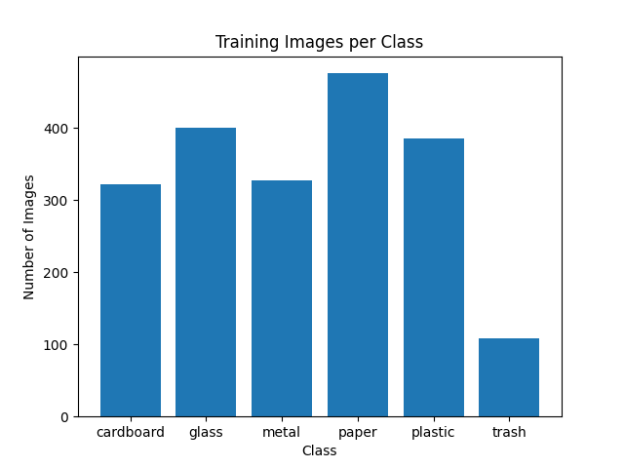

5. DATA PREPROCESSING
The following preprocessing steps were applied:
- All images were resized to 224 × 224 pixels.
- Pixel values were normalized to a range between 0 and 1.
- Data augmentation techniques such as rotation, flipping, zooming, and brightness adjustment were used.
- Class weights were applied to reduce the impact of dataset imbalance.

6. MODEL ARCHITECTURE
The model is developed using MobileNetV2, a lightweight convolutional neural network architecture designed for efficient image processing.
Features:
- Pretrained on ImageNet dataset.
- Transfer learning used to extract image features.
- Last 30 layers were unfrozen for fine-tuning.
- Added custom dense layers for classification.
- Applied dropout layers to reduce overfitting.
Architecture includes:
- Global Average Pooling Layer
- Dense layers (512 and 256 neurons)
- Dropout layers
- Softmax output layer

7. TRAINING PROCESS
The model was trained using:
- Optimizer: Adam
- Learning rate: 0.0001
- Epochs: 25
- Loss function: Categorical Crossentropy
- Batch size: 32
The training and validation accuracy increased steadily over the training process.
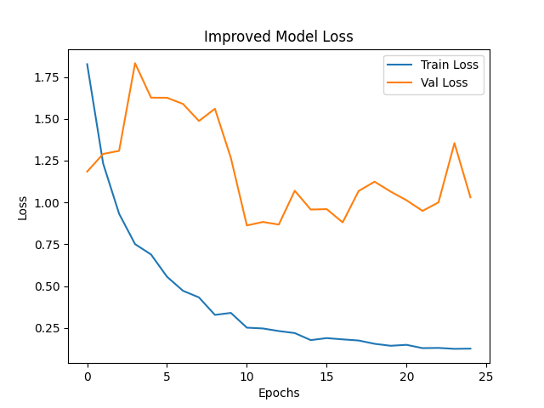

8. MODEL EVALUATION
After training, the model was evaluated using the test dataset.
Model Performance:
- Training accuracy: ~96%
- Validation accuracy: ~79–80%
Classification Report:
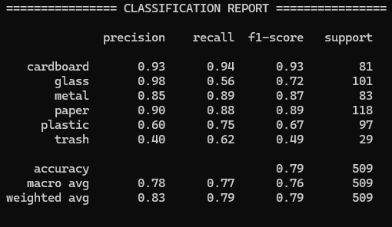
Confusion Matrix:
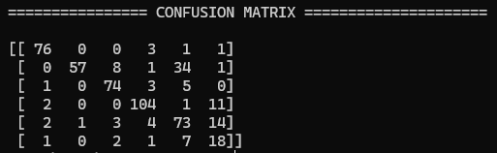
The model performs well on categories such as cardboard, glass, and paper, but shows relatively lower performance for trash and plastic due to variation in shapes and textures.

9. APPLICATION INTERFACE
A web-based user interface is developed using Streamlit. The interface allows users to:
- Upload waste images
- View predicted class
- View prediction confidence scores
The application makes the system interactive and practical for real-world usage.
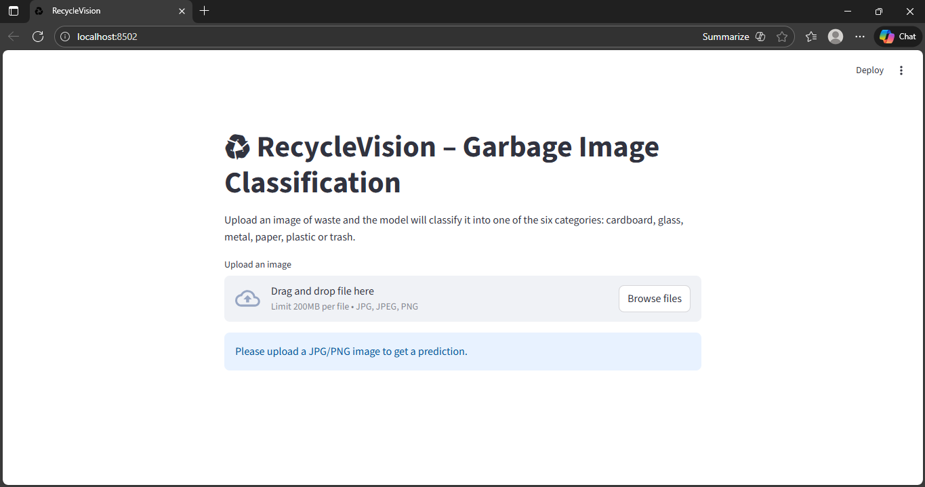
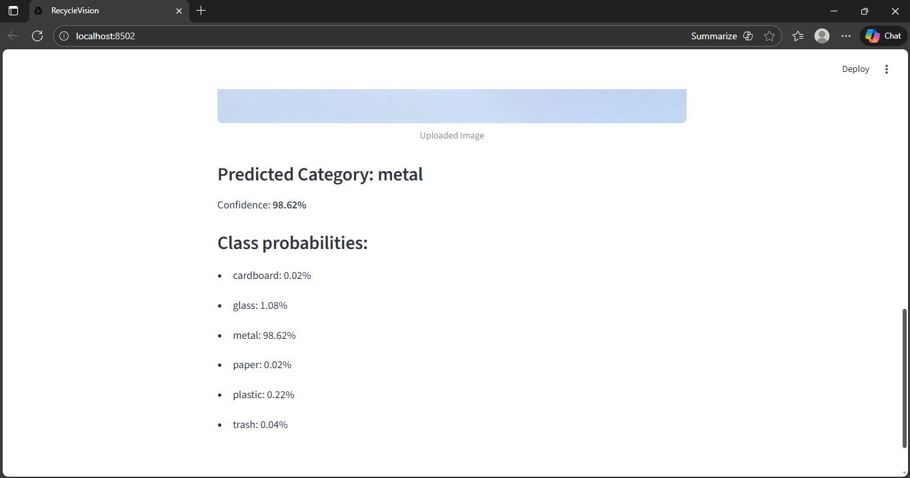
10. RESULTS AND DISCUSSION
The final model achieves an acceptable classification accuracy of around 80%. Through fine-tuning and regularization methods, the model improves generalization capabilities.
Strong performance is observed on structured materials, while complex materials like trash remain challenging due to high variance in appearances.

11. CONCLUSION
This project demonstrates the successful implementation of deep learning for garbage image classification. By utilizing transfer learning and CNN architectures, a reliable classification system has been developed.
The application can assist in smart waste management systems and reduce human effort. The approach can be expanded and enhanced further with more data and advanced architectures.

12. FUTURE SCOPE
Potential future enhancements include:
- Integration with IoT-enabled smart bins.
- Real-time camera-based classification.
- Deployment on edge devices.
- Training using larger and more diverse datasets.
- Use of EfficientNet or Vision Transformers.

13. REFERENCES
- Kaggle TrashNet Dataset
- TensorFlow Documentation
- MobileNetV2 Research Paper
- Scikit-learn Documentation
- Streamlit Documentation

