TEAM LEADER

Delhi rani .A

TEAM MEMBERS

**Kowsalya**.**S**

**Mathuri.K**

**Nithiya.P**

**Nivetha.R**



INTRODUCTION:

**According to the internal revenue service (IRS),business expension are ordinary and necessary costs incurred to operate your business.**

PURPOSE OF THE PROJECT :

**The purpose of the project is used to determine the size of the required investment to create to create or modify assets it is during the early phases that alternative plans are considered that need to to be priced.**

DETAILS:

**We have used the link to download the data set** [**https://drive.google.com/file/d/1GFaQFRuccOHCnZKik_Rpfn5CUao8_INJ/view**](https://drive.google.com/file/d/1GFaQFRuccOHCnZKik_Rpfn5CUao8_INJ/view)

DATA VISUALIZATION:

**Data visualization is the process of creating graphical representation of data in order to help people understand and explore visualization.**

[**https://drive.google.com/file/d/13N1fxFjsDOourmF-kRbxYtjEHklW28-q/view?usp=drive_link**](https://drive.google.com/file/d/13N1fxFjsDOourmF-kRbxYtjEHklW28-q/view?usp=drive_link)

[**https://drive.google.com/file/d/1xbKBU6tYhDhVqFfBnzirYUf46Qm8ivK0/view?usp=drive_link**](https://drive.google.com/file/d/1xbKBU6tYhDhVqFfBnzirYUf46Qm8ivK0/view?usp=drive_link)

[**https://drive.google.com/file/d/1Lma4_uFLjOFkobnFr5eFsoUTwdcOv-CW/view?usp=drive_link**](https://drive.google.com/file/d/1Lma4_uFLjOFkobnFr5eFsoUTwdcOv-CW/view?usp=drive_link)

[**https://drive.google.com/file/d/1e3VHra0ZETV9gSPCV5cTT2CP8MLOo88t/view?usp=drive_link**](https://drive.google.com/file/d/1e3VHra0ZETV9gSPCV5cTT2CP8MLOo88t/view?usp=drive_link)

DASHBOARD

VISUALIZATION

VISUALIZATION

DATA SET

DASHBOARD:

**Dashboard is a graphical user interface that display information and data Is a given easy organized to read format**

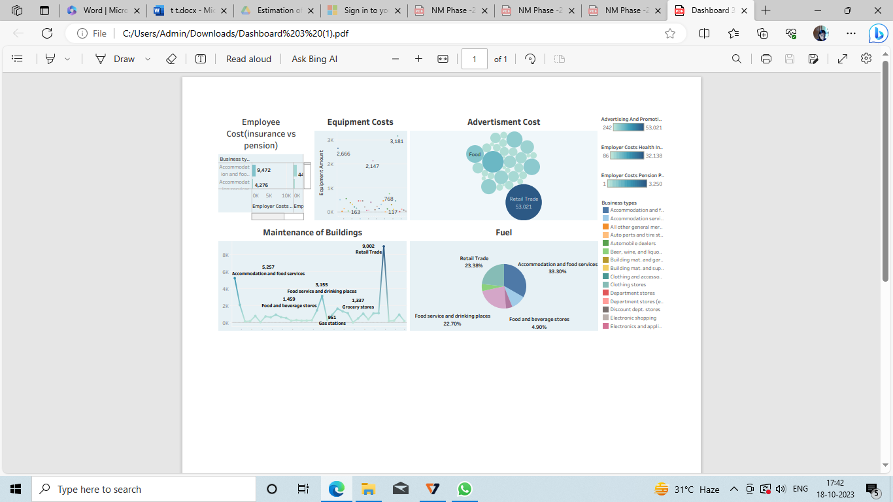

STORIES :

A Data Story is a way of presenting data and analyse in a narrative format with a goals of making information more engaging easier to understand a data story,typically includes clear introduction that sets stage and explain THE CONTEXT FOR THAT DATA BODY.THAT PRESENT THE DATA AND ANALYSIS in a logical and systemetic way and conclusion that summarizes the key findsand highlights.the complication.Data story can be told as veriety of medium such as report,presentation,interactive,vizuallization and videos.

