4.4. SOFTWARE REQUIREMENTS SPECIFICATION:
4.4.1) Apache Tomcat Installation
Apache Tomcat is an open-source Web server and servlet container. It requires a Java Standard Edition Runtime Environment (JRE) version 6 or later. The chit fund system developed uses an Apache Tomcat server version 8.5. Apache Tomcat’s server is called Catalina that contains all the specification for the server that is modified to the needs. Coyote connector component is used to get the response to and fro the server using JK protocol.

STEPS TO INSTALL:
- Download then install the JRE from http://www.oracle.com/technetwork/java/javase/downloads/index.html
- Then download and install the Apache Tomcat, a binary distribution of tomcat from http://tomcat.apache.org/
- Unpack the binary distribution so that it resides in its own directory (conventionally named "apache-tomcat-[version]").
- Configure Environment Variables
    - Set CATALINA_HOME and CATALINA_BASE (optional).
    - The CATALINA_HOME environment variable should be set to the location of the root directory of the "binary" distribution of Tomcat.
    - The CATALINA_BASE environment variable specifies location of the root directory of the "active configuration" of Tomcat. It is optional. It defaults to be equal to CATALINA_HOME.
- Set JRE_HOME or JAVA_HOME.
5.1.1 The JRE_HOME variable is used to specify location of a JRE. The JAVA_HOME variable is used to specify location of a JDK.

5.1.2 Using JAVA_HOME provides access to certain additional start-up options that are not allowed when JRE_HOME is used. If both JRE_HOME and JAVA_HOME are specified, JRE_HOME is used. The best place to include these variables is a "setenv" script.
- Other Variables like CATALINA_OPTS are optional to set with. It allows specification of additional options for the java command to start tomcat.
- Start Tomcat
    - On Windows
%CATALINA_HOME%\bin\startup.bat
Or
%CATALINA_HOME%\bin\catalina.bat start
Or
$CATALINA_HOME/bin/catalina.sh start

4.4.2) DERBY Installation
cdC:\BXP Dev Env\eclipse-kepler-win32-1.0\eclipse-kepler-win32\jdk7-u51\db\bin
set DERBY_HOME=C:\Data\jdk7-u51\db;
set JAVA_HOME=C:\Data\jdk7-u51\bin;
set PATH=C:\Data\jdk7-u51\db\bin;C:\Data\jdk7-u51\bin;%PATH%;
set DERBY_HOME=C:\Data\jdk7-u51\db
C:\BXP Dev Env\eclipse-kepler-win32-1.0\eclipse-kepler-win32\jdk7-u51\db\bin>startNetworkServer -h 172.00.00.00
Bringing up your Client :
cdC:\BXP Dev Env\eclipse-kepler-win32-1.0\eclipse-kepler-win32\jdk7-u51\db\bin
set DERBY_HOME=C:\Data\jdk7-u51\db;
set JAVA_HOME=C:\Data\jdk7-u51\bin;
set PATH=C:\Data\jdk7-u51\db\bin;C:\Data\jdk7-u51\bin;%PATH%;
set DERBY_HOME=C:\Data\jdk7-u51\db
ij;
6.2.APACHE MAVEN

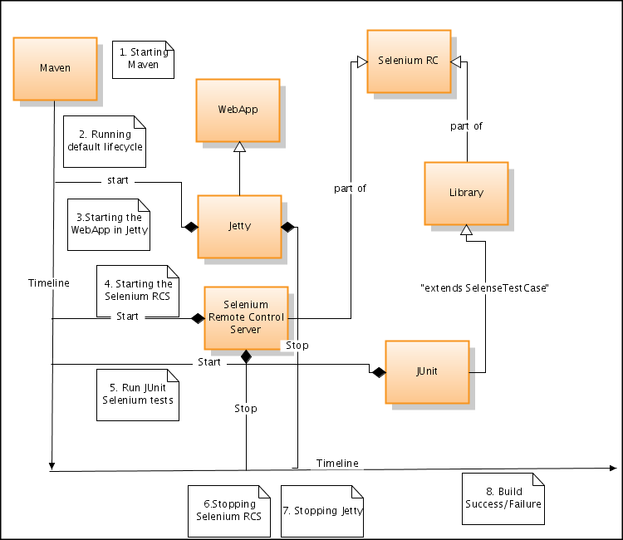
    - BLOCK DIAGRAM
Figure 6.2.1
Maven is a comprehension and software project management tool that allows a developer to develop based on project object model(POM). Maven’s key feature is dependency management. It helps to download the required JAR’s for the project build.
    - Dependencies

The core feature of Maven is dependency management. Its dependency handling mechanism is well built up around a coordinate system that identifies the individual artefacts such as software libraries and modules.
A POM provides all the configurations needed for a single project. The general configuration covers the project's name, its dependencies and its owner on other projects. One can also configure the individual phases of the project’s build process that are implemented as plugins.
4.4.3) AngularJS
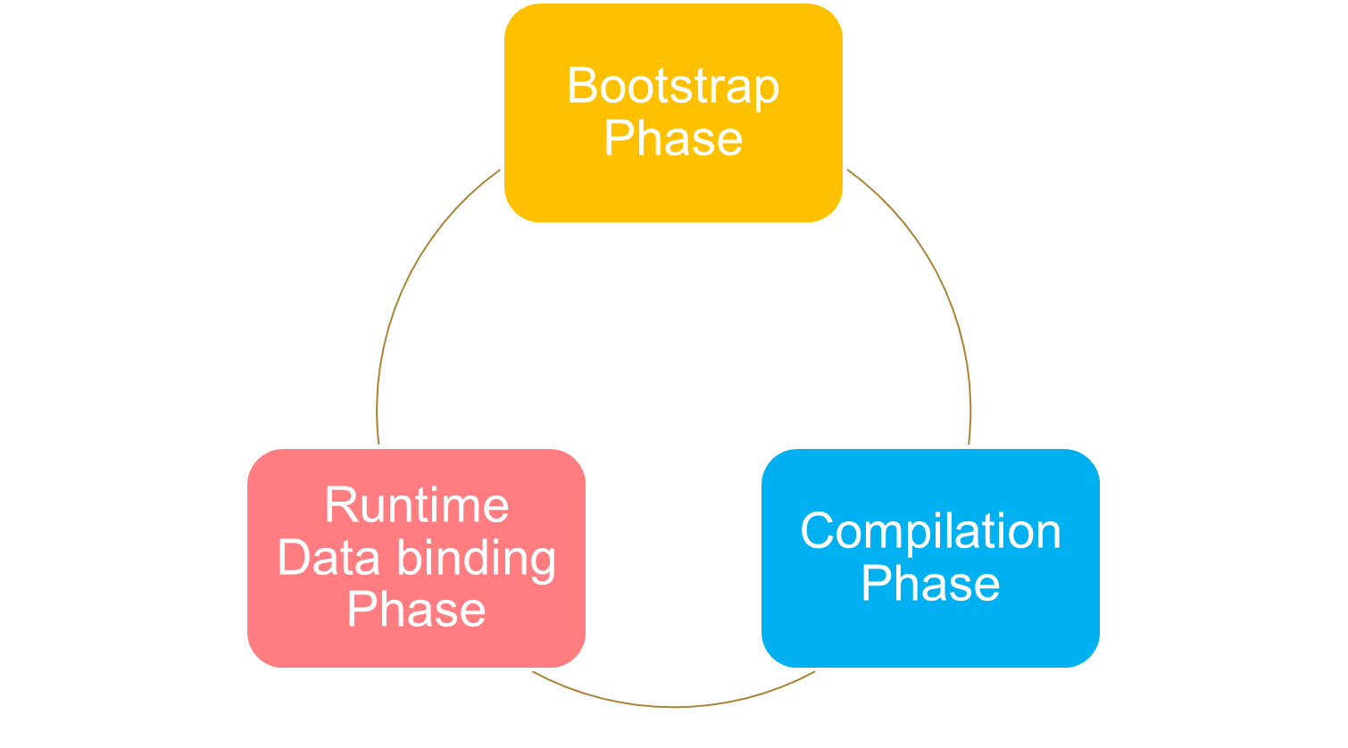
Angular is a client side JavaScript framework for dynamically adding interactivity for HTML. Data-binding is an automatic way of updating the view whenever the model changes, as well as updating the model whenever the view changes.It saves developer’s productivity by reducing considerable amount of code for manipulating, traversing and listening to DOM. AngularJS has a built-in dependency injection subsystem that helps the developer by making the application easier to develop, understand, and test.
Figure 4.4.3.1

To use Angular JS include the following script in the head tag.
<script src="https://ajax.googleapis.com/ajax/libs/angularjs/1.4.8/angular.min.js"></script>

Using Angular JS with RESTful web services a responsive table like the below can be generated.
PRESENT WORK:

Results and discussions:

Home page:

Admin page:

Login page:

