User home page:

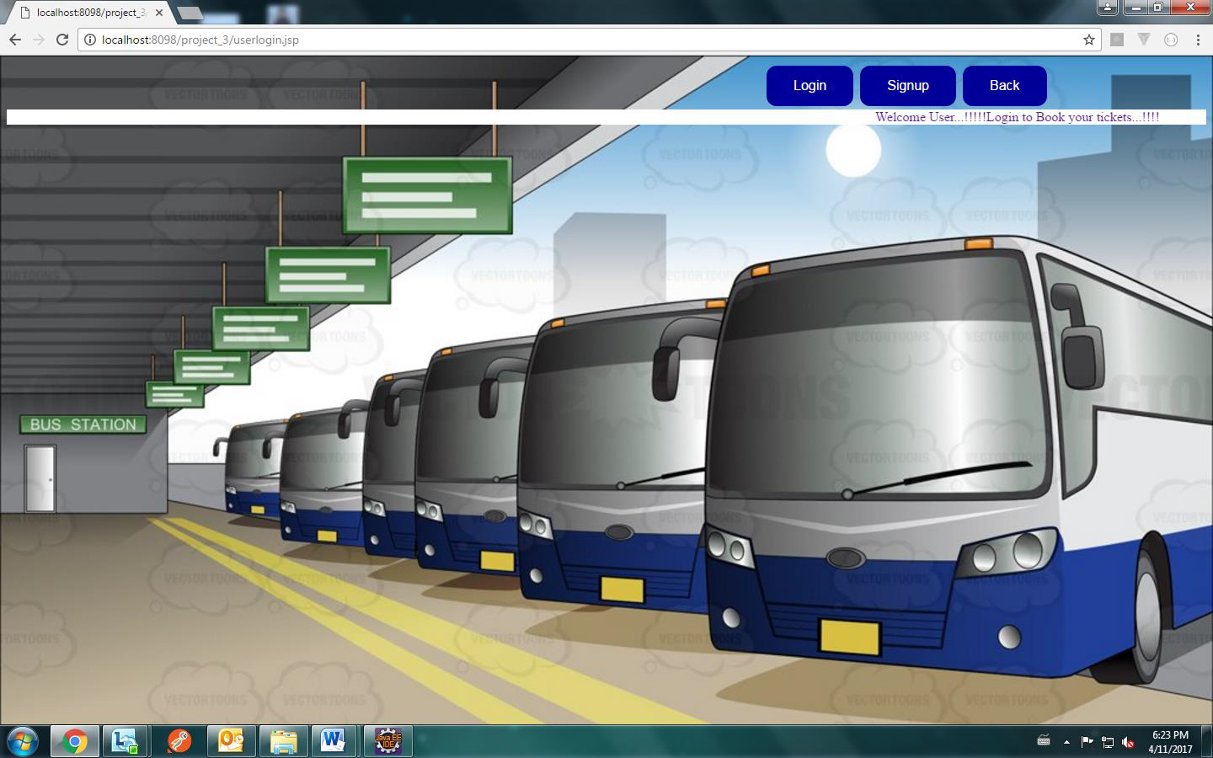

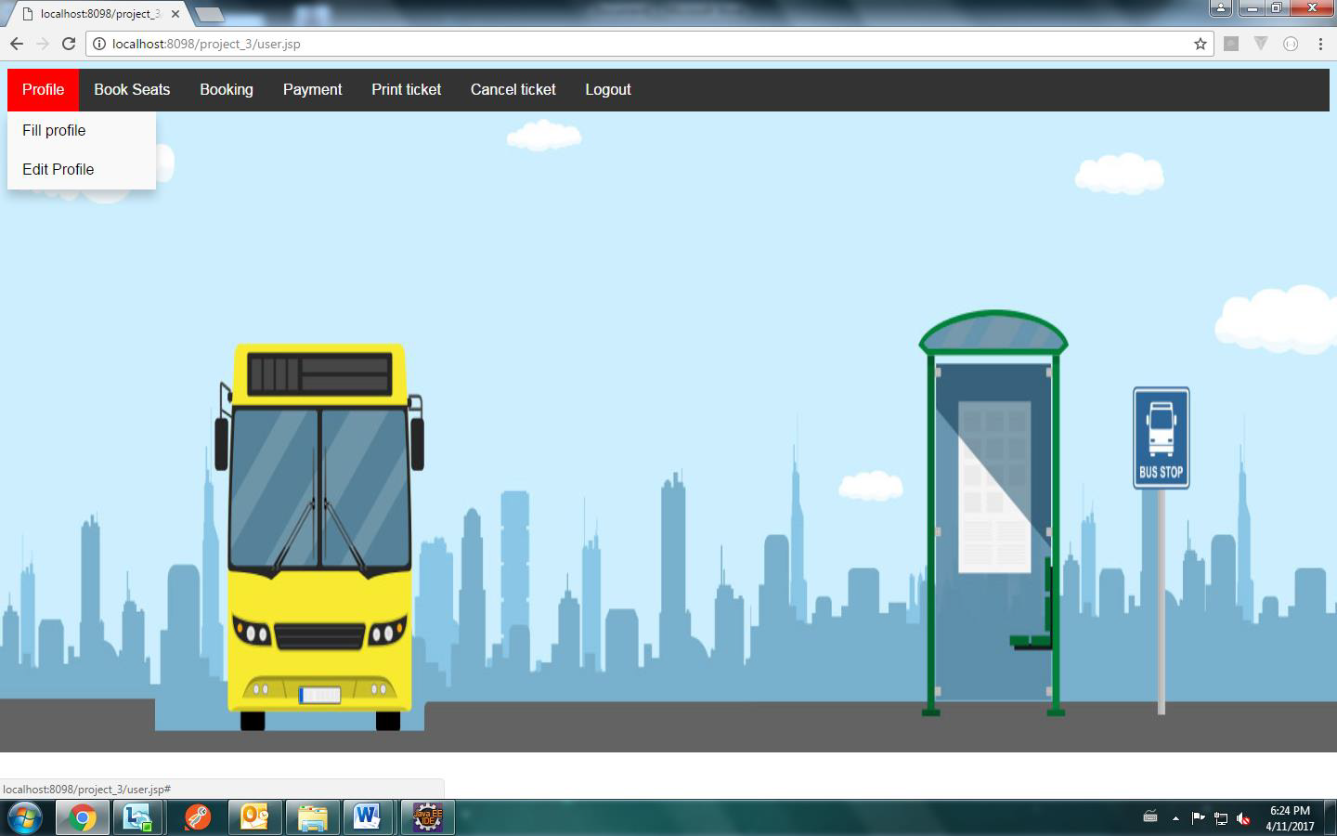

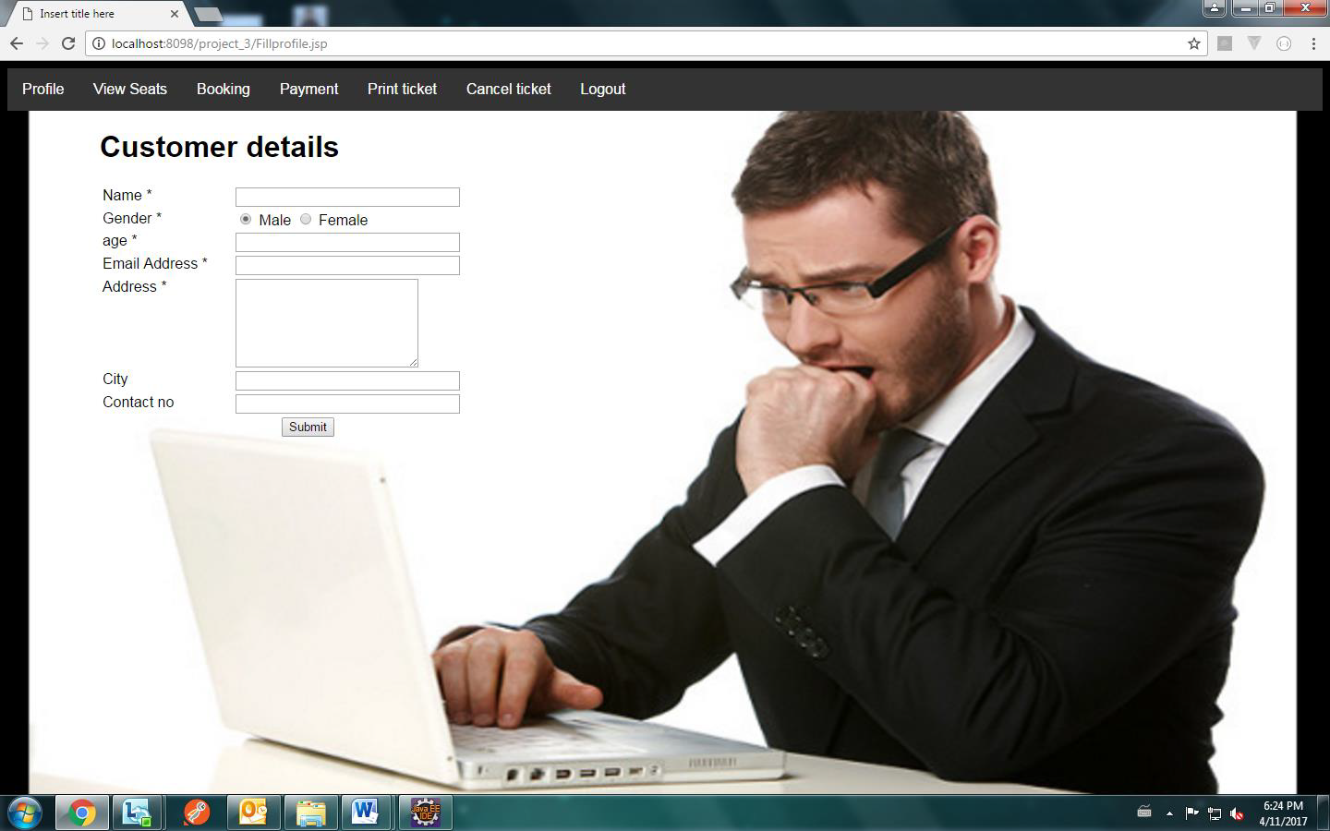



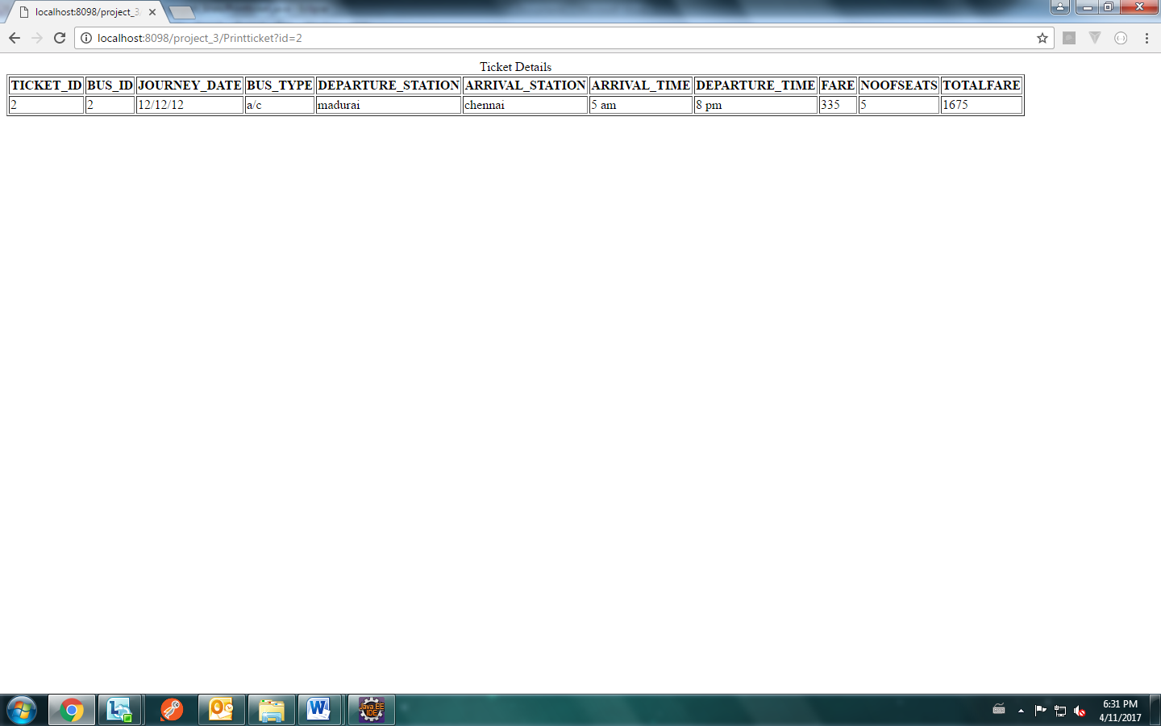

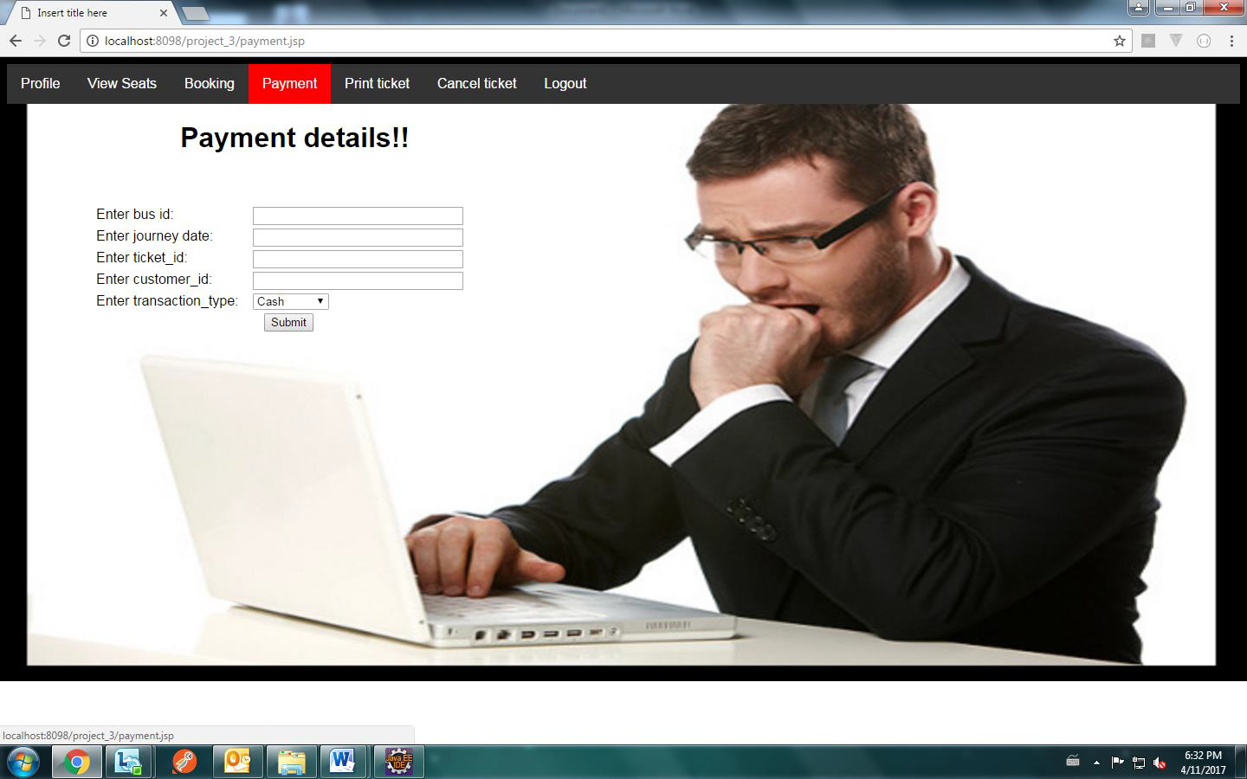

References:

1. Asad, A.A., Ayad, M.J. and Hayder, N.K. (2012). Design and Developing Online Iraqi Bus Reservation

System Using Unified Modeling Language. *International Journal of Scientific knowledge* Available at:

http://www.ijsk.org/uploads/3/1/1/7/3117743/v3i103_information_technology.pdf Accessed 13th December 2014

2. Gayathry, S. (2013). *Online Bus Ticketing System:* Tactful Management Research Journal Through Case Studies.RedBus.in

3. Goessl, L. (2009). *Business Advantages of a Relational Database*. Available at:

http://www.insidebusiness360.com/index.php/business-advantages-of-a-relational-database-15806/

4. Invaderzim08, (2011).*Online Bus Reservation System. Retrieved from*

http://www.studymode.com/essays/Bus-Reservation-System-741084.html Accessed 20th November 2014

5. Maike, J.P. (2014). Train, bus and museum - Interrelations of diverse actors within integrated E - ticketing

schemes. Available at: http://www.mobil-tum.vt.bgu.tum.de/fileadmin/w00bqi/www/Session_Poster/Puhe.pdf

Accessed 16th October 2014

6. Melisa, K. (2007).*Online Bus Ticketing System:* University Of Malaykuala Lumpur Accessed 17th November 2014

7. Mezghani, M. (2008). Study on Electronic Ticketing in Public Transport. Available at:

http://www.emta.com/IMG/pdf/EMTA-Ticketing.pdf Accessed: 16th November 2014

8. Paskaleva, K. (2014). Integrated Public e-Services: Joining-up Strategies and Technologies for City Available

at: http://www.europarl.europa.eu/RegData/etudes/etudes/join/2014/513551/IPOL

JOIN_ET%282014%29513551_EN.pdf Accessed 18th October 2014

9. Pricewaterhouse Coopers (2011). Smart & Integrated Ticketing Report for Scotland. Available at:

http://www.transportscotland.gov.uk/files/documents/reports/j13684/j13684.pdf Accessed: 30th October 2014

10. Shivaji. Varma. (2010). *Bus reservation system. Retrieved from*

http://shivajivarma.wordpress.com/2010/09/20/dbms-project-bus-reservation Accessed 19th November 2014

<https://inautixonline.inautix.com/>– iNautix Company.