**Bechdel Test(simplified)**

Note this is not an actual Bechdel test, as the contents of the interaction between two females is not being taken into account, just the fact there is an interaction is sufficient for my simplified test to be passed.

First, the script is scraped from the IMSDB website

Then the TMDB API is used to find details of the film cast (personal API key used here).

Then a list of tuples is made containing every interaction between two characters in the movie.

The cast details are used to determine the gender of each character.

Female-Female interactions are searched for and results data is produced. From the data, if a movie contains a [Female, Female] tuple, it is considered to have passed the Bechdel Test(simplified). In the given timeframe, unfortunately I couldn’t find a way to also check if the subject of the interaction was not about a man. Which is the actual Bechdel test.

I have also constructed a bar chart for analysis of the data, here is an example:

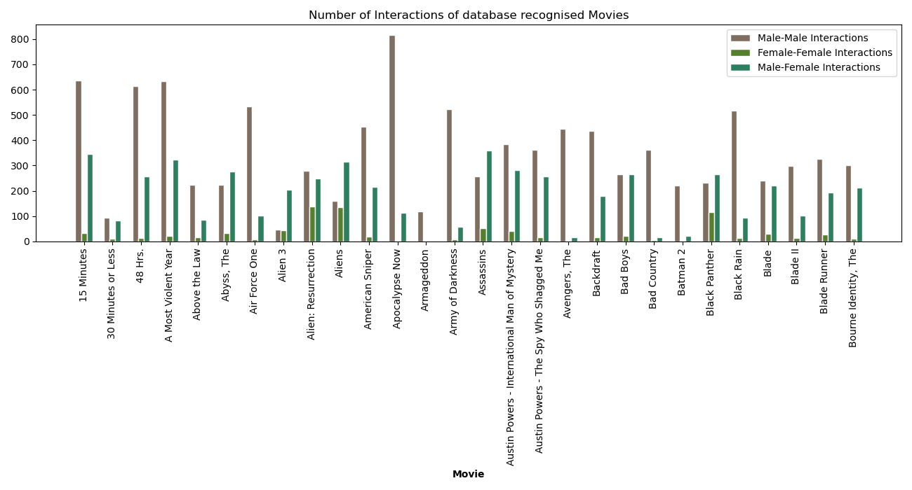

Some of the bars are hard to see, but in the approximately 50 movies I have scraped from IMSDB (My laptop couldn’t handle more than 50, the processor was too slow). All of the movies pass my test.

However, as you can see, the ratio of male-male interactions to female-female interactions in movies is shockingly low. Even though all movies pass the test, some of the bars are not visible due to the numbers being so low. Exceptions include Alien: Resurrection, Aliens and Black Panther. The highest difference goes to Apocalypse Now, with almost 800 male-male interactions compared to negligible female-female interactions.