**VBSAPI {NK29012016}**

http://127.0.0.1:8081/api/GetAll

http://127.0.0.1:8081/api/vb/100/vbrDetails

http://127.0.0.1:8081/api/vb/102/Delete

<http://127.0.0.1:8081/api/postOperation?VBR=700&VRN=A700&Amount=5000.00>

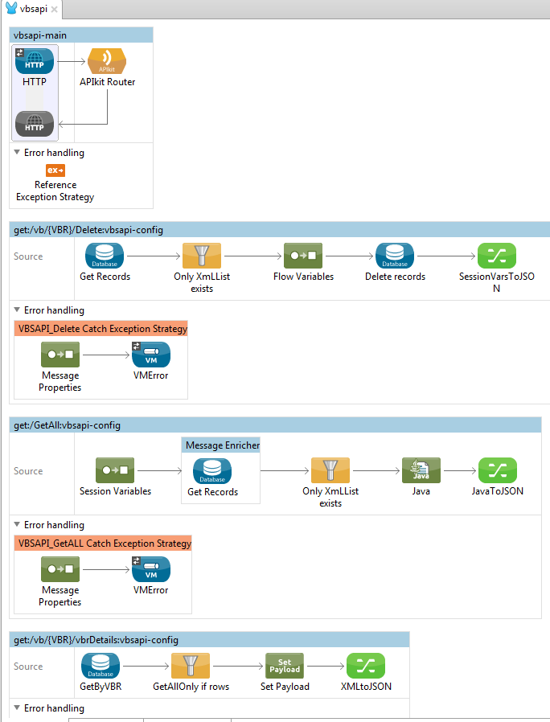

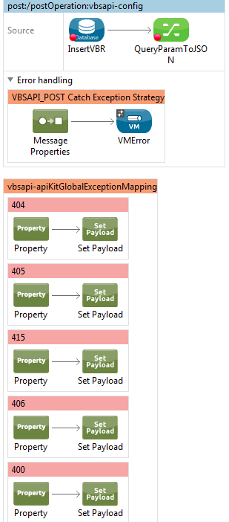

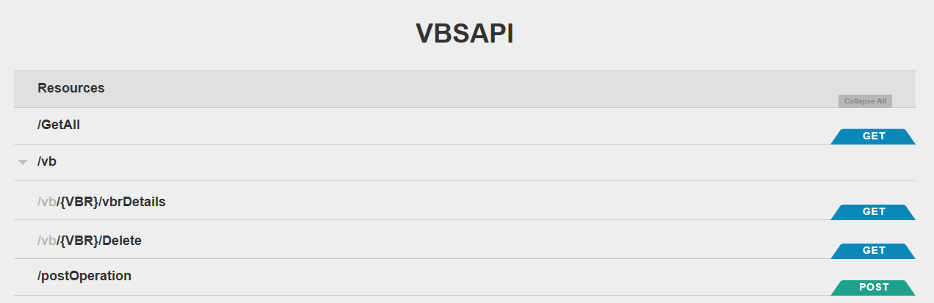

1. GetAll : <http://127.0.0.1:8081/api/GetAll>

{

"VBLoad": {

"DateGenerated": "07-01-2016",

"VBLoadList": {

"VB": {

"VBR": "100",

"VRN": "A100",

"DateBooked": "01-01-2016",

"TimeBooked": "09:15",

"Amount": 20.0

},

"VB": {

"VBR": "101",

"VRN": "A100",

"DateBooked": "01-01-2016",

"TimeBooked": "20:00",

"Amount": 100.0

},

"VB": {

"VBR": "101",

"VRN": "A100",

"DateBooked": "01-01-2016",

"TimeBooked": "20:00",

"Amount": 100.0

}

}

}

}

1. <http://127.0.0.1:8081/api/vb/100/vbrDetails>

{

"VBLoad": {

"DateGenerated": "07-01-2016",

"VBLoadList": {

"VB": {

"VBR": "100",

"VRN": "A100",

"DateBooked": "01-01-2016",

"TimeBooked": "09:15",

"Amount": "20.00"

}

}

}

}

1. http://127.0.0.1:8081/api/postOperation?VBR=700&VRN=A700&Amount=5000.00http://127.0.0.1:8081/api/postOperation?VBR=700&VRN=A700&Amount=5000.00http://127.0.0.1:8081/api/postOperation?VBR=700&VRN=A700&Amount=5000.00

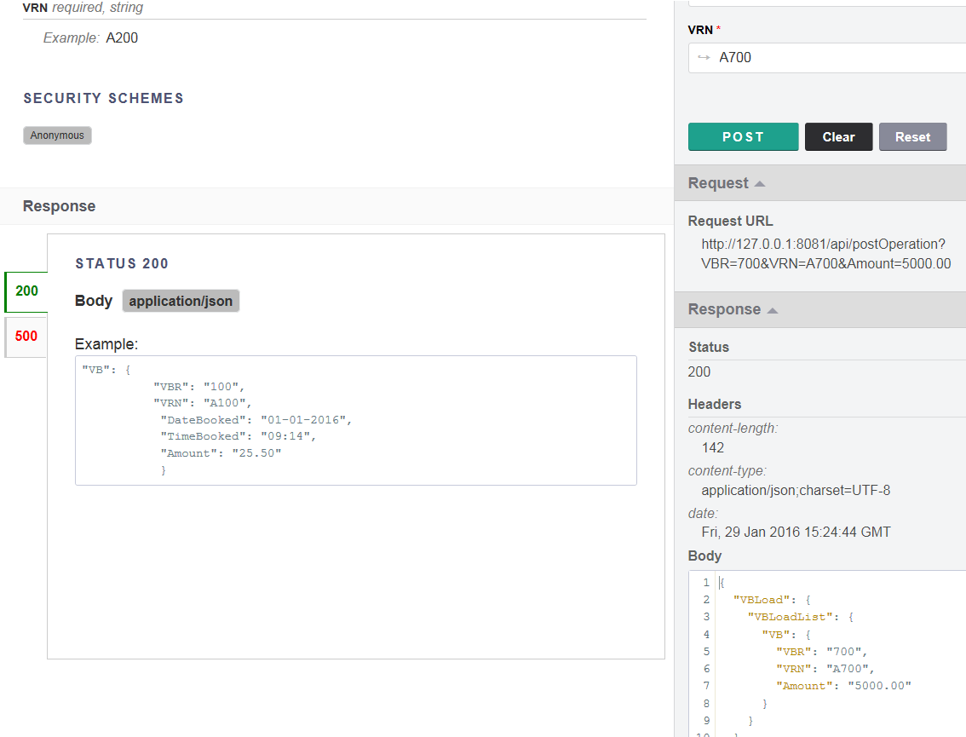

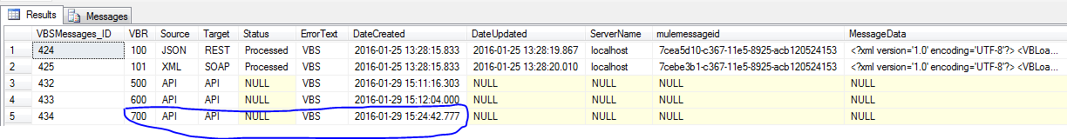

1. <http://127.0.0.1:8081/api/vb/100/Delete>

{

"VBLoad": {

"DateGenerated": "07-01-2016",

"VBLoadList": {

"VB": {

"VBR": "100",

"VRN": "A100",

"DateBooked": "01-01-2016",

"TimeBooked": "09:15",

"Amount": "20.00"

}

}

}

}

