Mule3.8 BP **APIKIT REST Maven**

http://127.0.0.1:8081/console/

<http://127.0.0.1:8081/api/bp/TR2/bpDetails>

<http://127.0.0.1:8081/api/bp/TR5/Delete>

http://127.0.0.1:8081/api/postOperation?TransactionRef=200&TransactionType=A200&Amount=5000.00

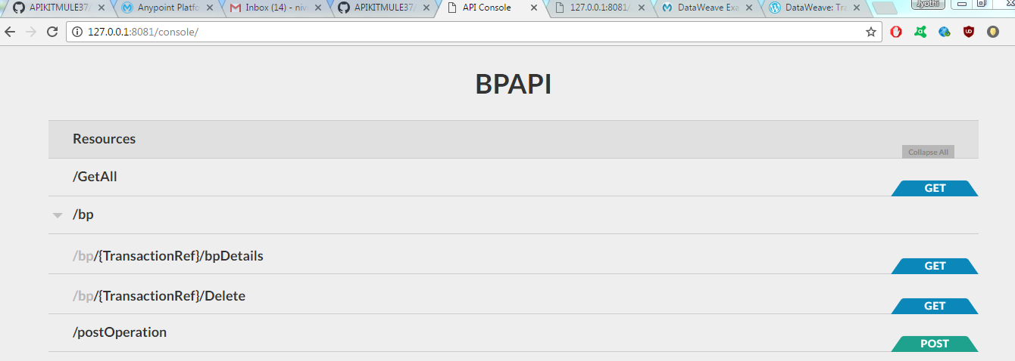

**GET**

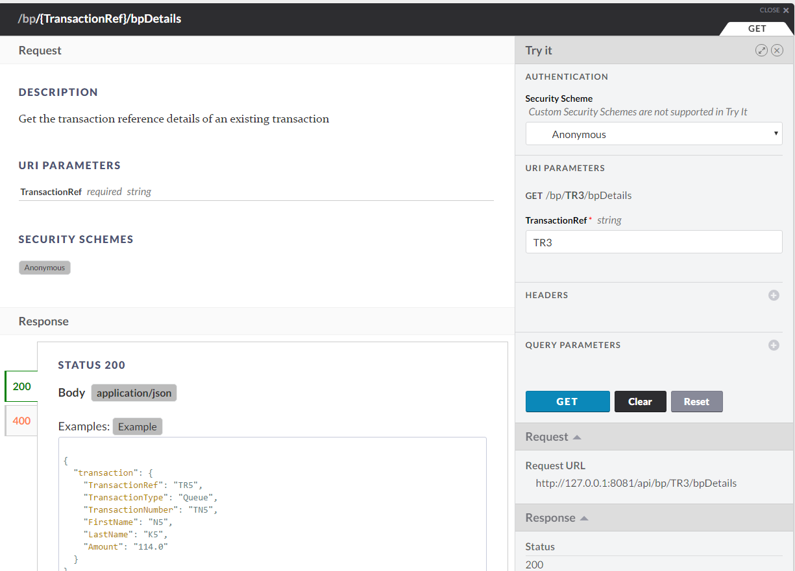

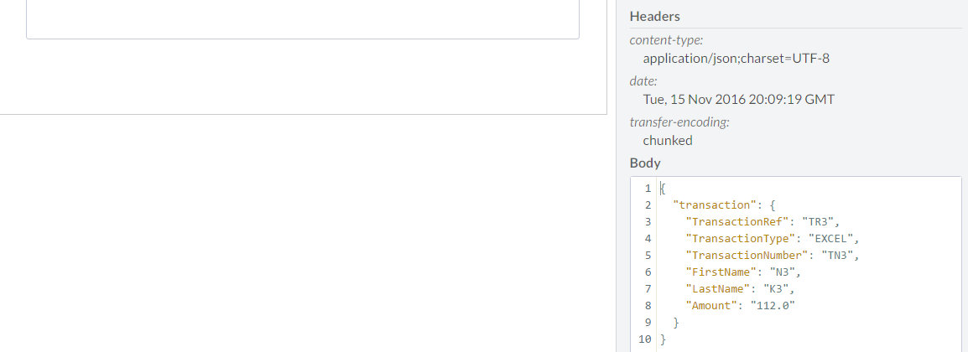

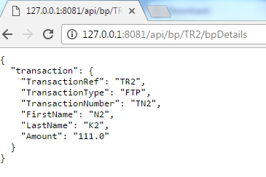

**DELETE**

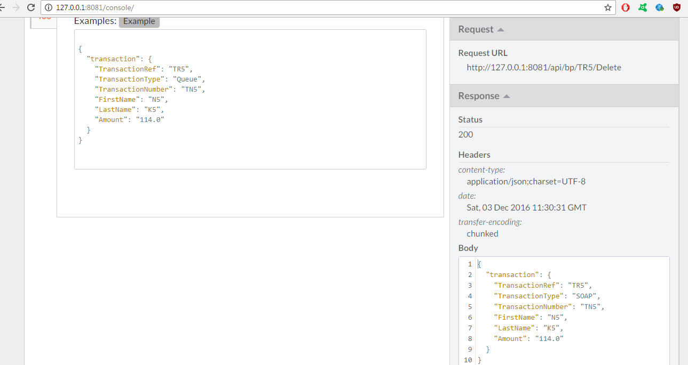

**POST**

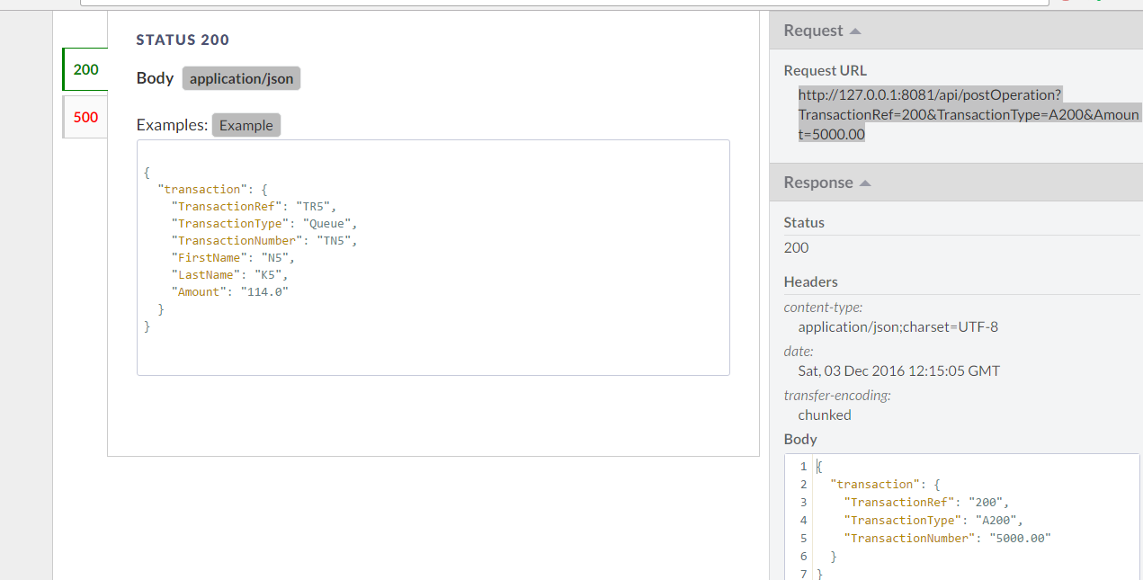

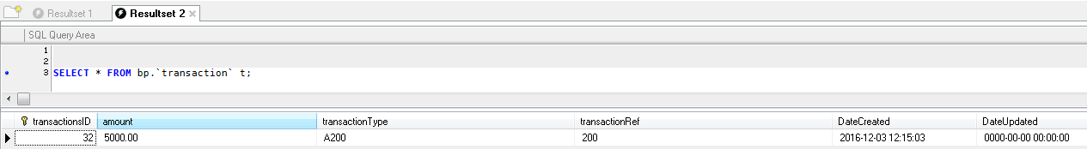

**AnyPoint – API MANAGER**

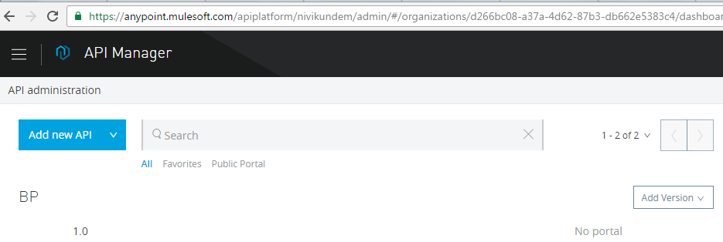

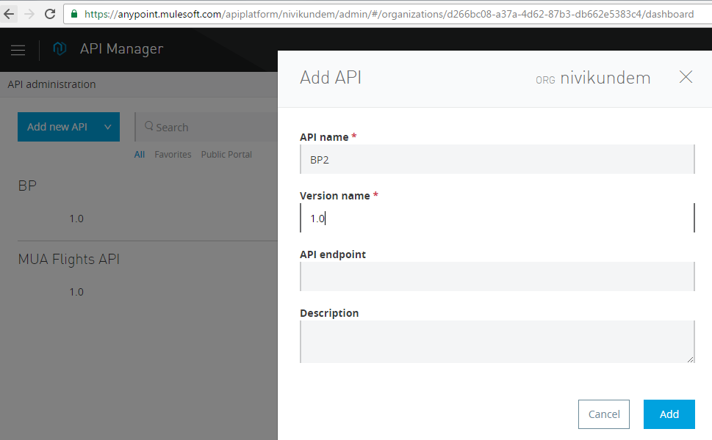

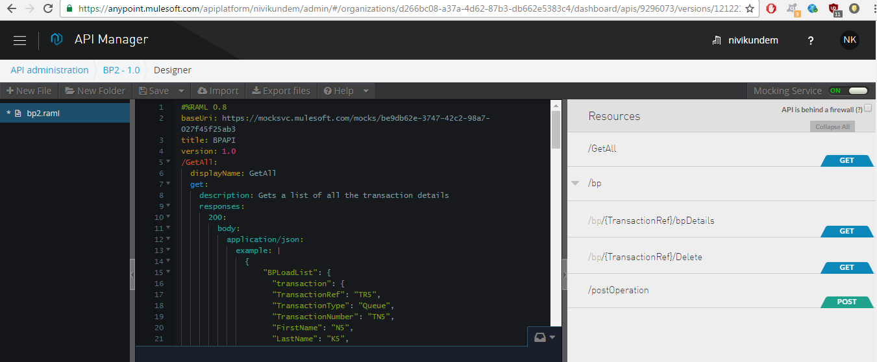

**Mule Flows**

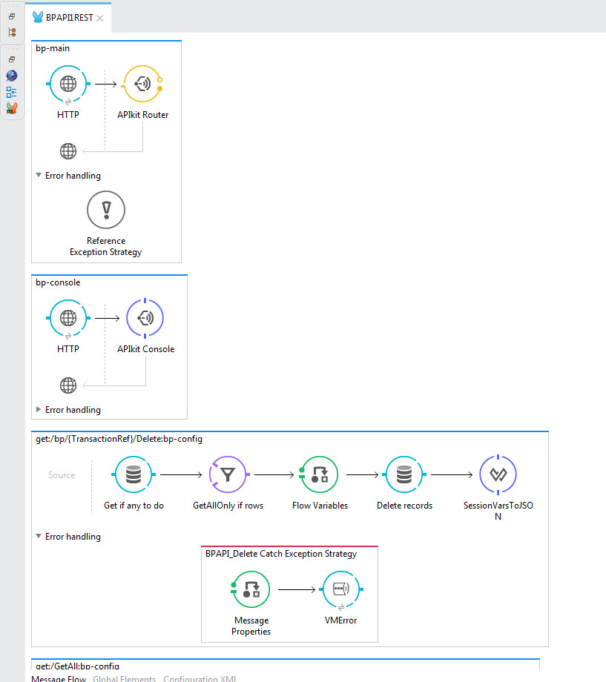

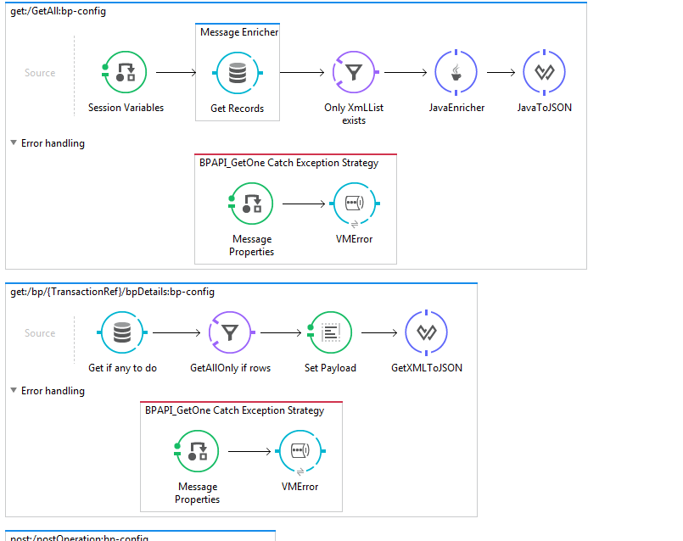

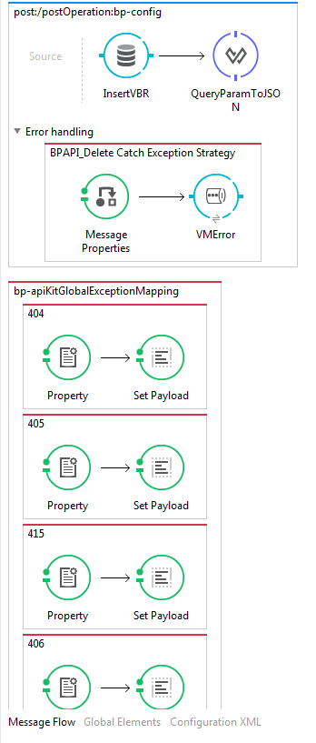

**Interface/Project structure**

