**Mule Salesforce connector – NK 10/01/2017**

1. **SalesForce1WatermarkBatchProcess**

Polls the transactions from DB, if the transaction already been fetched/processed in the past, it will not process it, if it is new transaction it will process.

In other words, using watermark feature, even though it fetches all the records according to query, it sends to the Salesforce only the new records.

Using batch process instead of looping through each record, it process all records as a batch and commits as batch and on completion gives number of records processed and number of records failed.

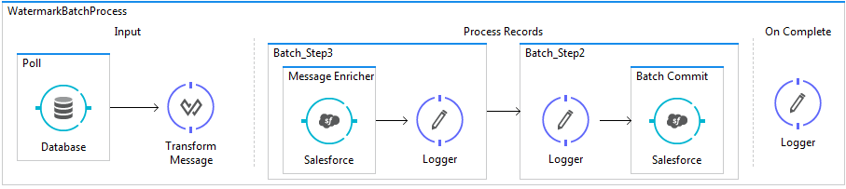

**Config XML**

<?xml version=*"1.0"* encoding=*"UTF-8"*?>

<mule xmlns:sfdc=*"http://www.mulesoft.org/schema/mule/sfdc"*

xmlns:batch=*"http://www.mulesoft.org/schema/mule/batch"*

xmlns:dw=*"http://www.mulesoft.org/schema/mule/ee/dw"*

xmlns:db=*"http://www.mulesoft.org/schema/mule/db"*

xmlns=*"http://www.mulesoft.org/schema/mule/core"* xmlns:doc=*"http://www.mulesoft.org/schema/mule/documentation"*

xmlns:spring=*"http://www.springframework.org/schema/beans"*

xmlns:xsi=*"http://www.w3.org/2001/XMLSchema-instance"*

xsi:schemaLocation=*"http://www.mulesoft.org/schema/mule/sfdc http://www.mulesoft.org/schema/mule/sfdc/current/mule-sfdc.xsd*

*http://www.mulesoft.org/schema/mule/batch http://www.mulesoft.org/schema/mule/batch/current/mule-batch.xsd*

*http://www.mulesoft.org/schema/mule/ee/dw http://www.mulesoft.org/schema/mule/ee/dw/current/dw.xsd*

*http://www.mulesoft.org/schema/mule/db http://www.mulesoft.org/schema/mule/db/current/mule-db.xsd*

*http://www.springframework.org/schema/beans http://www.springframework.org/schema/beans/spring-beans-current.xsd*

*http://www.mulesoft.org/schema/mule/core http://www.mulesoft.org/schema/mule/core/current/mule.xsd"*>

<batch:job name=*"WatermarkBatchProcess"*>

<batch:input>

<poll doc:name=*"Poll"*>

<fixed-frequency-scheduler frequency=*"30"* timeUnit=*"SECONDS"*/>

<watermark variable=*"lastAccountID"* default-expression=*"0"* selector=*"MAX"* selector-expression=*"#[payload.accountID]"*/>

<db:select config-ref=*"ESBDBDatabase"* doc:name=*"Database"*>

<db:parameterized-query><![CDATA[select *

from accounts

where postal='RM16' and accountID > #[flowVars.lastAccountID]]]></db:parameterized-query>

</db:select>

</poll>

<dw:transform-message doc:name=*"Transform Message"*>

<dw:set-payload><![CDATA[%dw 1.0

%output application/java

---

payload map ((payload01 , indexOfPayload01) -> {

Id: payload01.accountID as :string,

Name: payload01.name,

BillingStreet: payload01.street,

BillingCity: payload01.city,

BillingState: payload01.state,

BillingPostalCode: payload01.postal,

BillingCountry: payload01.country

})]]></dw:set-payload>

</dw:transform-message>

</batch:input>

<batch:process-records>

<batch:step name=*"Batch_Step3"*>

<enricher source=*"#[payload.size() &gt; 0]"* target=*"#[recordVars.exists]"* doc:name=*"Message Enricher"*>

<sfdc:query config-ref=*"SalesforceBA"* query=*"dsql:SELECT Name FROM Account WHERE Name = '#[payload.Name]'"* doc:name=*"Salesforce"*/>

</enricher>

<logger message=*"#['\n\nRecordvar : '+payload]"* level=*"INFO"* doc:name=*"Logger"*/>

</batch:step>

<batch:step name=*"Batch_Step2"* accept-expression=*"#[!recordVars.exists]"*>

<logger message=*"#['\n\nRecordvarcheck2 : '+payload]"* level=*"INFO"* doc:name=*"Logger"*/>

<batch:commit size=*"100"* doc:name=*"Batch Commit"*>

<sfdc:create config-ref=*"SalesforceBA"* type=*"Account"* doc:name=*"Salesforce"*>

<sfdc:objects ref=*"#[payload]"*/>

</sfdc:create>

</batch:commit>

</batch:step>

</batch:process-records>

<batch:on-complete>

<logger message=*"#['varprocessed :'+payload.processedRecords+' Failed '+payload.failedRecords]"* level=*"INFO"* doc:name=*"Logger"*/>

</batch:on-complete>

</batch:job>

</mule>

**Logs**

Even though DB select fetched records because these were already processed, batch process did not commit.

**Before adding new transaction:**

INFO 2017-01-10 20:03:56,605 [pool-34-thread-1] com.mulesoft.module.batch.engine.DefaultBatchEngine: Input phase completed

INFO 2017-01-10 20:03:56,620 [pool-34-thread-1] com.mulesoft.module.batch.engine.queue.BatchQueueLoader: Starting loading phase for instance 'e699ce40-d76f-11e6-a249-ced920524153' of job 'WatermarkBatchProcess'

INFO 2017-01-10 20:03:56,627 [pool-34-thread-1] com.mulesoft.module.batch.engine.queue.BatchQueueLoader: Finished loading phase for instance e699ce40-d76f-11e6-a249-ced920524153 of job WatermarkBatchProcess. 0 records were loaded

INFO 2017-01-10 20:03:56,627 [pool-34-thread-1] com.mulesoft.module.batch.engine.DefaultBatchEngine: Instance 'e699ce40-d76f-11e6-a249-ced920524153' of job 'WatermarkBatchProcess' has no records to process. It's execution will be finished now

INFO 2017-01-10 20:03:56,628 [pool-34-thread-1] com.mulesoft.module.batch.engine.DefaultBatchEngine: Starting execution of onComplete phase for instance e699ce40-d76f-11e6-a249-ced920524153 of job WatermarkBatchProcess

INFO 2017-01-10 20:03:56,669 [pool-34-thread-1] org.mule.api.processor.LoggerMessageProcessor: **varprocessed :0 Failed 0**

INFO 2017-01-10 20:03:56,670 [pool-34-thread-1] com.mulesoft.module.batch.engine.DefaultBatchEngine: Finished execution of onComplete phase for instance e699ce40-d76f-11e6-a249-ced920524153 of job WatermarkBatchProcess

INFO 2017-01-10 20:03:56,709 [pool-34-thread-1] com.mulesoft.module.batch.engine.DefaultBatchEngine: Finished execution for **instance 'e699ce40-d76f-11e6-a249-ced920524153' of job 'WatermarkBatchProcess'. Total Records processed: 0. Successful records: 0. Failed Records: 0**

INFO 2017-01-10 20:03:56,709 [pool-34-thread-1] com.mulesoft.module.batch.engine.DefaultBatchEngine:

INFO 2017-01-10 20:03:56,898 [pool-34-thread-1] org.mule.transport.polling.watermark.Watermark: Watermark value will not be updated since poll processor returned no results

**Now after adding new transaction in the DB table.**

Recordvar : {Id=5, Name=Johnny Depp, BillingStreet=street5, BillingCity=city5, BillingState=state5, BillingPostalCode=RM16, BillingCountry=UK}

INFO 2017-01-10 20:08:50,263 [batch-job-WatermarkBatchProcess-work-manager.01] com.mulesoft.module.batch.DefaultBatchStep: Step Batch_Step3 finished processing all records for instance 99344f30-d770-11e6-a249-ced920524153 of job WatermarkBatchProcess

INFO 2017-01-10 20:08:50,284 [batch-job-WatermarkBatchProcess-work-manager.02] com.mulesoft.module.batch.engine.DefaultBatchEngine: Starting execution of onComplete phase for instance 99344f30-d770-11e6-a249-ced920524153 of job WatermarkBatchProcess

INFO 2017-01-10 20:08:50,285 [batch-job-WatermarkBatchProcess-work-manager.02] org.mule.api.processor.LoggerMessageProcessor: varprocessed :1 Failed 0

1. **Salesforce2CRUD**

Creating CRUD operations on the Salesforce contact object using mule’s salesforce connector.

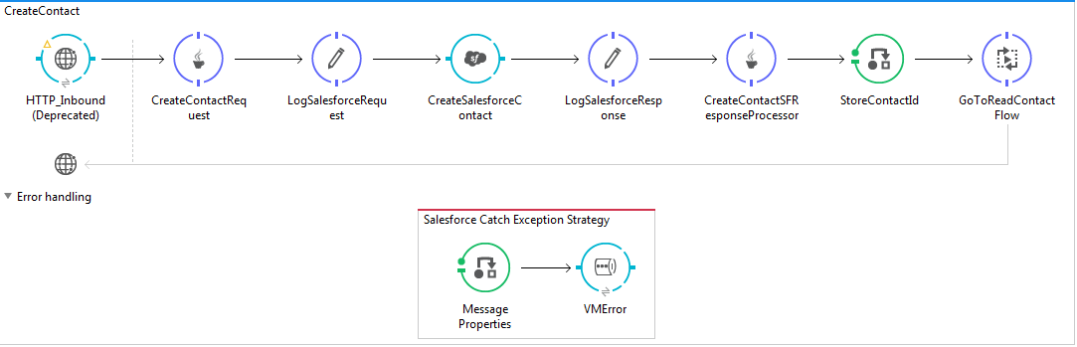

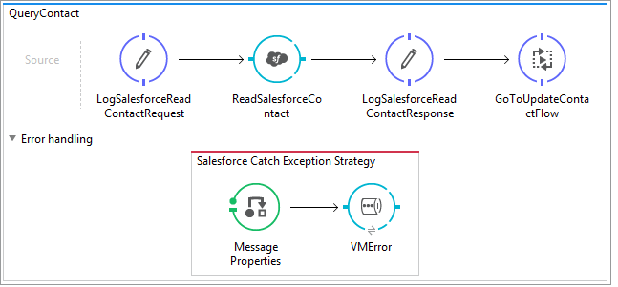

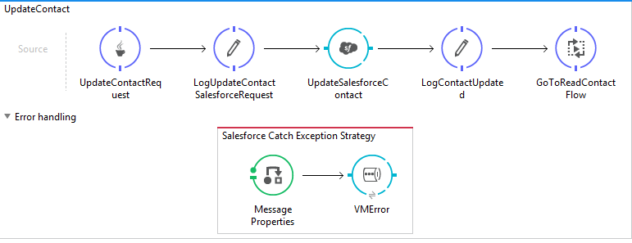

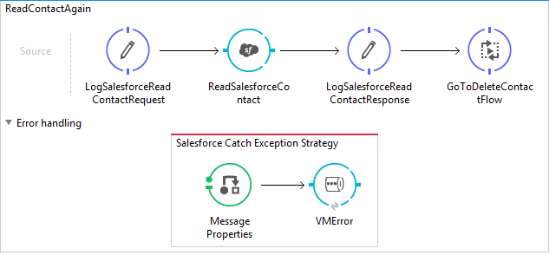

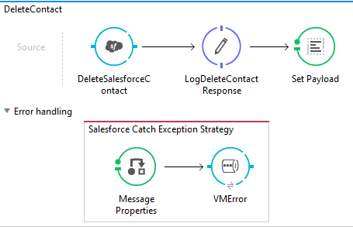

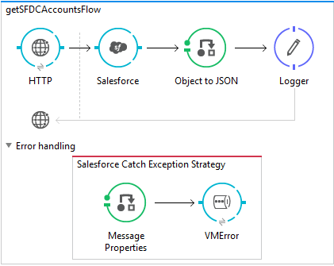

<?xml version=*"1.0"* encoding=*"UTF-8"*?>

<mule xmlns:vm=*"http://www.mulesoft.org/schema/mule/vm"*

xmlns:json=*"http://www.mulesoft.org/schema/mule/json"*

xmlns:http=*"http://www.mulesoft.org/schema/mule/http"* xmlns:sfdc=*"http://www.mulesoft.org/schema/mule/sfdc"* xmlns=*"http://www.mulesoft.org/schema/mule/core"* xmlns:doc=*"http://www.mulesoft.org/schema/mule/documentation"*

xmlns:spring=*"http://www.springframework.org/schema/beans"*

xmlns:xsi=*"http://www.w3.org/2001/XMLSchema-instance"*

xsi:schemaLocation=*"*

*http://www.mulesoft.org/schema/mule/vm http://www.mulesoft.org/schema/mule/vm/current/mule-vm.xsd http://www.mulesoft.org/schema/mule/json http://www.mulesoft.org/schema/mule/json/current/mule-json.xsd*

*http://www.springframework.org/schema/beans http://www.springframework.org/schema/beans/spring-beans-current.xsd*

*http://www.mulesoft.org/schema/mule/core http://www.mulesoft.org/schema/mule/core/current/mule.xsd*

*http://www.mulesoft.org/schema/mule/http http://www.mulesoft.org/schema/mule/http/current/mule-http.xsd*

*http://www.mulesoft.org/schema/mule/sfdc http://www.mulesoft.org/schema/mule/sfdc/current/mule-sfdc.xsd"*>

<flow name=*"CreateContact"*>

<http:inbound-endpoint exchange-pattern=*"request-response"* host=*"localhost"* port=*"1001"* path=*"SFDC_CRUD"* doc:name=*"HTTP_Inbound"*/>

<component class=*"com.sf.crud.CreateContactRequest"* doc:name=*"CreateContactRequest"*/>

<logger message=*"Salesforce Request----&gt; #[payload]"* level=*"INFO"* doc:name=*"LogSalesforceRequest"*/>

<sfdc:create config-ref=*"SalesforceBA"* doc:name=*"CreateSalesforceContact"* type=*"#[payload.type]"*>

<sfdc:objects ref=*"#[payload.objects]"*/>

</sfdc:create>

<logger message=*"SFDC output:: ------ #[payload]"* level=*"INFO"* doc:name=*"LogSalesforceResponse"*/>

<component class=*"com.sf.crud.CreateContactResponseProcessor"* doc:name=*"CreateContactSFResponseProcessor"*/>

<message-properties-transformer overwrite=*"true"* scope=*"session"* doc:name=*"StoreContactId"*> <add-message-property key=*"sObjectId"* value=*"#[payload]"*/>

</message-properties-transformer>

<flow-ref name=*"QueryContact"* doc:name=*"GoToReadContactFlow"*/>

<catch-exception-strategy doc:name=*"Salesforce Catch Exception Strategy"*>

<message-properties-transformer scope=*"session"* doc:name=*"Message Properties"*>

<add-message-property key=*"errorprocess"* value=*"#['Salesforce']"*/>

<add-message-property key=*"errormessage"* value=*"#['Failed to create a contact']"*/>

<add-message-property key=*"erroradditionaltext"* value=*"#['Failed to create a contact in Salesforce']"*/>

</message-properties-transformer>

<vm:outbound-endpoint exchange-pattern=*"request-response"* path=*"Salesforce.queue.VMError"* doc:name=*"VMError"*/>

</catch-exception-strategy>

</flow>

<flow name=*"QueryContact"* doc:name=*"QueryContact"*>

<logger level=*"INFO"* doc:name=*"LogSalesforceReadContactRequest"*/>

<sfdc:query config-ref=*"SalesforceBA"* query=*"SELECT Id,Name,BillingStreet, BillingCity,BillingState,BillingPostalCode,BillingCountry FROM Account WHERE Id = '#[sessionVars.sObjectId]'"* doc:name=*"ReadSalesforceContact"*/>

<logger level=*"INFO"* doc:name=*"LogSalesforceReadContactResponse"* message=*"Created contact details : #[payload]"*/>

<flow-ref name=*"UpdateContact"* doc:name=*"GoToUpdateContactFlow"*/>

<catch-exception-strategy doc:name=*"Salesforce Catch Exception Strategy"*>

<message-properties-transformer scope=*"session"* doc:name=*"Message Properties"*>

<add-message-property key=*"errorprocess"* value=*"#['Salesforce']"*/>

<add-message-property key=*"errormessage"* value=*"#['Failed to update a contact']"*/>

<add-message-property key=*"erroradditionaltext"* value=*"#['Failed to update a contact in Salesforce']"*/>

</message-properties-transformer>

<vm:outbound-endpoint exchange-pattern=*"request-response"* path=*"Salesforce.queue.VMError"* doc:name=*"VMError"*/>

</catch-exception-strategy>

</flow>

<flow name=*"UpdateContact"* doc:name=*"UpdateContact"*>

<component class=*"com.sf.crud.UpdateContactRequest"* doc:name=*"UpdateContactRequest"*/>

<logger message=*"Update Request----&gt; #[payload]"* level=*"INFO"* doc:name=*"LogUpdateContactSalesforceRequest"*/>

<sfdc:update-single config-ref=*"SalesforceBA"* type=*"#[payload.type]"* doc:name=*"UpdateSalesforceContact"*>

<sfdc:object ref=*"#[payload.object]"*/>

</sfdc:update-single>

<logger message=*"Update Output----&gt; #[payload]"* level=*"INFO"* doc:name=*"LogContactUpdated"*/>

<flow-ref name=*"ReadContactAgain"* doc:name=*"GoToReadContactFlow"*/>

<catch-exception-strategy doc:name=*"Salesforce Catch Exception Strategy"*>

<message-properties-transformer scope=*"session"* doc:name=*"Message Properties"*>

<add-message-property key=*"errorprocess"* value=*"#['Salesforce']"*/>

<add-message-property key=*"errormessage"* value=*"#['Failed to update a contact']"*/>

<add-message-property key=*"erroradditionaltext"* value=*"#['Failed to update a contact in Salesforce']"*/>

</message-properties-transformer>

<vm:outbound-endpoint exchange-pattern=*"request-response"* path=*"Salesforce.queue.VMError"* doc:name=*"VMError"*/>

</catch-exception-strategy>

</flow>

<flow name=*"ReadContactAgain"* doc:name=*"ReadContactAgain"*>

<logger level=*"INFO"* doc:name=*"LogSalesforceReadContactRequest"*/>

<sfdc:query config-ref=*"SalesforceBA"* query=*"SELECT Id,Name,BillingStreet, BillingCity,BillingState,BillingPostalCode,BillingCountry FROM Account WHERE Id = '#[sessionVars.sObjectId]'"* doc:name=*"ReadSalesforceContact"*/>

<logger level=*"INFO"* doc:name=*"LogSalesforceReadContactResponse"* message=*"Query Output: #[payload]"*/>

<flow-ref name=*"DeleteContact"* doc:name=*"GoToDeleteContactFlow"*/>

<catch-exception-strategy doc:name=*"Salesforce Catch Exception Strategy"*>

<message-properties-transformer scope=*"session"* doc:name=*"Message Properties"*>

<add-message-property key=*"errorprocess"* value=*"#['Salesforce']"*/>

<add-message-property key=*"errormessage"* value=*"#['Failed to create a account']"*/>

<add-message-property key=*"erroradditionaltext"* value=*"#['Failed to create a account in Salesforce']"*/>

</message-properties-transformer>

<vm:outbound-endpoint exchange-pattern=*"request-response"* path=*"Salesforce.queue.VMError"* doc:name=*"VMError"*/>

</catch-exception-strategy>

</flow>

<flow name=*"DeleteContact"* doc:name=*"DeleteContact"*>

<sfdc:delete config-ref=*"SalesforceBA"* doc:name=*"DeleteSalesforceContact"*>

<sfdc:ids> <sfdc:id>#[sessionVars.sObjectId]</sfdc:id> </sfdc:ids>

</sfdc:delete>

<logger level=*"INFO"* doc:name=*"LogDeleteContactResponse"* message=*"Delete Output-----&gt; #[payload]"*/>

<set-payload value=*"&quot;CRUD Operations executed successfully. Please check the logs for details&quot;"* doc:name=*"Set Payload"*/>

<catch-exception-strategy doc:name=*"Salesforce Catch Exception Strategy"*>

<message-properties-transformer scope=*"session"* doc:name=*"Message Properties"*>

<add-message-property key=*"errorprocess"* value=*"#['Salesforce']"*/>

<add-message-property key=*"errormessage"* value=*"#['Failed to read a contact']"*/>

<add-message-property key=*"erroradditionaltext"* value=*"#['Failed to read a contact in Salesforce']"*/>

</message-properties-transformer>

<vm:outbound-endpoint exchange-pattern=*"request-response"* path=*"Salesforce.queue.VMError"* doc:name=*"VMError"*/>

</catch-exception-strategy>

</flow>

<flow name=*"getSFDCAccountsFlow"*>

<http:listener config-ref=*"HTTP_Listener_Configuration"* path=*"/sfdc"* doc:name=*"HTTP"*/>

<sfdc:query config-ref=*"SalesforceBA"* query=*"dsql:SELECT AccountNumber,BillingCity,BillingCountry,BillingPostalCode,BillingState,BillingStreet,Name FROM Account WHERE BillingPostalCode = 'RM166BP'"* doc:name=*"Salesforce"*/>

<json:object-to-json-transformer doc:name=*"Object to JSON"*/>

<logger message=*"#[payload]"* level=*"INFO"* doc:name=*"Logger"*/>

<catch-exception-strategy doc:name=*"Salesforce Catch Exception Strategy"*>

<message-properties-transformer scope=*"session"* doc:name=*"Message Properties"*>

<add-message-property key=*"errorprocess"* value=*"#['Salesforce']"*/>

<add-message-property key=*"errormessage"* value=*"#['Failed to fetch an account']"*/>

<add-message-property key=*"erroradditionaltext"* value=*"#['Failed to fetch a contact an account']"*/>

</message-properties-transformer>

<vm:outbound-endpoint exchange-pattern=*"request-response"* path=*"Salesforce.queue.VMError"* doc:name=*"VMError"*/>

</catch-exception-strategy>

</flow>

</mule>

**Logs**

INFO 2017-01-10 20:26:27,791 [[Mule38SaaSMaven].connector.http.mule.default.receiver.03] org.mule.api.processor.LoggerMessageProcessor: **Salesforce Request----> {type=Contact, objects=[{Email=nivi.kundem@bp.com, FirstName=Nivi, MobilePhone=0000, LastName=Kundem**}]}

INFO 2017-01-10 20:26:28,245 [[Mule38SaaSMaven].connector.http.mule.default.receiver.03] org.mule.api.processor.LoggerMessageProcessor: SFDC output:: ------ **[[SaveResult errors='{[0]}'**

**id='0035800000i1csFAAQ'**

**success='true'**

]

]

INFO 2017-01-10 20:26:28,248 [[Mule38SaaSMaven].connector.http.mule.default.receiver.03] org.mule.api.processor.LoggerMessageProcessor: Created contact details : org.mule.streaming.ConsumerIterator@46da830c

INFO 2017-01-10 20:26:28,249 [[Mule38SaaSMaven].connector.http.mule.default.receiver.03] org.mule.api.processor.LoggerMessageProcessor: **Update Request----> {object={Email=nivi.kundem2@bp.com, FirstName=Nivi2, Id=0035800000i1csFAAQ, MobilePhone=2222, LastName=Kundem2**}, type=Contact}

INFO 2017-01-10 20:26:28,597 [[Mule38SaaSMaven].connector.http.mule.default.receiver.03] org.mule.api.processor.LoggerMessageProcessor: Update Output----> [SaveResult errors='{[0]}'

id='0035800000i1csFAAQ'

success='true'

]

org.mule.api.processor.LoggerMessageProcessor: Delete Output-----> [[DeleteResult errors='{[0]}'

id='0035800000i1csFAAQ'

success='true'

]

]

**Output**

Before executing the interface

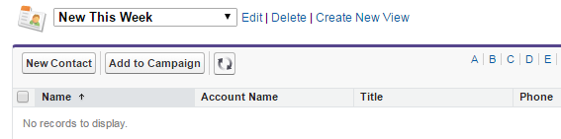

After executing or triggering the create

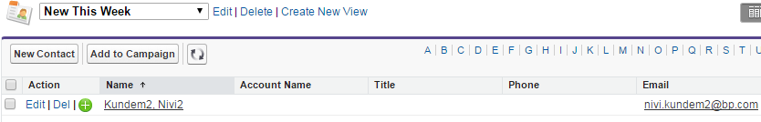

1. **Salesforce3Subscriber**

Whenever account transactions amends in the salesforce.

Mule Salesforce subscriber fetches that transactions.

For this create a TOPIC in the salesforce by following below steps

In the Salesforce’s Developer console

Publish topic in the Salesforce developer control

PushTopic pushTopic = new PushTopic();

pushTopic.ApiVersion = 23.0;

pushTopic.Name = 'Account6';

pushTopic.Description = 'All records for the Account object';

pushtopic.Query = 'SELECT Id, Name FROM Account';

insert pushTopic;

System.debug('Created new PushTopic: '+ pushTopic.Id);

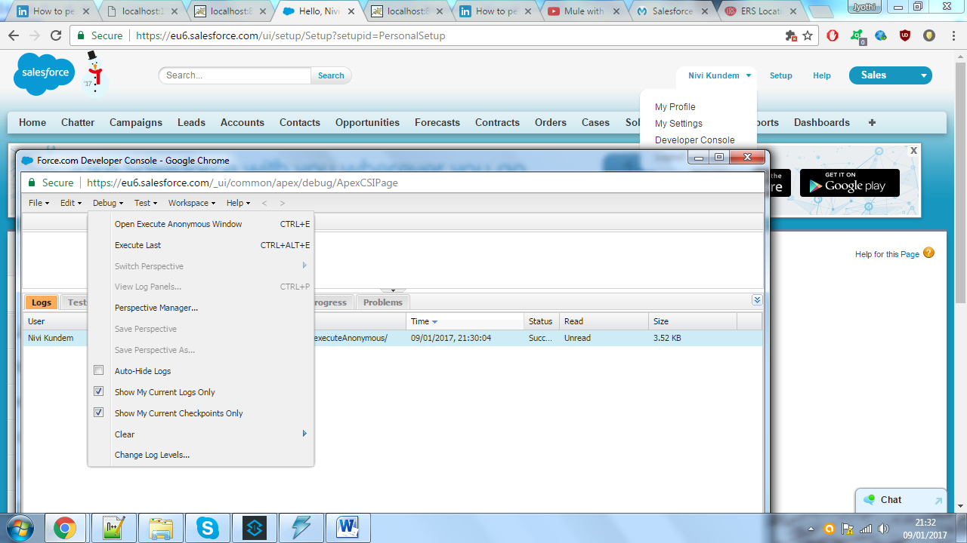

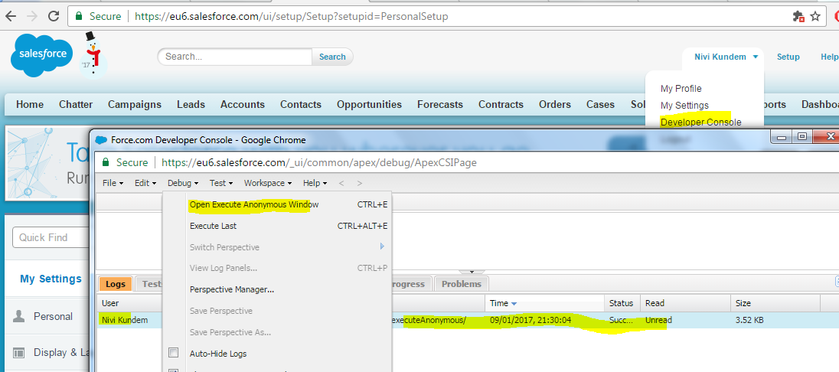

Consume the topic using MULE ESB subscriber

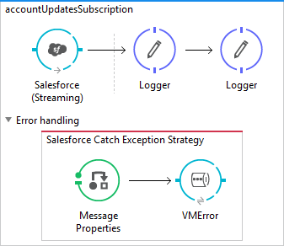

**Config XML**

<?xml version=*"1.0"* encoding=*"UTF-8"*?>

<mule xmlns:vm=*"http://www.mulesoft.org/schema/mule/vm"*

xmlns:http=*"http://www.mulesoft.org/schema/mule/http"* xmlns:sfdc=*"http://www.mulesoft.org/schema/mule/sfdc"*

xmlns=*"http://www.mulesoft.org/schema/mule/core"* xmlns:doc=*"http://www.mulesoft.org/schema/mule/documentation"*

xmlns:spring=*"http://www.springframework.org/schema/beans"*

xmlns:xsi=*"http://www.w3.org/2001/XMLSchema-instance"*

xsi:schemaLocation=*"*

*http://www.mulesoft.org/schema/mule/vm http://www.mulesoft.org/schema/mule/vm/current/mule-vm.xsd http://www.mulesoft.org/schema/mule/sfdc http://www.mulesoft.org/schema/mule/sfdc/current/mule-sfdc.xsd*

*http://www.springframework.org/schema/beans http://www.springframework.org/schema/beans/spring-beans-current.xsd*

*http://www.mulesoft.org/schema/mule/core http://www.mulesoft.org/schema/mule/core/current/mule.xsd*

*http://www.mulesoft.org/schema/mule/http http://www.mulesoft.org/schema/mule/http/current/mule-http.xsd"*>

<flow name=*"accountUpdatesSubscription"*>

<sfdc:subscribe-topic topic=*"Account6"* config-ref=*"SalesforceBA"* doc:name=*"Salesforce (Streaming)"*/> <!-- INBOUND ENDPOINT -->

<!-- REST OF YOUR FLOW -->

<logger level=*"INFO"* message=*"****** Received an event for Salesforce Object ID #[map-payload:Id]"* doc:name=*"Logger"*/>

<logger level=*"INFO"* message=*"****** Received an event for Salesforce Object ID #[map-payload:Name]"* doc:name=*"Logger"*/>

<catch-exception-strategy doc:name=*"Salesforce Catch Exception Strategy"*>

<message-properties-transformer scope=*"session"* doc:name=*"Message Properties"*>

<add-message-property key=*"errorprocess"* value=*"#['Salesforce']"*/>

<add-message-property key=*"errormessage"* value=*"#['Failed to subscribe post a change']"*/>

<add-message-property key=*"erroradditionaltext"* value=*"#['Failed to subscribe post a change in Salesforce']"*/>

</message-properties-transformer>

<vm:outbound-endpoint exchange-pattern=*"request-response"* path=*"Salesforce.queue.VMError"* doc:name=*"VMError"*/>

</catch-exception-strategy>

</flow>

</mule>

**Logs**

INFO 2017-01-10 20:47:11,006 [[Mule38SaaSMaven].accountUpdatesSubscription.stage1.02] org.mule.api.processor.LoggerMessageProcessor: ****** Received an event for Salesforce Object ID 00158000002XCC7AAO

INFO 2017-01-10 20:47:11,006 [[Mule38SaaSMaven].accountUpdatesSubscription.stage1.02] org.mule.api.processor.LoggerMessageProcessor: ****** **Received an event for Salesforce Object ID Johnny Depp**