**VBSDWDataweave NK25012016 {MULE3.7}**

Mule 3.7 Demo for Converting files from XML/JSON/EXCEL to standard XML using Dataweave ,java objects , inserting into the DB and sending the xml using SOA (REST / SOAP) clients

**Vbs1GetInputFiles**

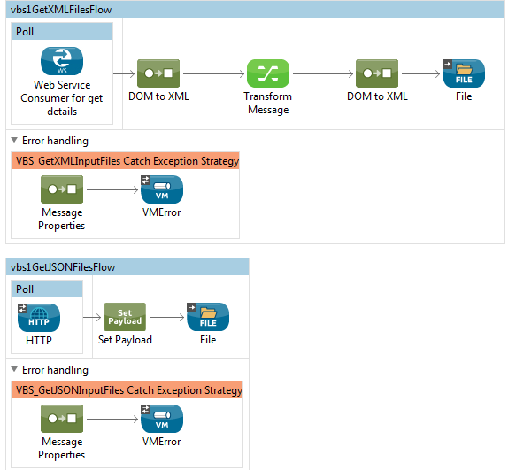

**Vbs2FileProcessor**

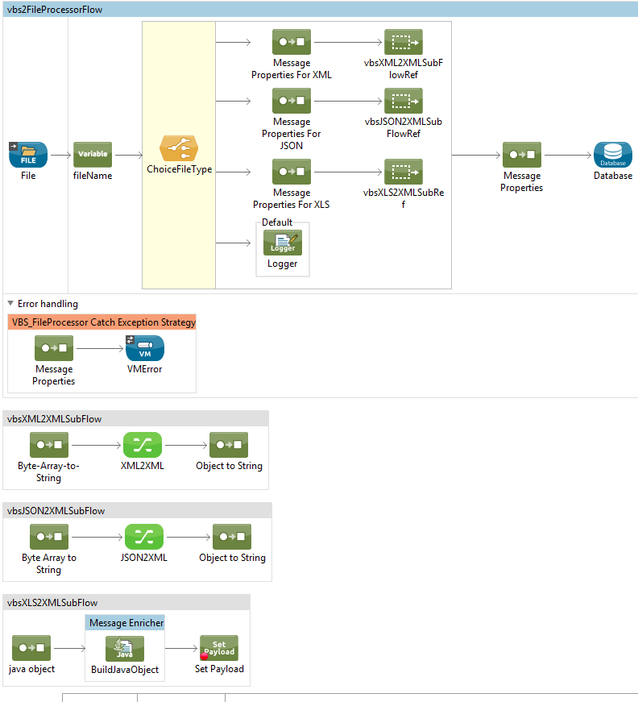

**Vbs3MessageProcessor**

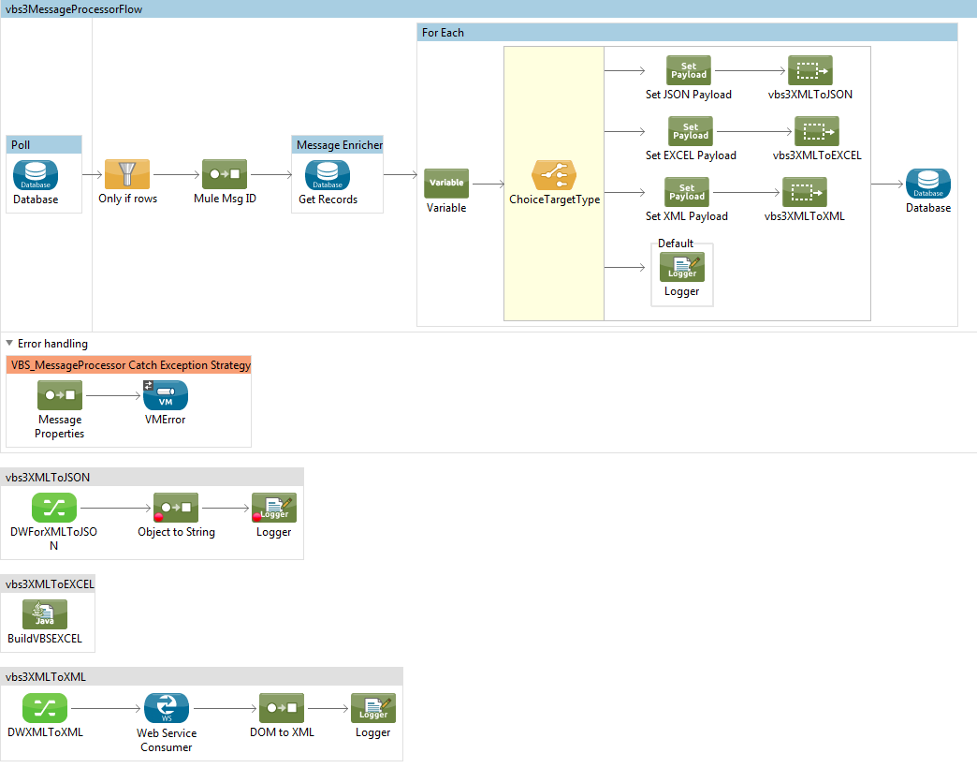

**Vbs4ErrorInsertVM**

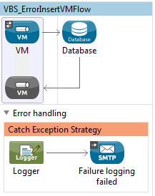

**Vbs99999Global**

