**MULE38BPMAVEN {NK12112016}**

**Mule flows:**

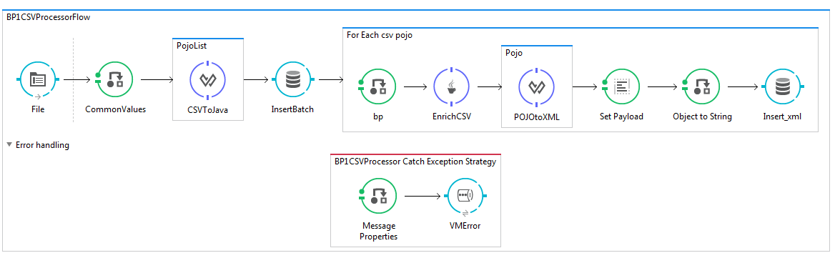

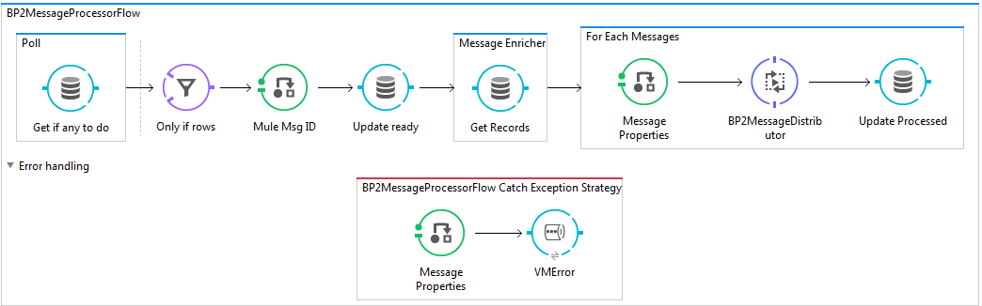

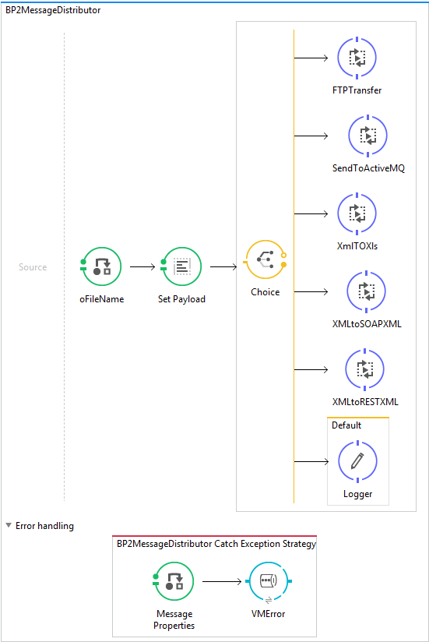

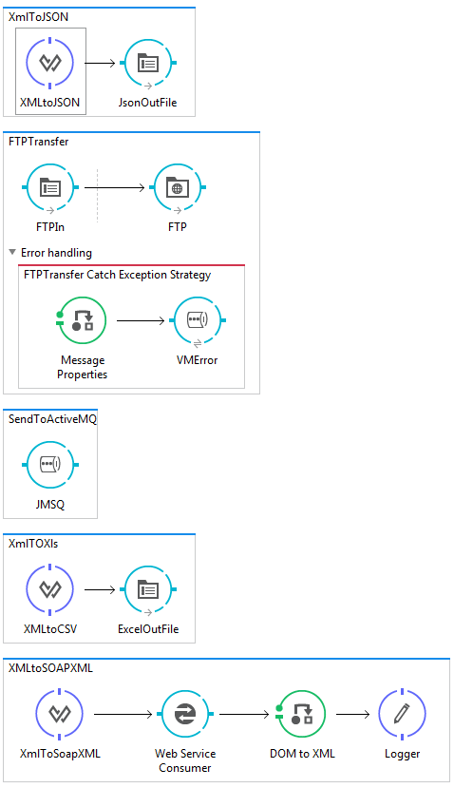

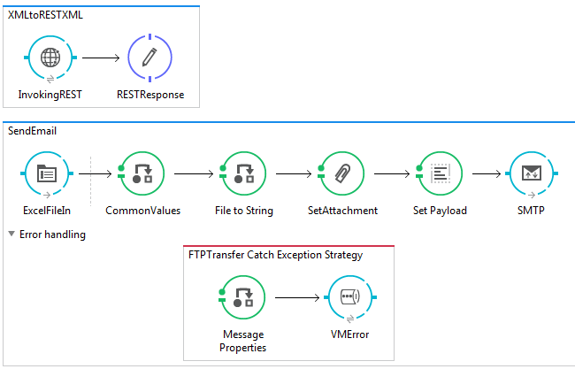

**Global flow{config flow}**

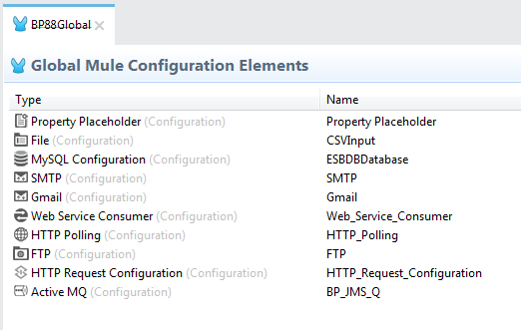

**Catch exception strategies logger flow**

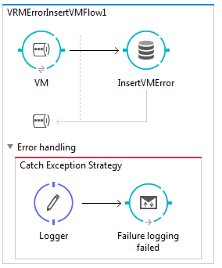

**Project/Interface Structure**

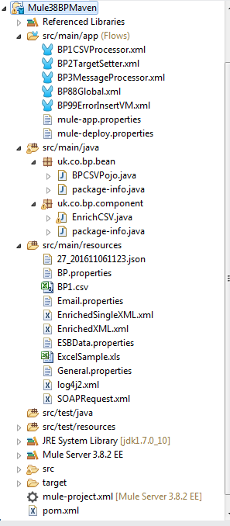

**ActiveMQ Details**

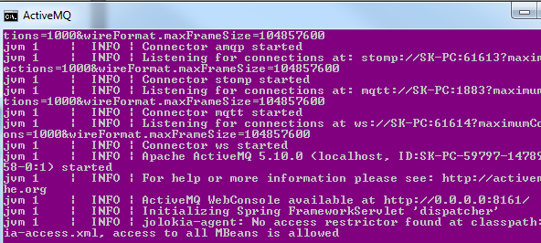

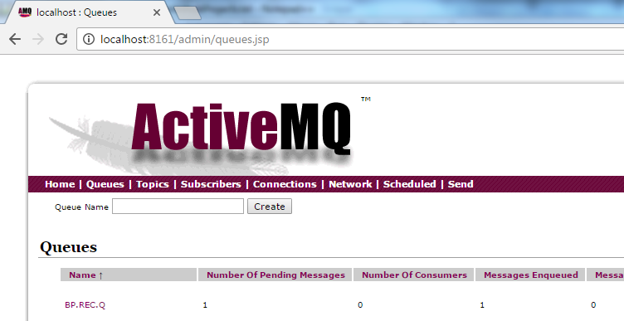

**Input/archive folders structure**

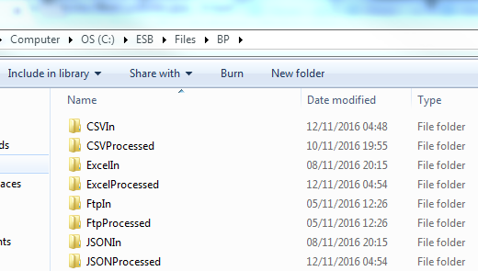

**REST sample**

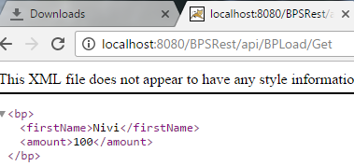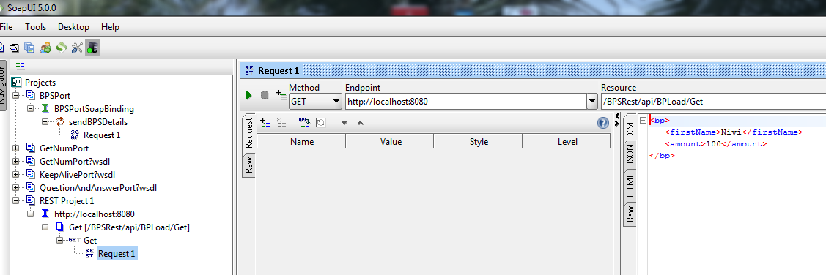

**Soap sample**

<soapenv:Envelope xmlns:soapenv="http://schemas.xmlsoap.org/soap/envelope/" xmlns:bps="http://www.nivi.com/BPSWS/">

<soapenv:Header/>

<soapenv:Body>

<bps:sendBPSDetails>

<BPLoad>

<DateGenerated>?</DateGenerated>

<BPLoadList>

<BP>

<TransactionRef>a</TransactionRef>

<TransactionType>EXCEL</TransactionType>

<TransactionNumber>c</TransactionNumber>

<FirstName>Nivi</FirstName>

<LastName>Kundem</LastName>

<Amount>100</Amount>

</BP>

</BPLoadList>

</BPLoad>

</bps:sendBPSDetails>

</soapenv:Body>

</soapenv:Envelope>

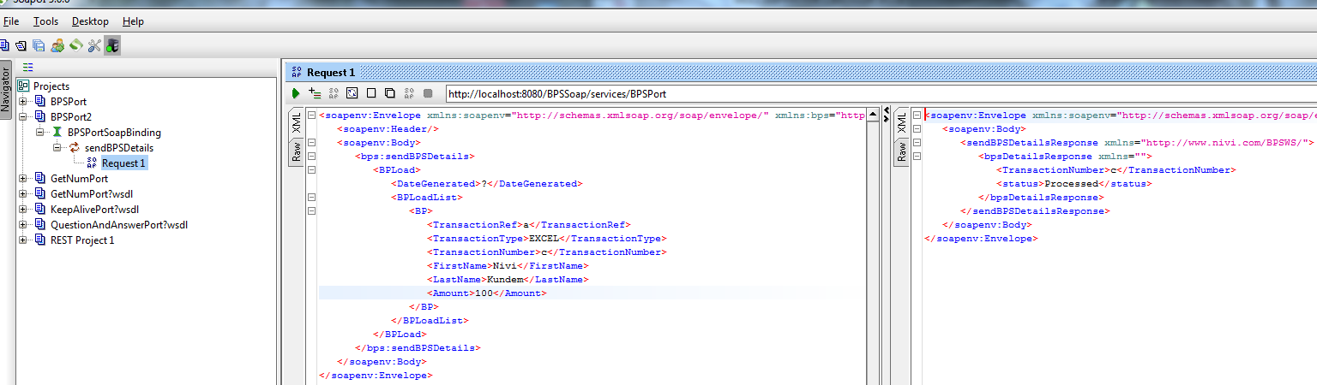

**DB**

**Batch table**



**BPTransaction table**

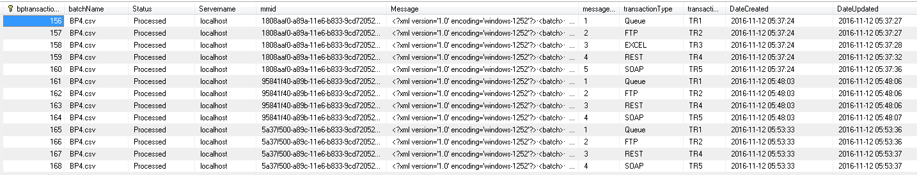

**FTP**

