Mule3.8 AWS [Amazon webservices] S3 and SQS

**Mule Flows**

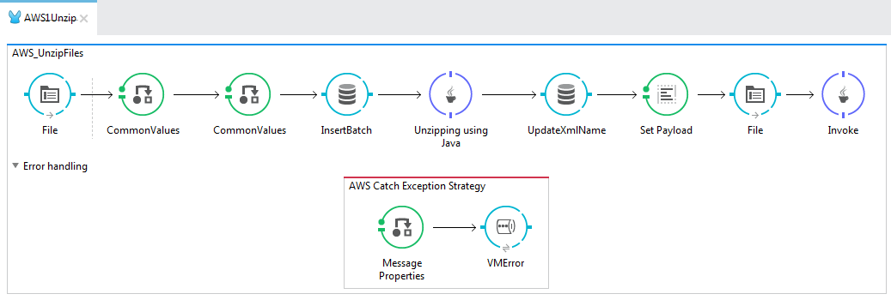

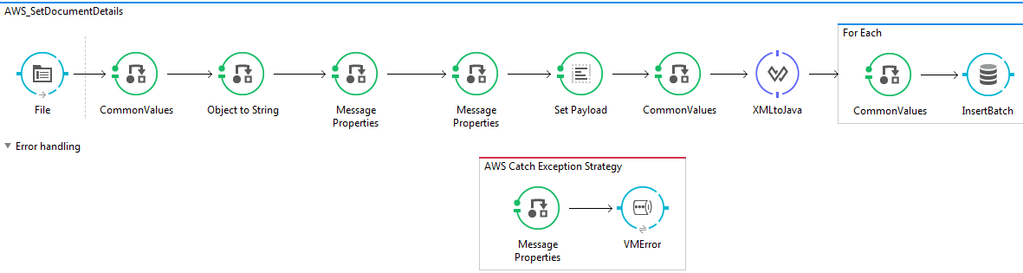

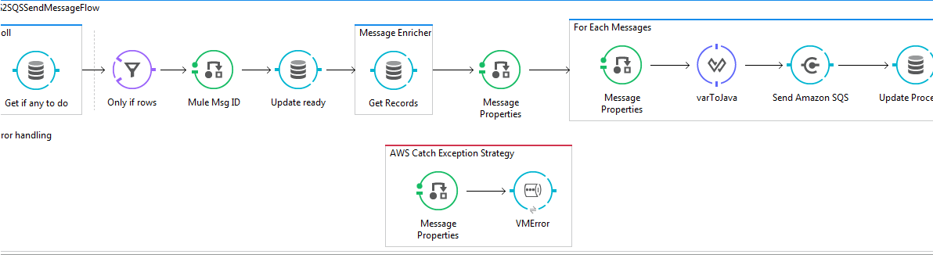

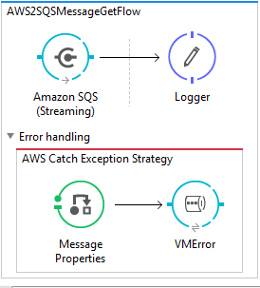

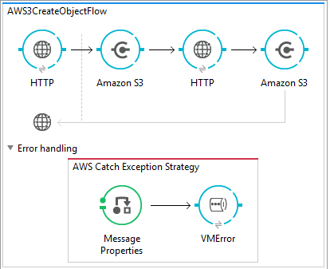

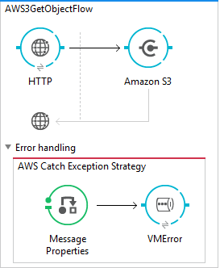

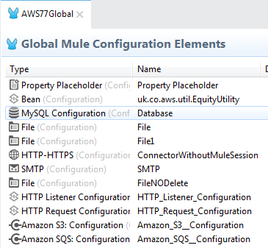

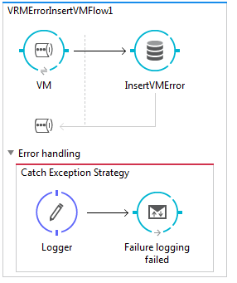

**Interface/Project structure**

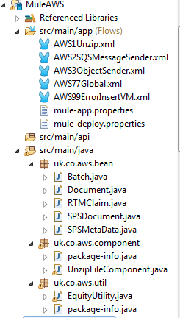

**AWS console details**

**AWS SQS**

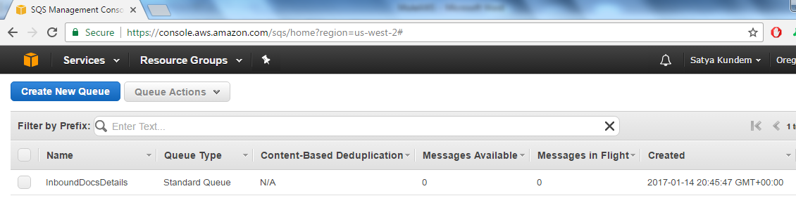

INFO 2017-01-16 17:13:18,613 [[MuleAWS].File.receiver.01] org.mule.transport.file.FileMessageReceiver: Lock obtained on file: C:\ESB\Files\Aws\Zip\Good.zip

xmlName 20141201094706201.XML

INFO 2017-01-16 17:13:19,499 [[MuleAWS].File.receiver.01] org.mule.lifecycle.AbstractLifecycleManager: Initialising: 'File1.dispatcher.1416931108'. Object is: FileMessageDispatcher

INFO 2017-01-16 17:13:19,499 [[MuleAWS].File.receiver.01] org.mule.lifecycle.AbstractLifecycleManager: Starting: 'File1.dispatcher.1416931108'. Object is: FileMessageDispatcher

INFO 2017-01-16 17:13:19,521 [[MuleAWS].File.receiver.01] org.mule.transport.file.FileConnector: Writing file to: C:\ESB\Files\Aws\Image\localhost\ZipProcessed\Good.zip

INFO 2017-01-16 17:13:19,677 [[MuleAWS].File1.receiver.01] org.mule.transport.file.FileMessageReceiver: Lock obtained on file: C:\ESB\Files\Aws\InDev\20141201094706201.XML

INFO 2017-01-16 17:13:31,315 [[MuleAWS].AWS2SQSMessageGetFlow.stage1.02] org.mule.api.processor.LoggerMessageProcessor: Message :: docId : 782805,docName : 01463159.PDF

INFO 2017-01-16 17:13:31,481 [[MuleAWS].AWS2SQSMessageGetFlow.stage1.02] org.mule.api.processor.LoggerMessageProcessor: Message :: docId : 782808,docName : 0146315C.PDF

INFO 2017-01-16 17:13:31,978 [[MuleAWS].AWS2SQSMessageGetFlow.stage1.02] org.mule.api.processor.LoggerMessageProcessor: Message :: docId : 782806,docName : 0146315A.PDF

INFO 2017-01-16 17:13:32,153 [[MuleAWS].AWS2SQSMessageGetFlow.stage1.02] org.mule.api.processor.LoggerMessageProcessor: Message :: docId : 782809,docName : 0146315D.PDF

INFO 2017-01-16 17:13:32,325 [[MuleAWS].AWS2SQSMessageGetFlow.stage1.02] org.mule.api.processor.LoggerMessageProcessor: Message :: docId : 782804,docName : 01463158.PDF

INFO 2017-01-16 17:13:32,502 [[MuleAWS].AWS2SQSMessageGetFlow.stage1.02] org.mule.api.processor.LoggerMessageProcessor: Message :: docId : 782810,docName : 0146315E.PDF

INFO 2017-01-16 17:13:32,674 [[MuleAWS].AWS2SQSMessageGetFlow.stage1.02] org.mule.api.processor.LoggerMessageProcessor: Message :: docId : 782807,docName : 0146315B.PDF

**AWS S3**

[**http://localhost:8081/CreateObject**](http://localhost:8081/CreateObject)

[**http://localhost:8081/GetObject**](http://localhost:8081/GetObject)

