**Implementation of the Springboot web application : SpringbootQE2WebApplication :**

http://localhost:2211/VehicleRegistrationView

|  |  |
| --- | --- |
| **Technologies** | **Softwares** |
| Java 8/J2E Spring Boot Spring MVC Spring Security Spring JPA/Hibernate  Spring JMS/ActiveMQ Maven MySql Tomcat(Built In) JSP/JSTL HTML/CSS  Javascript/jQuery  SOAP Client/Server  REST Client/Server | **ActiveMQ** ::: admin/admin  Start :: C:\JobSearch\Softwares\ActiveMQ\apache-activemq-5.14.3\bin\win64 :: activemq  <http://localhost:8161/admin/queues.jsp>  **Tomcat** ::: admin/admin  Start :: C:\JobSearch\Softwares\Tomcat9\apache-tomcat-9.0.0.M17-windows-x64\apache-tomcat-9.0.0.M17\bin :: startup  http://localhost:2211/manager/html  **QE2Webapp** :::  http://localhost:2211/VehicleRegistrationView  **WSDL:**  http://localhost:2211/BridgeCrossingWS/services/BridgeCrossingPort.wsdl  **STS:**  C:\JobSearch\Softwares\spring-tool-suite-3.8.3.RELEASE-e4.6.2-win32-x86_64\sts-bundle\sts-3.8.3.RELEASE\STS.exe  **MySQL**::: root/root  C:\Program Files (x86)\MySQL\MySQL Query Browser 1.1\MySQLQueryBrowser.exe  **Postman [RestClient]**  <http://localhost:2211/ProxamaAPI/ProxamaAPIApplication/api/registration>  <http://localhost:2211/ProxamaAPI/ProxamaAPIApplication/api/store/1487228402700/nivii/kundem>  <http://localhost:2211/ProxamaAPI/ProxamaAPIApplication/api/retrieve/1487276157906/EX54NSN>  <http://localhost:2211/ProxamaAPI/ProxamaAPIApplication/api/retrieve/1487276157906> |

**Project Structure**

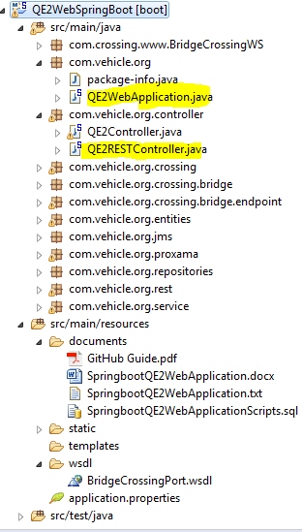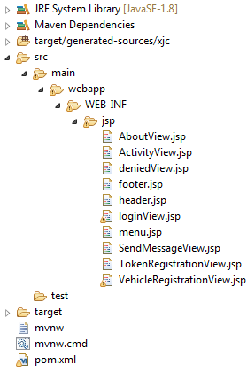

**Interface web application screenshots : http://localhost:2211/VehicleRegistrationView**

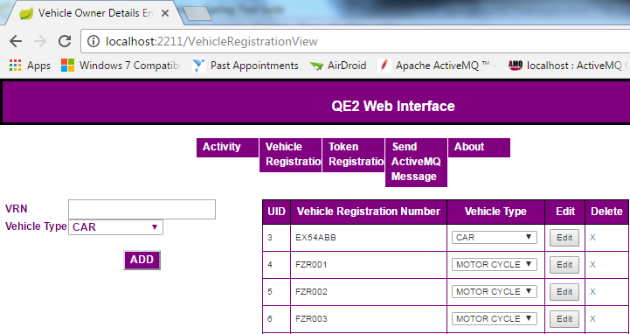

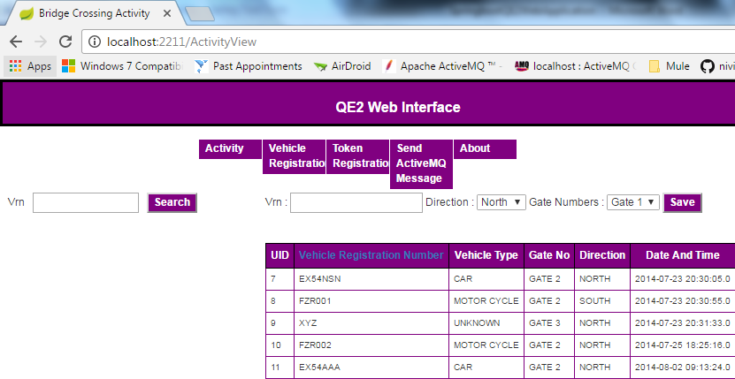

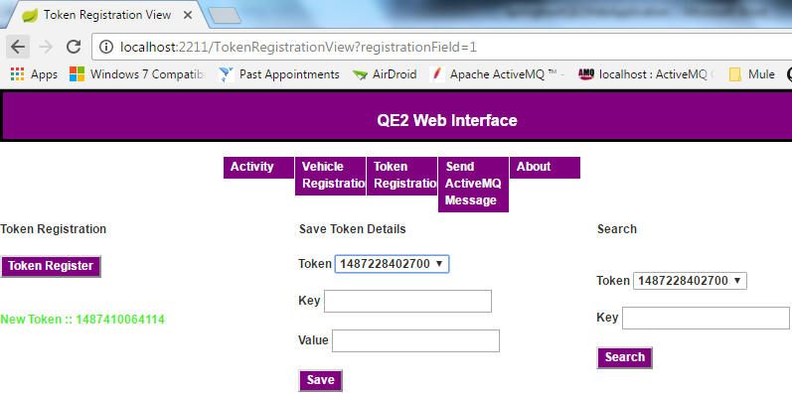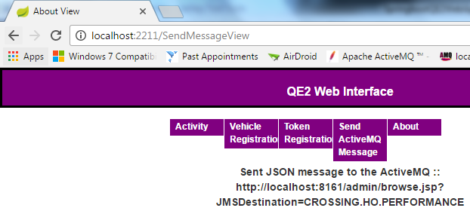

**ActiveMQ Screenshots**

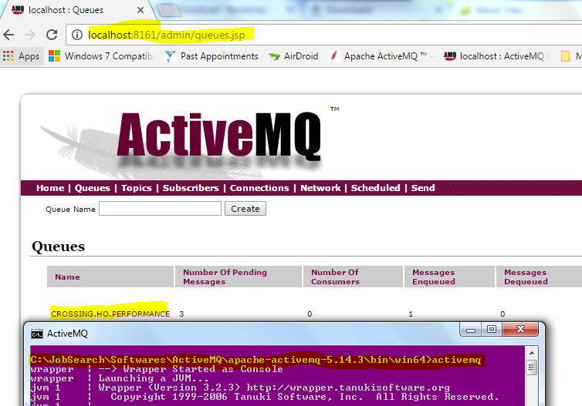

**Postman screenshots**

http://localhost:2211/ProxamaAPI/ProxamaAPIApplication/api/registration

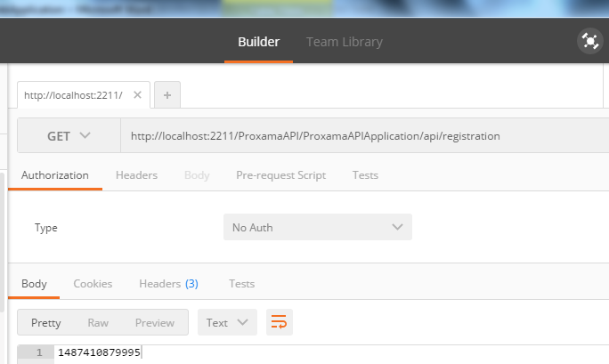

http://localhost:2211/ProxamaAPI/ProxamaAPIApplication/api/store/1487228402700/nivii/kundem

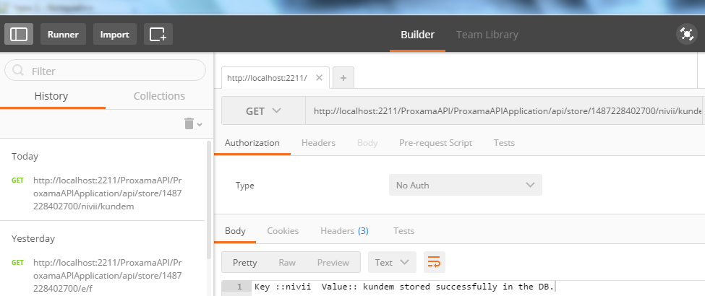

http://localhost:2211/ProxamaAPI/ProxamaAPIApplication/api/retrieve/1487276157906/EX54NSN

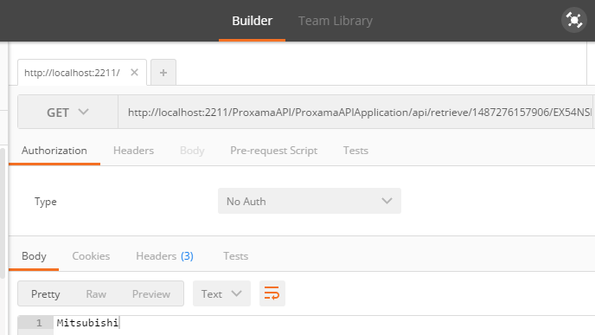

**http://localhost:2211/ProxamaAPI/ProxamaAPIApplication/api/retrieve/1487276157906**