Q1 Write a program to print multiples of a number upto a limit. Take inputs from the user.

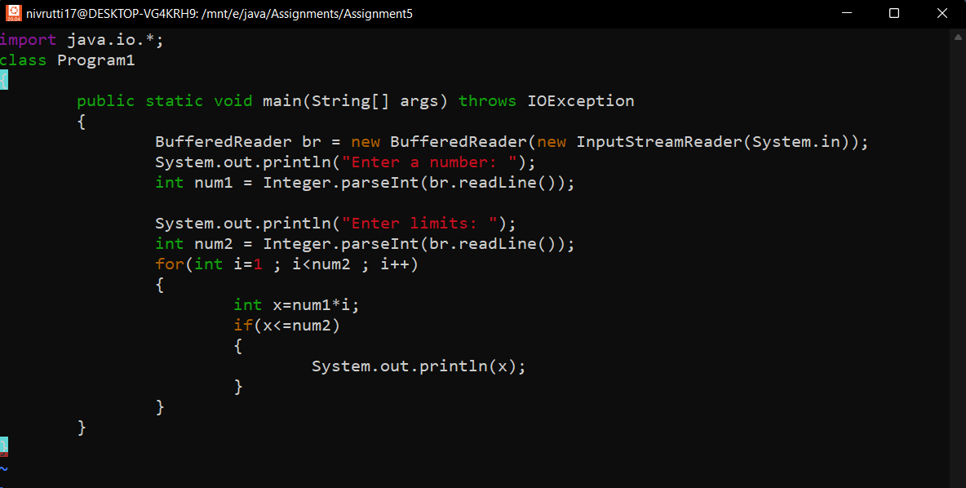

OUTPUT:

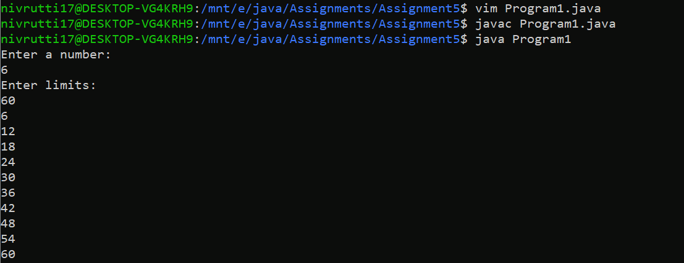

Q.2) write a program to print the following pattern & Take no of rows from the user.

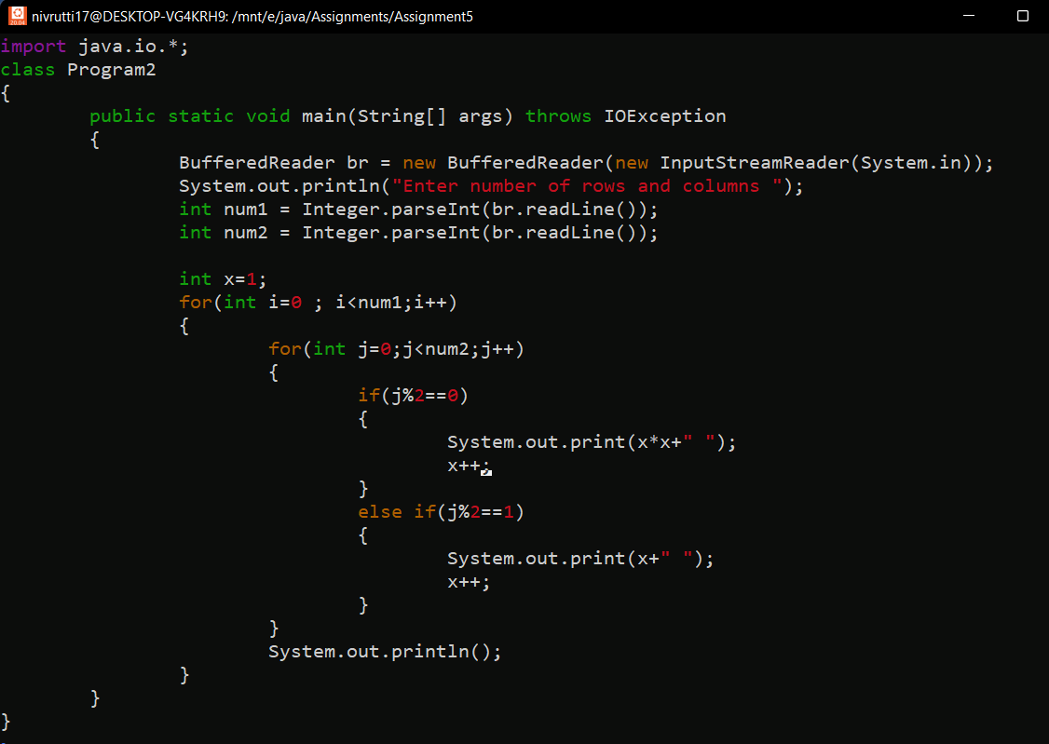

OUTPUT:

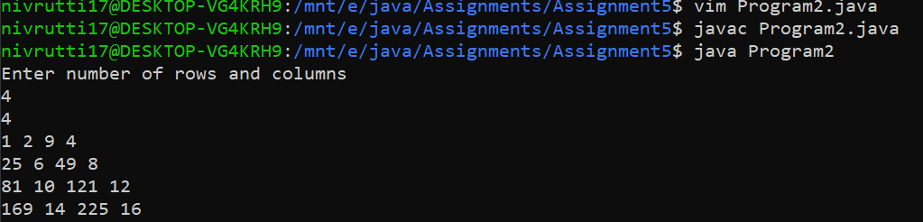

Q3

write a program to print the following pattern & Take no of rows from the user.

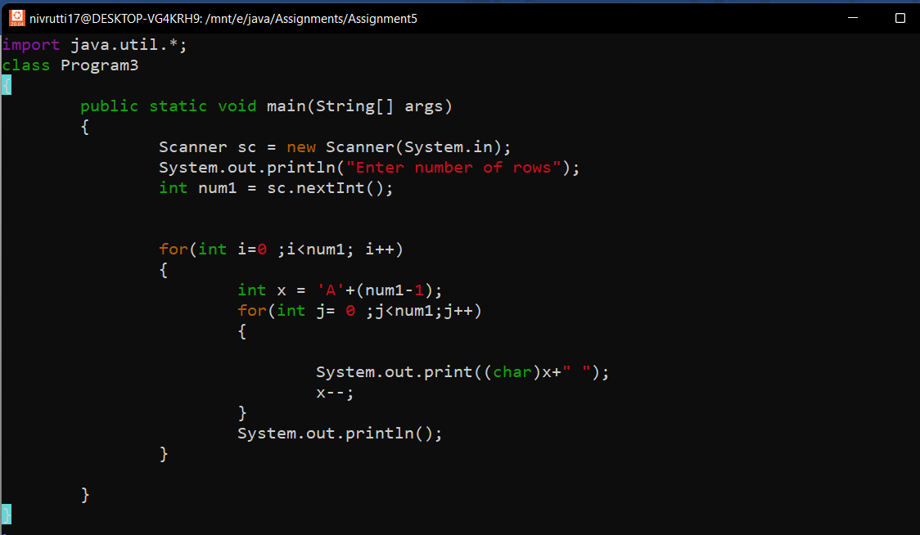

OUTPUT:

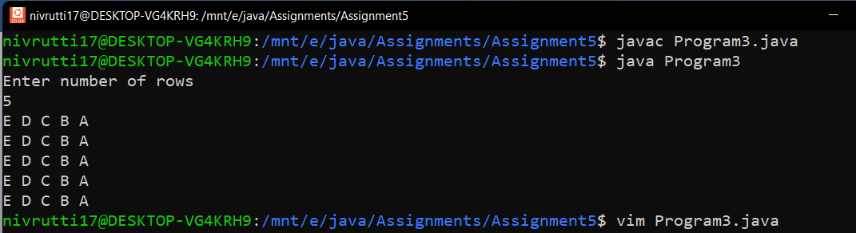

Q4 write a program to print the following pattern using a nested while loop & Take no of rows from the user.

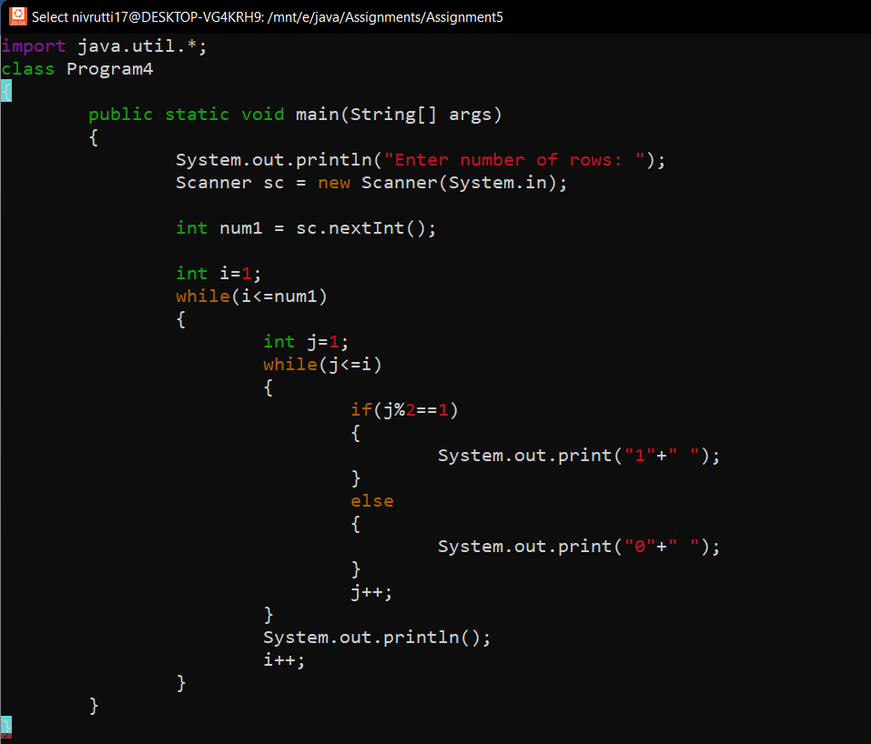

OUTPUT:

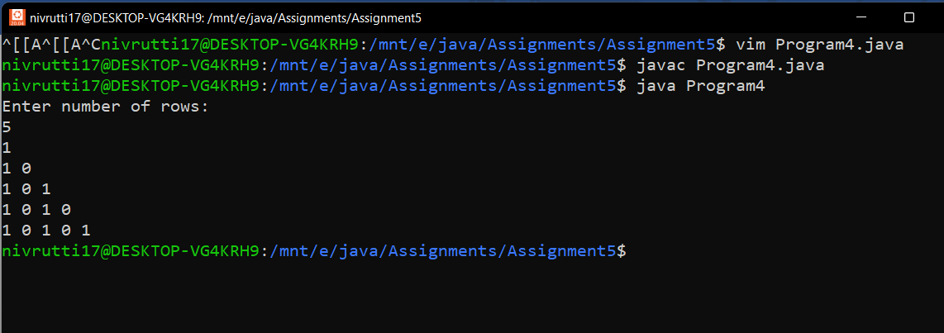

Q5 write a program to print the following pattern & Take no of rows from the user.

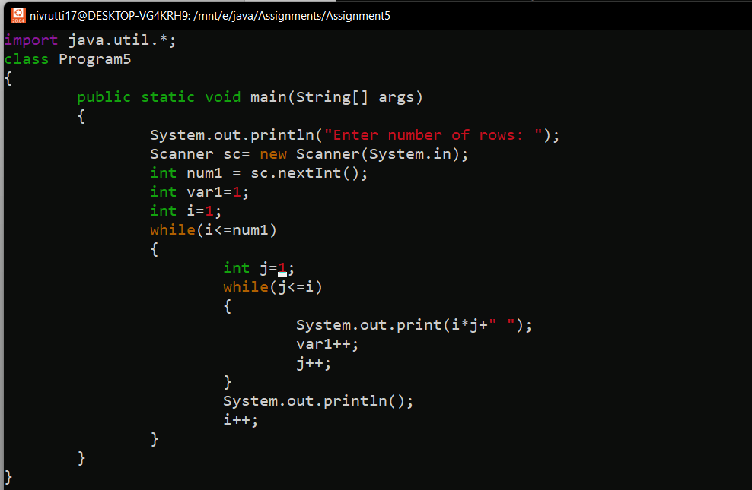

OUTPUT:

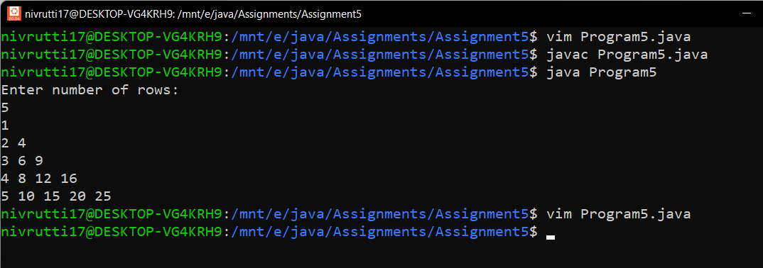

Q6 Write a program to print the tables of 1 to n numbers in reverse order.

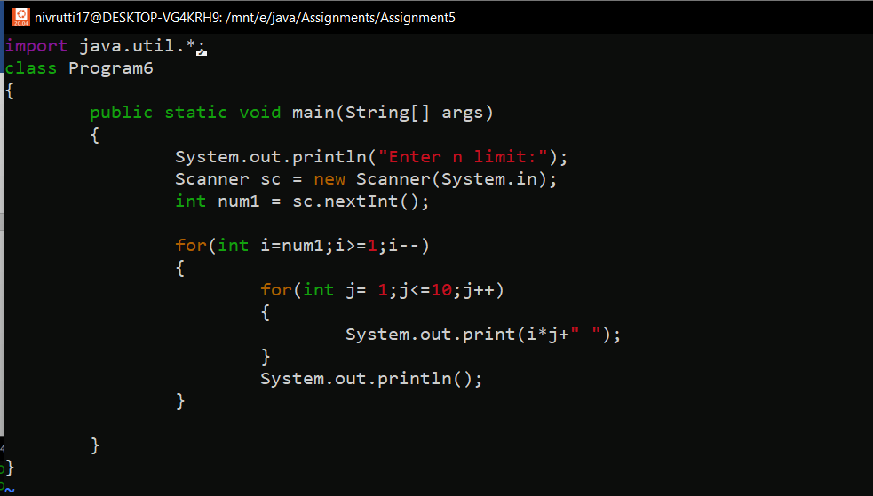

OUTPUT:

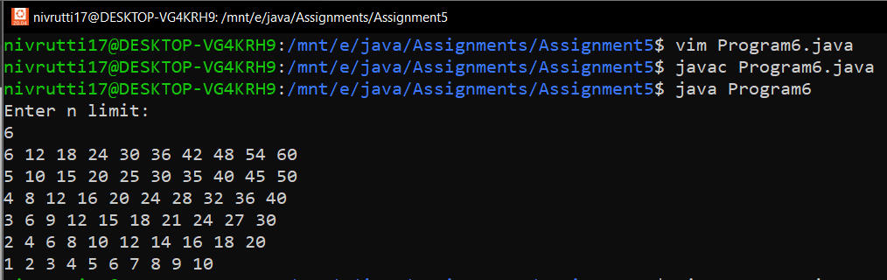

Q7 Write a program to print alternative numbers in reverse order between 15 to 30.

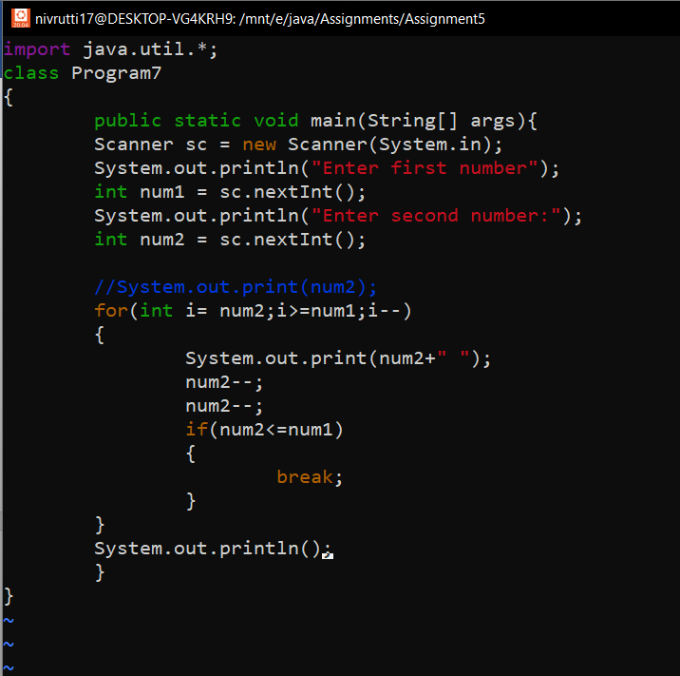

OUTPUT:

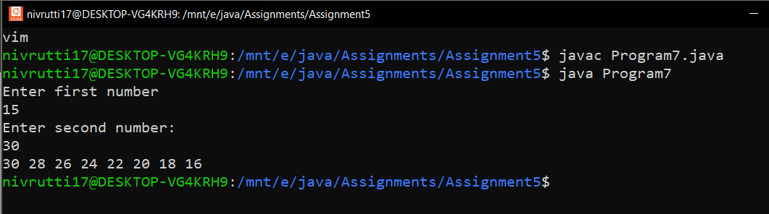

Q8)

Write a program to print the count of even numbers which are divisible by 5 from 1 to 50 .

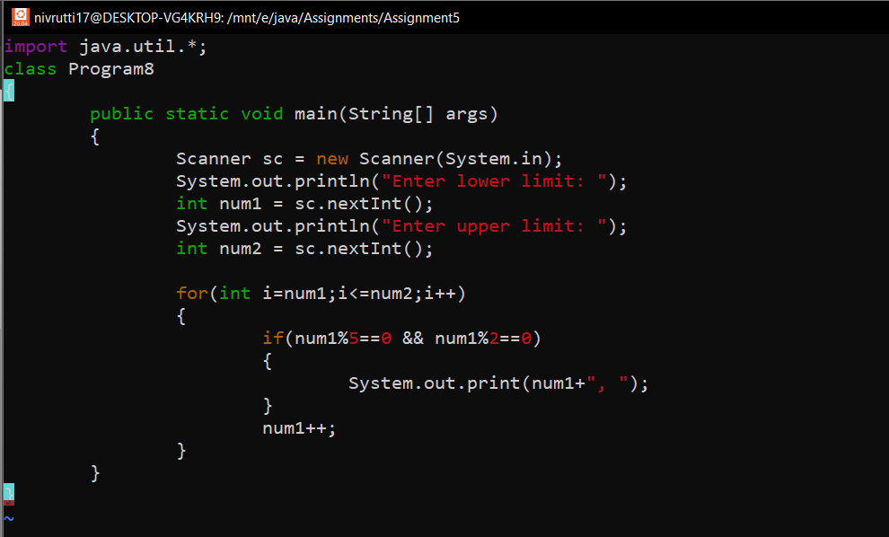

OUTPUT:

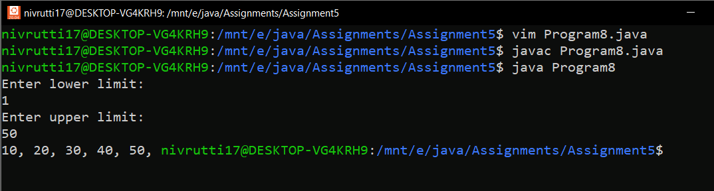

Q9 write a program to print the following pattern & Take no of rows from the user.

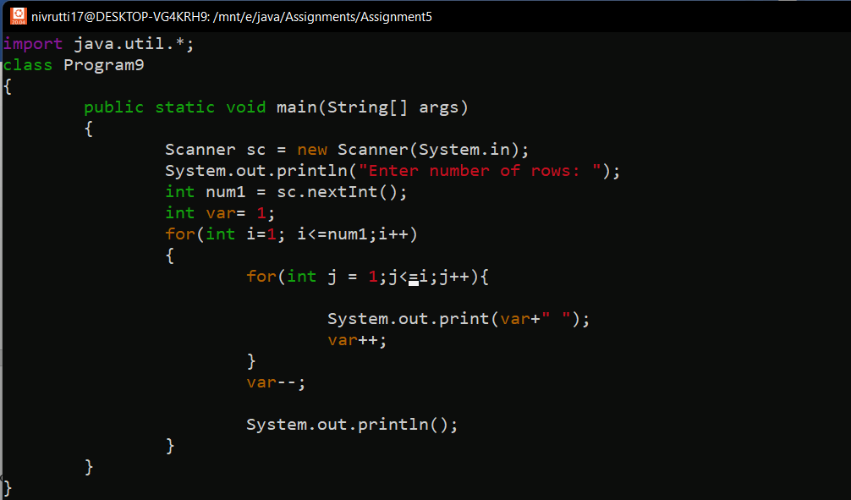

OUTPUT:

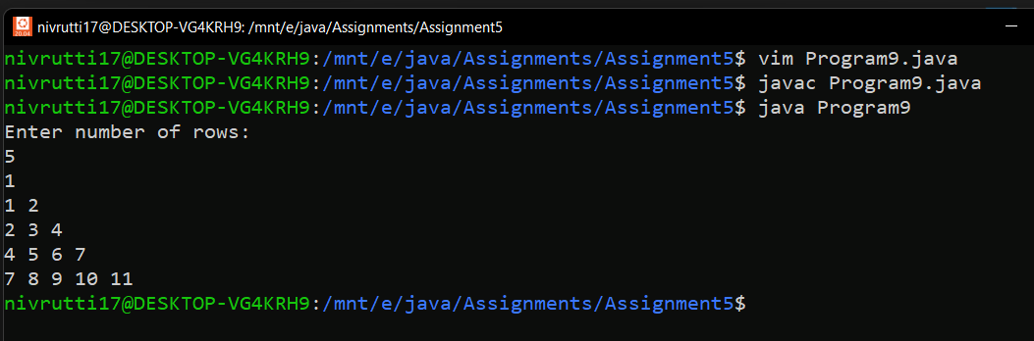

Q10 write a program to print a series of prime numbers from entered range. ( Take a start and end number from user ).

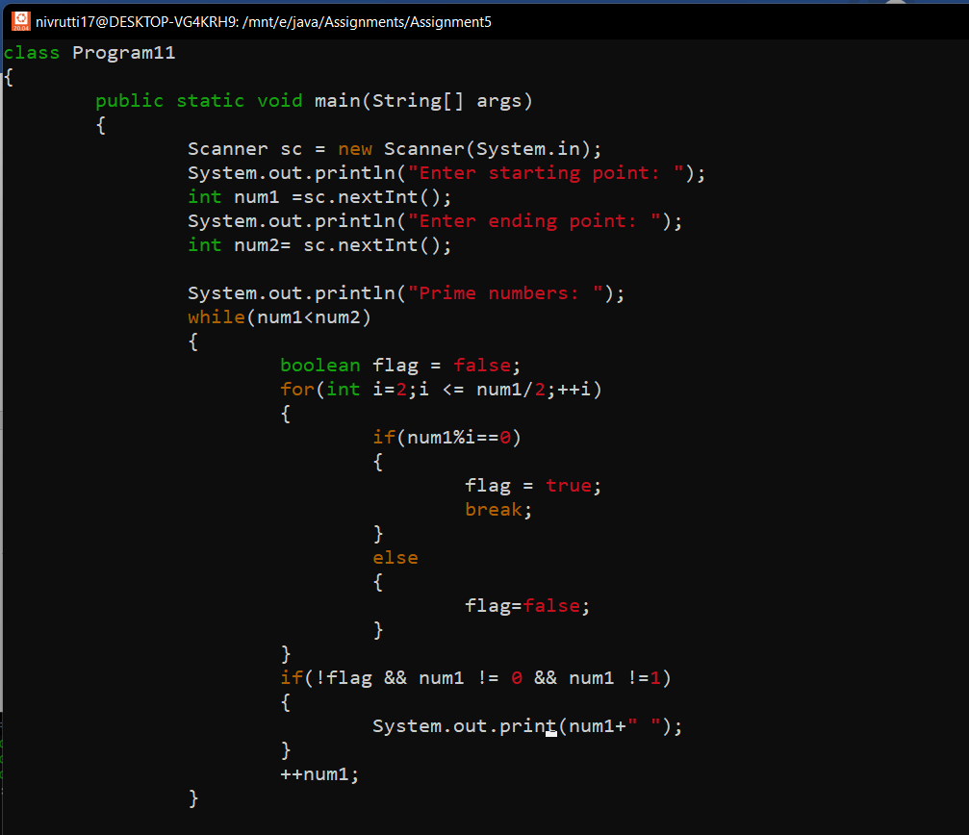

OUTPUT:

