Write a program in which ask the user to enter a number from 0 to 5 and print it's spelling,if the entered number is greater than 5 print entered number is greater than 5.

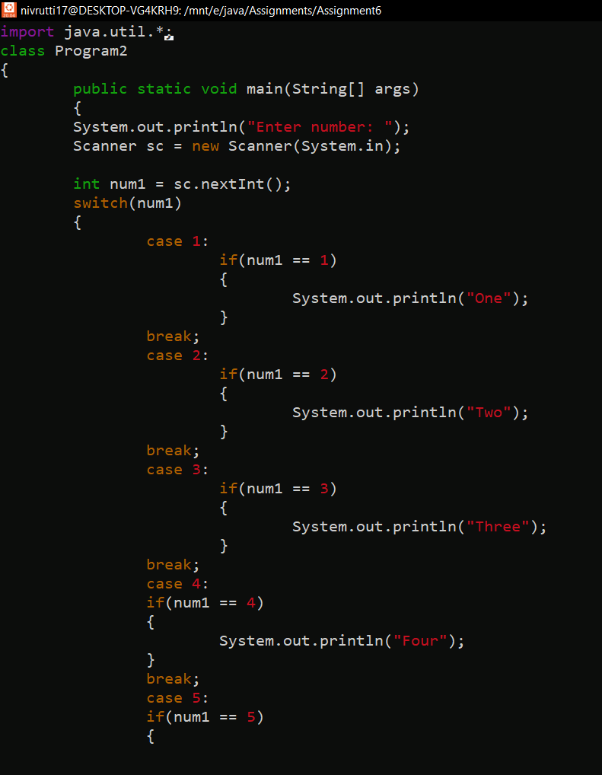

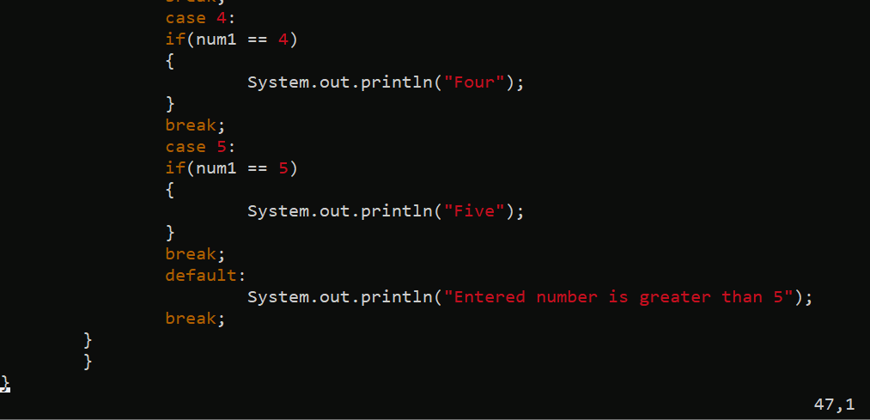

OUTPUT:

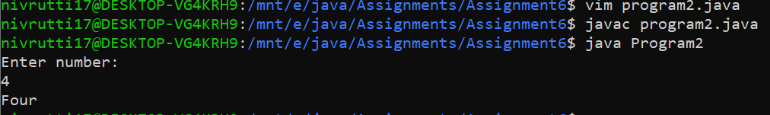

Write a program in which user should enter two numbers if both the numbers are positive multiply them and provide to switch case to verify number is even or odd, if user enters any negative number program should terminate saying “Sorry negative numbers not allowed”.

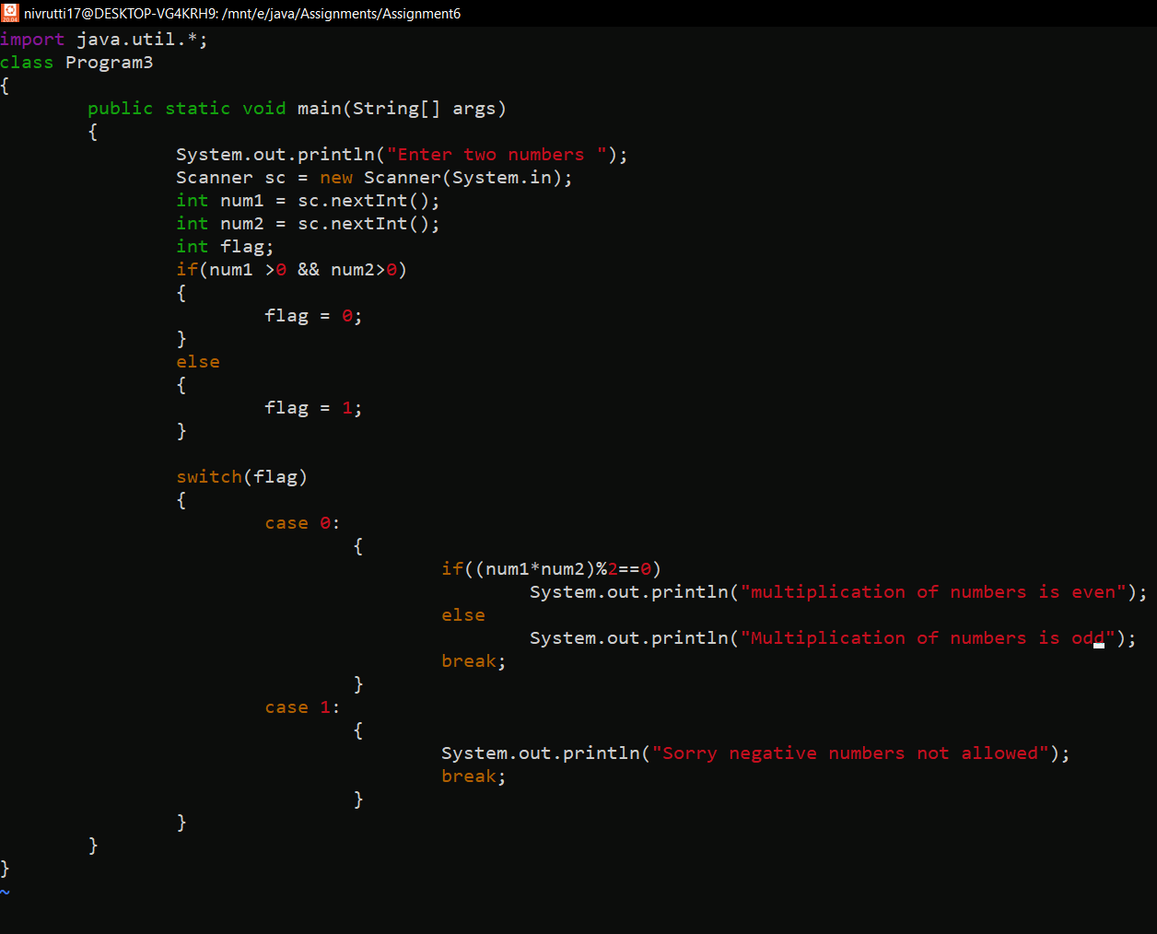

OUTPUT:

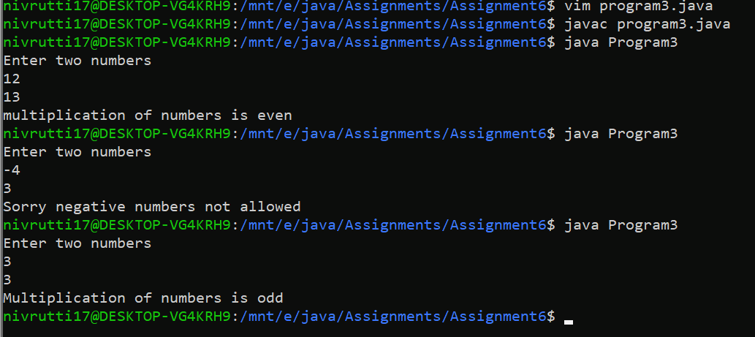

Take choice from user Show this to user.

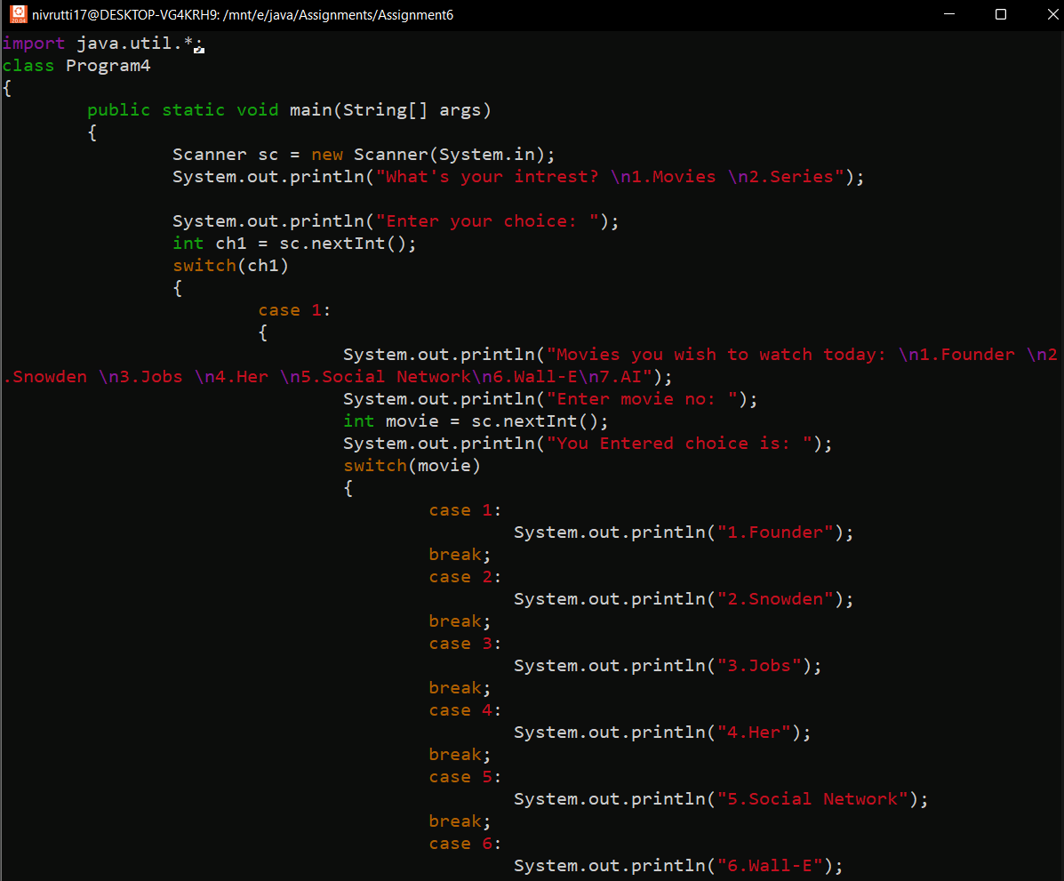

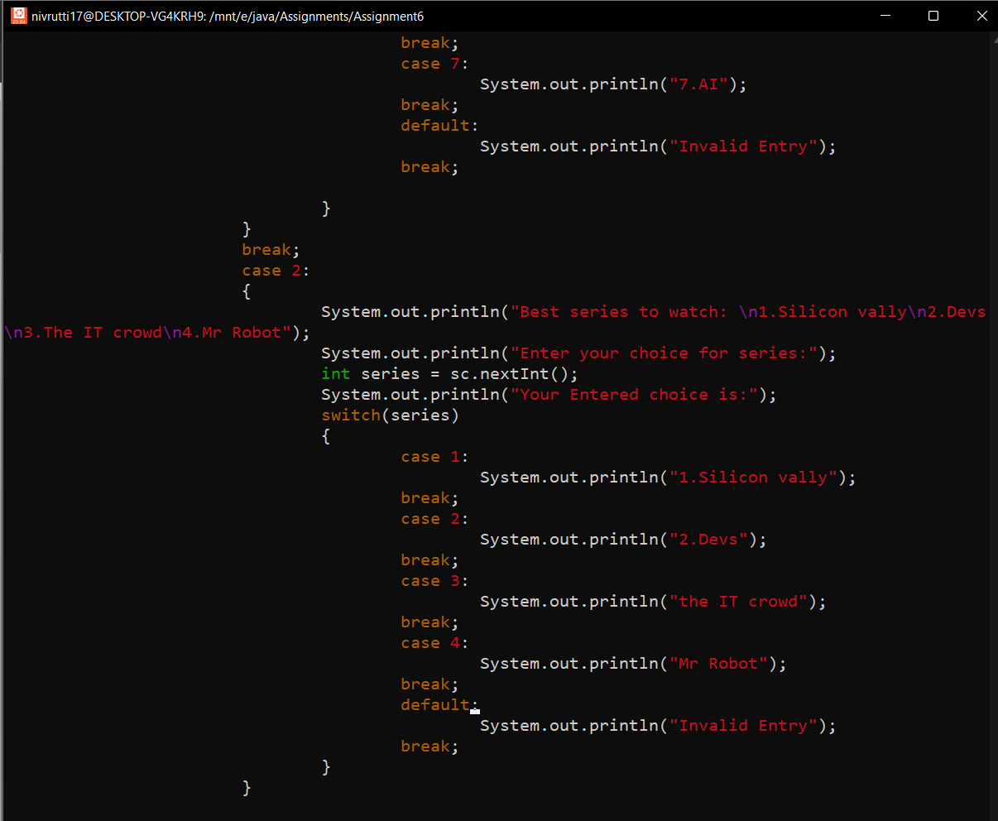

OUTPUT:

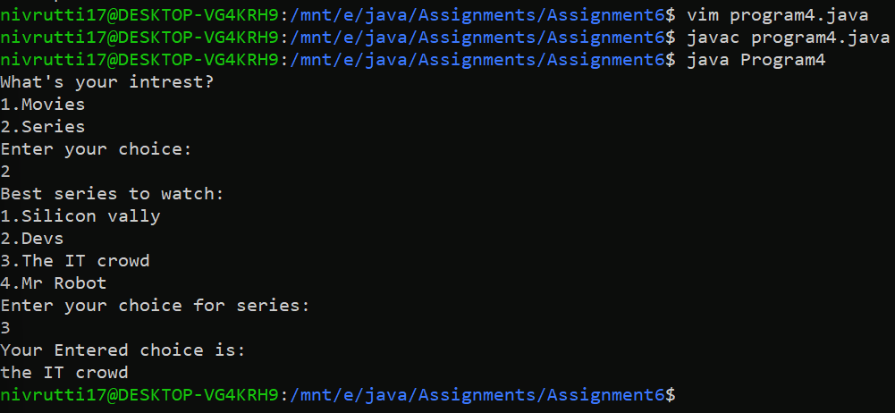

Write a real time example which shows a index like above code.

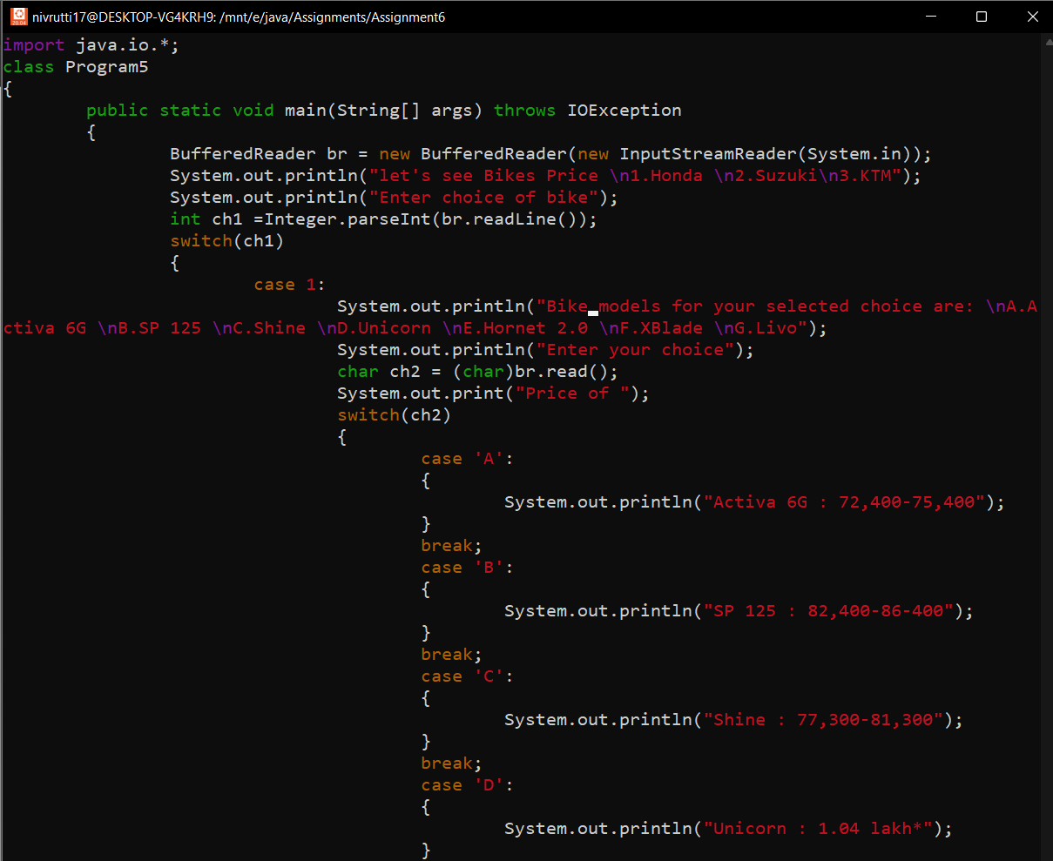

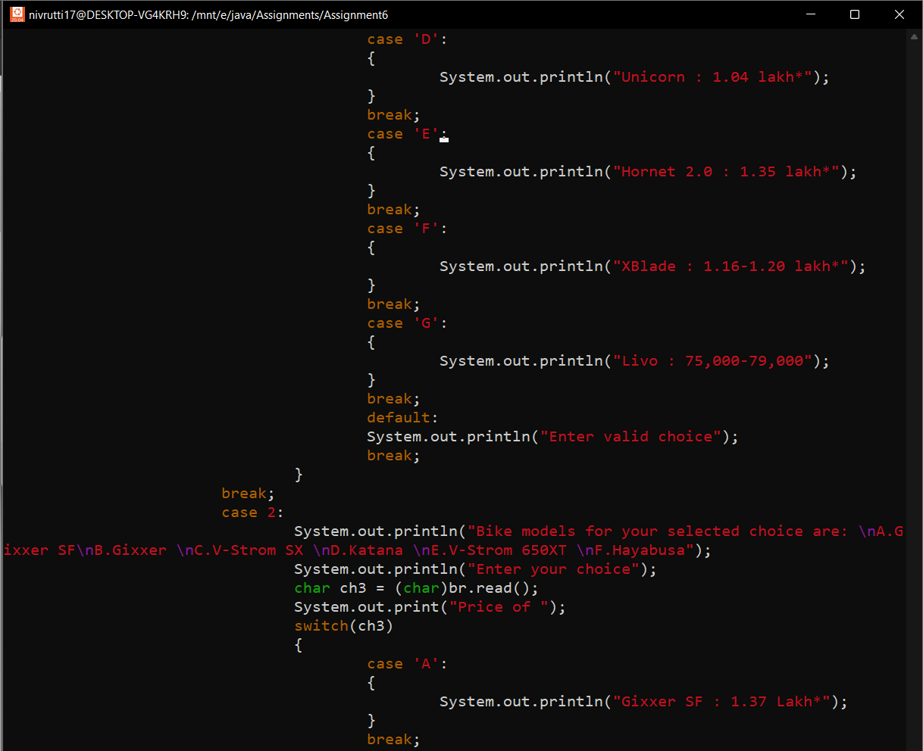

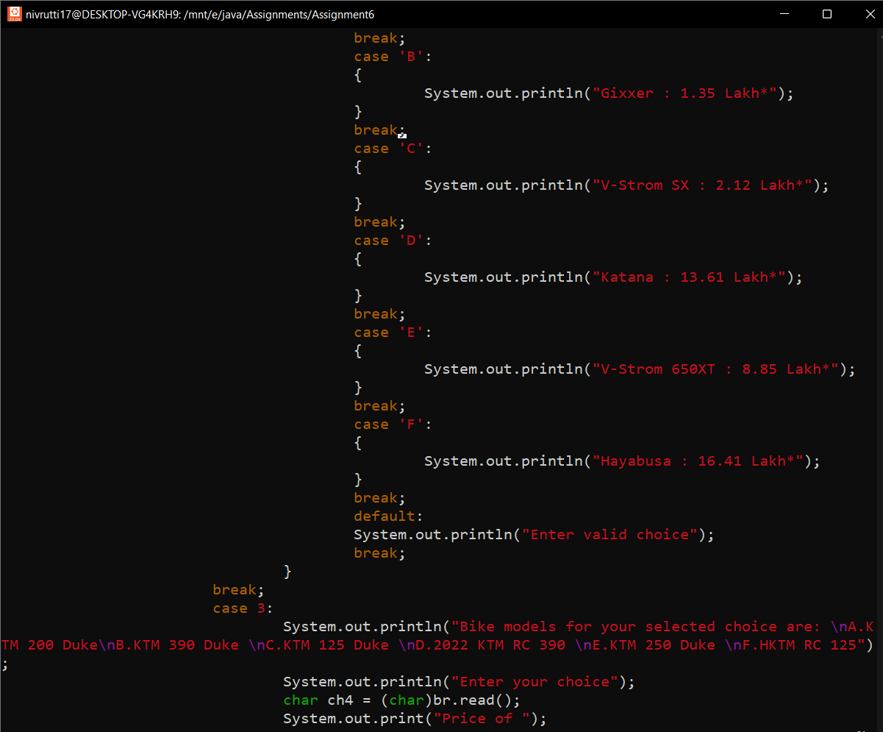

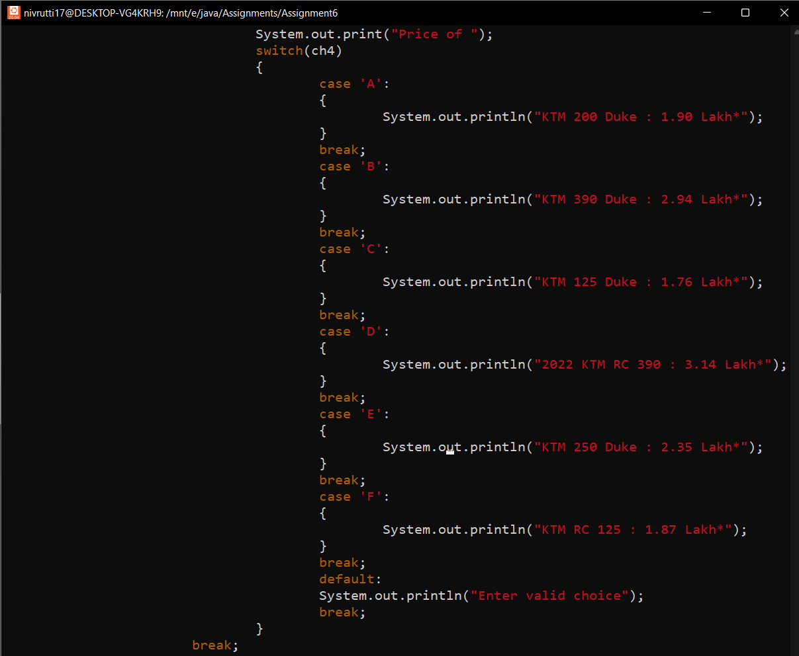

OUTPUT:

