Write a program to create an array of 5 integer elements. And print all 5 elements from an array (take hardcoded values in array).

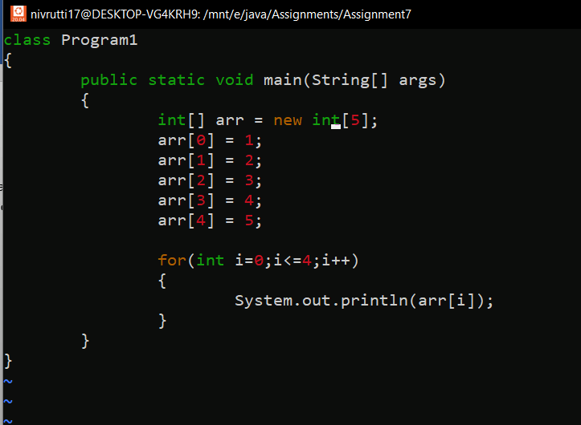

OUTPUT:

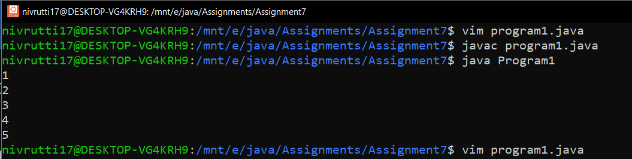

Write a program to create an array of 5 integer elements. Insert from the user and print 5 elements from an array.

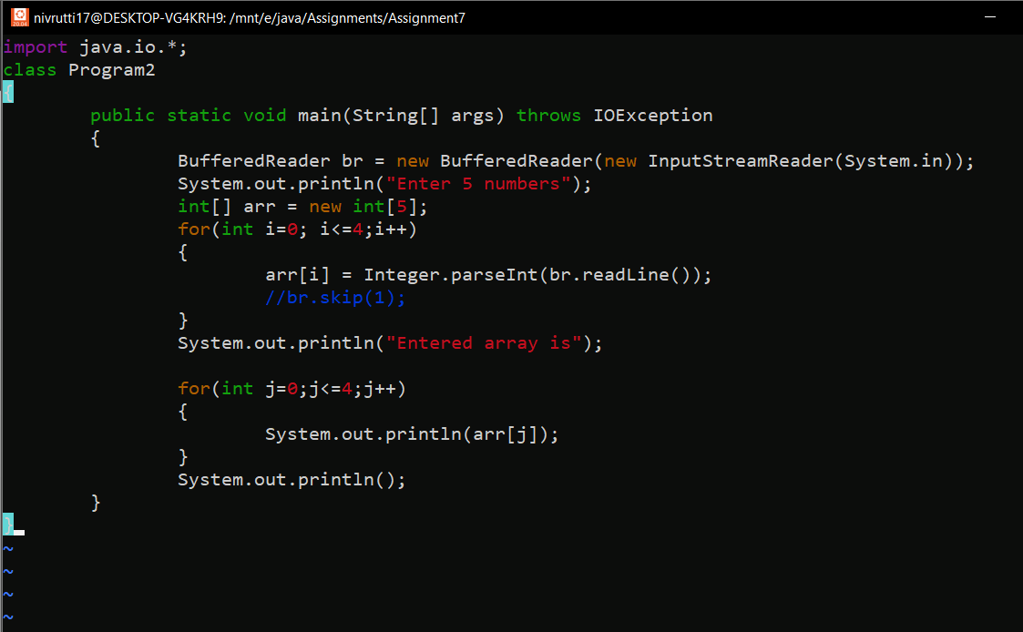

OUTPUT:

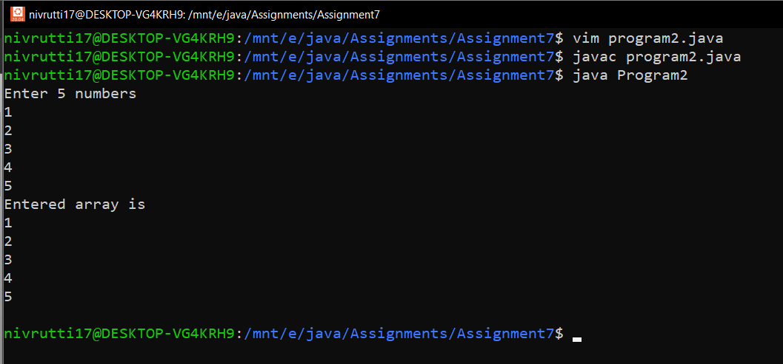

Write a program to create an array of ‘n’ integer elements. Where ‘n’ value should be taken from the user. Insert the values from users and print accordingly.

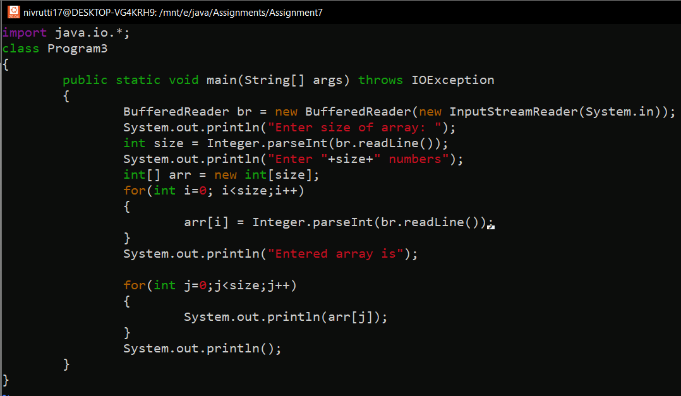

OUTPUT:

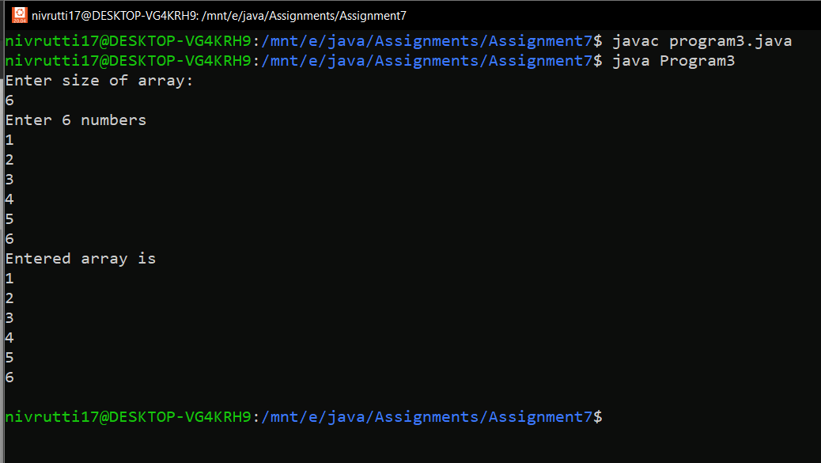

Write a program to create an array of ‘n’ integer elements. Where ‘n’ value should be taken from the user. Insert the values from users and print even numbers from the array.

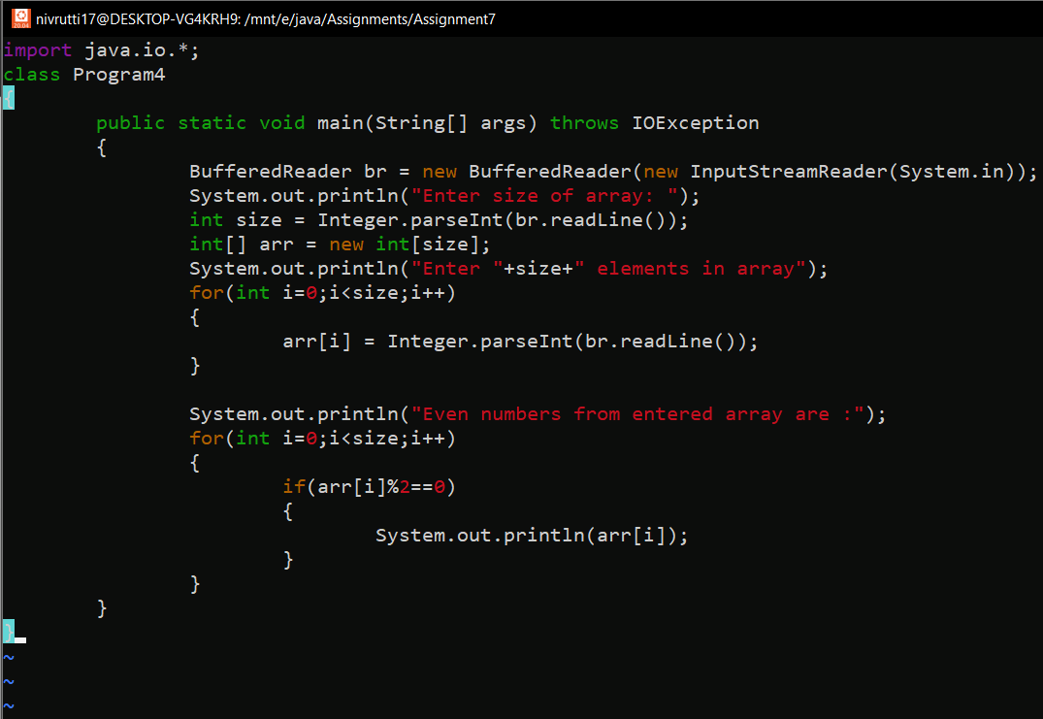

OUTPUT:

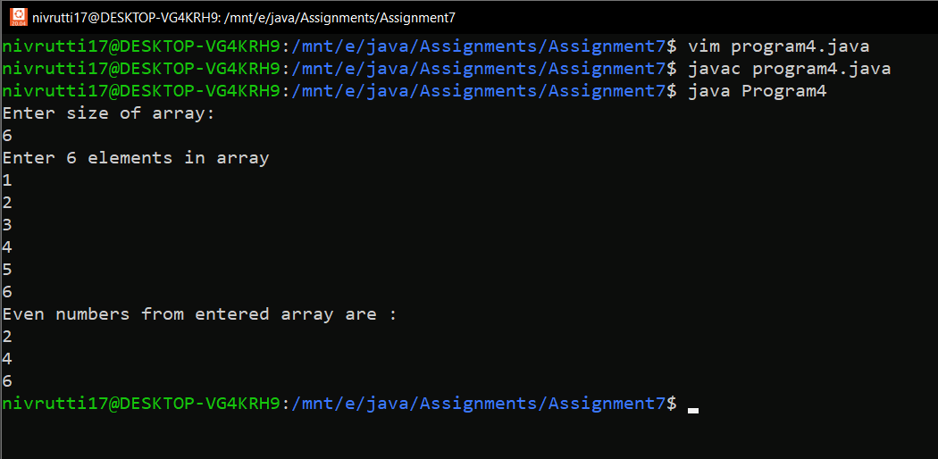

Write a program to create an array of ‘n’ integer elements. Where ‘n’ value should be taken from the user. Insert the values from users and find the max number from the array.

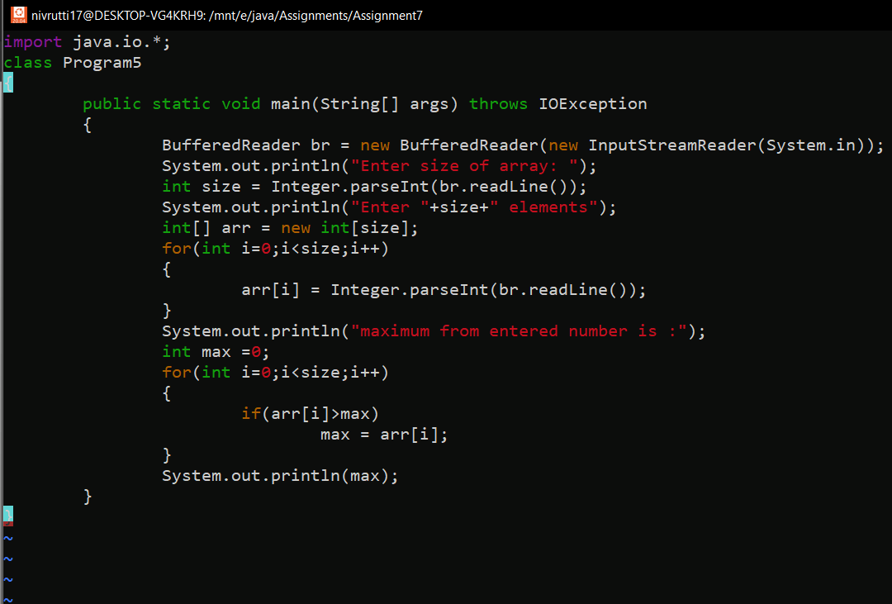

OUTPUT:

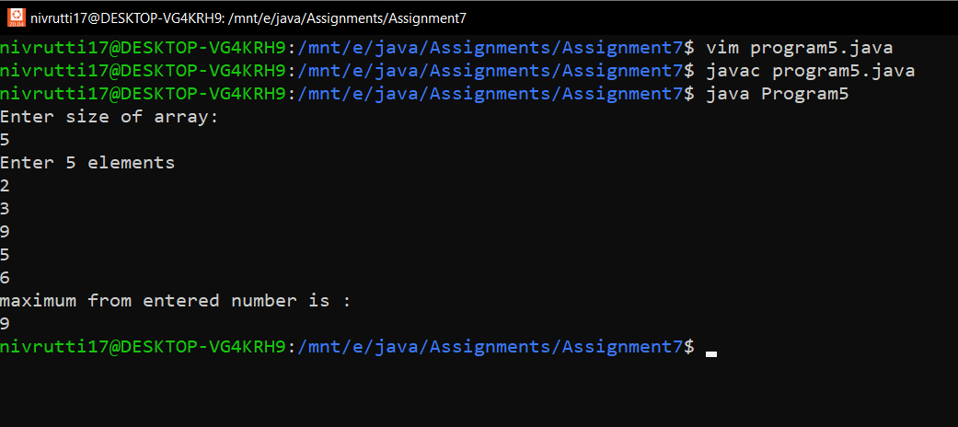

Write a program to create an array of ‘n’ integer elements. Where ‘n’ value should be taken from the user. Insert the values from users and find the min number from the array.

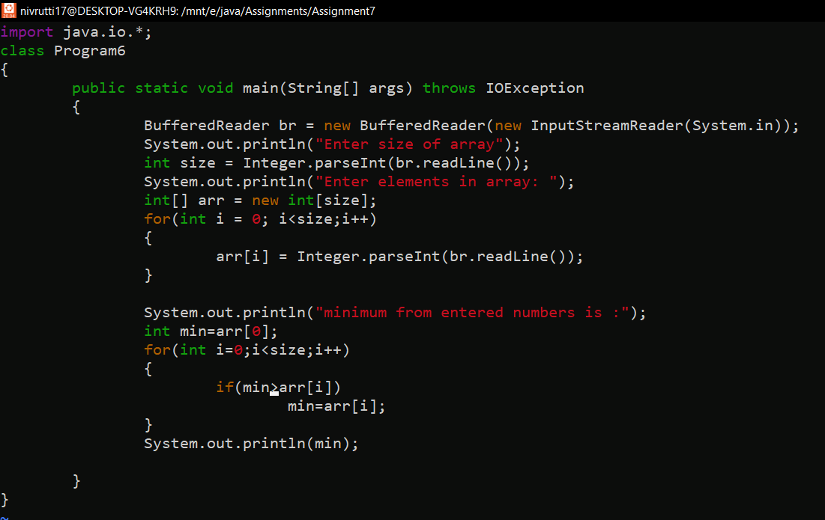

OUTPUT:  
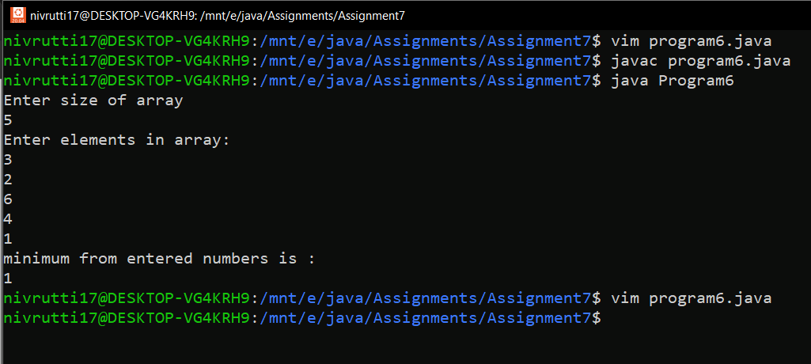

Write a program to create an array of ‘n’ integer elements. Where ‘n’ value should be taken from the user. Insert the values from users and find the sum of all elements in the array.

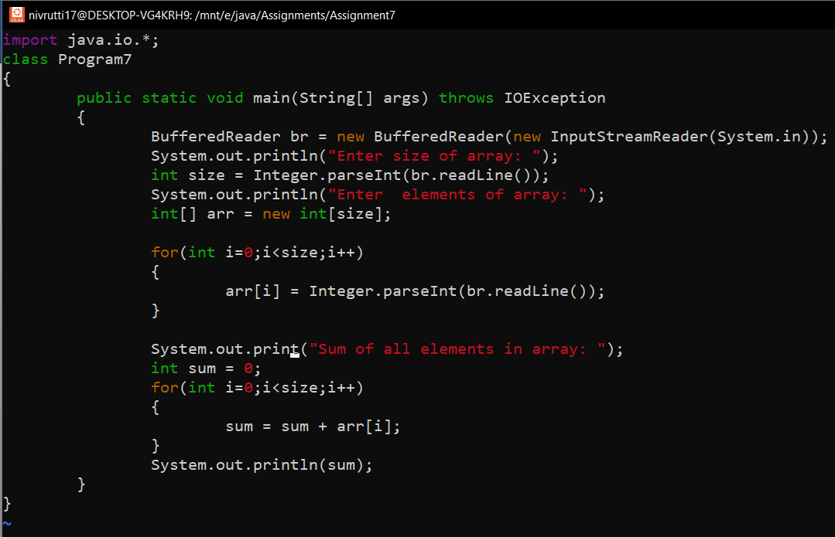

OUTPUT:

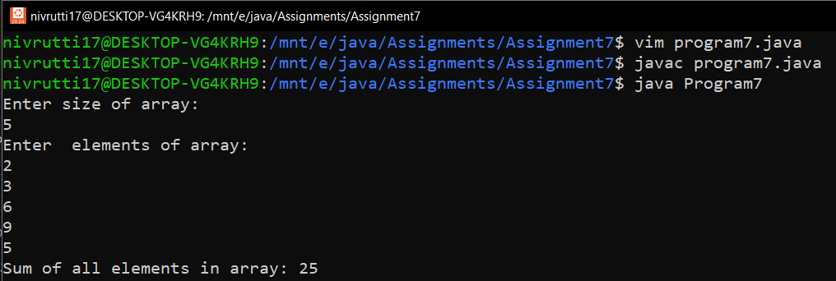

Write a program to create an array of ‘n’ integer elements. Where ‘n’ value should be taken from the user. Insert the values from the user and find the frequency of digit.