1. Create Table Portal.ThreadView

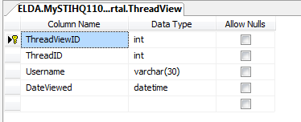

ThreadViewID should be set to primary key with auto number property

1. Alter Table Portal.EventTeamScore

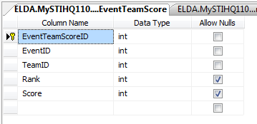

Add a primary key field “EventTeamScoreID”, with auto number property.

The SQL server will auto generate keys for previously inserted data