## Short answer Questions (20 points)

1. What is the difference between an entity (class) and an entity instance?

An entity may be defined as a thing which is recognized as being capable of an independent existence and which can be uniquely identified.

An entity is an abstraction from the complexities of some domain. When we speak of an entity we normally speak of some aspect of the real world which can be distinguished from other aspects of the real world.

Any entity occurrence is an object that is a member of the entity class. There is a one to one relationship between an object in the real world and an occurrence of an entity instance.

1. What is the goal of normalization and why it important?

The goal of normalization is to remove redundancies in the database schema. Another way of saying this is that we want a database design so that each fact is stored only in one place.

This is important because it prevents update anomalies which are errors caused by the failure to update a fact stored in more than one place.

1. Why should an attribute that contains information about an entity instance not be used as part of a primary key?

It is important to keep in mind that relationships are modeled by primary – foreign -key pairs. If the primary contains information about the entity stored in the primary key and if the primary key value is changed then it would be necessary to change every foreign key that references the primary key.

Failure to do so can break a relationship and loss of database integrity.

1. Define entity integrity.

**Entity integrity** deals with ensuring that a entity is correctly identified by the primary key. There are two rules for ensuring entity integrity. They Are:

* Every primary key attribute cannot have a NULL value.
* The combined primary key must unique.

1. Define referential integrity.

**Referential integrity** is a property of data which, when satisfied, requires every value of one attribute (column) of a relation (table) to exist as a value of another attribute in a different (or the same) relation (table).

## Entity-Relationship Diagram (30 points)

1. Consider the following scenario. Sketch an entity relationship model. Do not include the attributes bit only the entities and relationships. Use the chicken foot notation. You goal is to develop a conceptual model that is normalized to third normal form. Use the next page to write your final answer.

*UPS prides itself on having up-to-date information on the processing and current location of each shipped item. To do this, UPS relies on a company-wide information system. Shipped items are the heart of the UPS product tracking information system. Shipped items can be characterized by item number (unique), weight, dimensions, insurance amount, destination, and final delivery date. Shipped items are received into the UPS system at a single retail center. Retail centers are characterized by their type, uniqueID, and address. Shipped items make their way to their destination via one or more standard UPS transportation events (i.e., flights, truck deliveries). These transportation events are characterized by a unique scheduleNumber, a type (e.g, flight, truck), and a deliveryRoute.*

The answer can be found in the file Visual Paradigm project in this folder. The file name is **E2Q6.vpp**.

1. For each of the entity classes you used in your ERD list the appropriate attributes. Underline the primary key attributes in the table. Designate foreign key attributes by FK(entity-name) to designate entity pointed two be a foreign key. For example, a Section entity might have the following attributes, primary keys, and foreign key attributes.

**Entity: Section**

**Attribute Foreign Key Table**

SectionID

OrderDate

ShippingDate

SalesTax

CustomerID Customer

Write your answers on the next page.

# See the entity relationship diagram above.

## Third normal form design (30 points)

1. Below is the UTA drop slip. Use this slip to draw an ERD with added attributes. The ERD should be in third normal form. Use the chicken-foot notation.

See the answer in the Visual Paradigm project file

## Resolving a many to many relationship (20 points)

Suppose we are given the following partial ERD.

## 

9.1 Can the entity Person be in third normal form given the partial ERD? Justify your answer. (10 points)

No it cannot be in third normal form. A M:M relationship is implies embedded repeating groups so it is not even in the first normal form.

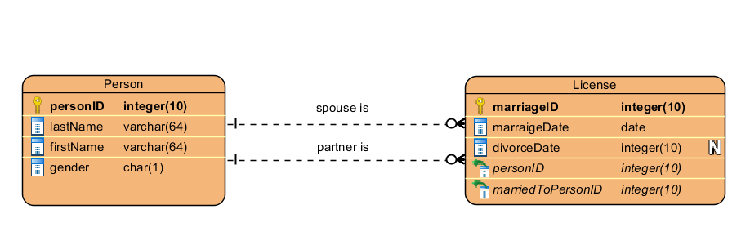

9.2 If your answer to the above question is no redraw the diagram so that the tables created from the diagram will be in third normal form. (10 points)