**PREF:** INSY 5335

Fall/Spring/Summer 2015

**Instructor(s):** Dr. Craig Slinkman

**Office Number:** COBA 532

**Office Telephone Number: 817-**272-3549

**Email Address:** slinkman@uta.edu

**Faculty Profile:**  <http://www.uta.edu/ra/real/faculty/slinkman>

**Office Hours:**

Location Day Time

Central Library Monday 19:00 – 21:30 Hours

Central Library Tuesdays 19:30 – 21:39 Hours

And by appointment

**Library Office Hours Location**

**North**

**Elevators**

**Stairs**

**South**

I will be in the south side of the second floor Central Library of my library office. If you need help with your computer please be sure and bring it with you.

**Section Information:**

|  |  |  |  |  |  |
| --- | --- | --- | --- | --- | --- |
| [INSY 5335-001 (80829)](javascript:submitAction_win0(document.win0,'CLASS_TITLE$3');) | APPLIED DATABASE MANAGEMENT (Lecture) | 23 | We 7:00PM - 9:50PM | COBA150 | Aug 27, 2015- |

**Catalog Description**

Concepts, tools, and technologies associated with the design, implementation and management of large databases are presented. Topics include data models (with emphasis on E/R model and relational model), database design and implementation, database query language, transaction management, and distributed databases. Recent advances in data management are also discussed. Use of a commercial DBMS is required. Prerequisite: INSY 5309 or approval of MSIS Graduate Advisor.

**Student activities and points**

|  |  |
| --- | --- |
| Activity | Points |
| H01: ERD | 5 |
| H02: Normalization | 5 |
| H03: SQL | 10 |
| H04: Transaction processing | 5 |
| Exam 1 | 20 |
| Exam 2 | 20 |
| Final Exam | 30 |
| Total | 100 |

**Assigned grades**

The following table is a list of the guaranteed points needed to earn a grade. It can happen that the number of points needed to earn a grade may decrease but this is very unlikely.

|  |  |
| --- | --- |
| Grade | Required  points |
| A | $$>89$$ |
| B | $$>79$$ |
| C | $$>59$$ |
| D | $$>49$$ |
| F | $$≤49$$ |

**Student Learning Outcomes**

The student should be able to:

1. Describe the characteristics of the relational model.
2. Be able to create a logical database model that models business rule.
3. Be familiar with the first four levels of data normalization.
4. Be able to map the logical design to SQL.
5. Be able to create a database using SQL. We will use SQLite for our DBMS.
6. Be able to use SQL to retrieve data from a relational DBMS.
7. Describe, database design, the database life cycle.
8. Discuss conceptual design.
9. Mapping logical designs to physical designs.
10. Discuss the issues in distributed database design/
11. Discuss the issues in transaction management and concurrency control
12. Discuss issues involved in performance management
13. Discuss the major issues involved in distributed database design.

**Required Textbooks and Other Course Materials**

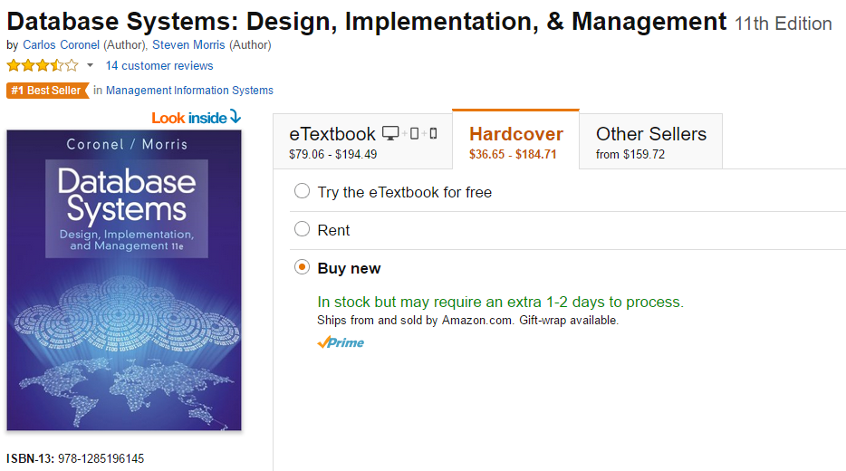

**Attendance:**

Attendance is not required but as I cover topics that are not in the text failure to come to class will be fatal to your professional aspirations.

**Make-up Exams**:

There will be no make-up exams. However, the final exam grade will be used to substitute for any missed exams.

There is no make-material for missing homework. Late homework will lose points at 1 point per late day. Thus, if your homework is 2 days late you will lose 2 out of the 5 possible points before your homework is graded.

**Expectations for Out-of-Class Study**:

A general rule of thumb is this: for every credit hour earned, a student should spend 3 hours per week working outside of class. Hence, a 3-credit course might have a minimum expectation of 9 hours of reading, study, etc. Beyond the time required to attend each class meeting, students enrolled in this course should expect to spend at least an additional 2 hours per week of their own time in course-related activities, including reading required materials, completing assignments, preparing for exams, etc.

**Grade Grievances**

Any appeal of a grade in this course must follow the procedures and deadlines for grade-related grievances as published in the current University Catalog. [Some instructors opt to cut and paste the relevant policy here. No faculty members, department, school or college may create his/her/its own grade grievance policy.

For undergraduate courses, see <http://catalog.uta.edu/academicregulations/grades/#undergraduatetext>.

For graduate courses, see <http://catalog.uta.edu/academicregulations/grades/#graduatetext>.

**Drop Policy**

Students may drop or swap (adding and dropping a class concurrently) classes through self-service in MyMav from the beginning of the registration period through the late registration period. After the late registration period, students must see their academic advisor to drop a class or withdraw. Undeclared students must see an advisor in the University Advising Center. Drops can continue through a point two-thirds of the way through the term or session. It is the student's responsibility to officially withdraw if they do not plan to attend after registering. **Students will not be automatically dropped for non-attendance**. Repayment of certain types of financial aid administered through the University may be required as the result of dropping classes or withdrawing. For more information, contact the Office of Financial Aid and Scholarships (<http://wweb.uta.edu/aao/fao/>).

**Disability Accommodations:**

UTArlington is on record as being committed to both the spirit and letter of all federal equal opportunity legislation, including *The Americans with Disabilities Act (ADA), The Americans with Disabilities Amendments Act (ADAAA),* and *Section 504 of the Rehabilitation Act.* All instructors at UT Arlington are required by law to provide “reasonable accommodations” to students with disabilities, so as not to discriminate on the basis of disability. Students are responsible for providing the instructor with official notification in the form of a letter certified by the **Office for Students with Disabilities (OSD).** Students experiencing a range of conditions (Physical, Learning, Chronic Health, Mental Health, and Sensory) that may cause diminished academic performance or other barriers to learning may seek services and/or accommodations by contacting

**The Office for Students with Disabilities, (OSD)** [www.uta.edu/disability](http://www.uta.edu/disability) or calling 817-272-3364.

**Counseling and Psychological Services, (CAPS)** [www.uta.edu/caps/](http://www.uta.edu/caps/) or calling 817-272-3671.

Only those students who have officially documented a need for an accommodation will have their request honored. Information regarding diagnostic criteria and policies for obtaining disability-based academic accommodations can be found at [www.uta.edu/disability](http://www.uta.edu/disability) or by calling the Office for Students with Disabilities at (817) 272-3364.

**Title IX:** *The University of Texas at Arlington does not discriminate on the basis of race, color, national origin, religion, age, gender, sexual orientation, disabilities, genetic information, and/or veteran status in its educational programs or activities it operates. For more information, visit*[*uta.edu/eos*](http://www.uta.edu/hr/eos/index.php)*. For information regarding Title IX, visit* [www.uta.edu/titleIX](http://www.uta.edu/titleIX).

**Academic Integrity:**

Students enrolled all UT Arlington courses are expected to adhere to the UT Arlington Honor Code:

*I pledge, on my honor, to uphold UT Arlington’s tradition of academic integrity, a tradition that values hard work and honest effort in the pursuit of academic excellence.*

*I promise that I will submit only work that I personally create or contribute to group collaborations, and I will appropriately reference any work from other sources. I will follow the highest standards of integrity and uphold the spirit of the Honor Code.*

UT Arlington faculty members may employ the Honor Code as they see fit in their courses, including (but not limited to) having students acknowledge the honor code as part of an examination or requiring students to incorporate the honor code into any work submitted. Per UT System *Regents’ Rule* 50101, §2.2, suspected violations of university’s standards for academic integrity (including the Honor Code) will be referred to the Office of Student Conduct. Violators will be disciplined in accordance with University policy, which may result in the student’s suspension or expulsion from the University.

**Electronic Communication**

UT Arlington has adopted MavMail as its official means to communicate with students about important deadlines and events, as well as to transact university-related business regarding financial aid, tuition, grades, graduation, etc. All students are assigned a MavMail account and are responsible for checking the inbox regularly. There is no additional charge to students for using this account, which remains active even after graduation. Information about activating and using MavMail is available at <http://www.uta.edu/oit/cs/email/mavmail.php>.

**Student Feedback Survey**

At the end of each term, students enrolled in classes categorized as “lecture,” “seminar,” or “laboratory” shall be directed to complete an online Student Feedback Survey (SFS). Instructions on how to access the SFS for this course will be sent directly to each student through MavMail approximately 10 days before the end of the term. Each student’s feedback enters the SFS database anonymously and is aggregated with that of other students enrolled in the course. UT Arlington’s effort to solicit, gather, tabulate, and publish student feedback is required by state law; students are strongly urged to participate. For more information, visit <http://www.uta.edu/sfs>.

**Final Review Week**

A period of five class days prior to the first day of final examinations in the long sessions shall be designated as Final Review Week. The purpose of this week is to allow students sufficient time to prepare for final examinations. During this week, there shall be no scheduled activities such as required field trips or performances; and no instructor shall assign any themes, research problems or exercises of similar scope that have a completion date during or following this week *unless specified in the class syllabus*. During Final Review Week, an instructor shall not give any examinations constituting 10% or more of the final grade, except makeup tests and laboratory examinations. In addition, no instructor shall give any portion of the final examination during Final Review Week. During this week, classes are held as scheduled. In addition, instructors are not required to limit content to topics that have been previously covered; they may introduce new concepts as appropriate.

**Emergency Exit Procedures**

Should we experience an emergency event that requires us to vacate the building, students should exit the room and move toward the nearest exit. When exiting the building during an emergency, one should never take an elevator but should use the stairwells. Faculty members and instructional staff will assist students in selecting the safest route for evacuation and will make arrangements to assist individuals with disabilities.

([http://www.uta.edu/police/Evacuation Procedures.pdf](http://www.uta.edu/police/Evacuation%20Procedures.pdf))

**Student Support Services**

UT Arlington provides a variety of resources and programs designed to help students develop academic skills, deal with personal situations, and better understand concepts and information related to their courses. Resources include tutoring, major-based learning centers, developmental education, advising and mentoring, personal counseling, and federally funded programs. For individualized referrals, students may visit the reception desk at University College (Ransom Hall), call the Maverick Resource Hotline at 817-272-6107, send a message to [resources@uta.edu](mailto:resources@uta.edu), or view the information at http://www.uta.edu/universitycollege/resources/index.php

**Tentative Course Schedule**



**Emergency Phone Numbers**: In case of an on-campus emergency, call the UT Arlington Police Department at **817-272-3003** (non-campus phone), **2-3003** (campus phone). You may also dial 911. Non-emergency number 817-272-3381