Nick Chang

DCE LAB 1 (designing and analyzing a DCE)

Short Background:

Discrete Choice Experiments were originally an economic research tool designed to quantify the importance of specific attributes that contribute to a decision (Lancsar & Louviere, 2008). DCEs have since been repurposed into healthcare fields by using them to analyze medical decision making (Chen et. al, 2015; Hauber et. al, 2016; Lancsar & Louviere, 2008; Mulbacher & Johnson, 2016; Poder et. al, 2019; Shanahan et. al, 2019; Trapero-Bertran et. al, 2019). Many of the studies that use DCEs to inform healthcare policy and spending pit two comparable treatments for the same medical problem against each other in order to quantify the importance of each attribute of the treatment (Chen et. al, 2015; Poder et. al, 2019; Shanahan et. al, 2019; Trapero-Bertran et. al, 2019).

TERMS:

Below I created a table of common terms that are used in the design and analysis of DCE’s.

|  |  |  |  |
| --- | --- | --- | --- |
| Ex.  figure# | Abbreviation | Term | Definition |
| DESIGN TERMS | | | |
| 1 | DCE | Discrete Choice Experiment | A type of experiment that identifies the important choice factors in a specific decision. |
| 1 |  | Attribute | A characteristic of the choice that exists in all of the choices even if it exists differently |
| 1 |  | Level | The different possibilities of how an attribute may exist within a choice(typically expressed through a numerical or qualitative value) |
| 1 |  | Treatment/Alternative | a choice represented by a combination of attributes and their levels |
| 1 |  | Choice set | single set of alternatives for a participant to choose from |
| 1 | OMED | Orthogonal Main-Effect Design | Essentially a way to describe two treatments in terms of their attributes and levels |
|  |  | multinomial DCE | DCE with 3 or more alternatives/treatments |
|  |  | binary DCE | DCE with only 2 treatments |
| 1 |  | opt out DCE | A DCE that includes an opt out option if neither treatment seem enticing |
|  |  | Forced Choice | A DCE with no opt out option, forcing participants to choose from one of the available options |
|  |  | Common Base | A DCE where every choice set has one choice that appears in all choice sets |
|  |  | Labeled | the alternatives are labeled so they can be distinguished from eachother |
|  |  | Generic | each choice set uses alternative 1 and alternative 2 |
|  | RD | Rotation design | Unlabeled DCE design slowly increases or decreases "levels" within the attributes for one option and looks at when the individual switches their choice to the other option |
|  | MaM | Mix and Match design | Modifies the rotation design by addition a randomization process (does the same thing but in a different order) |
|  | LMA | LMA Design | creates a very different format that uses rows in the OMED to correspond to alternatives and columns of attributes and levels. Doesn't appear to be used much. |
| ANALYSIS TERMS | | | |
|  | CL | Conditional Logit | a model that asks a participant would you rather A or B (and maybe C or more) |
|  | BL | Binomial Logit | a model that asks a participant would you buy this product yes or no |

EXAMPLES:

FIGURE 1

This is a single choice set in a DCE, the design is an OMED layout

The green dots indicate an attribute, while the red dots indicate the level

Therapy A and Therapy B are both examples of treatments or alternatives

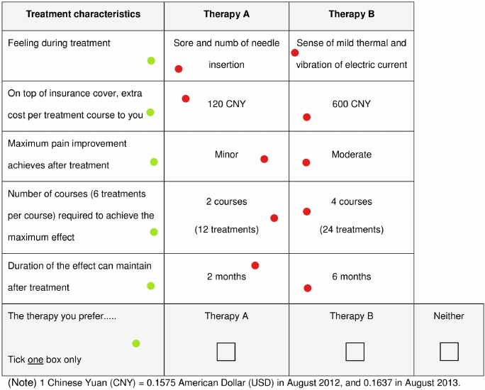

Figure 1: Example of an unlabeled DCE OMED design created by Chen et. al, 2015

STEPS:

Recently I did a literature review of DCE’s specifically regarding their methodology. Below I created an outline of the steps involved in designing and analyzing DCE’s

1. Create the design
   * 1. define the situation in which respondents will need to make this decision
     2. specify the options a respondent may have
     3. define the options in terms of their attributes and levels
     4. decide to include or leave out the opt out option
     5. decide on the number of alternatives per choice set

Typically, these steps are done using lit reviews, interviews, pilot surveys and focus groups.

 It should be noted that application of an OMED to create choice sets is a restrictive approach in which all main effects can be estimated, but two-way or higher-order interaction effects cannot. If interaction effects are deemed to be important in determining respondent choice, an alternative design approach should be considered (e.g., Street and Burgess, 2007). It should also be noted that interaction effects can have an influence on main effects

1. Conduct the survey with your DCE design
   1. writing the questions (choice sets)
   2. creating questionnaire (design OMED)
   3. Determine sampling frame of targeted population
   4. select survey modality
   5. decide on sampling method
   6. choose sample size
   7. sample respondents
2. Prepare dataset and analyze data
   1. prepare and clean data
   2. perform analysis

Learning Resources:

The first resource I found was a website created by Hideo Aizaki and designed to teach DCE design and analysis in R:

<http://lab.agr.hokudai.ac.jp/nmvr/02-dce.html>

Next I found a paper on the same topic: <https://pdfs.semanticscholar.org/b0fb/05e51e02d4eda914888ae0590dd65b45ff9a.pdf>

Another resource I found is a paper describing a new package in R that is designed to help with DCE design and analysis: <https://www.sciencedirect.com/science/article/abs/pii/S1755534519300703?via%3Dihub>

Lastly I used a textbook written by Hideo Aizaki that covers stated preference methodology of which DCE is a part of: <https://www.taylorfrancis.com/books/9780429065699>

References

Azaki, H. (2019, August 29). Non-Market Valuation with R. Retrieved March 29, 2020, from http://lab.agr.hokudai.ac.jp/nmvr/02-dce.html

Aizaki, Hideo & Nishimura, Kazushi. (2008). Design and Analysis of Choice Experiments Using R: A Brief Introduction. Agricultural Information Research. 17. 10.3173/air.17.86.

Chen, L.-C., Cheng, L.-J., Zhang, Y., He, X., & Knaggs, R. D. (2015). Acupuncture or Low Frequency Infrared Treatment for Low Back Pain in Chinese Patients: A Discrete Choice Experiment. *PLOS ONE,* 10(5), e0126912. doi:10.1371/journal.pone.0126912

Hauber, A. B., González, J. M., Groothuis-Oudshoorn, C. G., Prior, T., Marshall, D. A., Cunningham, C., . . . Bridges, J. F. (2016). Statistical Methods for the Analysis of Discrete Choice Experiments: A Report of the ISPOR Conjoint Analysis Good Research Practices Task Force. *Value in Health,* 19(4), 300-315. doi:10.1016/j.jval.2016.04.004

Hess, S., & Palma, D. (2019). Apollo: A flexible, powerful and customisable freeware package for choice model estimation and application. *Journal of Choice Modelling*, 32, 100170. doi:10.1016/j.jocm.2019.100170

Lancsar, E., & Louviere, J. (2008). Conducting Discrete Choice Experiments to Inform Healthcare Decision Making. *PharmacoEconomics,* *26*(8), 661-677. doi:10.2165/00019053-200826080-00004

Mühlbacher, A., & Johnson, F. R. (2016). Choice Experiments to Quantify Preferences for Health and Healthcare: State of the Practice. *Applied Health Economics and Health Policy,* *14*(3), 253-266. doi:10.1007/s40258-016-0232-7

Poder, T. G., Beffarat, M., Benkhalti, M., Ladouceur, G., & Dagenais, P. (2019). A discrete choice experiment on preferences of patients with low back pain about non-surgical treatments: Identification, refinement and selection of attributes and levels*. Patient Preference and Adherence*, Volume 13, 933-940. doi:10.2147/ppa.s201401

Shanahan, M., Larance, B., Nielsen, S., Cohen, M., Schaffer, M., & Campbell, G. (2019). A protocol for a discrete choice experiment: Understanding patient medicine preferences for managing chronic non-cancer pain. *BMJ Open,* *9*(8). doi:10.1136/bmjopen-2018-027153

Trapero-Bertran, M., Rodríguez-Martín, B., & López-Bastida, J. (2019). What attributes should be included in a discrete choice experiment related to health technologies? A systematic literature review. *Plos One,* *14*(7). doi:10.1371/journal.pone.0219905