**What is the relationship between tweet sentiment and episode sentiment?**

As it turns out, twitter only keeps tweets on it’s user_timeline api back to December 2016, or about 15-16 months, and the search api only returns results up to a week prior. Additionally, I was unable to find a way to filter through the api based on date outside of the since_id and max_id parameters to use another tweet’s id to set a time parameter. I had hoped to use the official Game of Thrones twitter to locate tweets at the start and finish of each episode, but even then the official twitter was inconsistent in tweeting out at the start and/or finish of each episode.

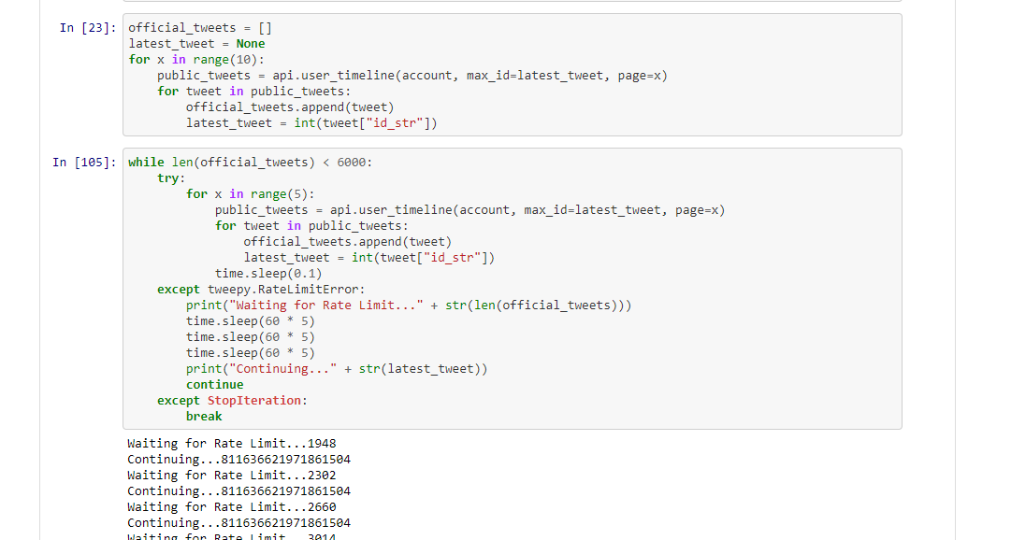

**What can I do?**

I have a massive file of all of the twitter data available on GameofThrones official account from the api. What kind of information can I find in here?

**How does the sentiment compare between GameofThrones official account and it’s fans?**

I first ran a sentiment analysis on all of the tweets I had pulled, and graphed it, revealing the top graph on the following page. Then I searched for #GameofThrones and plotted all of that sentiment, revealing the second graph. Comparing the two, it is clear that the official account is far more positive than the general tweeting public. In the future, it would be interesting to compare positive sentiments between varying official accounts, and see if different industries, genres, or other factors contribute to general twitter sentiment used for marketing.

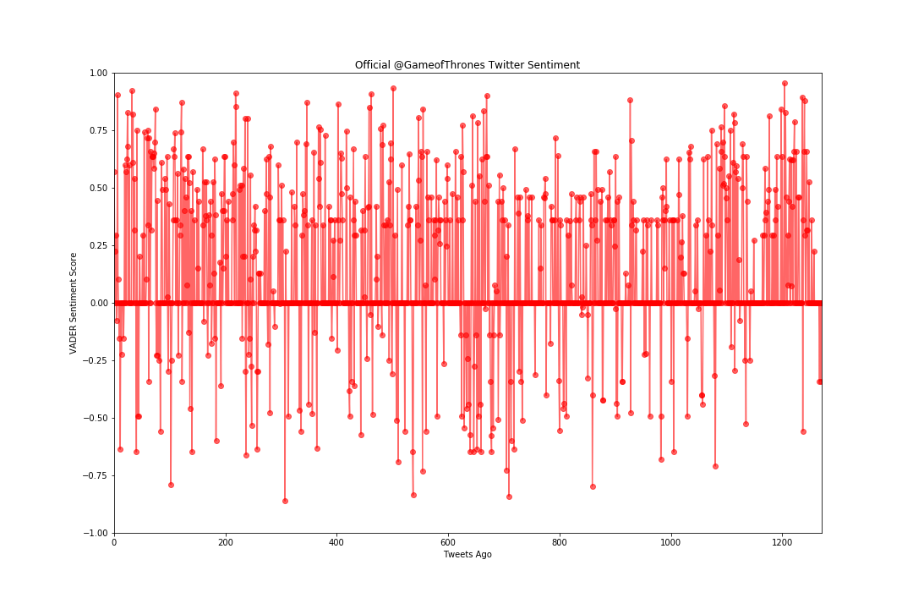

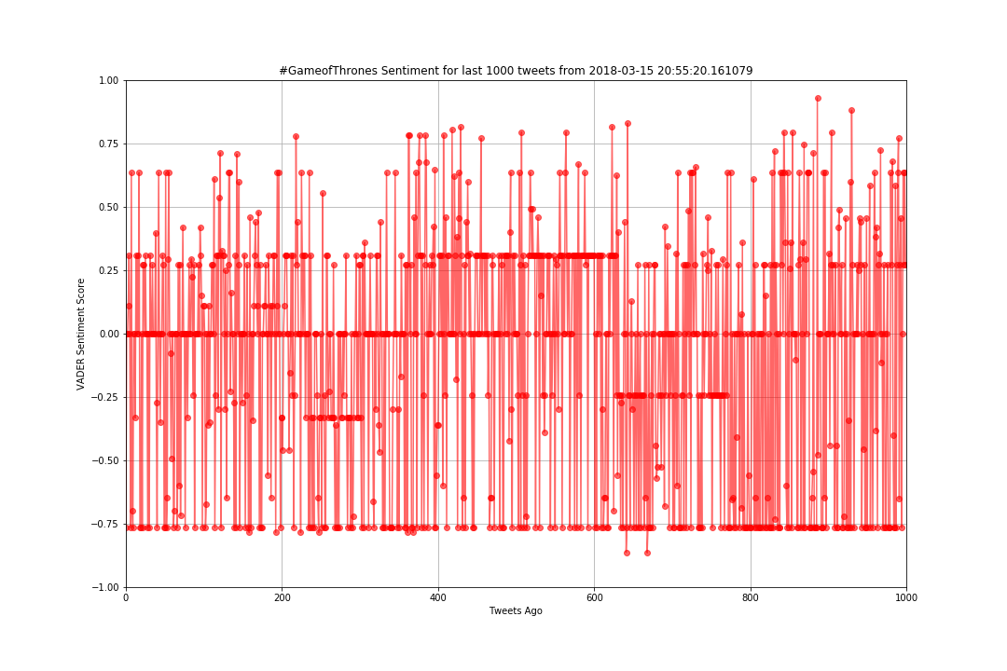

**What does GameofThrones’ twitter network look like?**

With the twitter information of course came any other user mentions, so I thought to count each users mentions and see if there are any patterns or curiosities. Interestingly enough, @GameofThrones mentioned itself 338 times in 1271 tweets. In presenting this, I decided to leave off itself and cut off HBO, the channel it is on, as those mentions are par for the course, but there is still some interest that HBO has a massive number of mentions so I left some of it in. I divided twitter accounts into five categories:

* HBO / Marketing - Twitter accounts for GameofThrones, HBO, other HBO shows, or companies that sell Game of Thrones products.
* GoT Cast/Staff - Game of Thrones staff twitter accounts, be they actors, actresses, composers, or anything else.
* Critic / Influencer - I put newspaper / internet critics and youtube influencer accounts together because they seem to fulfill a similar purpose to me: non Game of Thrones sources telling you how you should be watching this show.
* Fan Account - Fake accounts run by fans playing at being characters in the show. Interacting with the fan base through these, approving of their fan-fictions and fantasies is a great way to build a community.
* Other - Unrelated accounts, such as sports teams, music venues, GIPHY, and reddit. Could be that the service was used or being promoted by Game of Thrones.

We can see that, of course, marketing or HBO related tweets come in massively number one, followed by cast, fans, and influencers. But also of interest are the number of accounts associated with these mention numbers:

* HBO / Marketing: 4 Accounts, 517 Tweets, 100+TPA (tweets per account)
* GOT Cast/Staff: 10 Accounts, 115 Tweets, 11.5 TPA
* Critic / Influencer: 4 Accounts, 40 Tweets, 10 TPA
* Fan Account: 3 Accounts, 54 Tweets, 18 TPA
* Other: 10 Accounts, 96 Tweets, 9.6 TPA

