by Lukas Setiawan
lukassetiawan@yahoo.com
Nov 8, 2026

RSA :
p . q = n
p, q is prime number

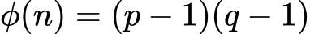

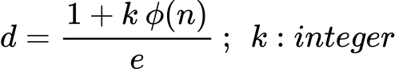

Encryption :

e is public key

Decryption :

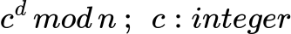
d is private key

SLIMMING BRUTE FORCE :

The idea is to find p first as one of the prime factors, then get q using q=n/p.
The method as follows :
- On this app, the lower boundary required a minimum 3 digits decimal.
- Eliminate last digit n is 2 and 5(because there is no two prime numbers if multiply got last digit 2 or 5.
- On a 3 digit or higher of prime number, the last digit must be 1 or 3 or 7 or 9 and so with p.
- First find a length digits of n(e.g 11 digits).
- Find digit p using: ceil(digit n/2), e.g, ceil(11/2)=6 digits.
- This method is called the "Slimming Brute Force", where it covers all possibilities to find p.
- After length digits of p or q found, we find all prime numbers(or candidates p) on [a,b], where a= 10^(m-1), b=(10^m)-1, where m is length digit of p. Example m=3, so p on the [100,999] with assume p & q got the same length digit.
- If two factors have different length digit then we use the 2nd scenario where we decrease a as the left boundary to find candidates of p where a becomes a= 10^(m-1-g), g start from 1. Now a=10(2 digit), [a,b] becomes [10,99],and so on.
- We can use the Sieve of Atkin algorithm to find all prime numbers on a given interval.
- We try the first scenario with assume p, q got the same length digit(it's usually used, because if one of the factor got shorter digit, easier to break), and try others scenarios till found p(automatically found q also). We got all candidates for p.
- Check the right candidate use: if (n mod p)=0 then p found & find q using q=n/p.
- We already have e, p, q.
- d=(1+k phi(n))/e ; we loop k as integer till satisfied the equation(start with k=1).
- Finally we got d as our private key.

