by Lukas Setiawan

email: [lukassetiawan@yahoo.com](mailto:lukassetiawan@yahoo.com)

(Jan 15, 2025)

**EXTENDED GOLDEN SEARCH METHOD**

To find multiple critical points (maximum and minimum) of the function simultaneously.

**Here is the idea(algorithm) :**

* Input Function Y=F(x).
* Input interval [lb,rb], where the multiple critical points located (lb is left boundary & rb is right boundary).
* Input gamma as const width step size to count F(x), we can increase or decrease gamma as input variable.
* From x=lb as  left boundary or starting point, we are use four points(x1,x2,x3,x4) to determine two slopes. First point x1, then x2=x1+gamma, x3=x2+gamma,

x4=x3+gama, or x(i+1)=xi+gamma.

* Then calculate F(x1), F(x2), F(x3) and F(x4) to know the sign of the slope(negative/positive).
* If F(x2)-F(x1) is positive and  F(x4)-F(x3) is negative, means we got maximum point(because at max point the slope changes from positive to negative). Otherwise If F(x2)-F(x1) is negative and  F(x4)-F(x3) is positive, means we got minimum point. We continue iterate till got slopes changes.
* If critical point found(max or min) then we use Golden Search method to find coordinate of the point.
* After we found first point then we search next critical points with the same procedure till reach right boundary.
* Finally we got all the max and/or min points. Then plot it on the graph.
* Done.

Golden Search algorithm.

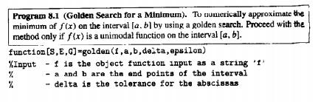

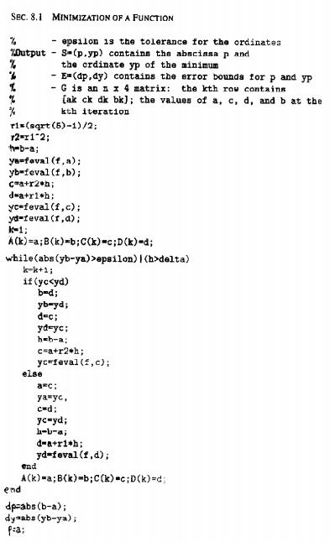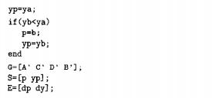

(The algorithm took from the book Numerical method using Matlab third edition 1999 by John H. Mathews and Kurtis D. Fink page 412).