by Lukas Setiawan

email: [lukassetiawan@yahoo.com](mailto:lukassetiawan@yahoo.com)

(Jan 31, 2025)

**MULTI-INTERSECTION POINT FINDER USING EXTENDED FALSE POSITION METHOD**

To find multiple intersection points between two graph(function) simultaneously.

**Illustration**

If two graphs intersected, there are two possibility.

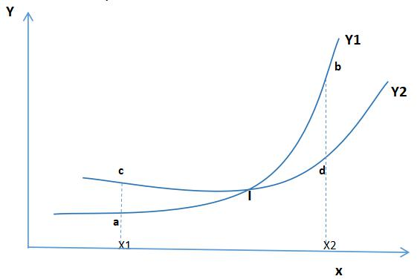

1. **First Possibility**

There are five point at intersect graph above :

- a(x1,y1)

- b(x2,y1)

- c(x1,y2)

- d(x2,y2)

And I(Xint,Yint) is intersection point.

When two graph intersected must be fullfil one of the two condition.

First condition is : F1(x1) < F2(x1) and F1(x2) > F2(x2)

1. **Second possibility**

Just like the first, but point a or (x1,y1) on the position above of point c or (x1,y2).

So the condition becomes F1(x1) > F2(x1) and F1(x2) < F2(x2).

The idea is if the one of two condition above fullfil then we got intersection point.

Intersection point can be solve using finding root method.

When two graph intersect, Y1=Y2, so Y1-Y2=0. It’s a Nonlinear problem or Finding root problem. We can solve this problem using one of the method to finding root.

In this case we are use False Position method.

**Here is the idea(algorithm) :**

* Input Function Y1=F(x) and Y2=G(x).
* Input interval [lb,rb], where the multiple intersection points located (lb is left boundary & rb is right boundary).
* Input delta and epsilon as tolerances.
* Input gamma as const width step size to count F(x) and G(x), we can increase or decrease gamma as input variable.
* From x=lb as  left boundary or starting point, we are use four points(a,b,c,d) to make condition. Where a is point (x1,y1), b is (x2,y1), c is (x1,y2) and d is (x2,y2).
* When two graph intersected must be fullfil this condition (look illustration).

1. F1(x1) < F2(x1) and F1(x2) > F2(x2) or
2. F1(x1) > F2(x1) and F1(x2) < F2(x2)

* First point x1, then x2=x1+gamma or x(i+1)=xi+gamma.
* Then calculate F1(x1), F2(x1), F1(x2) and F2(x2) to know the condition.
* If the one of the two condition above fullfil, means the two graphs intersected.
* We are continue calculate Fi(xi) where I=1,2. till conditional fullfil.
* If we got position of intersection (x1 & x2) then use False Position method to find coordinate of the intersection point.
* After we found first point then we search next intersection points with the same procedure till reach right boundary.
* Finally we got all the intersection points. Then plot it on the graph.
* Done.

**False Position Algorithm.**

**False Position Formula :**

$$c_{i}=b_{i}−\frac{f(b_{i})(b_{i}−a_{i})}{f(b_{i})−f(a_{i})}$$

*for i = 0,1,2,…..,n*

Latex version:

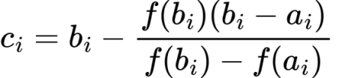

Look next page…

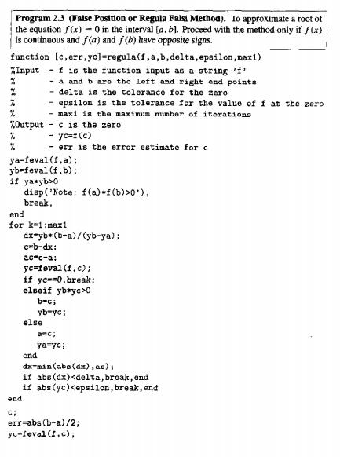

(The algorithm took from the book Numerical method using Matlab third edition 1999 by John H. Mathews and Kurtis D. Fink page 60).