Navier-Stokes Equations (Incompressible Flow): Millennium prize.

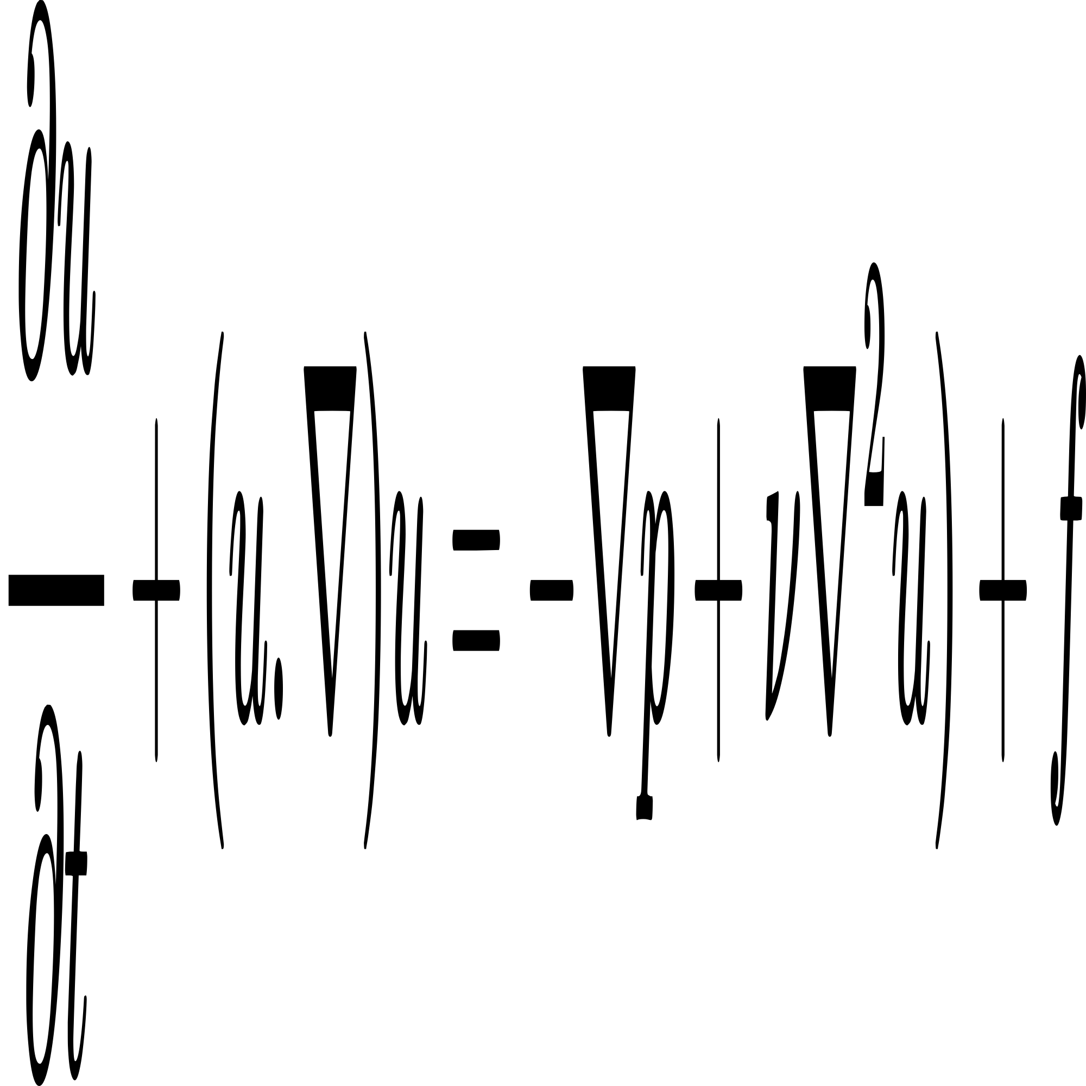

wps

Van der Pol Equation:

(example of nonlinear ODEs that have no analytical solution)

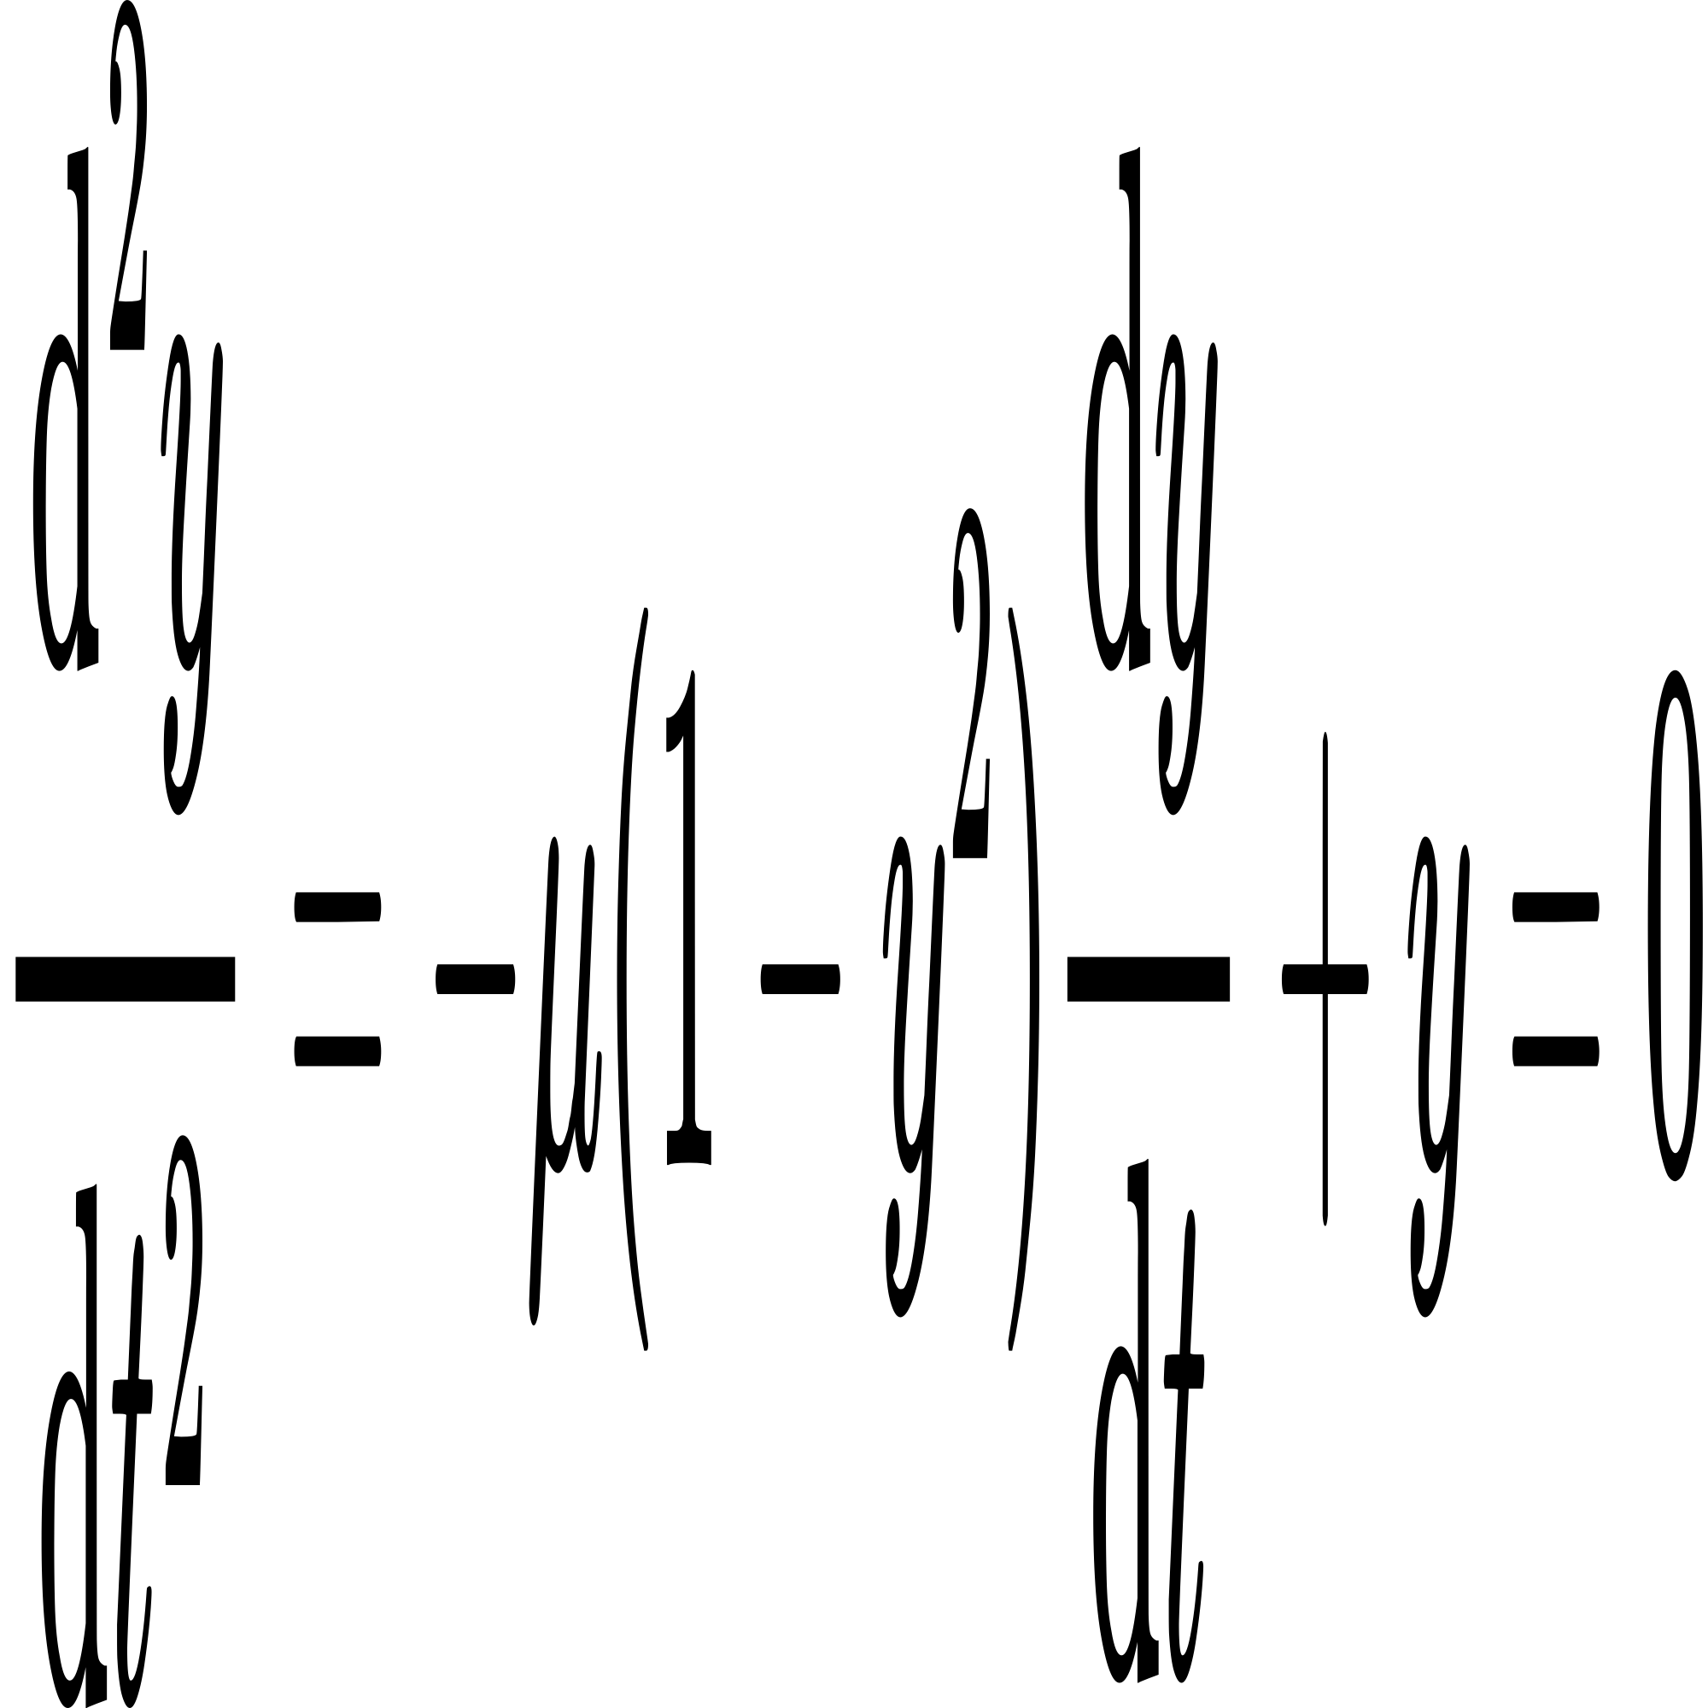

Nonlinear Schrödinger Equation (NLS): , example of nonlinear PDEs

