Navier-Stokes Equations (Incompressible Flow):

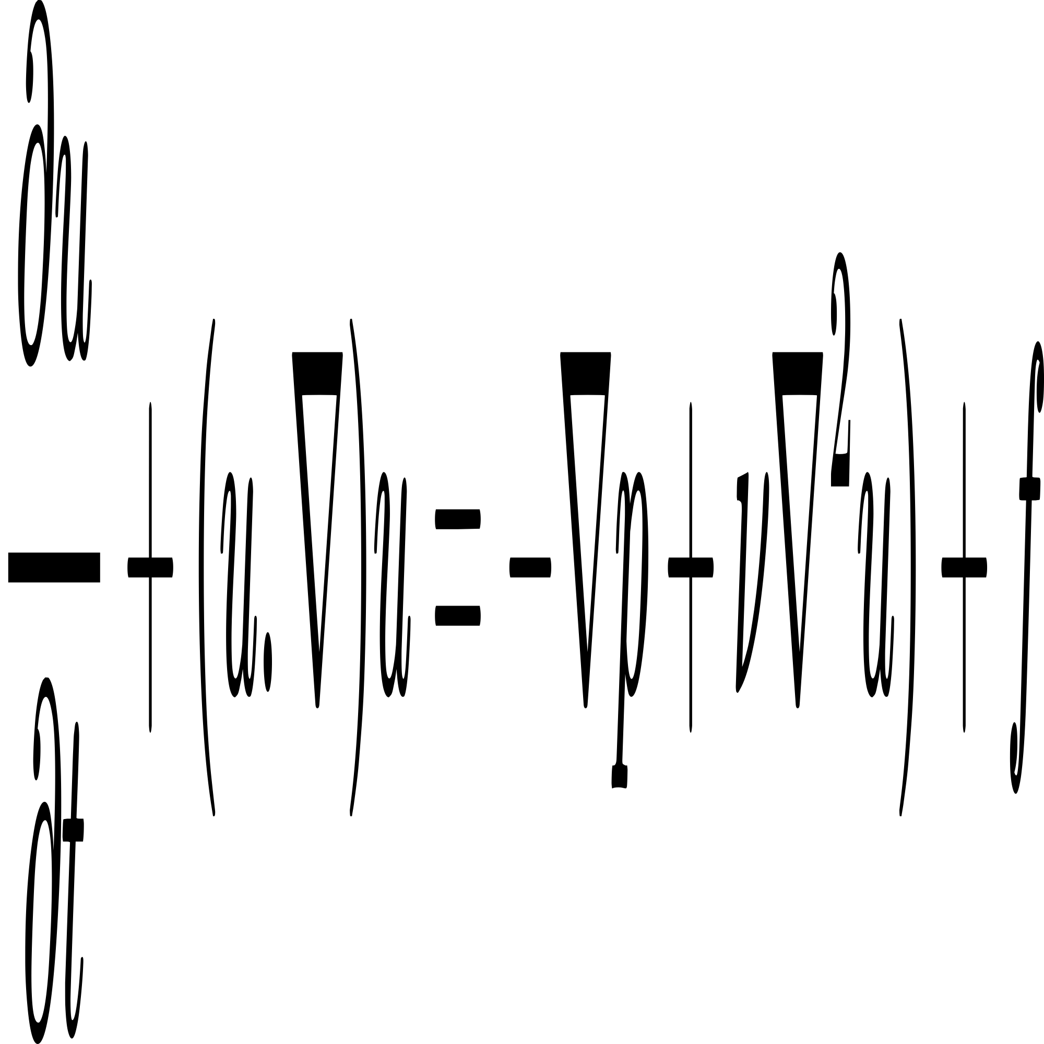

wps