Burgerbib

# Usage model

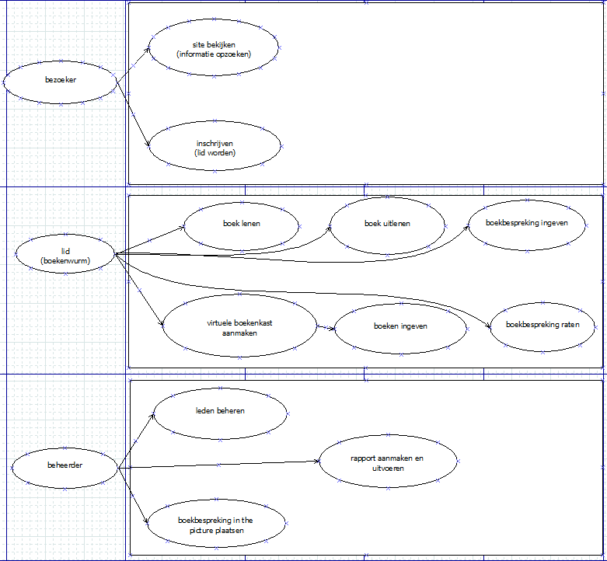

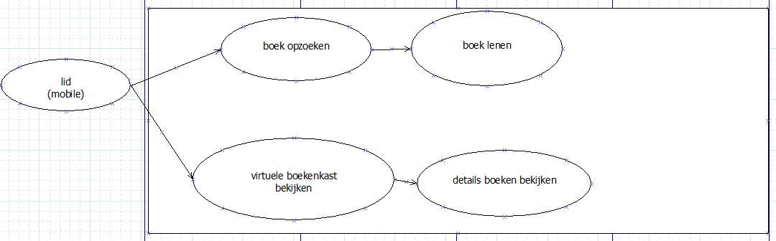

# Domain model



# Wireframe website

# 

# 

# Wireframe mobile

