

GO HOME

OUTER PLANETS

INNER PLANETS

OTHER GALAXIES

O CONTACT

PROJECTS

O GALLERY

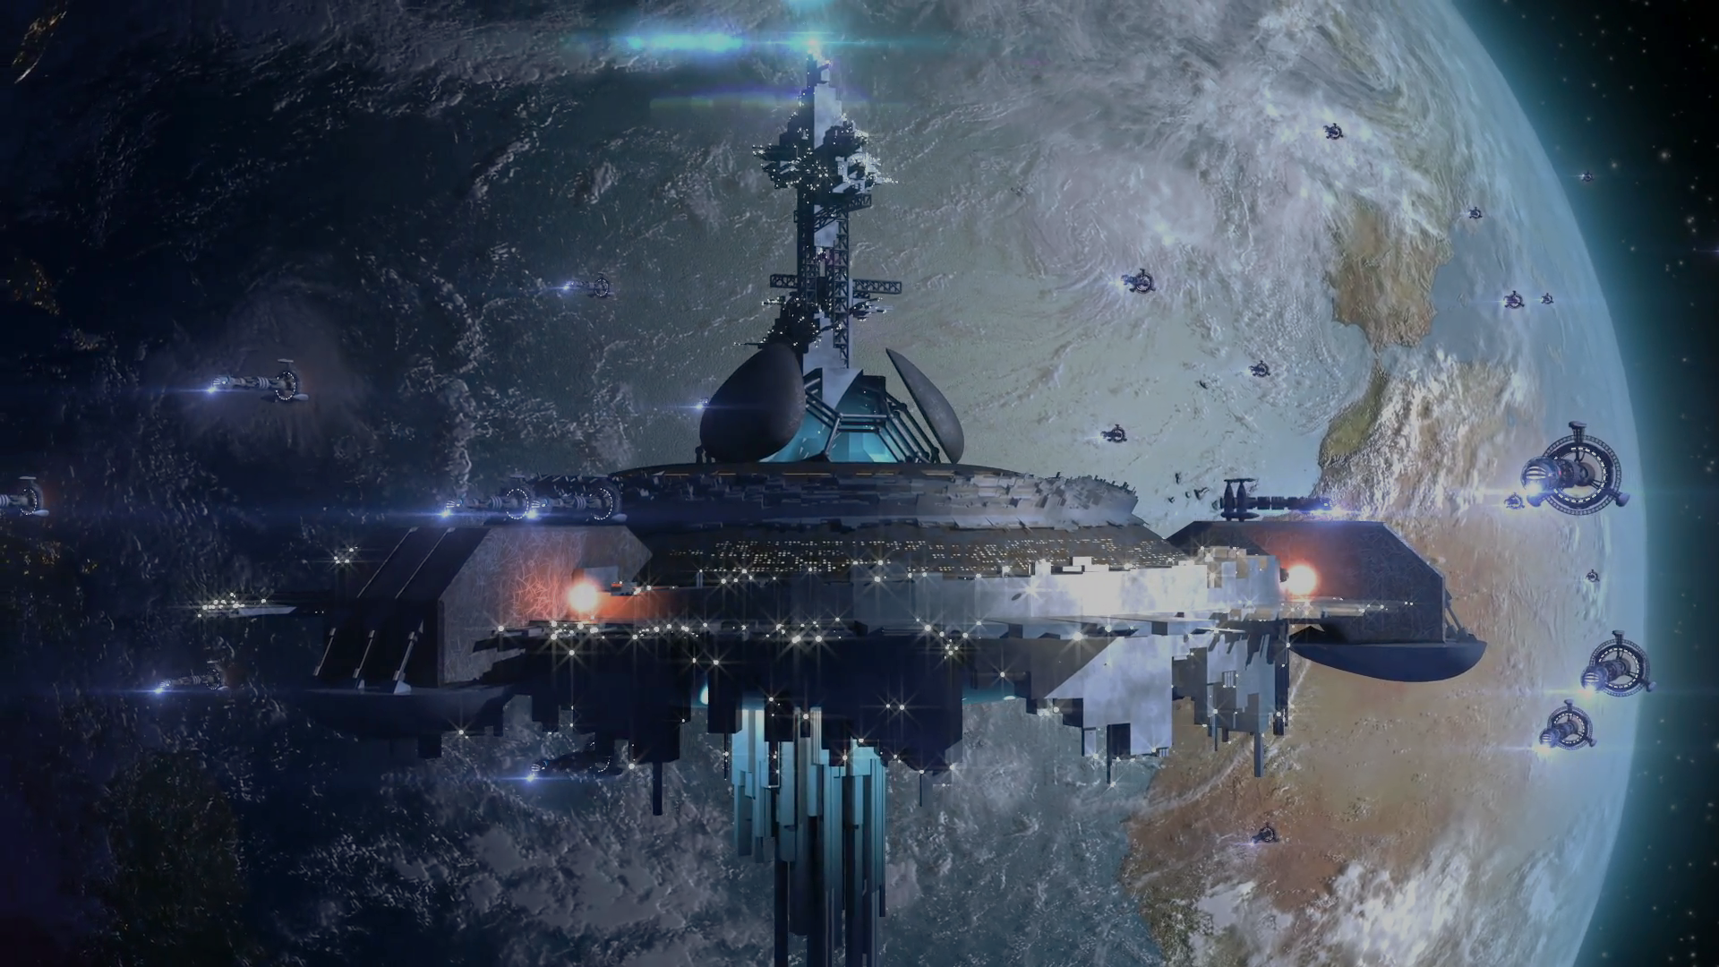

[Traducir a español?](Español.htm)

Our Mission: Our Vision:

Sfddalskdflkjasdjflasldkfjlajsldfjfgsdfgsdfgsdfgsdfgdsf

Sfddalskdflkjasdjflasldkfjlajsldfj

Sfddalskdflkjasdjflasldkfjlajsldfj

Sfddalskdflkjasdjflasldkfjlajsldfj

Sfddalskdflkjasdjflasldkfjlajsldfj

Sfddalskdflkjasdjflasldkfjlajsldfj

Sfddalskdflkjasdjflasldkfjlajsldfj

Sfddalskdflkjasdjflasldkfjlajsldfj

Asdfsfdasdfasfasfasdfsafdasdfasdfasdfasdfasdfsaf

Asdfasdfasdf

Asdfa

Sdf

Asdf

asdf

Follow ExoVoyage | [Facebook](https://www.facebook.com/ExoVoyage-2442619925763664/?modal=admin_todo_tour) Youtube [Instagram](https://www.instagram.com/)