**How to run digits:(first time installation)**

sudo docker run --runtime=nvidia --name digits -d -p 5000:5000 nvidia/digits

sudo docker commit 58dc4814cc3333243375dce5e105585ec1152a338f764801ebdeddaf4a1fada

sudo docker run -it sha256:692c094964d1561ec6d744244c074c136f31c094347388b28a612cfc0231690f

Name of the container : digit (Including Labelling tool and NVIDIA digits)

**For running the docker container bash (can enter root)**

docker exec -it **digit** /bin/bash

**\*Restart container**

docker restart **digit**

**\*Exit container**

docker stop **digit**

**Start the Labeling tool**

docker exec -it digit /bin/bash

cd root/flask-final

conda activate gputest

python main.py

**How to show the webpage: (NEED INTERNET CONNECTION), some jquery is imported from net.**

**IP(Depend on server):Port**

* Port is set to 5001
* Check the docker container ip( use ifconfig)
* Access [http://172.17.0.2:5001](http://172.17.0.2:5001/)

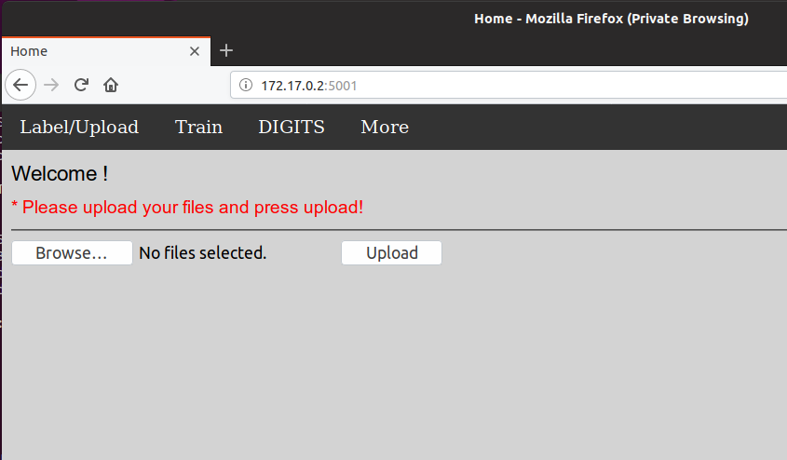

**Train** : When Clicked, it will automatically train the image in the **static/datasets/train/** folder, the training process can be seen in the **terminal**.

**DIGITS :** For accessing NVIDIA DIGITS

**More :** Just showing dropdowns, can be used to add option or link.

**Label/Upload** : Back to upload page, when clicked, it can reset the upload folder and variables.

**JSON File setting:**

* Open the config.json file.
* Just copy the style to add the window for labelling.
* The **posx** and **posy** means the x and y coordinate starting from the center of the image.
* **Width** and **height** is the size of the window.
* **Rotation** can be set arbitrarily.

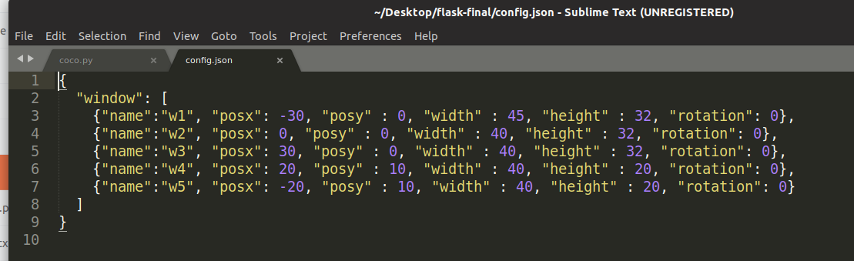

* When window added, we must also add the folder in the static/datasets/crop folder

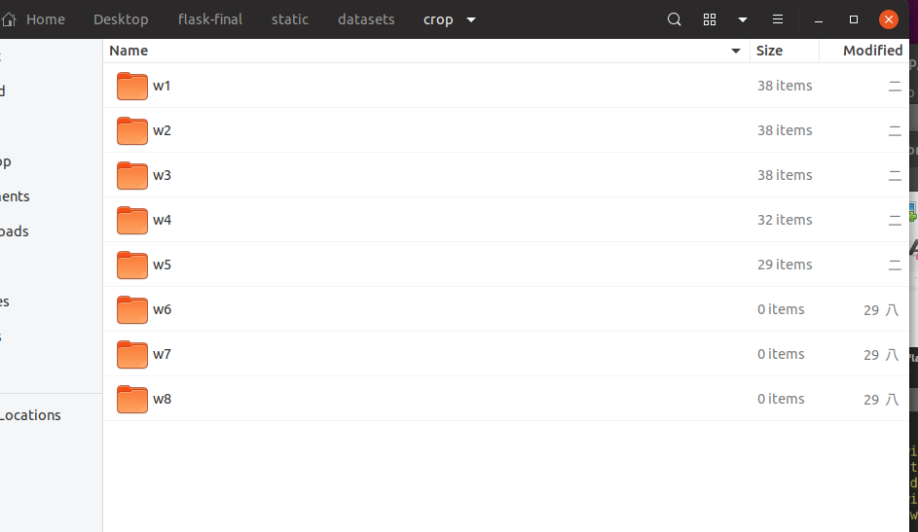

**Training :**

* Press the training button, if there is an error(tensor shape is not in graph), just re run python main.py and everything back to normal.

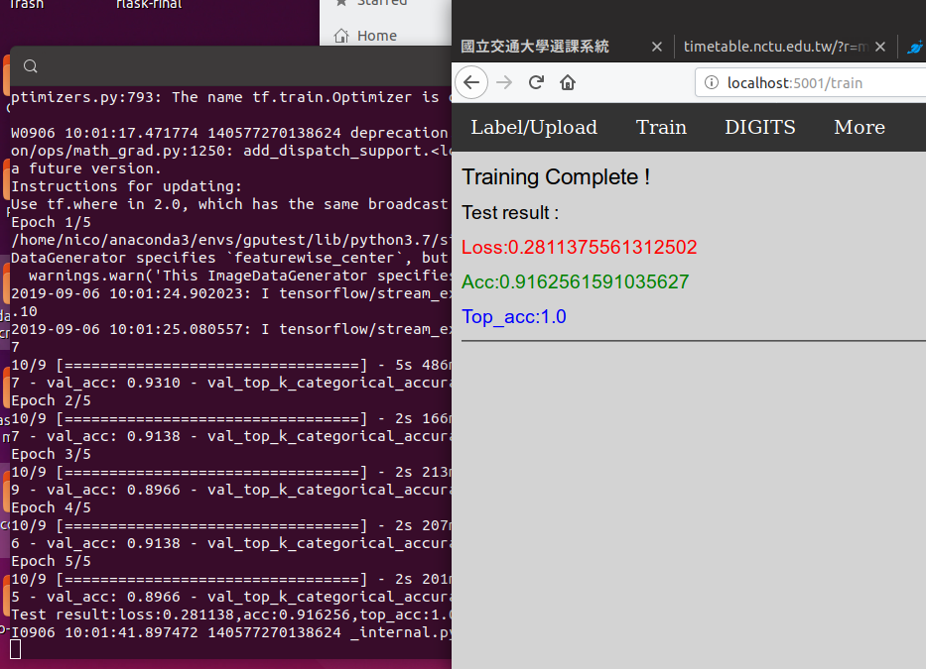

**How to label or INFER:**

* Click Upload
* After Uploading the files, we can either choose to Infer or Start-Label

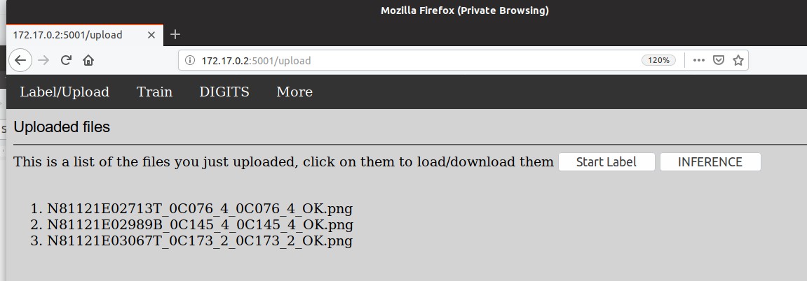

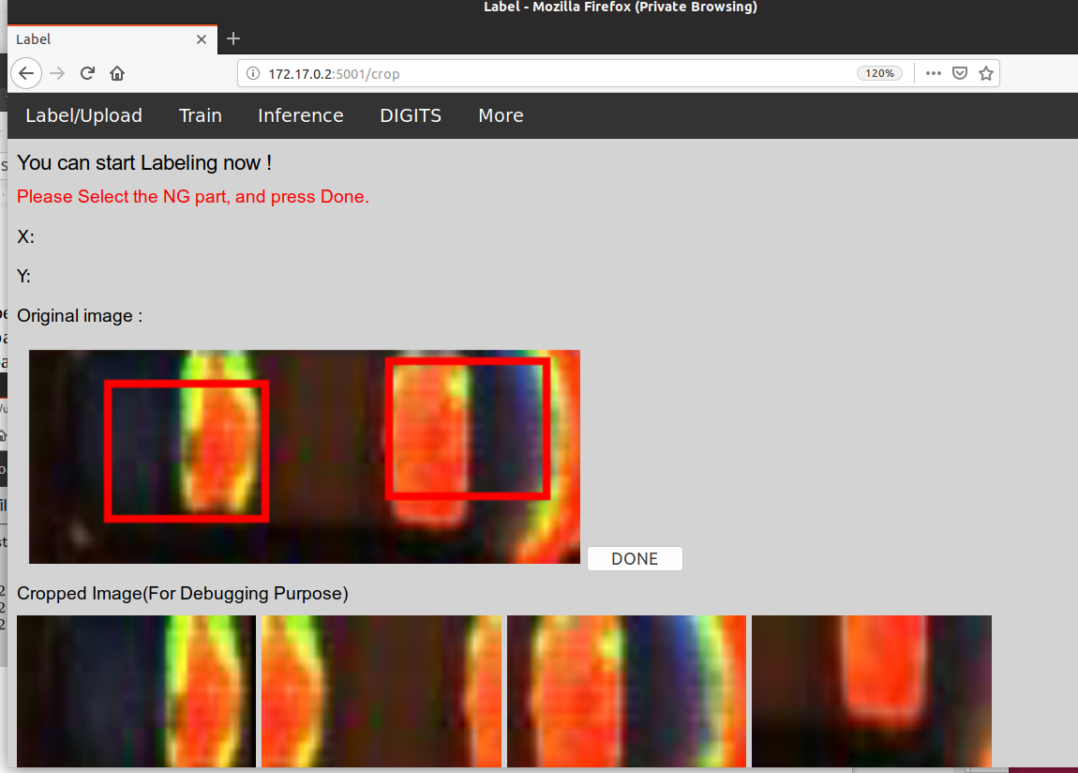

* Click the NG part and press DONE
* When all Pictures are labelled, it will automatically back to homescreen.

**INFERENCE:**

* Upload one image to infer.
* When uploaded, press **inference** button.
* Process can be seen in terminal. When finished, it will show the NG part in the red box.

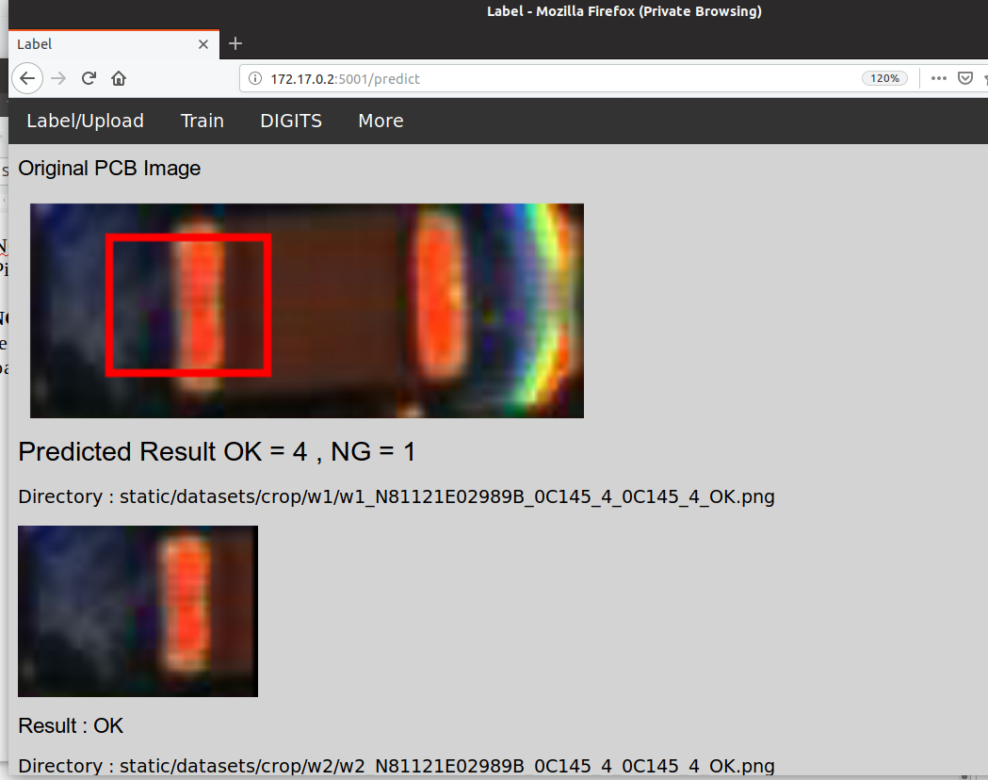

Notes :

* All web server can be modify in **flask-final/main.py** files.
* Port of the server can me modified in main functions.
* Directory of the nvidia digits in docker and how to modify the files in digits.

