How to run digits:(first time installation)

sudo docker run --runtime=nvidia --name digits -d -p 5000:5000 nvidia/digits

sudo docker commit 58dc4814cc3333243375dce5e105585ec1152a338f764801ebdeddaf4a1fada

sudo docker run -it sha256:692c094964d1561ec6d744244c074c136f31c094347388b28a612cfc0231690f

Name of the container : digit (Including Labelling tool and NVIDIA digits)

For running the docker container bash (can enter root)

docker exec -it digit /bin/bash

*Restart container

docker restart digit

*Exit container

docker stop digit

Start the Labeling tool
docker exec -it digit /bin/bash
cd root/flask-final
conda activate gputest
python main.py

How to show the webpage:
IP(Depend on server):Port
- Port is set to 5001
- Check the docker container ip( use ifconfig)
- Access http://172.17.0.2:5001
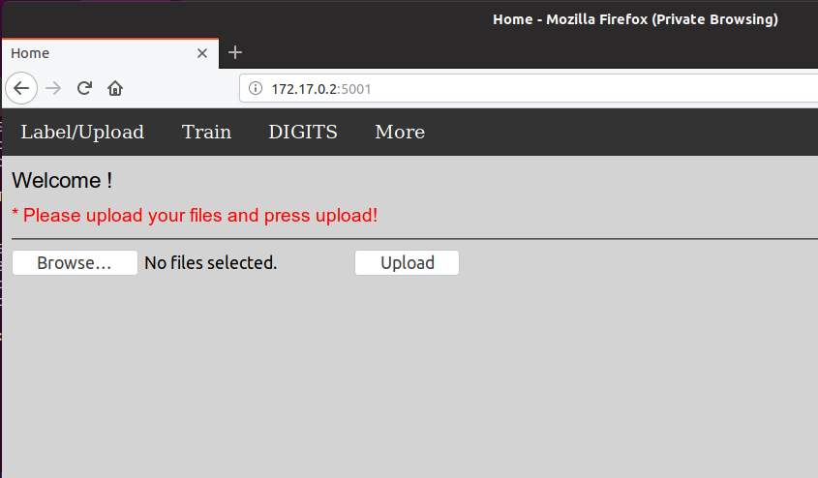

Train : When Clicked, it will automatically train the image in the static/datasets/infer/train/ folder, the training process can be seen in the terminal.
DIGITS : For accessing NVIDIA DIGITS
More : Just showing dropdowns, can be used to add option or link.
Label/Upload : Back to upload page, when clicked, it can reset the upload folder and variables.
JSON File setting:

- Open the config.json file.
- Just copy the style to add the window for labelling.
- The posx and posy means the x and y coordinate starting from the center of the image.
- Width and height is the size of the window.
- Rotation can be set arbitrarily.
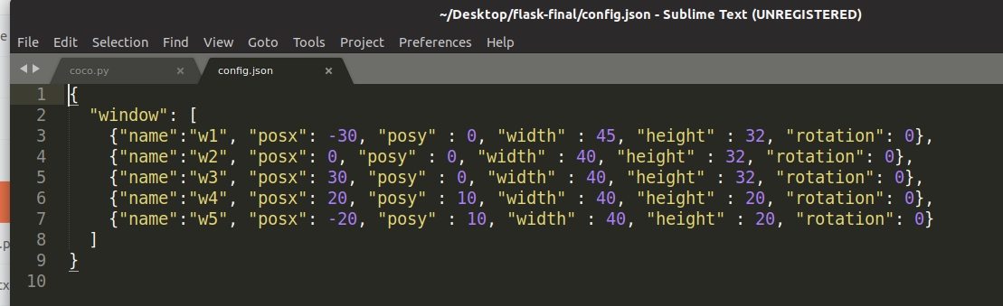
- When window added, we must also add the folder in the static/datasets/crop folder

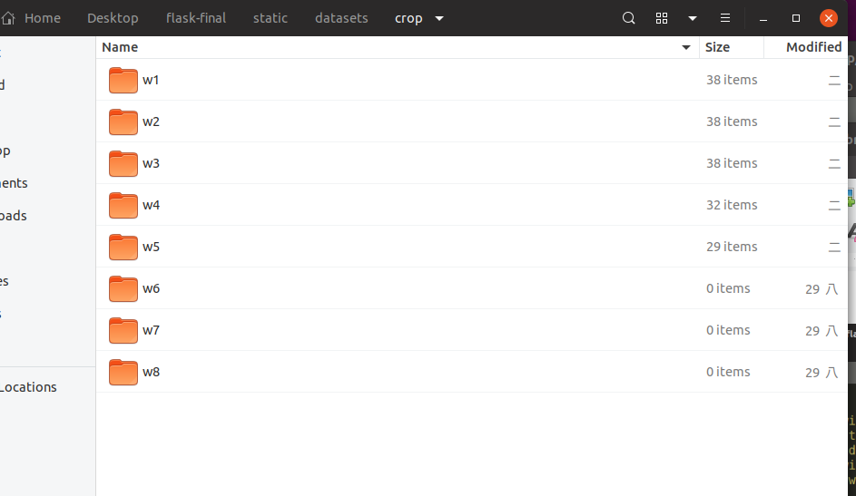
Training :
- Press the training button, if there is an error(tensor shape is not in graph), just re run python main.py and everything back to normal.
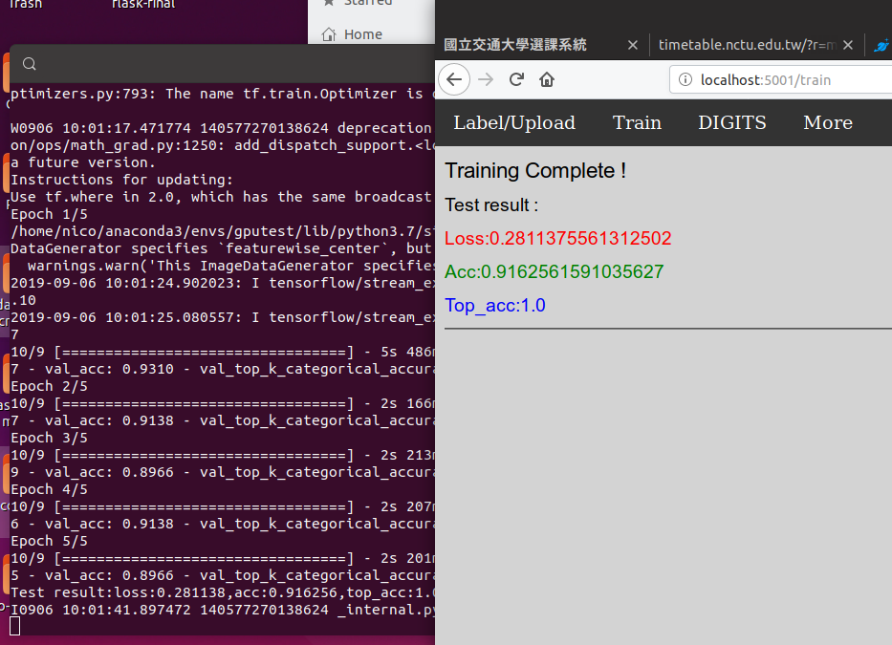

How to label or INFER:
- Click Upload
- After Uploading the files, we can either choose to Infer or Start-Label
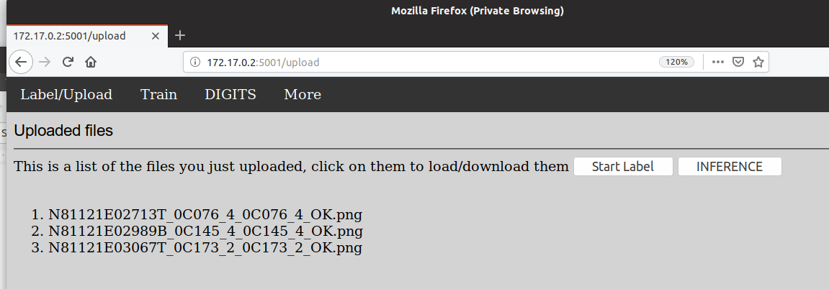
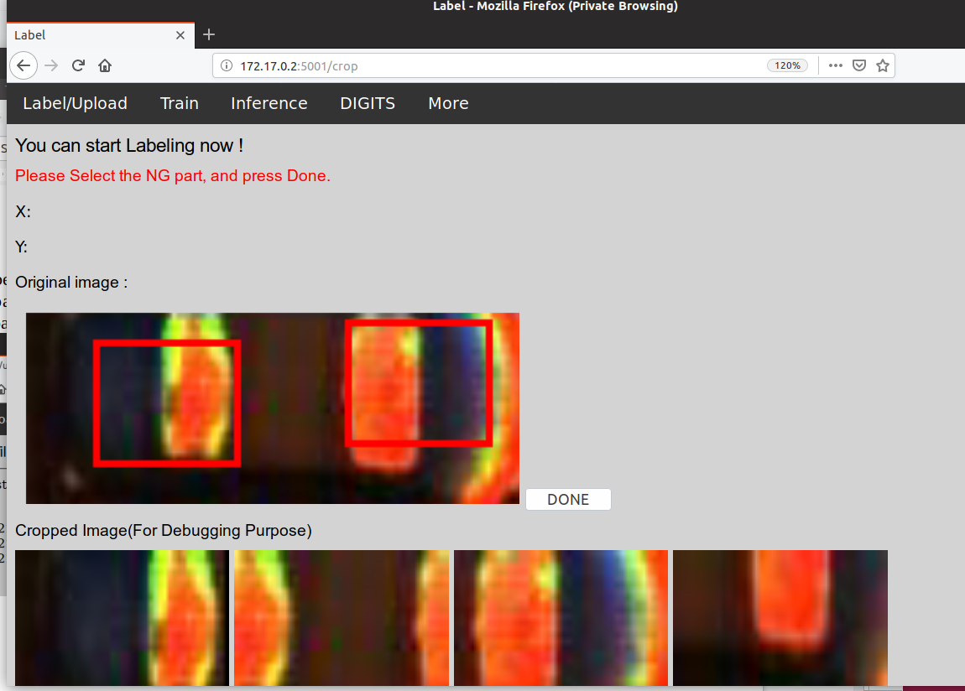

- Click the NG part and press DONE
- When all Pictures are labelled, it will automatically back to homescreen.

INFERENCE:
- Upload one image to infer.
- When uploaded, press inference button.
- Process can be seen in terminal. When finished, it will show the NG part in the red box.
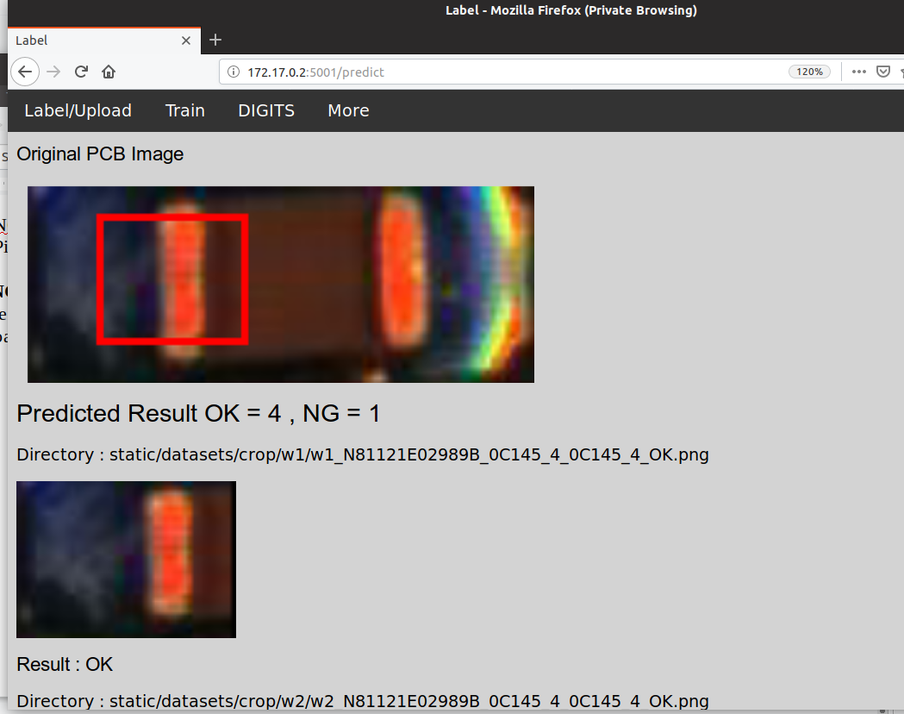

Notes :
- All web server can be modify in flask-final/main.py files.
- Port of the server can me modified in main functions.
- Directory of the nvidia digits in docker and how to modify the files in digits.
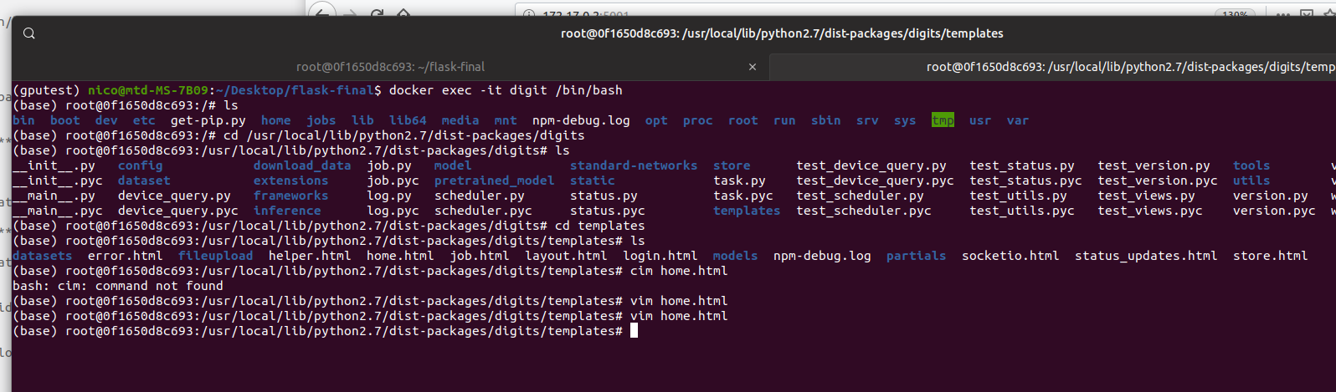
Modify the training data in the main.py file
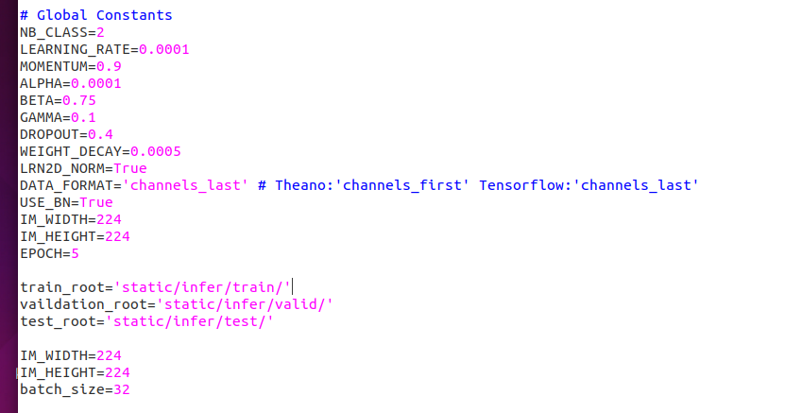
- We can change the directory of our training data by changing the train_root variables.
- Also applied for validation_root and test_root.

