# TECHNOLOGIES USED DIAGRAM

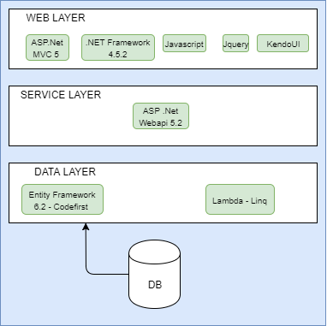

# COMPONENTS DIAGRAM

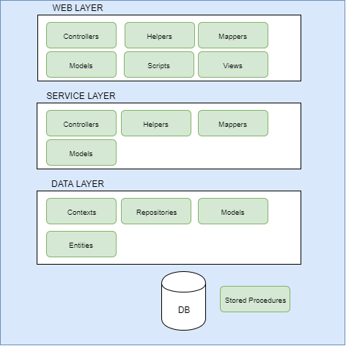

# ER DIAGRAM

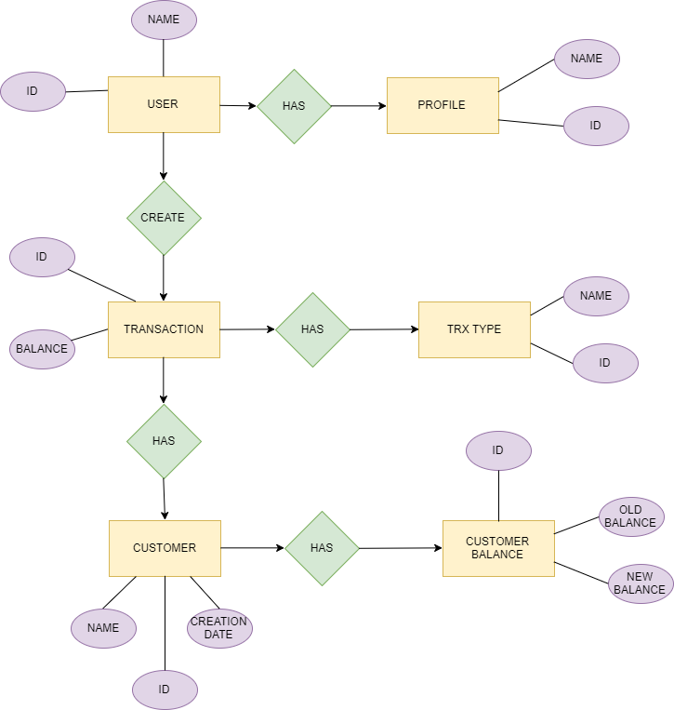

# DB DIAGRAM

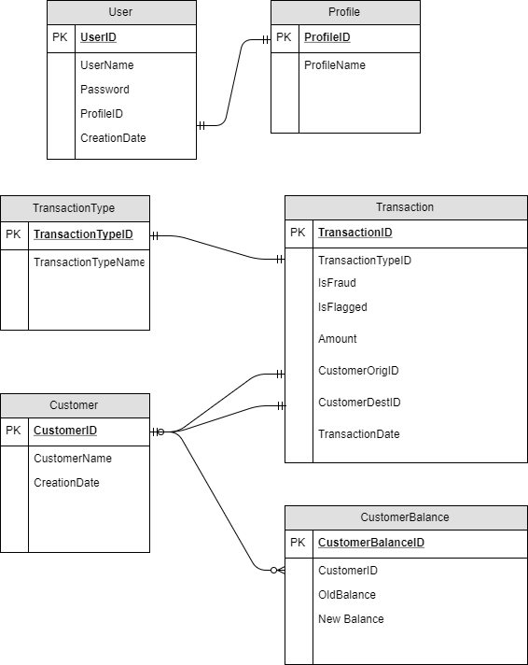

# Architecture Pattern

Layered architecture, divided in Web, Service and data layer.

SOLID

S: Single responsibility principle

Each class is used for its purpose, to isolate the responsibility of each object, leaving it only with the functionality that should contain.

D: Dependency inversion principle

If a new module was added, the CRUD operations can be created easily with the existing dynamic repo and no more repos need to be added.