**Name: Nayan Mandliya  
Roll No: 1911027**

**Division: A**

**Mern Batch: 1**

**Initial collection: workingonassign**

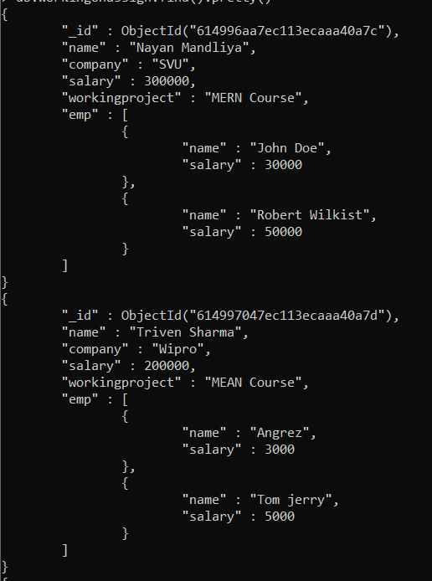 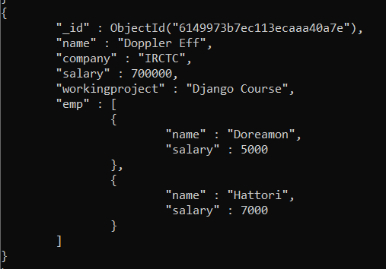

**Q) Demonstrating Find(): 1) To view all the documents present inside collection.**

**Query: db.workingonassign.find()**

**Output:**

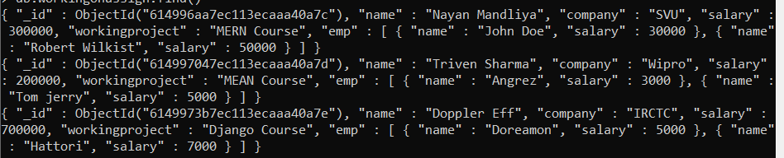

**2) To view documents matching a particular criterion.**

**Query: db.workingonassign.find({'name': 'Nayan Mandliya'})**

**Output:**



**Q) Demonstrating pretty(): To view all the documents of a collection in JSON visual representation.**

**Query: db.workingonassign.find().pretty()**

**Output:**

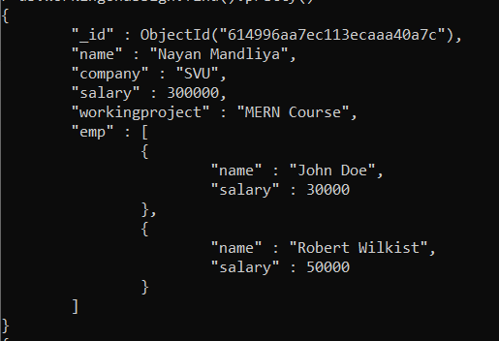

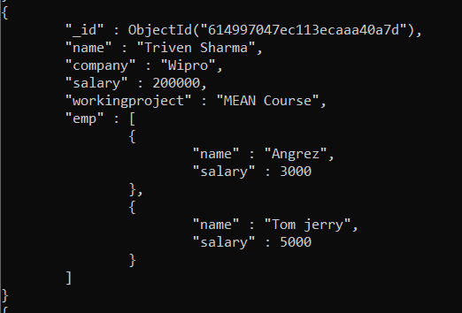 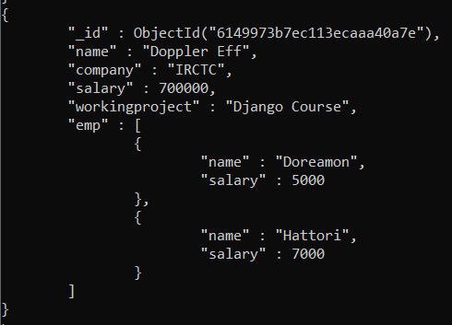

**Q) Demonstrating OR:**

**Query: db.workingonassign.find({$or: [ {'company': 'SVU'}, {'salary': {$lt: 250000}}]}).pretty()**

**Output:**

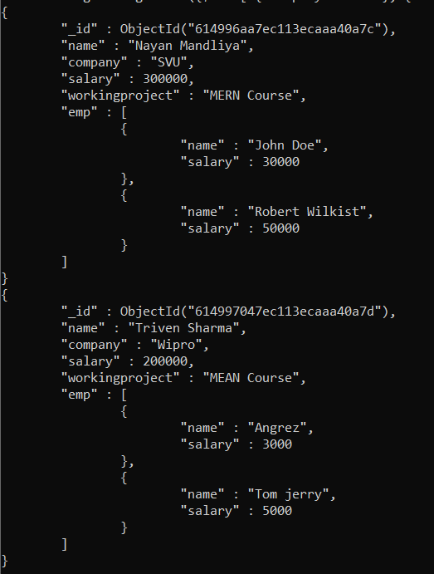

**Q) Demonstrating AND:**

**Query: db.workingonassign.find({$and: [ {'company': 'IRCTC'}, {'salary': {$gt: 500000}}]}).pretty()**

**Output:**

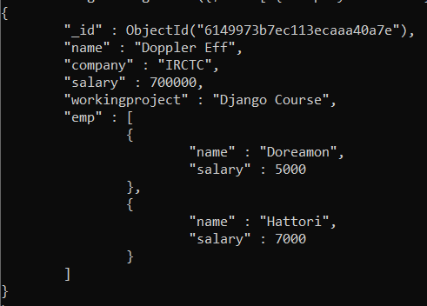

**Q) Demonstarting OR and AND together: 1) And inside OR.**

**Query: db.workingonassign.find({$or: [{'workingproject': 'MERN Course'},{$and: [{'workingproject':'MEAN Course'},{'emp.salary': 5000}]}]}).pretty()**

**Output:**

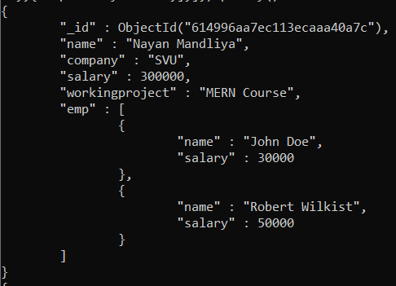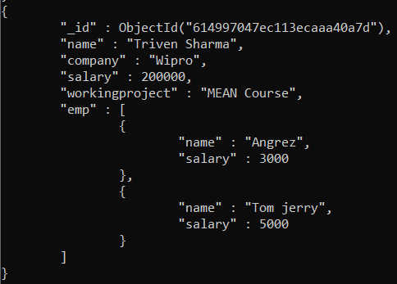

**2) OR inside AND.**

**Query: db.workingonassign.find({'company':'IRCTC', $or: [{'emp.name': 'Hattori'},{'emp.salary': 50000}]}).pretty()**

**Output:**

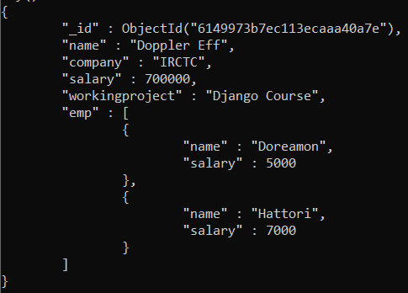

**Q) Update Document:**

**Query: db.workingonassign.update({'company':'IRCTC'}, {$set: {'workingproject': 'Python Course'}})**

**Output:**

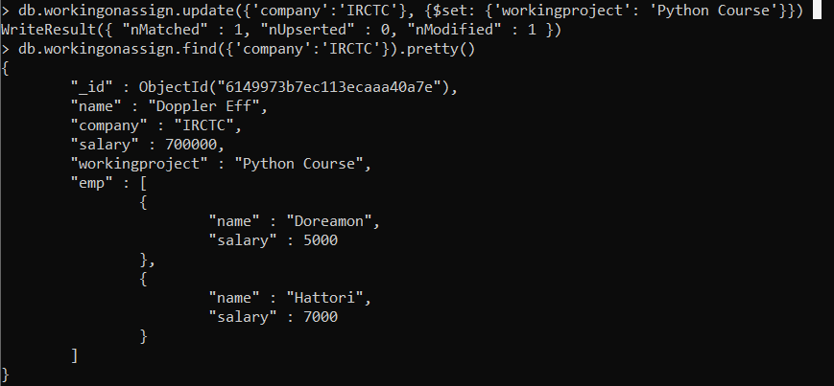

**Q) Remove document:**

**Query: db.workingonassign.remove({'company':'IRCTC'})**

**Output:**

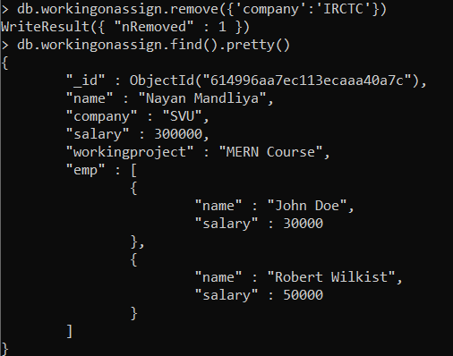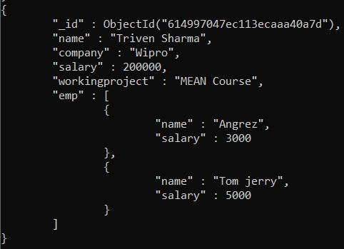

**Q) Demonstrating different clauses:**

**1) Equality: db.workingonassign.find({'name':'Nayan Mandliya'}).pretty()**

**Query:**

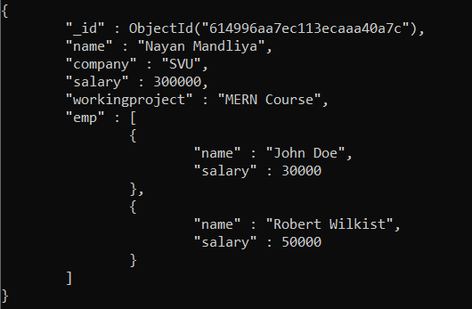

**Output:**

**2) $lt:**

**Query: db.workingonassign.find({'salary':{$lt: 250000}}).pretty()**

**Output:**

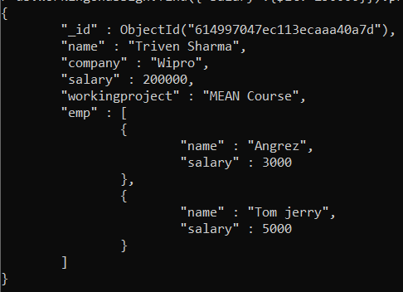

**3) $lte:**

**Query: db.workingonassign.find({'salary':{$lte: 300000}}).pretty()**

**Output:**

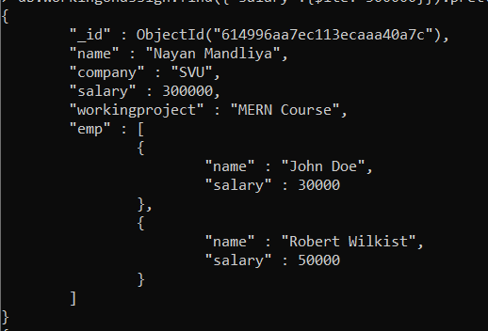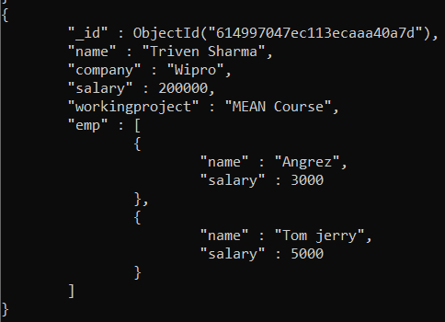

**4) $gt:**

**Query: db.workingonassign.find({'salary':{$gt: 200000}}).pretty()**

**Output:**

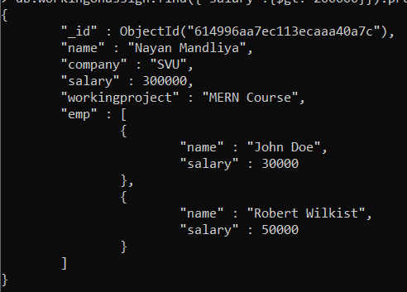

**5) $gte:**

**Query: db.workingonassign.find({'emp.1.salary':{$gte: 5000}}).pretty()**

**Output:**

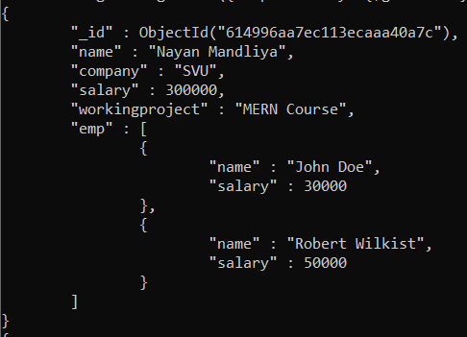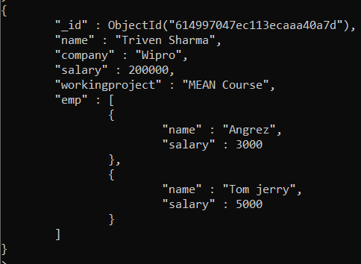

**6) $ne:**

**Query: db.workingonassign.find({'workingproject': {$ne: 'MEAN Course'}}).pretty()**

**Output:**

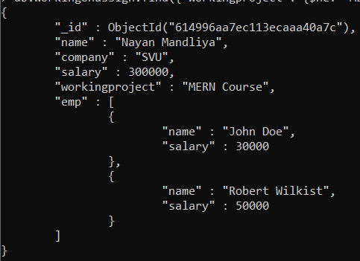

**Q) Projection:**

**Query: db.workingonassign.find({},{'name':1,'company':1,'salary':1,'_id':0})**

**Output:**

