**Abstract**

The purpose of this proposal is to try and convince Cineplex theatres that I have a solution that would allow them to change their method of admitting people into movies. It would create an efficient, waste-free, electronic system that will allow people to purchase tickets online and enter the theatre without needing to print out a paper ticket stub for an employee to verify. In addition to improving wait times and eliminating waste, it will cut down on costs while encourage more people to come to cineplex theatres instead of alternatives, making money for the company in the long run.

Phasing Out Paper Ticket Stubs to a Modern, Waste-Free, Electronic System

By: Philip Dumaresq – 40082638

A report submitted in partial fulfilment of ENCS 282

Concordia University – March 2019

Contents

List of Figures v

List of Tables vi

1. Introduction 1

1.1 Purpose 1

1.2 Background 1

1.3 Scope 2

2. Solution Criteria 3

2.1 Approach 3

2.1.1 Description 3

2.1.2 Major Parts 3

2.1.3 Functions 4

2.2 Result 4

3. Plan of Action 5

3.1 Step 1 – Minimum Viable Product 5

3.1.1 – QR Code generator software 5

3.1.2 – QR Code scanners 5

3.1.3 – Results 6

3.2 Step 2 – Entry using Scene cards 6

3.2.1 – Scene card only and distribution software 6

3.2.2 – Reading and distributing scene card hardware 7

3.2.3 – Phase out 7

3.2.3 – Result 7

3.3 Step 3 – Link Scene cards and Cineplex accounts to work together 8

3.3.1 – Linking Scene cards and cineplex accounts 8

3.3.2 – Enabling on the spot scene card distribution 8

3.3.3 – Phasing out 8

3.3.4 – Result 9

3.4 Step 4 – Finishing phasing out existing system 9

3.4.1 – Disabling of ticket stub distribution 9

3.4.2 – Removal of cashiers entirely 9

3.4.3 – Result 10

4. Schedule 11

4.1 Step 1 – Minimum Viable Product 12

4.2 Step 2 – Entry using Scene cards 12

4.3 Step 3 – Link Scene cards and Cineplex accounts to work together 12

4.4 Step 4 – Finishing phasing out existing system 13

5. Budget 14

5.1 Management 14

5.2 Labour 14

5.3 Material 15

5.4 Total budget 16

6. Qualifications 17

6.1 Management 17

6.2 Labour 17

7. Conclusion 19

7.1 Summary 19

7.2 Contact 19

8. References 20

8.1 Links 20

8.2 Images 20

# List of Figures

Figure 1: Train Ticket from 1912 2

Figure 2: Cineplex Scene Card 3

Figure 3: QR Code Scanner 3

Figure 4: Gantt Chart 11

# List of Tables

Table 1: Budget Spreadsheet 16

# 1. Introduction

This report will cover everything you need to know regarding my proposal for replacing the existing paper system for ticket stubs. It will examine the reason that this needs to be done and how it can be achieved. I will go over the schedule to complete this project as well as how much I believe will be necessary in budget.

## 1.1 Purpose

What I would like to propose is a method for completely eliminating physical ticket stubs at movie theatres. Ticket stubs are wasteful and pointless and could so easily be eliminated using modern technology. Using QR codes on a mobile app or simply having more durable and reusable physical cards that you can load up with your movie ticket, we can replace the wasteful ticket stubs with an environment friendly and quicker to use system for theatres. All it would require is improvements and extensions to the current infrastructure.

While many places already allow you to buy movie tickets online, many of them still force you to print out a physical ticket at the theatre or on your own printer at home. While those places are a step ahead, the end goal of this would be phasing that out entirely as well and going entirely electronic. Giving movie-goers the option to gain entry using either a reusable card, or a code on their phone.

## 1.2 Background

Movie theatres around the world use the decades old system to get in to see a movie showing: presenting your ticket stub. Ticket stubs have been a go-to for over a century (Figure 1), with theatre, travel and sporting events along with many other industries using them. Today however, 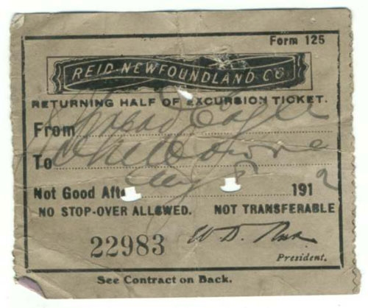everyone else seems to be trying to move on from the physical ticket stub, with airlines all giving the option for electronic boarding passes and most events having QR code scans for entrance. However, movie theatres seem to be slow at adopting the electronic ticketing. According to a 2018 survey[1], Americans collectively go to out to the movies almost 3 billion times annually, in turn generating approximately 30,000 tons of waste in ticket stubs only.

Figure 1: Train Ticket from 1912

## 1.3 Scope

Cineplex theatres is the largest movie theatre chain in Canada, and one of the biggest in North America[2]. It owns and operates over 160 theatres, making it a huge contributor to this overarching waste issue. While not being the largest, I’m target Cineplex with this proposal because of two contributing factors: Cineplex is locally the most prominent theatre, and they already have a head start on the infrastructure to perform this migration with electronic ticket booths and Scene cards. The Scene rewards card’s purpose right now is to provide benefits and encouragement to people to use the Cineplex theatres, but having these cards, they can further be used to scan your way into a theatre using an electronic card reader.

# 2. Solution Criteria

My solution to solving this problem is to eliminate paper ticket stubs from cineplex theatres entirely. All ticketing will happen online, or through a scene card.

## 2.1 Approach

The approach is simple. Give the customers two new options to gain entry to the theatre, take away the current only option of using a paper ticket stub.

### 2.1.1 Description

The new system will work in two ways. To purchase a ticket, you will either do it online, or at an electronic kiosk in the theatre. Purchasing at a kiosk, you’ll need to swipe your scene card to load the movie onto your account. Once a ticket has been purchased using either method, you can scan your way in using either a QR code on your phone or your scene card. The method of purchase and method of entry are independent as you can link your card to your account and use them interchangeably.

### 2.1.2 Major Parts

There are 2 major user-oriented components to this system. The first one is the QR code [3] scanner (Figure 3). The QR code will allow people to access the theatres without needing to have a scene card and without needing to stop at a kiosk or anything. It can all be done entirely from your phone. The second major component is the scene card [4] (Figure 2). The scene card is convenient because cineplex already has it in place. The functionality of it would just need to be extended on the software side to allow people to use scene cards to get into movies. In addition to the QR Code and scene card, there would need to be some components implemented that wouldn’t seen by customers. There would need to be phone/tablets stationed at the entrances where the ticket people are to allow them to scan a QR code with a tablet, and there would need to be a magnetic card reader to allow you to use your scene card as well.

Figure 2: Cineplex Scene Card

Figure 3: QR Code Scanner

### 2.1.3 Functions

The purpose of the QR code and scene card are to allow people to access the theatres through use of modern technology and cut down on the waste of getting a ticket stub. They serve the same purpose but give customers options to chose from in terms of how they prefer to scan into the theatre.

## 2.2 Result

The result of all this will be a waste-free, electronic system. It will cut down on costs of employees, make money whenever a user purchases a new scene card, and improve the overall flow of theatres. Making it quicker to get in by making it online and expanding the user’s options. It also incentivises the use of scene cards, getting more people onto the Cineplex system and encouraging people to chose cineplex theatres over competitors.

# 3. Plan of Action

My plan of action comes in 4 major steps. Each step is carefully measured to ensure the success of this system. At each phase in the plan, a safety net is introduced so that should the next step fail, there will always be something to use. Where relevant, I will also undershoot on estimations to ensure that nothing happens too quickly that could potentially bring about widespread failure without an immediate recovery option.

## 3.1 Step 1 – Minimum Viable Product

This step will involve making all the necessary changes to existing software infrastructure to begin allowing this migration to happen. In this step, no existing solutions will be phased out, but rather more options will be introduced.

### 3.1.1 – QR Code generator software

The first thing that must be added to create an MVP would be the option to scan your way into a theatre without printing a ticket. Through the existing Cineplex app, users would be able to generate a QR code to scan into the movies instead of needing to print out the ticket. This would be simply generating a QR code and while that code is valid (i.e 45 minutes before and after the movie for example), they can enter and exit the theatre area by scanning their phone.

### 3.1.2 – QR Code scanners

To make a QR code work, the second key piece of the MVP would be making sure that all employees working at the entrances have a phone or tablet that can scan the codes. Some places already have this, so it would be a matter of making it ubiquitous. It would involve making a second application – or an employee, locked in part of the existing app, that includes a QR code scanner, so that when people bring them their phones, they can just scan to let them in.

### 3.1.3 – Results

Results of step 1: No changes to the existing options for entry. New option added where employees carry a QR code scanner to allow people in.

Should this step fail, you can fall back on the present system with no changes.

## 3.2 Step 2 – Entry using Scene cards

The second thing that must be done to allow users to enter a theatre via their scene cards is connecting their scene cards to their accounts. The reasoning for this is that if a user purchases a ticket on their phone while at home, but they don’t have data, then they can use their scene cards to get in and it will be linked to their accounts. In this phase, more infrastructure will also be introduced to push the scene cards harder.

### 3.2.1 – Scene card only and distribution software

Create software to scan your scene card at the electronic ticket booths so that your phone isn’t necessary to purchase a ticket. You can purchase the ticket, then scan your scene card to have it associated with your account,

Existing ticket booths can also have software installed on them that give users the option to print out a scene card if they don’t have one – allowing them to load their movie onto the card account instead of printing out a ticket. For now, this needs to remain disabled, but installation should begin now. If the electronic booths are not updatable remotely, this software should be made to be enabled remotely.

### 3.2.2 – Reading and distributing scene card hardware

The new hardware required for this would be simply be a card reader that can be plugged into a USB-C or Apple port that would read the card and transmit the user ID to the scanner to check if they have a valid entry. These types of scanners exist already, it would be a matter of purchasing them to allow employees to use a single device for both methods of entry.

Existing ticket booths can also be retrofitted with card machines for people to get a scene card if they don’t have one yet. Without an account, scene cards can be used individually with an anonymized account created linked to that card. Can later be merged with a cineplex account through the app.

### 3.2.3 – Phase out

At this step, phasing out of people selling tickets at booths can begin at the theatres that have electronic ticketing booths.

### 3.2.3 – Result

Results of step 2: Nothing phased out entirely yet – starting to remove some people from the process as this is already somewhat underway in theatres. This step introduces the ability to scan in from your scene card.

Should this step fail, you can fall back on the present system with no changes.

## 3.3 Step 3 – Link Scene cards and Cineplex accounts to work together

At this point, clients have 3 separate options for gaining entry – buying a ticket, scanning their scene card, and using a QR code. This phase will now begin to combine the new options introduced in phases 1 and 2.

### 3.3.1 – Linking Scene cards and cineplex accounts

The required software in this section would be giving users the option to link their scene cards and their cineplex accounts. To facilitate this process, allow users to simply take a picture of their scene card and it’ll add that card to their account. Then once they purchase a movie ticket, it’s linked to both the card and the app, so they can access the theatre with either.

Users can purchase tickets through their scene cards at the theatre by scanning it and enter using their phone. The two systems become interchangeable, but both continue to exist separately. A scene card will work without a cineplex account or the app and vice versa.

### 3.3.2 – Enabling on the spot scene card distribution

Enable the distribution of scene cards at theatres. With the card makers that got retrofitted in, they can now be loaded with empty scene cards that a user can chose to get a new one should they not currently have a scene card.

### 3.3.3 – Phasing out

At this point, removal of cashiers will continue and the remaining one’s roles will be shifted slowly to a more customer-support oriented job. They will be trained to be available to direct customers towards the machines as well as helping customers buy tickets from their phones or showing clients how to link their scene card and their cineplex accounts.

### 3.3.4 – Result

Users can now enter the movies with either system and use them interchangeable. Cashiers selling tickets are phasing out more and moving their role to helping users.

## 3.4 Step 4 – Finishing phasing out existing system

At this point, users can completely use scene cards or the cineplex app together, separately, or entirely interchangeable. This is a solid system at this point, and the old system can finish being phased out entirely.

### 3.4.1 – Disabling of ticket stub distribution

Disable the distribution of ticket stubs on card readers, and make the only option be to either load it onto your scene card/cineplex account or to distribute a new scene card if you don’t have one.

### 3.4.2 – Removal of cashiers entirely

This step is to remove the trip to the counter to buy a physical ticket entirely. The remaining cash staff will be shifted entirely to the support role or to other cleaning tasks throughout the theatre.

### 3.4.3 – Result

Physical paper stubs are entirely phased out, everything is done online or at electronic ticket booths and loaded onto a scene card and/or cineplex account.

# 4. Schedule

Developing software takes time. Integrating hardware and software takes a lot of time. In this phase, time estimates will be overshot to keep things on course. It’s taking a realistic approach at how system development projects often go to avoid the frequent pitfalls of cutting corners to stay on schedule that results in systems failing. It should also be noted that the maintenance of the software will become a persistent task, and once each phase has ended, both software and hardware will need to be continuously maintained. For a summary of the predicted schedule, the Gantt chart below (Figure 4) shows an overview of each phase in the proposal.

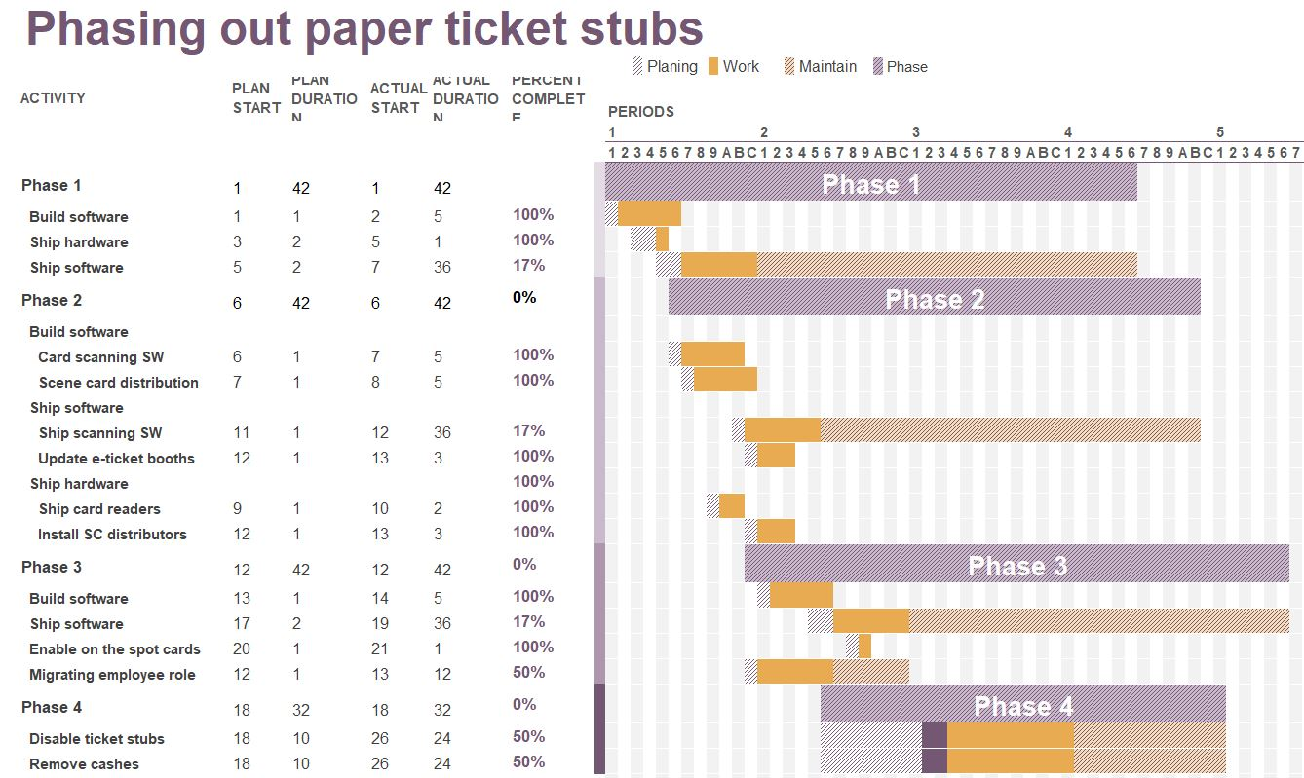

#### Figure 4: Gantt Chart

## 4.1 Step 1 – Minimum Viable Product

Development of the software will take a while, not because it will necessarily take that long to develop it, but because it needs to be a well designed and very robust system if it’s ever to become the sole method of ticket purchasing.

For this reason, the design of the software should be done over the course of 6 months.

Implementing this new system will take place over the course of a year after the software has been shipped. The change needs to be gradual to make it a phasing out of the existing system. This step will continue well into step 2 and 3, introducing one new piece at a time.

## 4.2 Step 2 – Entry using Scene cards

This step has the most going on in it. Software and hardware are being developed and shipped all at the same time. The software should be developed in parallel since the two pieces of software will ultimately need to work together, and so communication between the two of them will be important. They’re offset from each other to give each one focused time, but overall work in parallel. The physical installation will all be done at the same time over the course of 3 months, with one person doing both hardware and software installs. The shipped software will stay in active maintenance for 6 months after development to ensure stability.

## 4.3 Step 3 – Link Scene cards and Cineplex accounts to work together

The software portion for this will likely only need to be one or two developers while the rest work on continuing to maintain systems. Now that the bulk of the development is done, there can be more focus on making sure these systems are working exactly as they should before becoming the only option. After the first 6 months of the phase, all software will then be under active maintenance.

## 4.4 Step 4 – Finishing phasing out existing system

This step there isn’t a lot to be done schedule wise. Once employee roles are migrated, slowly stop hiring new people to fill in the roles and play it by ear for each location to see how successfully migration is being handled.

# 5. Budget

In this section I will give an estimate on how much money will be required to complete this project. A part of the project will be to maintain the created systems, and so this doesn’t cover the continued cost once the project is done – although that will just be developer salary.

## 5.1 Management

For management, I be managing 5 developers, plus contractors across the country. In addition, I will need to coordinate with the managers for the theatres for employee training. I think $150,000 a year is a reasonable salary needing to manage so many separate resources.

## 5.2 Labour

Most of the labour involved in this project is the development and maintenance of software. This will be a team of 5 developers. Each developer should be making about $75,000 per year[5], making them cost about $750K for the whole project, plus benefits, which would bring it up to around $1.1M. At the end of the first phase, two more people should be brought on for a year to do maintenance and have the rest of the 5 team members take care of maintenance once the development is done. The other two developers will be around $250K for a year plus their benefits.

There will also need to be someone who physically goes to locations to install the card machines and do necessary software upgrades. With 160 locations, there will need to be many people contracted to do this. Over the course of 3 months, you could have 3 people go to each of the major cities and install them in theatres. One person could cover east coast, one for west, one for central. For a 3-month contract, lots of travel and manual labour installing the physical machines, I think each person’s contract should be about $50K, totalling $150K for on-site installation.

## 5.3 Material

There are 3 things to consider for material costs. The price of devices for each theatre to have, the price of the card scanners, and the price of the card machines. Assuming an iPad mini is bought as the card reader and QR code scanner, and two were purchased for each theatre, that would be $150,000 [6].

The price for a magstripe reader that works with an iPad can vary in price and there are many options available. I would estimate that annual costing of it would be between $500K and $1M [7] (This is based on Cineplex’s yearly revenue, initial prices would be much lower and the cost of servicing the machines is based on their use, so it would be split between phone scanning and scene cards. Real costs would likely be lower than this).

The cost of cards with magnetic strips is about $0.5 per card [8]. Assuming distributing 1M new cards every 6 months (this will plateau quickly), it’ll cost around $500K for each phase.

## 5.4 Total budget

The cost for management comes out to $300,000, plus $1,125,000 for developers and another $150,000 for on-site installation. Total cost of employment comes out to $1,575,000 for the two-year span of the core project. Continued maintenance will incur more costs. Cost of material for the project I estimate to be $150,000 upfront for the hardware, and up to another $500,000 to $1,000,000 per year for external services. Plus $1M for the new scene cards, this will be a total of $3.6 million for the duration of the two-year plan outlined in the project. 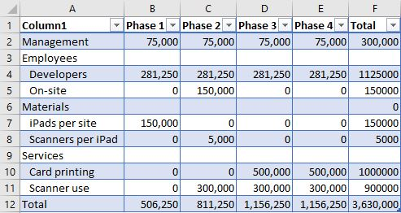

#### Table 1: Budget Spreadsheet

# 6. Qualifications

In this section, I will outline the necessary qualifications of people to be hired for this project. I will be outlining my own qualifications for managing this project as well as what will be needed in terms of workforce.

## 6.1 Management

In terms of management, I am qualified for this position as I have experience working in various types of IT roles. I know the language of the programmers, the database engineers, as well as the IT staff going on site to theatre locations. I have very strong communication skills and highly value transparency and open communication.

## 6.2 Labour

The qualifications for the labour will be primarily software developers. We will need full stack programmers who are familiar with the technologies that the current software infrastructure is built in. This is likely going to be experienced full stack developers if only 5 are getting hired. We will need 1 person especially strong in database architecture, management and organization who can communicate with other database administrators throughout cineplex. We will also likely need 1 person especially strong in iOS development, and one person in Android development. While everyone should be able to do all these things, it would be beneficial to find 3 people who specialize in them at the very least.

In addition to the developers, 3 people who can go on site to install the necessary software and hardware will be required. They will handle making sure the ticketing kiosks are able to handle distributing a new scene card to customers. The people doing this will need to have knowledge of working with the hardware systems on location and will to be someone who has experience working entirely unsupervised while travelling between many cities. As such, someone who has worked in IT, especially doing network installation would likely be a good fit for this role. Network engineers are often on short contracts and can handle this type of job. Training on how to use the specific hardware and software might be necessary but being technical people that won’t be an issue.

# 7. Conclusion

In conclusion, Cineplex theatres should switch over to this efficient, waste free system. It will reduce waste, reduce costs, and streamline the process of purchasing tickets and getting into movies while attracting people towards cineplex theatres over competitors.

## 7.1 Summary

This document covers the necessary steps that need to be taken to implement this system. For each step, I outline how long it will take to achieve and what will be completed by the end of each one. Each step can fail individually, and you can fallback on the previous, so safety is highly considered when coming up with an approach. Overall the project should span about 2 years with continued time afterwards for maintenance. I outline a budget required for this system totalling up to 2.75 million dollars over the course of the main project. This is a huge migration, and so I think $2.75M is a decent figure.

## 7.2 Contact

Name: Philip Dumaresq

Email: [phdumaresq@gmail.com](mailto:phdumaresq@gmail.com)

Phone number: (613) 447-4889

LinkedIn: <https://www.linkedin.com/in/phdumaresq/>

Address:

121 rue du Tartan,

Gatineau QC,

J9J 0W2, CA

# 8. References

## 8.1 Links

1. <https://www.statista.com/statistics/264396/frequency-of-going-to-the-movies-in-the-us/>
2. <https://en.wikipedia.org/wiki/List_of_movie_theater_chains#Canada>
3. <https://en.wikipedia.org/wiki/QR_code>
4. <https://www.cineplex.com/Promos/Scene>
5. <https://www.payscale.com/research/CA/Job=Computer_Programmer/Salary/f9d1c146/Experienced>
6. <https://www.apple.com/shop/buy-ipad/ipad-mini-4>
7. <https://www.idwholesaler.com/pvc.html>
8. <https://fitsmallbusiness.com/best-credit-card-readers-for-iphone/>

## 8.2 Images

1. <https://proxy.duckduckgo.com/iu/?u=https%3A%2F%2Fthumbs.dreamstime.com%2Fb%2Fscan-qr-code-to-mobile-phone-electronic-scan-digital-technolo-technology-barcode-vector-illustration-58691184.jpg&f=1>
2. <https://mediafiles.cineplex.com/Contests/FamilyFlicks/scene_card2.png>